Table of Contents

UNITED STATES

SECURITIES AND EXCHANGE COMMISSION

Washington, D.C. 20549

SCHEDULE 14A

(Rule 14a-101)

INFORMATION REQUIRED IN PROXY STATEMENT

SCHEDULE 14A INFORMATION

PROXY STATEMENT PURSUANT TO SECTION 14(a) OF THE

SECURITIES EXCHANGE ACT OF 1934
(AMENDMENT NO. )

Filed by the Registrant ☒

Filed by a Party other than the Registrant ☐

Check the appropriate box:

- Preliminary Proxy Statement

- Confidential, for Use of the Commission Only (as permitted by Rule 14a-6(e)(2))

- Definitive Proxy Statement

- Definitive Additional Materials

- Soliciting Material under Section 240.14a-2.


(Name of Registrant as Specified In Its Charter)

(Name of Person(s) Filing Proxy Statement, if other than Registrant)

Payment of Filing Fee (Check the appropriate box):

- No fee required.

- Fee computed on table in exhibit required by Item 25(b) per Exchange Act Rules 14a-6(i)(1) and 0-11

- Fee paid previously with preliminary materials.

Table of Contents
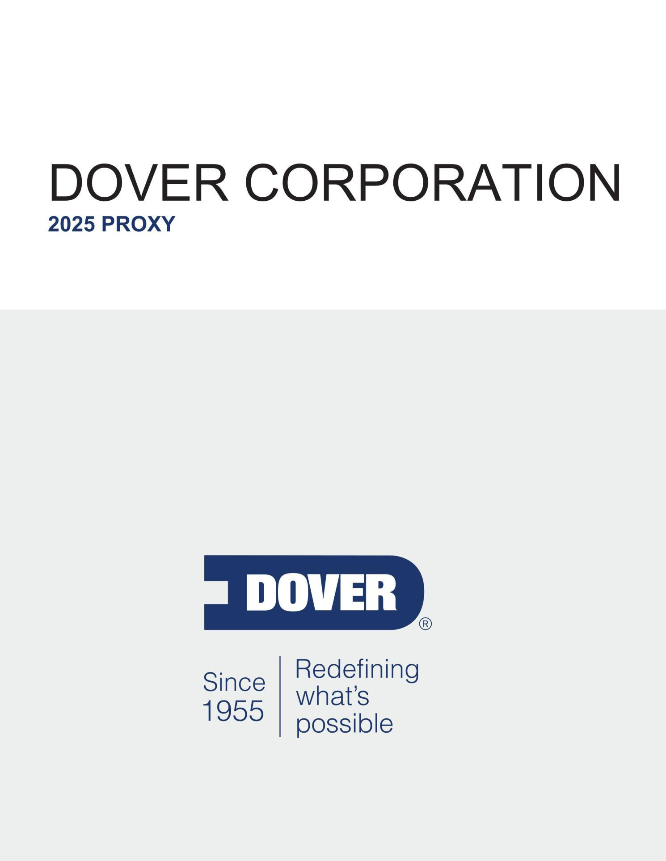

Table of Contents

Notice of 2025 Annual Meeting of Shareholders

May 2, 2025

9:00 a.m. Central Time
The Post Oak Hotel at Uptown Houston
1600 West Loop South
Houston, TX 77027

Dear Fellow Shareholder:

You are cordially invited to attend the Annual Meeting of Shareholders (the “Annual Meeting”) of Dover Corporation (“Dover” or the “Company”) at The Post Oak Hotel at Uptown Houston, 1600 West Loop South, Houston, TX 77027 on May 2, 2025, at 9:00 a.m., Central Time, to be held for the following purposes:

- To elect nine directors.

- To ratify the appointment of PricewaterhouseCoopers LLP (“PwC”) as our independent registered public accounting firm for 2025.

- To approve, on an advisory basis, named executive officer (“NEO”) compensation.

- To consider a shareholder proposal requesting an independent board chair, if properly presented.

- To consider such other business as may properly come before the Annual Meeting, including any adjournments or postponements thereof.

All holders of record at the close of business on March 10, 2025, are entitled to notice of and to vote at the Annual Meeting or any adjournments or postponements thereof. Whether or not you plan to attend the Annual Meeting, we urge you to vote your shares as soon as possible.

March 20, 2025

By authority of the Board of Directors,

Ivonne M. Cabrera

Secretary

Table of Contents

TABLE OF CONTENTS

Notice of 2025 Annual Meeting of Shareholders
Proxy Statement Summary |  |  |  |  |  |  |  |  |  |  |  |  |  |  |  |  |  |  |  |  |  |  |  |  |  |  |  |  |  |  |  |  |  |  |  |  |  |  | 1
 |  |  |  |  |  |  |  |  |  |  |  |  |  |  |  |  |  |  |  |  |  |  |  |  |  |  |  |  |  |  |  |  |  |  |  |  |  |  | 1
 | Annual Meeting Information |  |  |  |  |  |  |  |  |  |  |  |  |  |  |  |  |  |  |  |  |  |  |  |  |  |  |  |  |  |  |  |  |  |  |  |  |  | 1
 | Items of Business |  |  |  |  |  |  |  |  |  |  |  |  |  |  |  |  |  |  |  |  |  |  |  |  |  |  |  |  |  |  |  |  |  |  |  |  |  | 1
 | How to Submit Your Proxy |  |  |  |  |  |  |  |  |  |  |  |  |  |  |  |  |  |  |  |  |  |  |  |  |  |  |  |  |  |  |  |  |  |  |  |  |  | 1
 | Company Overview |  |  |  |  |  |  |  |  |  |  |  |  |  |  |  |  |  |  |  |  |  |  |  |  |  |  |  |  |  |  |  |  |  |  |  |  |  | 2
 | 2024 Performance |  |  |  |  | Overview |  |  |  |  |  |  |  |  |  |  |  |  |  |  |  |  |  |  |  |  |  |  |  |  |  |  |  |  |  |  |  |  | 4
 | Governance and Board Highlights |  |  |  |  |  |  |  |  |  |  |  |  |  |  |  |  |  |  |  |  |  |  |  |  |  |  |  |  |  |  |  |  |  |  |  |  |  | 5
 | Shareholder Engagement |  |  |  |  |  |  |  |  |  |  |  |  |  |  |  |  |  |  |  |  |  |  |  |  |  |  |  |  |  |  |  |  |  |  |  |  |  | 5
 |  |  |  |  |  |  |  |  |  |  |  |  |  |  |  |  |  |  |  |  |  |  |  |  |  |  |  |  |  |  |  |  |  |  |  |  |  |  | 6
 | 2024 Executive Compensation Highlights |  |  |  |  |  |  |  |  |  |  |  |  |  |  |  |  |  |  |  |  |  |  |  |  |  |  |  |  |  |  |  |  |  |  |  |  |  | 6
 | Director Nominees |  |  |  |  |  |  |  |  |  |  |  |  |  |  |  |  |  |  |  |  |  |  |  |  |  |  |  |  |  |  |  |  |  |  |  |  |  | 7
 | Board Composition |  |  |  |  |  |  |  |  |  |  |  |  |  |  |  |  |  |  |  |  |  |  |  |  |  |  |  |  |  |  |  |  |  |  |  |  |  | 8
Proposal 1 — Election of Directors |  |  |  |  |  |  |  |  |  |  |  |  |  |  |  |  |  |  |  |  |  |  |  |  |  |  |  |  |  |  |  |  |  |  |  |  |  |  | 9
 |  |  |  |  |  |  |  |  |  |  |  |  |  |  |  |  |  |  |  |  |  |  |  |  |  |  |  |  |  |  |  |  |  |  |  |  |  |  | 9
 | Criteria for Director Nominees |  |  |  |  |  |  |  |  |  |  |  |  |  |  |  |  |  |  |  |  |  |  |  |  |  |  |  |  |  |  |  |  |  |  |  |  |  | 9
 | Director Nomination Process |  |  |  |  |  |  |  |  |  |  |  |  |  |  |  |  |  |  |  |  |  |  |  |  |  |  |  |  |  |  |  |  |  |  |  |  |  | 10
 | 2025 Director Nominees |  |  |  |  |  |  |  |  |  |  |  |  |  |  |  |  |  |  |  |  |  |  |  |  |  |  |  |  |  |  |  |  |  |  |  |  |  | 11
 | Board Oversight and |  |  |  |  |  |  |  |  | Governance Practices |  |  |  |  |  |  |  |  |  |  |  |  |  |  |  |  |  |  |  |  |  |  |  |  |  |  |  |  | 20
 |  |  |  |  |  |  |  |  |  |  |  |  |  |  |  |  |  |  |  |  |  |  |  |  |  |  |  |  |  |  |  |  |  |  |  |  |  |  | 29
 | Shareholder Engagement and History of Board Responsiveness |  |  |  |  |  |  |  |  |  |  |  |  |  |  |  |  |  |  |  |  |  |  |  |  |  |  |  |  |  |  |  |  |  |  |  |  |  | 29
 | Environmental, Social, and Governance Oversight (ESG) |  |  |  |  |  |  |  |  |  |  |  |  |  |  |  |  |  |  |  |  |  |  |  |  |  |  |  |  |  |  |  |  |  |  |  |  |  | 31
 | Directors’ Compensation |  |  |  |  |  |  |  |  |  |  |  |  |  |  |  |  |  |  |  |  |  |  |  |  |  |  |  |  |  |  |  |  |  |  |  |  |  | 32
Proposal 2 — Ratification of Appointment of Independent Registered Public Accounting Firm |  |  |  |  |  |  |  |  |  |  |  |  |  |  |  |  |  |  |  |  |  |  |  |  |  |  |  |  |  |  |  |  |  |  |  |  |  |  | 34
 | Audit Committee Report |  |  |  |  |  |  |  |  |  |  |  |  |  |  |  |  |  |  |  |  |  |  |  |  |  |  |  |  |  |  |  |  |  |  |  |  |  | 35
 | Fees Paid to Independent |  |  |  |  |  |  |  |  |  |  | Registered Public Accounting Firm |  |  |  |  |  |  |  |  |  |  |  |  |  |  |  |  |  |  |  |  |  |  |  |  |  |  | 36
 | Pre-Approval of Services Provided by Independent Registered |  |  |  |  |  |  |  |  |  |  |  |  |  |  |  |  |  |  |  |  |  |  |  |  |  |  |  |  |  |  |  |  | Public Accounting Firm |  |  |  |  | 36
Compensation Discussion and Analysis |  |  |  |  |  |  |  |  |  |  |  |  |  |  |  |  |  |  |  |  |  |  |  |  |  |  |  |  |  |  |  |  |  |  |  |  |  |  | 37
 | Executive Summary |  |  |  |  |  |  |  |  |  |  |  |  |  |  |  |  |  |  |  |  |  |  |  |  |  |  |  |  |  |  |  |  |  |  |  |  |  | 37
 | Say on Pay Vote Results and Shareholder Engagement |  |  |  |  |  |  |  |  |  |  |  |  |  |  |  |  |  |  |  |  |  |  |  |  |  |  |  |  |  |  |  |  |  |  |  |  |  | 39
 | Dover’s Alignment with Leading Compensation Governance Practices |  |  |  |  |  |  |  |  |  |  |  |  |  |  |  |  |  |  |  |  |  |  |  |  |  |  |  |  |  |  |  |  |  |  |  |  |  | 40
 | Compensation Principles |  |  |  |  |  |  |  |  |  |  |  |  |  |  |  |  |  |  |  |  |  |  |  |  |  |  |  |  |  |  |  |  |  |  |  |  |  | 41
 | Compensation Process |  |  |  |  |  |  |  |  |  |  |  |  |  |  |  |  |  |  |  |  |  |  |  |  |  |  |  |  |  |  |  |  |  |  |  |  |  | 42
 | Elements of Executive |  |  |  |  |  |  | Compensation |  |  |  |  |  |  |  |  |  |  |  |  |  |  |  |  |  |  |  |  |  |  |  |  |  |  |  |  |  |  | 46
 | Other Benefits |  |  |  |  |  |  |  |  |  |  |  |  |  |  |  |  |  |  |  |  |  |  |  |  |  |  |  |  |  |  |  |  |  |  |  |  |  | 54
 | Other Elements | of Compensation |  |  |  |  |  |  |  |  |  |  |  |  |  |  |  |  |  |  |  |  |  |  |  |  |  |  |  |  |  |  |  |  |  |  |  |  | 56
 | Compensation Committee Report |  |  |  |  |  |  |  |  |  |  |  |  |  |  |  |  |  |  |  |  |  |  |  |  |  |  |  |  |  |  |  |  |  |  |  |  |  | 58
 | Executive Compensation Tables |  |  |  |  |  |  |  |  |  |  |  |  |  |  |  |  |  |  |  |  |  |  |  |  |  |  |  |  |  |  |  |  |  |  |  |  |  | 59
 | Summary Compensation Table |  |  |  |  |  |  |  |  |  |  |  |  |  |  |  |  |  |  |  |  |  |  |  |  |  |  |  |  |  |  |  |  |  |  |  |  |  | 59
 |  |  |  |  |  |  |  |  |  |  |  |  |  |  |  |  |  |  |  |  |  |  |  |  |  |  |  |  |  |  |  |  |  |  |  |  |  |  | 62
 | Grants of Plan-Based Awards in 2024 |  |  |  |  |  |  |  |  |  |  |  |  |  |  |  |  |  |  |  |  |  |  |  |  |  |  |  |  |  |  |  |  |  |  |  |  |  | 62
 | Outstanding Equity Awards at Fiscal |  |  |  |  |  |  |  |  |  |  |  |  |  |  |  |  |  |  |  |  |  |  |  |  | Year-End 2024 |  |  |  |  |  |  |  |  |  |  |  |  | 64
 | Option Exercises and Stock Vested in 2024 |  |  |  |  |  |  |  |  |  |  |  |  |  |  |  |  |  |  |  |  |  |  |  |  |  |  |  |  |  |  |  |  |  |  |  |  |  | 66
 | Pension Benefits through 2024 |  |  |  |  |  |  |  |  |  |  |  |  |  |  |  |  |  |  |  |  |  |  |  |  |  |  |  |  |  |  |  |  |  |  |  |  |  | 67
 |  |  |  |  |  |  |  |  |  |  |  |  |  |  |  |  |  |  |  |  |  |  |  |  |  |  |  |  |  |  |  |  |  |  |  |  |  |  | 68
 | Nonqualified Deferred Compensation |  |  |  |  |  |  |  |  |  |  |  |  |  |  |  |  |  |  |  |  |  |  |  |  |  |  |  |  |  |  |  |  |  |  |  |  |  | 68
 | Potential Payments upon Termination |  |  |  |  |  |  |  |  |  |  |  |  |  |  |  |  |  |  |  |  |  |  | or Change in Control |  |  |  |  |  |  |  |  |  |  |  |  |  |  | 69
 | Dover’s Equity Grant Practices for Senior Executives |  |  |  |  |  |  |  |  |  |  |  |  |  |  |  |  |  |  |  |  |  |  |  |  |  |  |  |  |  |  |  |  |  |  |  |  |  | 74
 | Pay versus Performance |  |  |  |  |  |  |  |  |  |  |  |  |  |  |  |  |  |  |  |  |  |  |  |  |  |  |  |  |  |  |  |  |  |  |  |  |  | 75

DOVER CORPORATION – 2025 Proxy Statement i

Table of Contents

TABLE OF CONTENTS
Proposal 3 — Advisory Resolution to Approve Named Executive Officer Compensation |  |  |  |  |  |  | 79
Shareholder Proposal |  |  |  |  |  |  | 80
 | Proposal 4 — | Shareholder Proposal Requesting an Independent Board Chair |  |  |  |  | 80
Share Ownership Information |  |  |  |  |  |  | 83
 | Security Ownership of |  | Certain Beneficial Owners and Management |  |  |  | 83
General Information About the Annual Meeting |  |  |  |  |  |  | 86

DOVER CORPORATION – 2025 Proxy Statement ii

Table of Contents


PROXY STATEMENT SUMMARY

Annual Meeting Information

Date:

May 2, 2025

Time:

9:00 a.m., Central Time

Record Date:

March 10, 2025

Location:

The Post Oak Hotel at Uptown Houston

1600 West Loop South

Houston, TX 77027

For additional information about our Annual Meeting, please see “General Information About the Annual Meeting.” We are first mailing this Notice of Annual Meeting and Proxy Statement beginning on or about March 20, 2025.

Items of Business

There are four proposals to be voted on at the Annual Meeting:

 |  | Board Voting | Page
ITEM | Proposal | Recommendation | Reference
ITEM 1 | The election of nine nominees for director | FOR each director | 9
ITEM 1 | The election of nine nominees for director | nominee | 9
ITEM 2 | The ratification of the appointment of PwC as our independent registered public accounting firm for | FOR | 34
 | 2025 | FOR | 34
ITEM 3 | An advisory resolution to approve NEO compensation | FOR | 79
ITEM 4 | A shareholder proposal requesting an independent board chair, if properly presented | AGAINST | 80

How to Submit Your Proxy

Even if you plan to attend the Annual Meeting in person, please submit your proxy as soon as possible using one of the following methods:

- Via internet by visiting www.proxyvote.com

- Via telephone by calling 1-800-690-6903

- Via mail by marking, signing and dating your proxy card or voting instruction form (if you received proxy materials by mail) and returning it to the address listed therein

DOVER CORPORATION – 2025 Proxy Statement 1

Table of Contents

PROXY STATEMENT SUMMARY
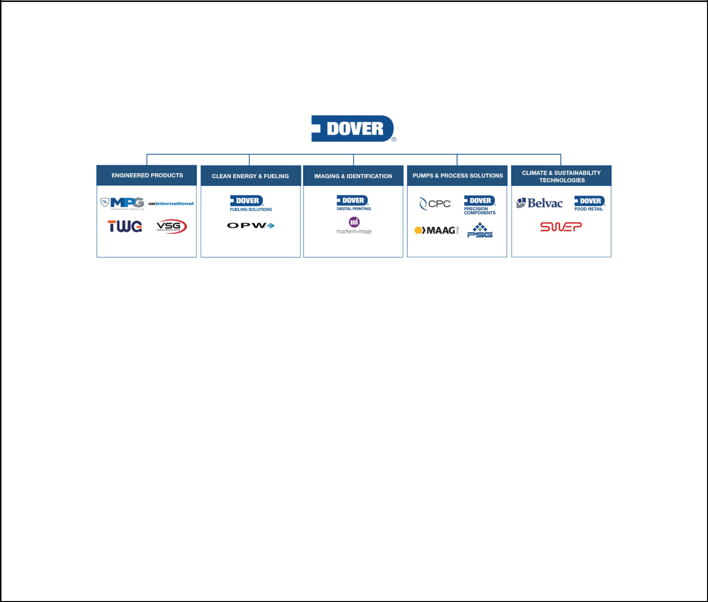

Company Overview

Dover is a diversified global manufacturer and solutions provider delivering innovative equipment and components, consumable supplies, aftermarket parts, software and digital solutions, and support services through five operating segments: Engineered Products, Clean Energy & Fueling, Imaging & Identification, Pumps & Process Solutions, and Climate & Sustainability Technologies. We combine global scale, operational agility, world-class engineering capability, and customer intimacy to lead the markets we serve. Recognized for our entrepreneurial approach for over 70 years, our team of approximately 24,000 employees takes an ownership mindset, collaborating with customers to redefine what’s possible.

Management Philosophy

- Our executive management team is committed to delivering shareholder value creation through a combination of sustained profitable growth, operational excellence, superior free cash flow generation, and productive capital re-deployment while adhering to a conservative financial policy.

- Our businesses seek to be leaders in a diverse set of growing markets where customers are loyal to trusted partners and suppliers, and value product performance and differentiation driven by superior engineering, manufacturing precision, total solution development, and excellent supply chain performance.

- Our companies are long-time leaders in their respective markets and are known for their innovation, engineering capability, and customer service excellence.

- Our sustainable business practices are focused on reducing environmental impact and developing products that help our customers meet their sustainability goals.

- Our operating structure of five business segments allows for differentiated acquisition focus consistent with our portfolio and capital allocation priorities which, coupled with value-creating functional expertise at our corporate center, presents opportunities to identify and capture operating synergies, such as global sourcing and supply chain integration, centralized shared services, and cross-pollination of manufacturing best practices.

- Our executive management team sets strategic direction, initiatives and goals, provides oversight of strategy execution and achievement of these goals for our business segments, and with oversight from our Board of Directors (our “Board”), makes capital allocation decisions, including organic investment initiatives, major capital projects, acquisitions, and the return of capital to our shareholders.

- Our operating culture fosters high ethical and performance standards, values accountability, rigor, trust, inclusion, respect, and open communications, and is designed to encourage individual growth and operational effectiveness.

DOVER CORPORATION – 2025 Proxy Statement 2

Table of Contents

PROXY STATEMENT SUMMARY


Company Goals

We are committed to driving superior shareholder return through three key tenets of our corporate strategy.

We are committed to achieving organic sales growth above global gross domestic product growth (4% to 6% annually on average) over a long-term business cycle, absent prolonged adverse economic conditions, complemented by growth through strategic acquisitions.

We are focused on improving returns on capital, as well as earnings margin, by enhancing our operational capabilities and making investments across the organization in growth capacity expansion, digital capabilities, automation, operations management, information technology, shared services, and talent. We also focus on continuous, effective cost management and productivity initiatives, including automation and digitally-supported manufacturing, supply chain optimization, e-commerce and digital go-to-market, restructuring, product complexity reduction, improved footprint utilization, strategic pricing and portfolio management.

We aim to generate strong and growing free cash flow and earnings per share (“EPS”) through strong earnings performance, productivity improvements, and active working capital management, which is enhanced by opportunistic divestitures allowing for concentration on growing our core platforms.

We support achievement of these goals by aligning management compensation with strategic and financial objectives, actively managing our portfolio to increase enterprise scale, improving business mix over time, pursuing acquisitions that fit the characteristics of an ideal Dover business, and investing in talent development programs.

2024 Financial Results

US GAAP |  | FY2024 | FY2023 | *
 | Revenue ($M) | 7,746 | 7,684 | 1%
 | Earnings from continuing operations ($M) | 1,400 | 944 | 48%
 | Diluted EPS from continuing operations ($) | 10.09 | 6.71 | 50%
Non-GAAP⁽¹⁾
 | Organic revenue change |  |  | —%
 | Adjusted earnings from continuing operations ($M)⁽²⁾ | 1,150 | 1,118 | 3%
 | Adjusted diluted EPS from continuing operations ($) | 8.29 | 7.95 | 4%

- Definitions and reconciliations of non-GAAP measures are included at the end of this proxy statement.

- Full year 2024 and 2023 adjusted earnings from continuing operations exclude after-tax purchase accounting expenses and restructuring and other costs. Full year 2024 also excludes an after-tax gain on disposition of a minority owned equity method investment, and the after-tax gain and post-closing adjustments on the disposition of De-Sta-Co.

* Change may be impacted by rounding.

DOVER CORPORATION – 2025 Proxy Statement 3

Table of Contents

PROXY STATEMENT SUMMARY

 | 2024 Performance Overview
 |  | • We continued our history of providing regular capital returns to shareholders by increasing our
 | Capital Return | quarterly dividend, marking our 69th consecutive year of dividend increases.
 | Program | • We made $500 million of share repurchases in 2024 by completing an accelerated share repurchase
 |  | program.
 |  | • We acquired eight businesses for approximately $674 million, net of cash acquired and including
 |  | contingent consideration. These acquisitions complement and expand upon our existing operations in our
 | Portfolio | Clean Energy & Fueling, Engineered Products, Imaging & Identification and Pumps and Process Solutions
 | Portfolio | segments.
 | Management | • As part of our effort to reduce our exposure to cyclical and capital intensive markets and, therefore, focus
 |  | on our higher margin and higher growth spaces, we completed the sale of our De-Sta-Co and
 |  | Environmental Solutions Group businesses.
 |  | • We delivered strong margin improvement in 2024, due to the positive mix impact from high margin high
 |  | growth platforms, rigorous cost containment and our continued focus on productivity initiatives such as
 |  | restructuring, supply chain optimization, automation, and product complexity reduction.
 | Operational | • We continued to build upon our four enterprise capabilities in support of margin expansion initiatives by
 | Execution & | (1) leveraging our Digital Labs team to improve our internal and market-facing digital capabilities,
 | Profitability | (2) improving utilization and optimization of our manufacturing footprint through centralized resources and
 |  | investment, (3) driving further centralized shared services under Dover Business Services, and
 |  | (4) investing in our India Innovation Center shared services with a focus on engineering capabilities.
 |  | • We captured synergies from recent acquisitions, presenting additional margin upside.
 |  | • Our businesses generated free cash flow of approximately 12% of revenue. We are focused on the most
 |  | efficient allocation of our capital to maximize returns on investment. We prioritize organic reinvestment to
 | Cash Flow & | support growth initiatives, productivity, and new product launches and made $168 million in capital
 | Capital Allocation | expenditures in 2024.
 | Capacity | • We ended 2024 in an advantaged cash position. We believe our available excess cash and leverage
 |  | capacity will allow us to execute against a strong acquisition pipeline and pursue opportunistic capital
 |  | return strategies.
 |  | • We continued to drive progress across our environmental, social, and governance (“ESG”) areas of focus.
 |  | • We continued to update our ESG website with information on topics identified as areas of focus during our
 |  | initial three-year ESG plan.
 |  | • We plan to continue to report our company-wide greenhouse gas (“GHG”) emissions and progress
 | ESG | against our science-based targets to reduce our GHG emissions, including an absolute reduction of
 | ESG | scope 1 and scope 2 market-based GHG emissions of 30 percent by 2030 (from a 2019 baseline year),
 |  | and an absolute reduction of scope 3 GHG emissions of 15 percent by 2030 (from a 2019 baseline year).
 |  | • We plan to continue to report our progress against our goal of reducing Total Recordable Injury Rate
 |  | (“TRIR”) by 40% by 2025 (from a 2019 baseline year). As of the end of 2023, we have achieved a 40%
 |  | TRIR reduction, and remain committed to continuing to prioritize health and safety compliance, risk
 |  | mitigation, and continuous process improvement across the organization.
 |  | DOVER CORPORATION – 2025 Proxy Statement 4

Table of Contents

PROXY STATEMENT SUMMARY


Governance and Board Highlights

Our Board is committed to sound governance practices designed to promote the long-term interests of shareholders and strengthen Board and management accountability. Highlights include:

BOARD OF DIRECTORS | GOVERNANCE HIGHLIGHTS
✓ Lead Independent Director | ✓ 15% ownership threshold required to call a special meeting
✓ 8 of our 9 director nominees are independent; fully independent | of shareholders
 | ✓ Proxy access right at 3%/3 years/2 or 20% of Board/20
standing committees | ✓ Proxy access right at 3%/3 years/2 or 20% of Board/20
✓ Regular executive sessions of independent directors | shareholder aggregation allowance
✓ Regular executive sessions of independent directors | ✓ Strong share retention guidelines for directors and executive
✓ Annual election of directors
✓ Annual election of directors | officers
✓ Majority voting for directors and director resignation policy in | ✓ Executive compensation driven by pay-for-performance
uncontested elections | philosophy
✓ Comprehensive annual individual evaluations of one-third of the | ✓ Executive officers not permitted to hedge or pledge company
directors | shares
✓ Robust succession planning | ✓ No supermajority voting provisions in our charter

Shareholder Engagement

We encourage feedback from shareholders and have a strong history of engaging with investors on a range of topics, including our executive compensation program and evolving trends and best practices. In 2024, we reached out to holders of approximately 62% of our shares outstanding, and engaged with governance professionals and/or portfolio managers at investors holding approximately 42% of our shares outstanding. Our shareholder engagement team consists of senior management and has also included our Lead Independent Director from time to time.

In meetings held after our 2024 Annual Meeting of Shareholders, we discussed a variety of topics with shareholders, ranging from Dover’s corporate strategy, including strategic priorities and portfolio actions, Board composition and oversight matters, and governance and executive compensation practices. We also discussed our focus on human capital and our sustainability vision. Investors continued to express broad support for our governance practices, including Board composition, our current Board leadership structure, and our executive compensation program. In recent years, we have made a number of enhancements to our practices, taking into account feedback from our shareholders. For more detailed information regarding these discussions, please see “Shareholder Engagement and History of Board Responsiveness” on page 29.

DOVER CORPORATION – 2025 Proxy Statement 5

Table of Contents

PROXY STATEMENT SUMMARY
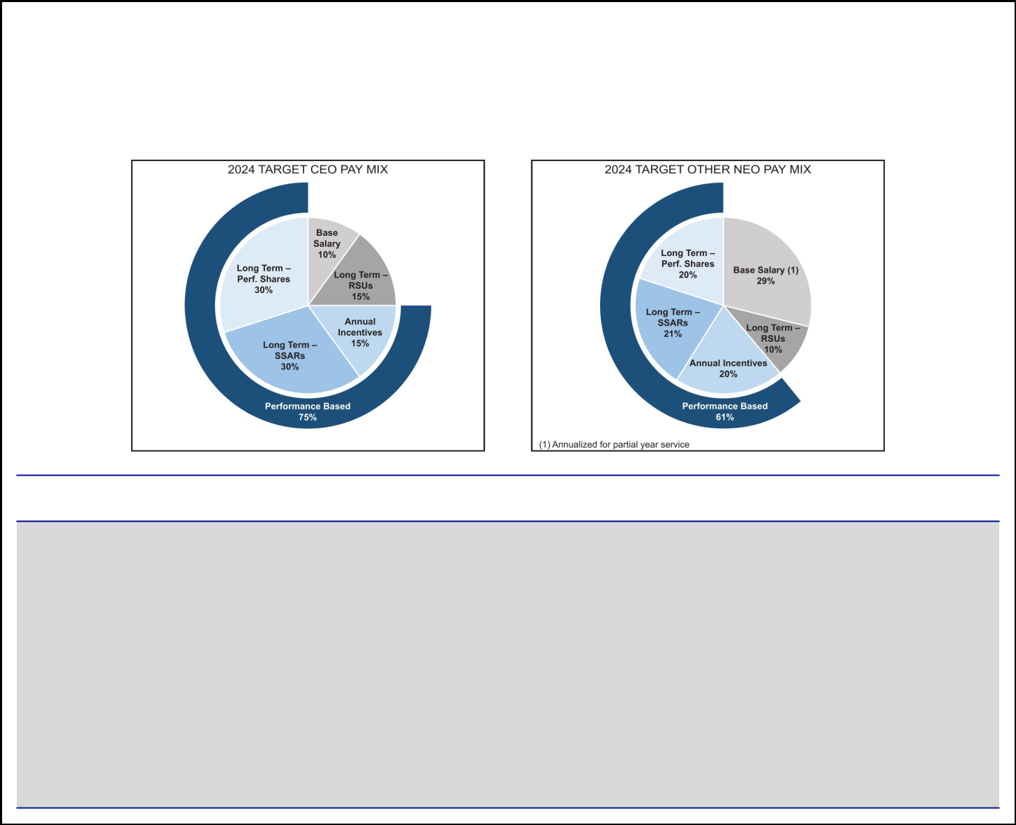

2024 Executive Compensation Highlights

Our compensation program for executive officers is designed to emphasize performance-based compensation in alignment with our business strategy.

The following table summarizes pay mix for our CEO and other NEOs, which is highly performance-based.

EXECUTIVE COMPENSATION PROGRAM HIGHLIGHTS

✓ Pay-for-performance philosophy — a substantial majority of NEO pay is performance-based and tied to Dover’s stock price performance

✓ Significant portion of long-term compensation is performance-based, with long-term incentives vesting over three years subject to rigorous three-year performance period

✓ Strong share ownership guidelines for NEOs

✓ Equity awards with anti-hedging and anti-pledging provisions

✓ Investors provided with clear disclosure regarding the individual strategic objectives and financial metrics in our Executive Officer Annual Incentive Plan (“AIP”)

✓ ESG oversight incorporated into our CEO’s individual strategic objectives in the AIP ✓ Robust clawback structure

DOVER CORPORATION – 2025 Proxy Statement 6

Table of Contents

PROXY STATEMENT SUMMARY
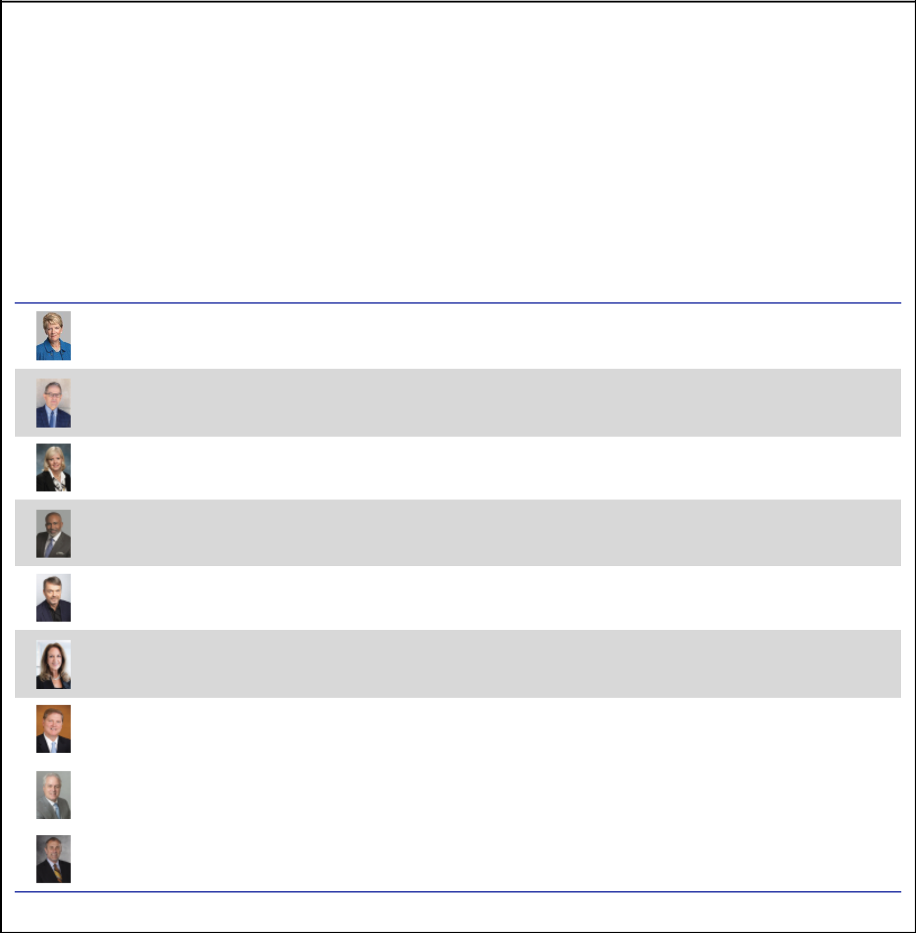

Director Nominees

Our Governance and Nominating Committee maintains an active and engaged Board through a robust refreshment process, which focuses on ensuring our Board has a diverse skill set that benefits from both industry- and company-specific knowledge of our longer-tenured directors, as well as fresh perspectives brought by our newer directors.

Recent Changes to the Board

Michael F. Johnston, our current Lead Independent Director, is not standing for re-election at the Annual Meeting, and his service as Lead Independent Director will cease at such time. The Board has appointed Keith E. Wandell as Lead Independent Director effective upon his re-election at the Annual Meeting. Effective as of the Annual Meeting, the size of the Board will be reduced to nine directors.

Dover expresses its deep appreciation to Mr. Johnston for his valuable guidance and contributions during his years of dedicated service on the Board.

 |  |  |  | OTHER PUBLIC
 |  |  | COMMITTEES | COMPANY
NAME | OCCUPATION | INDEPENDENT | MEMBERSHIPS* | BOARDS

Deborah L. DeHaas
Age: 65
Director Since: 2021

H. John Gilbertson, Jr.

Age: 68
Director Since: 2018

Kristiane C. Graham
Age: 67
Director Since: 1999

Marc A. Howze
Age: 61
Director Since: 2023

Michael Manley
Age: 61
Director Since: 2023

Danita K. Ostling
Age: 64
Director Since: 2023

Eric A. Spiegel
Age: 67
Director Since: 2017

CEO of the Corporate Leadership Center; Former Vice Chairman of Deloitte and Managing Partner of the Center for Board Effectiveness

Retired Managing Director at Goldman Sachs

Private Investor

Former Group President and Chief Administrative Officer at Deere & Company

CEO of AutoNation, Inc.

Former Partner at Ernst & Young LLP

Former President and CEO of Siemens USA; Special Advisor at Brighton Park Capital

✓

✓

✓

✓

✓

✓

✓

A, G | 1
F, G | 0
C, G | 0
A | 1
C, F | 1
A (Chair) | 1
A, F (Chair) | 1

 | Richard J. Tobin
 | Chair of the Board |  | No
 | Age: 61 | Chairman, President, and CEO of Dover | No | — | 1
 | Age: 61 | Chairman, President, and CEO of Dover | (CEO of Dover) | — | 1
 | Director Since: 2016 |  | (CEO of Dover)
 | Keith E. Wandell |  | ✓
 | Age: 75 |  | ✓
 | Director Since: 2015 | Former President and CEO of Harley-Davidson, Inc. |  | C (Chair), F | 1

*A = Audit Committee; C = Compensation Committee; G = Governance and Nominating Committee; F = Finance Committee

DOVER CORPORATION – 2025 Proxy Statement 7

Table of Contents

PROXY STATEMENT SUMMARY
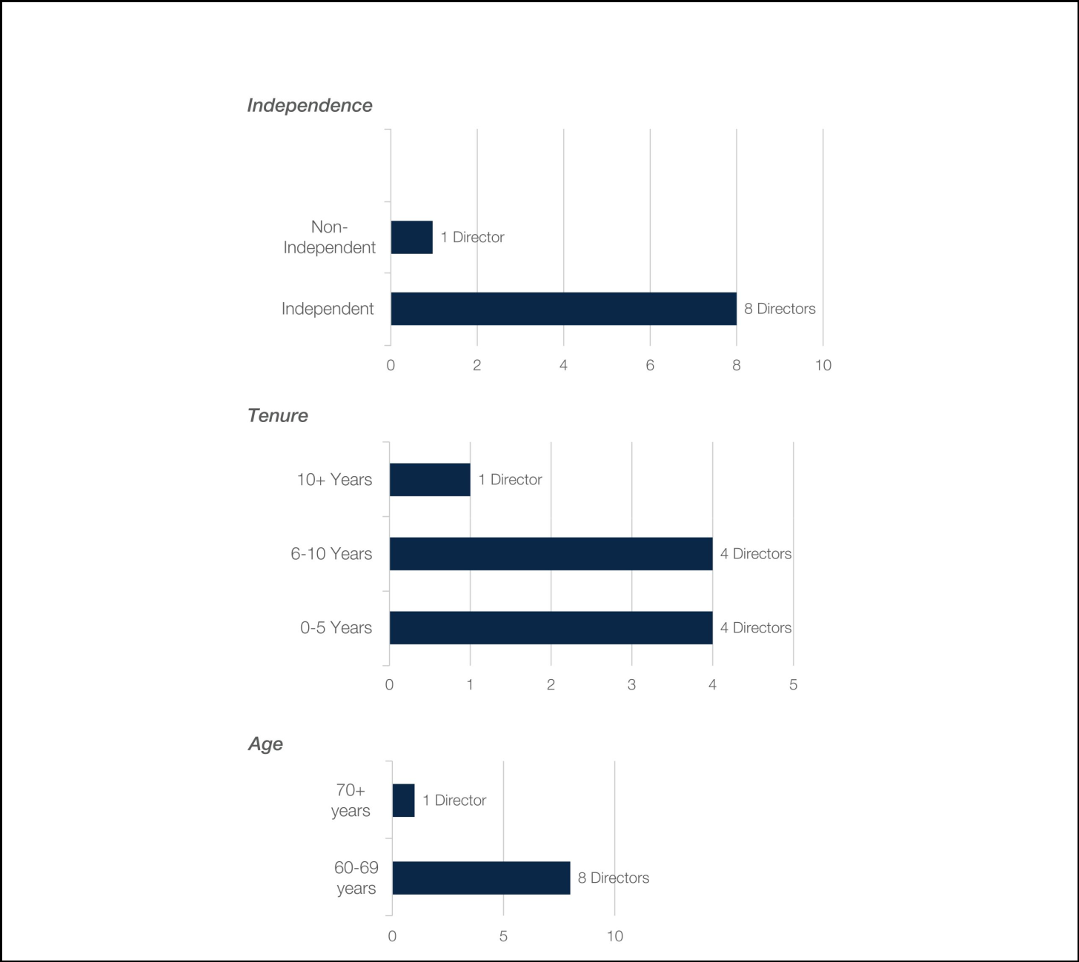

Board Composition

Upon Mr. Johnston’s Retirement, the Board will have the following composition:

DOVER CORPORATION – 2025 Proxy Statement 8

Table of Contents

Proposal 1 — Election of Directors

Criteria for Director Nominees

The Board seeks to recommend qualified director nominees who, in the opinion of the Board, demonstrate the highest personal and professional integrity as well as exceptional ability and judgment, who can serve as a sounding board for our CEO on planning and policy, and who will be most effective, together with the other nominees to the Board, in collectively serving the long-term interests of all our shareholders.

Key areas of expertise for director nominees, which are reflected in our current director nominees, include:

✓ Strategic M&A

✓ Global Operations &

Management

✓ Capital Markets

Expertise

✓ Strategy Development & Execution

✓ Risk Management Expertise

✓ Audit & Corporate

Governance Matters

✓ Human Capital Management

✓ Sustainability

✓ Executive Leadership

Experience

Experience with international acquisitions, post-merger integration, and portfolio restructuring

Experience with cross-border transactions, global market entry and expansion, and implementation of operational efficiency

Experience with capital markets and complex financing transactions

Experience with diversified manufacturing in many of the markets and product areas relevant to Dover’s businesses

Experience evaluating risk management policies and procedures

Experience with assurance and audit, regulation, and financial reporting

Experience attracting, developing and retaining talent and building strong cultures

Experience creating long-term value by embracing opportunities and managing risks deriving from ESG developments

Leadership experience as current or former CEOs and CFOs of global public companies

Skills Aligned with Dover’s Strategy. The Governance and Nominating Committee considers our current Board composition and the projected retirement date of current directors, as well as such other factors it may deem to be in the best interests of Dover and its shareholders, including a director nominee’s leadership and operating experience (particularly as a CEO), financial and investment expertise, and strategic planning experience. Given the global reach and broad array of the types of businesses operated by Dover, the Governance and Nominating Committee highly values director nominees with multi-industry and multi-geographic experience. We believe that our current director nominees possess the right mix of skills and backgrounds to enable us to achieve our strategic goals.

DOVER CORPORATION – 2025 Proxy Statement 9

Table of Contents

PROPOSAL 1 — ELECTION OF DIRECTORS

Diversity of Experiences and Backgrounds. In addition to ensuring our director nominees possess the core areas of expertise considered important by the Governance and Nominating Committee, our Board believes that diverse backgrounds, experiences, and perspectives enhance its decision-making and contribute to the success of Dover. In selecting director nominees, the Governance and Nominating Committee selects candidates who would increase the effectiveness of the Board, which includes consideration of each candidate’s experience, knowledge, backgrounds, skill, and tenure as compared to existing members of the Board. Our Board believes that diverse perspectives enhance its decision-making and contribute to the success of Dover.

Independence & Depth of Experience. The Corporate Governance Guidelines require at least two thirds of Dover’s Board to be independent. The Board believes ensuring appropriate independence exists among the directors enables the Board to effectively carry out its oversight responsibilities. Each director nominee is presently considered to be independent other than the CEO.

Director Attendance, Participation & External Commitments. The Board evaluates the past attendance and performance of directors, including through its robust evaluation process, as well as the other demands on the time of a director nominee to ensure external commitments will not impair their effective service. To facilitate this review, the Corporate Governance Guidelines require, among other things, that directors advise the Chair of the Board and Chair of the Governance and Nominating Committee in advance of accepting an invitation to serve on the board of another public company and that a member of Dover’s Audit Committee not serve on the audit committees of more than two public companies unless expressly permitted by Dover’s Board (accompanied by clear disclosure of the rationale in Dover’s next proxy statement). Each director nominee has complied, and is in compliance with, the Guidelines, and each director nominee attended 100% of Board meetings in 2024. Dover’s Board regularly reviews these policies for effectiveness. The Board believes each director nominee has contributed effectively to the work of the Board and its Committees in 2024 and remains presently able to do so.

Director Nomination Process

Whenever the Governance and Nominating Committee concludes that a new nominee to our Board is required or advisable, it will consider recommendations from directors, management, shareholders and, if it deems appropriate, consultants retained for that purpose. In such circumstances, it will evaluate individuals recommended by shareholders in the same manner as nominees recommended from other sources.

Shareholder Nominations for Director

Shareholders who wish to recommend an individual for nomination should send that person’s name and supporting information to the Governance and Nominating Committee, in care of the Corporate Secretary at our principal executive offices, 3005 Highland Parkway, Downers Grove, Illinois, 60515, or through our communications coordinator. Shareholders who wish to directly nominate an individual for election as a director, without going through the Governance and Nominating Committee, must comply with the procedures in our by-laws. Please see “General Information About the Annual Meeting” for nomination deadlines.

Proxy Access Shareholder Right

Following extensive engagement with our shareholders, our Board determined to adopt proxy access in February 2016, permitting a shareholder or group of up to 20 shareholders holding 3% of our outstanding shares of common stock for at least three years to nominate a number of directors constituting the greater of two directors or 20% of the number of directors on our Board, as set forth in detail in our by-laws.

DOVER CORPORATION – 2025 Proxy Statement 10

Table of Contents

PROPOSAL 1 — ELECTION OF DIRECTORS

2025 Director Nominees

There are nine nominees for election to our Board at this Annual Meeting, each to serve until the next annual meeting of shareholders or his or her earlier removal, resignation or retirement. All nominees currently serve on our Board and are being proposed for re-election by our Board.

Current director Michael F. Johnston is not standing for re-election and will retire from the Board effective as of the Annual Meeting. If any nominee for election becomes unavailable or unwilling to serve as a director before the Annual Meeting, an event which we do not anticipate, the persons named as proxies will vote for a substitute nominee or nominees as may be designated by our Board, or the Board may reduce the number of directors. Directors will be elected by a majority of the votes cast in connection with their election.

- Deborah L. DeHaas

Independent Director Nominee Director since: 2021

Age: 65

Committees: Audit, Governance and Nominating
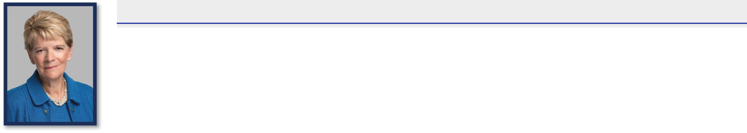

Skills and Qualifications:

- Significant leadership, financial and corporate governance expertise garnered from her nearly 40 years of experience at major audit, assurance and consulting firms

- Certified public accountant (“CPA”) and has extensive experience with financial, accounting, internal controls, and enterprise risk management

- Has deep expertise on governance, both as a topic and discipline, developed during her career at Deloitte

- As a former member of the Value Reporting Foundation Board (formerly the SASB Foundation Board), contributes valuable and well-informed insights on a variety of ESG matters

- Brings relevant public company board service, serving on the board of CF Industries Holdings, Inc.

- Brings experience and perspective on matters regarding human capital and culture, including succession planning, executive leadership development, and diversity and inclusion

- Holds a bachelor’s degree in management science and accounting from Duke University

- Included in the National Association of Corporate Directors (“NACD”) Directorship 100 from 2015-2020, recognizing influential leaders in corporate governance and is also an NACD Board Leadership Fellow

Business Experience:

- CEO of the Corporate Leadership Center, a non-profit executive leadership development organization

- Former Vice Chairman and National Managing Partner of the Center for Board Effectiveness at Deloitte

  - Former member of the U.S. Executive Committee

  - Former Vice Chairman and Chief Inclusion Officer

  - Former member of the U.S. Board of Directors

  - Former Vice Chairman and Central Region Managing Partner

  - Former Vice Chairman and Midwest Regional Managing Partner

  - Former Regional Managing Partner, Strategic Clients

- Former positions of increasing responsibility at Arthur Andersen, an audit, financial advisory, tax and consulting firm, most recently as Managing Partner & Business Advisory Assurance, Central Region

Other Board Experience:

- Director, member of Audit Committee and Environmental Sustainability and Community Committee at CF Industries Holdings, Inc.

DOVER CORPORATION – 2025 Proxy Statement 11

Table of Contents

PROPOSAL 1 — ELECTION OF DIRECTORS

- H. John Gilbertson, Jr.

Independent Director Nominee Director since: 2018

Age: 68

Committees: Finance, Governance and Nominating
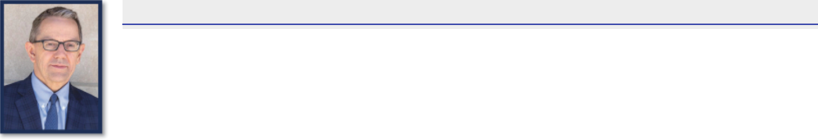

Skills and Qualifications:

- Extensive experience in corporate finance, capital markets, and mergers and acquisitions

- Considerable expertise and decades of experience in corporate governance and board and committee processes

- Served as a strategic and financial advisor to his clients, forming deep relationships with companies in a range of industries

- Has nearly four decades of experience in the professional and financial services industry

- Deep expertise in financial management, coupled with his analytical and collaborative mindset, allows him to make invaluable contributions to our Board

- Strong background in senior leadership development, succession planning, and organizational culture development

- Brings to the Board considerable expertise in financial risk oversight and capital allocation

- Bachelor’s degree in political economy from Dartmouth College and an MBA from Harvard University

Business Experience:

- Retired Managing Director at Goldman Sachs

- Served as Partner-in-Charge, Midwest Region Investment Banking Services

- Served as Managing Director at Travelers Group Inc.

- Former Associate, Mergers and Acquisitions at Morgan Stanley

- Former Consultant, Corporate Strategy at Bain & Company

- Former Assistant Treasurer, Corporate Banking at Chase Manhattan Bank

- Former News Reporter at The Providence Journal Company

Other Board Experience:

- Director and Chair of Audit Committee of Meijer, Inc. (“Meijer”)

- Former Director of AAR Corp.

- Former Chair of the Investment Committee of Rush University Medical Center

DOVER CORPORATION – 2025 Proxy Statement 12

Table of Contents

PROPOSAL 1 — ELECTION OF DIRECTORS

- Kristiane C. Graham

Independent Director Nominee Director since: 1999

Age: 67

Committees: Compensation, Governance and Nominating
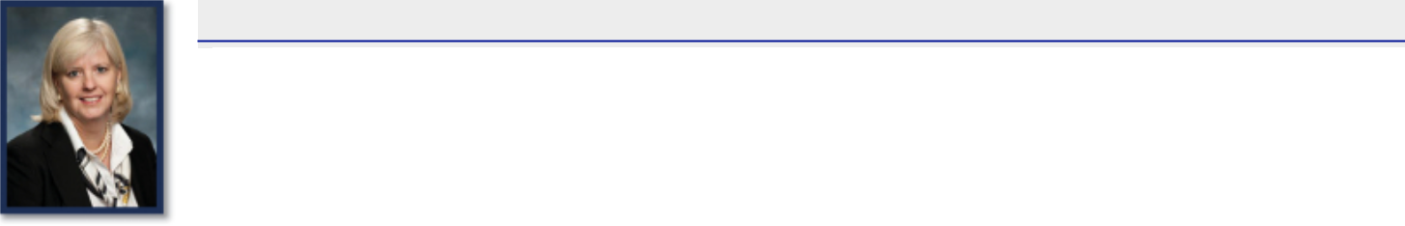

Skills and Qualifications:

- Experience as a private investor with substantial holdings of Dover stock and her shared interests in Dover, including interests through charitable organizations of which she is a director, makes her a good surrogate for our individual and retail investors

- Experience with a commercial bank, primarily as a loan officer; founded and operated an advisory company and a publication regarding international thoroughbred racing and now co-manages her family’s investments

- Actively works with and has served on the boards of various organizations to support the objectives of local communities, affordable housing, education, and health

- Co-manages the Graham Foundation and Graham family investments

- Serves on the Boards of Directors of Habitat for Humanity International (“HFHI”) and the U.S. Council of HFHI

- Serves on the Board of Trustees of the Virginia Museum of Fine Arts Foundation

- Serves as an Emeritus Trustee of the College Foundation of the University of Virginia and has previously served on the Advisory Board of the University of Virginia School of Nursing

- Brings valuable insights on the development of our policies and strategies relating to talent, leadership, and culture

- Devoted substantial time to monitoring the development of Dover operating company leaders, enabling her to provide the Board valuable insights regarding management succession

- As a member of one of the founding families of Dover, Ms. Graham also brings to the Board a sense of Dover’s historical values, culture and strategic vision which the Board believes is beneficial as it considers various strategic planning alternatives for shaping Dover’s future

Business Experience:

- Private Investor

DOVER CORPORATION – 2025 Proxy Statement 13

Table of Contents

PROPOSAL 1 — ELECTION OF DIRECTORS

- Marc A. Howze

Independent Director Nominee Director since: 2023

Age: 61 Committees: Audit
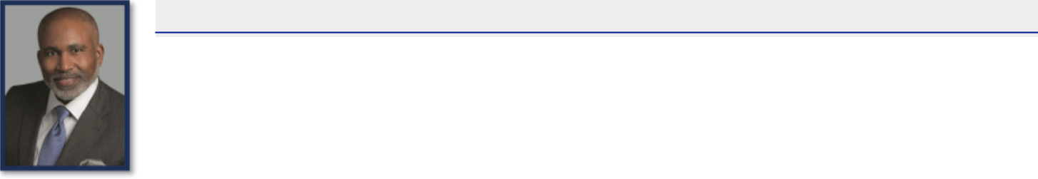

Skills and Qualifications:

- Brings significant leadership and business experience garnered during more than two decades at Deere & Company (“Deere”), including in his role as Senior Advisor, Office of the Chairman

- During his career, Mr. Howze spearheaded strategic initiatives focused on improving operations, delivering customer value, developing future leaders, making Deere a highly regarded employer, and promoting Deere’s brand

- Broad knowledge of global manufacturing, supply chain and aftermarket operations

- Extensive experience in succession planning and executive compensation

- Strong governance experience gained during service as the Corporate Secretary and Associate General Counsel

- Broad leadership, litigation and government contracting experience gained during service in the U.S. Army attaining the rank of major

- Holds a bachelor’s degree from the University of Michigan-Dearborn, a Juris Doctor from the University of Michigan Law School, and an MBA from the Fuqua School of Business at Duke University

Business Experience:

- Former Senior Advisor, Office of the Chairman at Deere

- Former Group President, Lifecycle Solutions and Chief Administrative Officer at Deere

- Former Senior Vice President and Chief Administrative Officer at Deere

- Former Vice President of Global Human Resources and Employee Communications at Deere

- Former Global Director Cotton Harvesting Business at Deere

- Former Manager of Business Development, Ag & Turf division at Deere

- Former Associate General Counsel and Corporate Secretary at Deere

- Former Special Assistant United State Attorney, US Army

Other Board Experience:

- Director, member of Finance Committee and Chair of Human Resources Committee at Nationwide Mutual Insurance Company

- Director, member of Finance Committee and Compensation and Executive Development Committee at Lincoln Electric Holdings, Inc.

DOVER CORPORATION – 2025 Proxy Statement 14

Table of Contents

PROPOSAL 1 — ELECTION OF DIRECTORS

- Michael Manley

Independent Director Nominee Director since: 2023

Age: 61

Committees: Compensation, Finance
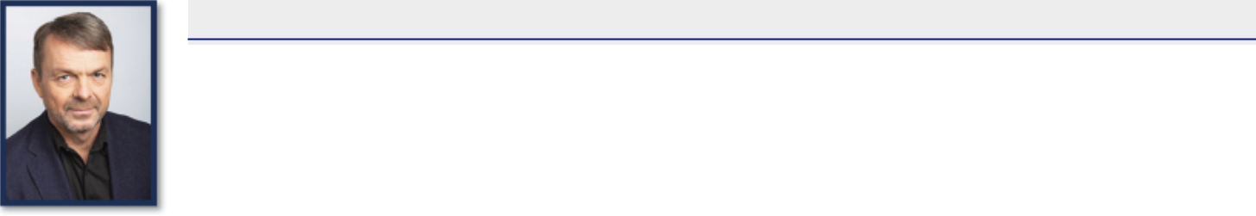

Skills and Qualifications:

- Currently the Chief Executive Officer of AutoNation, Inc., the largest automotive retailer in the United States

- Successfully managed a wide array of business models over his career

- Extensive knowledge of manufacturing operations and supply chains, multi-national business management, capital markets, and mergers and acquisitions

- MBA from Ashridge Management College and a Bachelor of Science in engineering from Southbank University

Business Experience:

- Chief Executive Officer AutoNation, Inc.

- Former head of Americas and member of the Group Executive Council for Stellantis N.V.

- Former Chief Executive Officer of Fiat Chrysler Automobiles N.V. (“FCA”), a predecessor to Stellantis N.V.

  - Former Executive Vice President – International Sales & Marketing, Business Development and Global Product Planning Operations

  - Former Chief Executive Officer of Jeep

  - Former Chief Executive Officer of Ram

  - Former Chief Operating Officer for the Asia Pacific region

  - Former FCA Global Executive Council member

Other Board Experience:

- AutoNation, Inc.

DOVER CORPORATION – 2025 Proxy Statement 15

Table of Contents

PROPOSAL 1 — ELECTION OF DIRECTORS

- Danita K. Ostling

Independent Director Nominee Director since: 2023

Age: 64

Committees: Audit (Chair)
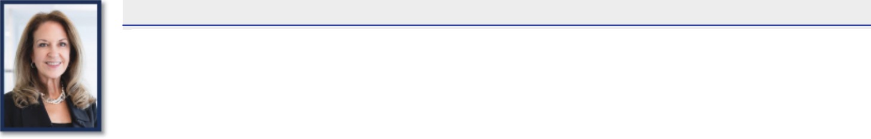

Skills and Qualifications:

- Brings extensive expertise in accounting and auditing, with significant experience consulting on complex accounting issues for large global companies and ESG reporting

- Certified public accountant (“CPA”), bringing subject matter knowledge with respect to accounting and audit standards, risk management and compliance, and evaluation of cybersecurity breaches and potential accounting and financial controls impacts

- Holds a bachelor’s degree in accounting from the University of Arkansas at Little Rock

Business Experience:

- Former partner and senior leader at Ernst & Young LLP (“EY”), serving in various leadership roles from 1999 until her retirement in 2021; and prior thereto, various positions with EY

  - Former Professional Practice Director, U.S. East Region

  - Former Americas IFRS Technical Leader

  - Former co-Director of Assurance Professional Practice – Accounting

  - Former Deputy Director of Global Assurance Professional Practice — Accounting

- Former Vice President, Corporate Accounting Policy and Advisory Group at Citigroup, Inc.

Other Board Experience:

- Director and Chair of Audit Committee of Circle Internet Financial, LLC

- Director and Audit Committee member of nVent Electric plc

- Former Director and Chair of Audit Committee of Varsity Brands, Inc.

DOVER CORPORATION – 2025 Proxy Statement 16

Table of Contents

PROPOSAL 1 — ELECTION OF DIRECTORS

- Eric A. Spiegel

Independent Director Nominee Director since: 2017

Age: 67

Committees: Audit, Finance (Chair)
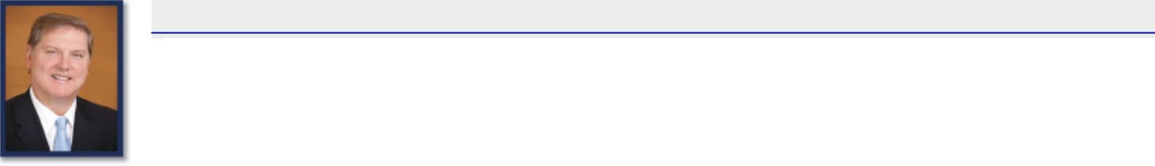

Skills and Qualifications:

- Experienced business leader with diversified, global experience who brings deep and valuable expertise in strategy development, corporate restructuring, portfolio management and M&A to our Board

- 40+ years of experience working with large, global companies in the energy and industrial markets, mostly recently as President & CEO of Siemens

USA

- At Siemens, he led strategic reviews across a portfolio of ~45 businesses in the company’s largest market with over $22 billion in revenue, 50,000 employees and over 60 manufacturing facilities

- Participated in the acquisition, divestiture, joint venture and carve-out of over 30 business units and segments

- Executed Siemens’ “Vision 2020” initiative to optimize growth and margins in the U.S., across all sectors

- Prior to Siemens, Mr. Spiegel was a global consultant at Booz Allen Hamilton focused on complex organizations in the energy, power, chemical, water, industrial and automotive fields

- At Booz, he worked with major energy clients globally on projects around corporate strategy, M&A, major capital projects, cost restructuring, margin enhancement and supply chain re-design and was also closely involved with the government sector

- An expert on the global energy industry, Mr. Spiegel co-authored the book Energy Shift: Game-changing Options for Fueling the Future

- Brings expertise in risk oversight, including climate-related risks

- Holds a bachelor’s degree in economics from Harvard University and an MBA from the Tuck School of Business at Dartmouth College

Business Experience:

- Special Advisor at Brighton Park Capital, a private equity firm, where he supports the firm’s sector investment teams and portfolio companies by providing strategic counsel on industry trends and growth strategies

- Former President and CEO of Siemens USA

- Former Managing Partner, Global Energy, Chemicals, and Power, and Managing Partner, Washington, D.C. office, and other roles at Booz & Company, Inc. (now known as Strategy&) and Booz Allen Hamilton, Inc., global consulting firms

- Former Associate, Energy and Industrials Practice, at Temple, Barker & Sloane, Inc. (now known as Oliver Wyman)

- Former Marketing and Strategy Manager at Brown Boveri & Cie (now known as ABB), a Swiss group of electrical engineering companies

- In connection with his position at Brighton Park Capital, Mr. Spiegel serves as Chair of Relatient, Inc.

Other Board Experience:

- Director and Risk Committee Chair of Liberty Mutual Holding Company, Inc.

- Director and Audit Committee member of Heramba Electric plc

- Director of TeamBuilder LLC

DOVER CORPORATION – 2025 Proxy Statement 17

Table of Contents

PROPOSAL 1 — ELECTION OF DIRECTORS

- Richard J. Tobin

Board Chair; President and Chief Executive Officer Director since: 2016

Age: 61 Committees: None
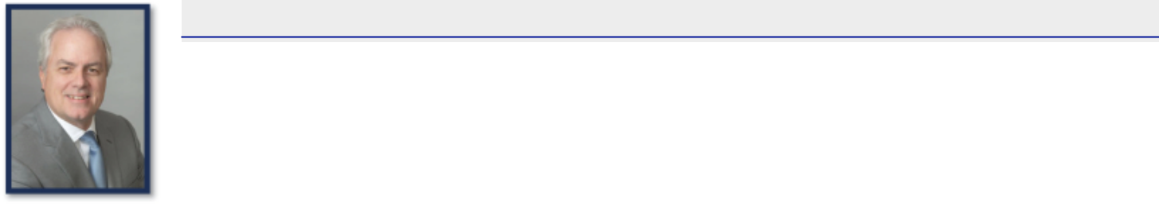

Skills and Qualifications:

- Mr. Tobin is Dover’s current Chairman, President, and CEO

- Has a broad range of industry and functional experiences acquired through regional and global leadership positions

- Former CEO of CNH Industrial, a complex international industrial company, where he led efforts to increase efficiencies, innovate through new technologies, expand geographically, and maximize the company’s portfolio of businesses

- Gained extensive experience in international finance, operations, management, and information technology in his prior roles

- Developed deep expertise with global capital markets through his international finance leadership roles

- Prior to beginning his business career, Mr. Tobin was an officer in the United States Army

- Member of the Board of Trustees of the John G. Shedd Aquarium in Chicago

- Formerly served on the U.S. Chamber of Commerce Board of Directors, and is a former member of the Business Roundtable

- Holds a bachelor of arts from Norwich University and an MBA from Drexel University

Business Experience:

- Chairman, President, and CEO of Dover

- Former CEO of CNH Industrial NV (“CNH Industrial”)

- Former Group Chief Operating Officer of Fiat Industrial S.p.A

- Former President and CEO of CNH Global NV

- Former CFO of CNH Global NV

- Former Chief Finance Officer & Head of Information Technology of SGS Group

- Former Chief Operating Officer for North America of SGS Group

Other Board Experience:

- Director of KeyCorp

- Former director of CNH Industrial

DOVER CORPORATION – 2025 Proxy Statement 18

Table of Contents

PROPOSAL 1 — ELECTION OF DIRECTORS

- Keith E. Wandell

Independent Director Nominee Director since: 2015

Age: 75

Committees: Compensation (Chair), Finance
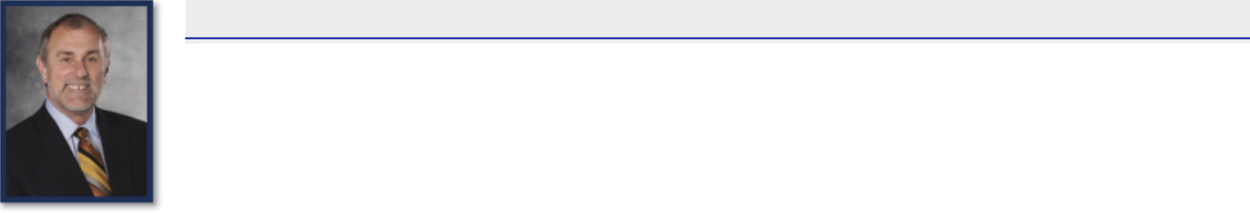

Skills and Qualifications:

- Mr. Wandell brings to the Board the valuable perspective of a strategic, experienced leader with a strong record focused on growth, profitability, international expansion and innovation

- Has over 30 years of experience in diversified manufacturing businesses, most recently as the former Chairman and CEO of Harley-Davidson, Inc. (“Harley-Davidson”) where he led transformation efforts across the company’s product development, manufacturing and retail functions, focused on international expansion and implemented a restructuring plan

- Prior to joining Harley-Davidson, Mr. Wandell served as President and Chief Operating Officer of Johnson Controls, Inc. (“Johnson Controls”) and helped manage the company’s entry into the Chinese car-battery market as well as its subsequent joint venture with China’s largest battery manufacturer

- Gained valuable insights into the effective development of executive leadership capabilities and strong corporate cultures through his experience as a senior leader at various companies

- Served on the boards of four other public companies, including the two on which he currently serves

- Holds a bachelor’s degree in business administration from Ohio University and an MBA from the University of Dayton

Business Experience:

- Former President and CEO of Harley-Davidson

- Former President and Chief Operating Officer of Johnson Controls

- Former Executive Vice President of Johnson Controls

- Former Corporate Vice President of Johnson Controls

- Former President of the Automotive Experience business of Johnson Controls

- Former President of the Power Solutions business of Johnson Controls

Other Board Experience:

- Director of Dana Incorporated

- Former Director of Constellation Brands, Inc. and Clarcor, Inc.

- Former Chairman of Harley-Davidson

THE BOARD RECOMMENDS A VOTE “FOR” THE ELECTION OF EACH

OF THE NOMINEES NAMED ABOVE.

DOVER CORPORATION – 2025 Proxy Statement 19

Table of Contents

PROPOSAL 1 — ELECTION OF DIRECTORS

Board Oversight and Governance Practices

Our Board is responsible for, and committed to, overseeing our long-term strategic development as well as managing the principal and most significant risks that we face. In carrying out this duty, our Board advises senior management to help drive long-term value creation for our shareholders. The Board delegates specific areas of responsibility to relevant Board committees, as detailed below under the heading “Overview of Committee Responsibilities”, who report on their deliberations to the Board. The following summarizes our Board’s key areas of oversight responsibility.

Board Oversight

 |  | KEY AREAS OF BOARD OVERSIGHT
Long-Term | • | One of the primary responsibilities of our Board is the oversight of management’s long-term strategy and
Long-Term |  | planning. Accordingly, our Board maintains a deep level of engagement with management in setting and
Business Strategy
Business Strategy |  | overseeing Dover’s long-term business strategy.
 | • | Our Board is focused on the efficient allocation of capital to drive growth and provide returns to our
 |  | shareholders. Our capital allocation priorities are organic investments, strategic acquisitions, and the return
 |  | of capital to our shareholders.
 | • | We consistently return cash to shareholders by paying dividends, which have increased annually over
 |  | each of the last 69 years.
Capital Allocation | • | We also undertake opportunistic share repurchases as part of our capital allocation strategy, most recently
Capital Allocation |  | completing a $500 million ASR program in July 2024.
 | • | We made approximately $168 million in capital expenditures in 2024 and $183 million in capital expenditures
 |  | in 2023, in line with our priority of organic reinvestment to support growth initiatives, productivity and
 |  | new product launches.
 | • | We employ a prudent financial policy to support our capital allocation strategy, which includes maintaining
 |  | an investment grade credit rating.
 | • | Businesses in our portfolio are continually evaluated for strategic fit.
 | • | We seek to deploy capital on acquisitions in attractive growth areas across our five segments. We
 |  | focus primarily on bolt-on acquisitions, applying strict selection criteria of market attractiveness
 |  | (including growth, market landscape, and performance-based competition), business fit (including
Portfolio |  | sustained leading position, revenue visibility, and favorable customer value-add versus switching cost or
Management |  | risk) and financial return profile (accretive growth and margins and double-digit return on invested capital).
 | • | We have sold or divested some of our businesses based on changes in specific market outlook,
 |  | structural changes in financial performance, value-creation potential, or for other strategic considerations,
 |  | which included an effort to reduce our exposure to cyclical markets or focus on our higher margin and higher
 |  | growth spaces.
 |  | DOVER CORPORATION – 2025 Proxy Statement 20

Table of Contents

PROPOSAL 1 — ELECTION OF DIRECTORS

 |  | KEY AREAS OF BOARD OVERSIGHT
 | • | Our Board has established a comprehensive enterprise risk management process to identify and
 |  | manage risks, and periodically reviews the processes established by management to identify and manage
 |  | risks and communicates with management about these processes.
Risk | • | We have established a risk assessment team consisting of senior executives, which annually, with the
Management |  | assistance of a consultant, oversees a risk assessment made at the corporate center, segment and
 |  | operating company levels and, with that information in mind, performs an assessment of the overall risks our
 |  | company may face and reports to the Board on that assessment. Each quarter, this team reassesses the
 |  | risks, the severity of these risks, and the status of efforts to mitigate them.
 | • | The full Board has oversight of ESG matters and is regularly briefed on strategic planning, risks, and
ESG |  | opportunities related to ESG by senior management, including our CEO.
ESG | • | Our Compensation Committee has integrated ESG oversight responsibility into our CEO’s individual
 |  | strategic objectives within the AIP.
 | • | Our entrepreneurial culture depends upon an inclusive approach that leverages employees’
 |  | contributions and diversity of perspectives, backgrounds, skills, and experiences.
 | • | We foster an operating culture with high ethical standards that values accountability, rigor, trust,
 |  | inclusion, respect, and open communication and is designed to encourage individual growth and operational
Culture & Human |  | effectiveness. We continue to make significant investments in talent development, including in the areas of
Capital |  | digital applications and operational management, and recognize that the growth and development of our
Management |  | employees is essential for our continued success.
 | • | As part of our commitment to strong corporate governance practices, we maintain an active and robust
 |  | ethics program. Our Code of Conduct applies to all employees and directors of Dover and its subsidiaries.
 |  | We enforce our Code of Conduct fairly and consistently, regardless of one’s position in Dover, and will not
 |  | tolerate retaliation against those who report suspected misconduct in good faith.
 | • | Another of the Board’s primary responsibilities is overseeing a sound Board and management
 |  | succession process. The Board has developed a comprehensive plan to address management
 |  | succession — both over the long term and for emergency purposes. The framework for the long-term plan
Succession |  | includes thoughtful, deliberate monitoring of management beyond our top executives to ensure Dover
Succession |  | continues to build a deep internal bench of talent.
Planning |  | continues to build a deep internal bench of talent.
Planning | • | Our Board is also focused on its own succession plan, which drives not only our director selection efforts,
 |  | but also how we approach Board and committee leadership structure and membership, with a focus on
 |  | critical board skills, diversity of experience and background, and independence.
 | • | The full Board is briefed on cybersecurity risks and preparedness, oversees major tasks related to
 |  | cybersecurity risk management, periodically reviews our response capabilities, and meets with the Senior
Cybersecurity |  | Vice President & Chief Digital Officer and our Chief Information Security Officer on at least an annual basis.
Cybersecurity | • | We regularly assess our threat landscape and monitor our systems and other technical security controls,
 |  | maintain information security policies and procedures, ensure maintenance of backup and protective
 |  | systems, and have a team of security personnel managing our efforts and initiatives.
 |  | DOVER CORPORATION – 2025 Proxy Statement 21

Table of Contents

PROPOSAL 1 — ELECTION OF DIRECTORS

Board Committees

Our Board has four standing committees — the Audit Committee, the Compensation Committee, the Governance and Nominating Committee, and the Finance Committee. The table below sets forth a summary of our committee structure and membership information.
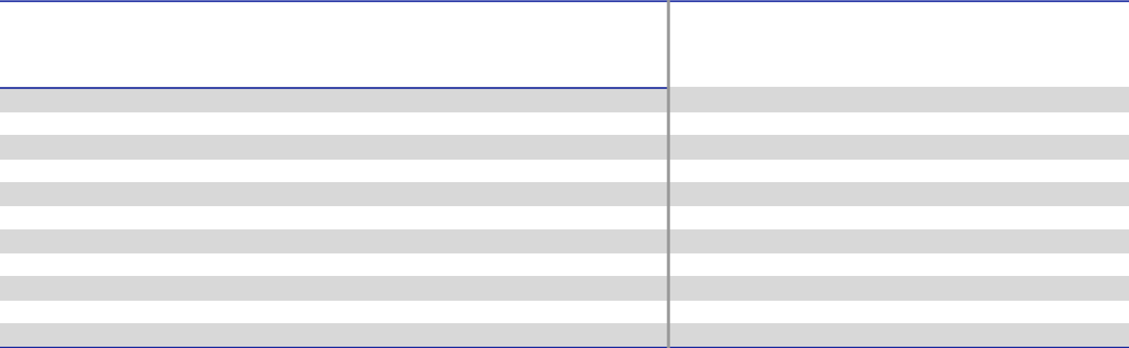

DIRECTOR

DEBORAH L. DEHAAS

H. JOHN GILBERTSON, JR.

KRISTIANE C. GRAHAM

MARC A. HOWZE

MICHAEL F. JOHNSTON*

MICHAEL MANLEY

DANITA K. OSTLING

ERIC A. SPIEGEL

RICHARD J. TOBIN

KEITH E. WANDELL

MEETINGS HELD IN 2024

 |  | Governance
 |  | and
Audit | Compensation | Nominating | Finance
Committee | Committee | Committee | Committee
✓ |  | ✓
 | ✓ | ✓ | ✓
✓ | ✓ | ✓
✓ | ✓ | ✓ (Chair)
✓ (Chair) | ✓ |  | ✓
✓ (Chair) |  |  | ✓ (Chair)
✓ |  |  | ✓ (Chair)
 | ✓ (Chair) |  | ✓
9 | 6 | 4 | 5

- Mr. Johnston is not standing for re-election and will retire from the Board effective as of the Annual Meeting, at which time the size of our Board will be reduced to nine members.

DOVER CORPORATION – 2025 Proxy Statement 22

Table of Contents

PROPOSAL 1 — ELECTION OF DIRECTORS

Overview of Committee Responsibilities

 |  |  |  |  | Audit Committee
 | Danita K. Ostling (Chair) |  | Key Responsibilities
 | Deborah L. DeHaas |  | • | Selecting and engaging our independent registered public accounting firm (“independent auditors”)
 | Marc. A Howze |  | • | Overseeing the work of our independent auditors and our internal audit function
 | Eric A. Spiegel |  | •
 | Eric A. Spiegel |  | • | Approving in advance all services to be provided by, and all fees to be paid to, our independent auditors,
 |  |  |  | who report directly to the committee
 |  |  | • | Reviewing with management and the independent auditors the audit plan and results of the auditing
 |  |  |  | engagement
 |  |  | • | Reviewing with management and our independent auditors the quality and adequacy of our internal control
 |  |  |  | over financial reporting
 |  |  | The Audit Committee holds regular quarterly meetings at which it meets separately with each of our
 |  |  | independent registered public accounting firm, PwC, our internal audit function, financial management and our
 |  |  | general counsel to assess certain matters including the status of the independent audit process,
 |  |  | management’s assessment of the effectiveness of internal control over financial reporting and the operation
 |  |  | and effectiveness of our compliance program. In addition, the Audit Committee, as a whole, reviews and
 |  |  | meets to discuss the contents of each Form 10-Q and Form 10-K (including the financial statements) prior to
 |  |  | its filing with the SEC.
 |  |  | Our Board has determined that all members of the Audit Committee except for Mr. Howze qualify as “audit
 |  |  | committee financial experts” as defined in the SEC rules.
 |  |  | The Audit Committee’s responsibilities and authority are described in greater detail in its written charter.

 |  |  |  |  | Compensation Committee
 | Keith E. Wandell (Chair) |  | Key Responsibilities
 | Kristiane C. Graham |  | The Compensation Committee, together with our independent directors, approves compensation for the CEO
 | Michael F. Johnston |  | of Dover. The functions of the Compensation Committee also include:
 | Michael Manley |  | • | Approving compensation for executive officers who report directly to the CEO (together with the CEO,
 |  |  |  | “senior executive officers”)
 |  |  | • | Granting awards and approving payouts under our 2021 Omnibus Incentive Plan (the “2021 LTIP”) and our
 |  |  |  | AIP
 |  |  | • | Approving changes to our executive compensation plans
 |  |  | • | Reviewing and recommending compensation for the Board
 |  |  | • | Overseeing succession planning and management development programs
 |  |  | The Compensation Committee’s responsibilities and authority are described in greater detail in its written
 |  |  | charter.
 |  |  |  |  | DOVER CORPORATION – 2025 Proxy Statement 23

Table of Contents

PROPOSAL 1 — ELECTION OF DIRECTORS

 |  |  |  | Governance and Nominating Committee
 | Michael F. Johnston (Chair) |  | Key Responsibilities
 | Deborah L. DeHaas |  | • | Developing and recommending corporate governance principles to our Board
H. John Gilbertson, Jr. |  |  | • | Annually reviewing the requisite skills and characteristics of board members as well as the size,
 | Kristiane C. Graham |  | •
 | Kristiane C. Graham |  |  | composition, functioning and needs of our Board as a whole
 |  |  | • | Considering and recommending to the Board nominees for election to, or for filling any vacancy on, our
 |  |  |  | Board in accordance with our by-laws, our governance guidelines, and the committee’s charter
 |  |  | • | Identifying and recommending to our Board any changes it believes desirable in the size and composition
 |  |  |  | of our Board
 |  |  | • | Recommending to our Board any changes it believes desirable in structure and membership of our Board’s
 |  |  |  | committees
 |  |  | • | Providing oversight of Dover’s practices on political contributions and lobbying expenses and reviewing
 |  |  |  | annually Dover’s political contributions and lobbying expenses
 |  |  | The Governance and Nominating Committee’s responsibilities and authority are described in greater detail in
 |  |  | its written charter.

 |  |  |  |  | Finance Committee
 | Eric A. Spiegel (Chair) |  | Key Responsibilities
 | H. John Gilbertson, Jr. |  | • | Reviewing and recommending for approval by the Board proposed changes to dividend policies, stock
 | Michael Manley |  |  | splits, and repurchase programs
 | Keith E. Wandell |  | • | Reviewing our capital structure, liquidity, and financing plans
 |  |  | • | Reviewing and approving the registration and issuance of debt or equity securities
 |  |  | • | Subject to thresholds determined from time to time by the Board, reviewing and approving, or reviewing
 |  |  |  | and recommending for Board approval, capital expenditures
 |  |  | • | Subject to thresholds determined from time to time by the Board, reviewing and approving, or reviewing
 |  |  |  | and recommending for Board approval, M&A transactions
 |  |  | • | Oversight of treasury, insurance, and tax planning matters
 |  |  | The Finance Committee’s responsibilities and authority are described in greater detail in its written charter.
 |  |  |  |  | DOVER CORPORATION – 2025 Proxy Statement 24

Table of Contents

PROPOSAL 1 — ELECTION OF DIRECTORS

Corporate Governance

Our Board is committed to sound governance practices and regularly reviews and refines our profile to reflect evolving best practices and matters raised by our shareholders. The following summarizes key aspects of our governance framework.

 |  | GOVERNANCE HIGHLIGHTS
Independent | • | Our Board has leadership that is independent from management, by way of a Lead Independent Director, and all
Board Leadership |  | directors are independent other than our Board Chair.
Special | • | Our by-laws include a right of shareholders holding 15% or more of the voting power of our outstanding stock to
Shareholder |  | call a special meeting of shareholders.
Meetings
No
Super-majority | • | We have no supermajority voting provisions in our charter.
Provisions
Board Committee | • | Our Board periodically reviews committee composition and chair positions, seeking the appropriate blend of
Refreshment |  | continuity and fresh perspectives on committees.
Annual Majority | • | All of our directors are elected annually by our shareholders.
Annual Majority | • Our directors must receive a majority of the votes cast in uncontested elections to be elected.
Vote Director
Elections & | • | We have a director resignation policy that requires a director to tender an irrevocable resignation letter to the Board
Mandatory |  | prior to being nominated, contingent on the director not receiving a majority of the votes cast in an uncontested
Resignation Policy |  | election and the Board’s acceptance of the resignation. The Governance and Nominating Committee will recommend
 |  | to the full Board whether to accept the resignation or whether to take other action.
 | • | Our by-laws permit a shareholder or a group of up to 20 shareholders owning 3% or more of our outstanding
Proxy Access |  | common stock continuously for at least three years to nominate and include in our proxy materials director
Proxy Access |  | candidates constituting up to the greater of two individuals or 20% of the Board, provided that the shareholder(s) and
 |  | the nominee(s) satisfy the requirements specified in our by-laws.

Board Leadership Structure

Chairman of the Board

Our Board believes that it should retain the flexibility to determine whether the Chair of the Board and Chief Executive Officer roles should be separated or combined based on the circumstances at any given point in time. The Board also believes that it is important to have strong, independent Board leadership to help ensure effective Board oversight and sound Board decision-making involving corporate strategy, performance, succession, and other critical matters. Accordingly, our Corporate Governance Guidelines require that, in the event the Chair of the Board is not an independent director, the independent directors will appoint an independent director as Lead Independent Director.

Mr. Tobin, who serves as our President, Chairman and Chief Executive Officer, was unanimously appointed Board Chair effective February 10, 2024. The Board’s decision to combine the roles of Chair and CEO under Mr. Tobin reflects the Board’s strong belief that he has demonstrated the leadership and strategic vision necessary to lead the Board and the Company. The Board believes that this leadership structure promotes efficient Board functioning, fosters a constructive and cooperative relationship between the Board and senior management and, together with an experienced Lead Independent Director, is the appropriate leadership structure for Dover at this time.

DOVER CORPORATION – 2025 Proxy Statement 25

Table of Contents

PROPOSAL 1 — ELECTION OF DIRECTORS

Lead Independent Director

The Board believes it is important to have strong and empowered leadership that is independent from management. In connection with the Board’s decision to appoint Mr. Tobin as Chair, the Board amended Dover’s Corporate Governance Guidelines to provide that whenever the Board Chair is not an independent director, the independent directors shall appoint an independent director to serve as Lead Independent Director. The independent directors appointed Michael F. Johnston, who led the Board as Chair from 2016 to 2024, as the Lead Independent director in February 2024. Mr. Johnston is not standing for re-election at the Annual Meeting, and his service as Lead Independent Director will cease at that time.

The Board has appointed Keith E. Wandell as Lead Independent Director effective upon his re-election at the Annual Meeting. In making the determination to appoint Mr. Wandell as the next Lead Independent Director, the independent directors took into consideration his tenure, knowledge of Dover’s business and strategy, and demonstrated independent voice in the boardroom. The Board concluded that Mr. Wandell, who has served on the Board since 2015 and who also has experience as lead independent director of another Fortune 500 company, is well positioned to provide independent leadership to the Board as it carries out its oversight responsibilities.

Dover’s Corporate Governance Guidelines set forth the significant authority and well-defined responsibilities of the Lead Independent Director, which include:

- Presiding at all meetings of the Board at which the Board Chair is not present, including executive sessions of the independent directors;

- Coordinating the activities of the independent directors, including having the authority to call meetings of the independent directors;

- Establishing the agenda for executive sessions of the independent directors;

- In consultation with the Board Chair and senior management, establishing the agenda for each Board meeting and ensuring that information provided to the Board is timely and appropriate;

- Facilitating communications between Board members, including serving as principal liaison between the independent directors and the Board Chair;

- Consulting with the Board Chair on such other matters as are pertinent to the Board and the Company;

- If appropriate, and in coordination with executive management, being available for consultation and direct communication with significant stakeholders; and

- Performing such other duties as may be specified by the Board.

Board, Committee and Individual Director Evaluations

Our Board and its committees conduct robust annual self-evaluations of their performance. In addition, our Board evaluates one-third of our directors on a rotating individual basis each year with the purpose of assisting each director to be a more effective member of the Board. New directors undergo the evaluation process in each of their first two years on the Board. Our directors believe the rotational nature of our evaluation process enables a more in-depth, comprehensive evaluation for each of our directors.

Directors’ Meetings and Attendance

During 2024, the Board met six times. No director attended less than 75% of the board meetings and standing committee meetings on which he or she served in 2024. Board attendance was 100% in 2024. Our independent directors meet at regularly scheduled executive sessions at least quarterly without management representatives or non-independent directors present. The Chair of the Board or the Lead Independent Director, as applicable, presides at these sessions. We expect our directors to attend the Annual Meeting. All directors then in office, other than Ms. Ostling, attended the 2024 Annual Meeting.

Our directors also regularly engage with management and outside subject matter experts outside of formal meetings. Examples include developing agendas and reviewing the content of materials in advance of meetings, calls, or in-person meetings with members of management to prepare for meetings, receiving periodic updates from management on significant operational or strategic developments between meetings, and, from time to time, engaging with shareholders.

DOVER CORPORATION – 2025 Proxy Statement 26

Table of Contents

PROPOSAL 1 — ELECTION OF DIRECTORS

Management Meetings and Site Visits

We encourage our directors to meet with senior managers throughout the enterprise and attend management’s strategic planning sessions. When considering businesses to visit, priority goes to those businesses identified as strategically important as well as those that were recently acquired. From time to time, the Board makes on-site visits to our businesses to tour the manufacturing facilities and meet face-to-face with company management and employees. These visits serve as an important tool in the Board’s succession planning process for our senior leadership team and enable a deeper understanding of our businesses and our culture.

Director Orientation and Education

All new directors participate in our director orientation program. New directors meet with senior corporate leaders to review and discuss our businesses, operations, strategy, end markets, governance, internal controls, and culture. We believe that our on-boarding approach, coupled with participation in regular Board and committee meetings, as well as additional exposure to our business through participation in management meetings and site visits, whether virtually or in-person, provides new directors a strong foundation in our businesses and accelerates their effectiveness to fully engage in Board deliberations.

Our Board also encourages directors to participate annually in continuing director education programs outside of the Boardroom, and we reimburse directors for their expenses associated with this participation.

Director Independence

Our Board has determined that each of the current members of the Board, except for Richard J. Tobin, who is our Chair and CEO, has no material relationship with Dover and satisfies all the criteria for being “independent” members of our Board. This includes the criteria established by the New York Stock Exchange (“NYSE”) listing standards, as well as our standards for classification as an independent director which are available on our website at www.dovercorporation.com. Our Board makes an annual determination of the independence of each nominee for director prior to his or her nomination for re-election. No director may be deemed independent unless the Board determines that he or she has no material relationship with Dover, directly or as an officer, shareholder or partner of an organization that has a material relationship with Dover.

Majority Standard for Election of Directors and Mandatory Resignation Policy

Under our by-laws and corporate governance guidelines, the voting standard in director elections is a majority of the votes cast. Under this majority of the votes cast standard, a director must receive more votes in favor of his or her election than votes against his or her election. Abstentions and broker non-votes do not count as votes cast with respect to a director’s election. In contested director elections (where there are more nominees than available seats on the board), the plurality standard will apply. Under the plurality standard, the nominees who receive the most “for” votes are elected to the Board until all seats are filled.

For an incumbent director to be nominated for re-election, he or she must submit an irrevocable resignation letter. The resignation will be contingent on the nominee not receiving a majority of the votes cast in an uncontested election and on the Board’s acceptance of the resignation. If an incumbent director fails to receive a majority of the votes cast in an uncontested election, the Governance and Nominating Committee will make a recommendation to our Board concerning whether to accept or reject the resignation or whether other action should be taken. Our Board will act on the resignation within 90 days following certification of the election results, taking into account the committee’s recommendation. The Board will publicly announce its decision and, if the resignation is rejected, the rationale for its decision.

Governance Guidelines and Code of Ethics

Our Board long ago adopted written corporate governance guidelines that set forth the responsibilities of our Board and the qualifications and independence of its members and the members of its standing committees. The Board reviews these guidelines at least annually, in light of evolving best practices, shareholder feedback and the evolution of our business. In addition, our Board has a long-standing Code of Conduct setting forth standards applicable to all of our companies and their employees, a code of ethics for our CEO and senior financial officers, and charters for each of its standing committees. All of these documents (referred to collectively as “governance materials”) are available on our website at www.dovercorporation.com.

DOVER CORPORATION – 2025 Proxy Statement 27

Table of Contents

PROPOSAL 1 — ELECTION OF DIRECTORS

Procedures for Approval of Related Person Transactions

We generally do not engage in transactions in which our senior executive officers or directors, any of their immediate family members or any of our 5% shareholders have a material interest. Should a proposed transaction or series of similar transactions involve any such persons and an amount that exceeds $120,000, it would be subject to review and approval by the Governance and Nominating Committee in accordance with a written policy and the procedures adopted by our Board, which are available with the governance materials on our website.

Under the procedures, management determines whether a proposed transaction requires review under the policy and, if so, presents the transaction to the Governance and Nominating Committee. The Governance and Nominating Committee reviews the relevant facts and circumstances of the transaction and approves or rejects the transaction. If the proposed transaction is immaterial or it is impractical or undesirable to defer the proposed transaction until the next committee meeting, the Chair of the committee decides whether to (i) approve the transaction and report the transaction at the next meeting or (ii) call a special meeting of the committee to review and approve the transaction. Should the proposed transaction involve the CEO or enough members of the Governance and Nominating Committee to prevent a quorum, the disinterested members of the committee will review the transaction and make a recommendation to the Board, and the disinterested members of the Board will then approve or reject the transaction. No director may participate in the review of any transaction in which he or she is a related person.

Communication with Directors

The Audit Committee has established procedures for (i) the receipt, retention and treatment of complaints regarding accounting, internal accounting controls or auditing matters (“accounting matters”) and (ii) the confidential, anonymous submission by employees of concerns regarding questionable accounting matters. Such complaints or concerns may be submitted to Dover, care of our Corporate Secretary or through the communications coordinator, an external service provider, by mail, fax, telephone, or via the internet as published on our website. The communications coordinator forwards such communications to Dover without disclosing the identity of the sender if anonymity is requested.

Shareholders and other interested persons may also communicate with our Board and the non-management directors in any of these same manners.

Such communications are forwarded to the Chair of the Governance and Nominating Committee.

DOVER CORPORATION – 2025 Proxy Statement 28

Table of Contents

PROPOSAL 1 — ELECTION OF DIRECTORS

Shareholder Engagement and History of Board Responsiveness

Shareholder Engagement

In 2024, we continued our focus on regularly engaging with our shareholders. We reached out to holders of approximately 62% of our shares outstanding and engaged with governance professionals and/or portfolio managers at investors holding approximately 42% of our shares outstanding. Our shareholder engagement team consists of senior management and has also included our Lead Independent Director from time to time. We also participate in various governance forums with our shareholders and regularly engage with shareholders through industry conferences and meetings.

We received feedback from investors on a range of topics, including corporate governance topics such as board composition and board refreshment. We are pleased with the feedback we received with investors on the topics we discussed, and look forward to ongoing engagement with our shareholders in order to continue to incorporate their views into our Board’s decision-making process. We aim to have best-in-class governance and compensation structures at Dover.

 |  | KEY ITEMS OF DISCUSSION AND FEEDBACK
Performance & | • | We reviewed our portfolio of businesses, performance, strategic priorities, and our focus on continuing to deliver long-
Long-Term | •
Long-Term |  | term value to shareholders.
Strategy |  | term value to shareholders.
Capital Allocation | • | We discussed how our balance sheet strength and history of prudent capital allocation serve as differentiating factors
Capital Allocation |  | that allow us to remain flexible.
 | • | We discussed our approach to human capital management and the role of the corporate center working with
Human Capital |  | operating company leadership on such matters.
Management | • | Shareholders expressed appreciation for continued transparency on the sustainability portion of our website regarding
 |  | workforce demographics.
 | • | We discussed progress against our science-based targets to reduce our GHG emissions and against our goal of
ESG |  | reducing TRIR by 40% by 2025 (from a 2019 baseline year).
ESG | • | We discussed that we continued to provide detailed disclosure of progress on our ESG goals, with a focus on preparing for
 |  | mandatory sustainability disclosure requirements.
Executive | • | After enhancements to our compensation program in recent years, informed by extensive shareholder feedback,
Executive |  | shareholders expressed continued support of our executive compensation program, which is aligned with our strategy and
Compensation |  | performance. In addition, they expressed support for the adoption of an additional performance metric (Tangible ROIC) for
 |  | performance shares granted under the LTIP.
Corporate | • | Our shareholders continued to express their broad support for our governance practices and shareholder rights,
Governance |  | including our Board’s independence and thoughtful composition, and our active Board refreshment process.

History of Board Responsiveness

We are committed to being responsive to our shareholders as demonstrated by the number of changes we have made over the years based on their input. In direct response to shareholder feedback, over the past 10 years, Dover has adopted and amended our special meeting right, adopted proxy access, implemented meaningful changes to our executive compensation program, removed all our super-majority voting provisions in our charter, adopted a cash severance policy, and enhanced our disclosures to investors. The table below highlights many of the changes to our governance structures and compensation program that have been implemented over the past several years informed by shareholder feedback. These changes specifically address shareholders’ areas of focus and input gathered through our extensive shareholder engagements and outreach efforts.

DOVER CORPORATION – 2025 Proxy Statement 29

Table of Contents

PROPOSAL 1 — ELECTION OF DIRECTORS
 | Year | % of Outstanding Shares | Actions in Response to Shareholder Feedback
 | Year | Outreached /Engaged | Actions in Response to Shareholder Feedback
 | 2025 | Ongoing | ✓ Currently engaging with shareholders on corporate governance, executive compensation and sustainability
 |  |  | ahead of the 2025 Annual Meeting
 |  |  | ✓ Adopted an additional performance metric (Tangible ROIC) for performance shares granted under the LTIP
 | 2024 | 62% / 42% | ✓ Completed our second set of human capital goals
 | 2024 | 62% / 42% | ✓ Continued to maintain strong corporate governance practices by amending Dover’s Corporate Governance
 |  |  | Guidelines to expressly define the authority and responsibilities of the Lead Independent Director
 |  |  | ✓ Continued to thoughtfully refresh the board, appointing three new independent and highly qualified directors
 |  |  | ✓ Adopted a cash severance policy
 | 2023 | 54% / 27% | ✓ Made several ESG accomplishments including:
 |  |  | ✓ Completing our initial set of human capital goals
 |  |  | ✓ Disclosing our EEO-1 workforce demographic data
 |  |  | ✓ Made several ESG accomplishments including:
 |  |  | ✓ Completing one human capital goal and staying on track to complete the other
 | 2022 | 63% / 39% | ✓ Continuing to disclose progress against GHG emissions goals and TRIR reduction goals
 |  |  | ✓ Amended Governance and Nominating Committee’s charter to provide for oversight of Dover’s practices on
 |  |  | political contributions and lobbying expenses
 |  |  | ✓ Continued to maintain a refreshed and qualified board by appointing an additional director
 |  |  | ✓ Made several ESG accomplishments including:
 | 2021 | 59% / 31% | ✓ Announcing goals to reduce our GHG emissions by 2030
 | 2021 | 59% / 31% | ✓ Undertaking a climate risk assessment aligned with the TCFD reporting framework
 |  |  | ✓ Setting new human capital goals
 |  |  | ✓ Establishing a working group of operating companies with a goal of embedding sustainability
 |  |  | considerations into product development
 |  |  | ✓ Implemented for 2020 executive compensation program:
 |  |  | ✓ Increased proportion of LTIP dedicated to performance shares and shifted from internal TSR to relative
 |  |  | TSR as metric for performance shares
 |  | Winter: 65% / 15% | ✓ Reduced maximum payout ceiling from 400% to 300% in LTIP
 | 2020 | Lead-up to 2020 AGM: | ✓ Reduced ownership threshold required to call a special meeting of shareholders to 15% from 25%
 | 2020 | 51% / 12% | ✓ Made several ESG accomplishments including:
 |  | Fall: 59% / 38% | ✓ A robust materiality assessment to help identify go-forward focus areas
 |  | Fall: 59% / 38% | ✓ The launch of the sustainability portion of our website
 |  |  | ✓ Publication of SASB and GRI indices
 |  |  | ✓ Release of an “investor tear sheet” covering key ESG highlights
 |  |  | ✓ Increased transparency into workforce demographics
 |  | Lead-up to 2019 AGM: | ✓ Achieved removal of all supermajority provisions through submission of management proposal and
 |  | Lead-up to 2019 AGM: | comprehensive retail investor campaign
 | 2019 | 63% / 37% | comprehensive retail investor campaign
 | 2019 | 63% / 37% | ✓ Enhanced disclosure regarding individual strategic objectives and financial metrics in AIP
 |  | Fall: 63% / 41% | ✓ Adopted comprehensive clawback policy
 |  |  | ✓ Incorporated ESG oversight into CEO’s individual strategic objectives in AIP
 | 2018 | 51% / 32% | ✓ Put forth management proposal to remove supermajority voting provisions alongside comprehensive
 | 2018 | 51% / 32% | campaign with retail investors to build support – did not pass
 | 2017 | 53% / 33% | ✓ Updated AIP to 60% financial metrics / 40% strategic objectives from 50% / 50%
 | 2017 | 53% / 33% | ✓ Put forth management proposal to remove supermajority voting provisions – did not pass
 | 2016 | 60% / 28% | ✓ Adoption of proxy access
 | 2016 | 60% / 28% | ✓ Put forth management proposal to provide shareholders with written consent right – did not pass
 | 2015 | 39% / 24% | ✓ Launched of governance-focused shareholder engagement program
 | 2014 | - / - | ✓ Adopted special meeting right

DOVER CORPORATION – 2025 Proxy Statement 30

Table of Contents

PROPOSAL 1 — ELECTION OF DIRECTORS

Environmental, Social, and Governance Oversight (ESG)

Throughout our history, our commitment to corporate responsibility and sustainability is approached in a way that supports business and has created significant value for our shareholders and stakeholders. Our vision for sustainability at Dover is “a sustainable innovation for every customer challenge.” This vision helps guide our efforts across our portfolio of operating companies and our team of approximately 24,000 employees. We remain focused on operating sustainably to help meet the goals of our customers, realize the full potential of our employees by fostering a culture that supports and values their efforts, and strengthen the communities in which we operate.

ESG Areas of Focus and Materiality Analysis

We pursue sustainability initiatives that support our employees, customers, and communities to ensure our businesses continue to create long-term value for our shareholders. Our areas of focus — identified and prioritized in our materiality analysis conducted in 2020 – represent the ESG issues most important to our business and stakeholders and continue to guide our sustainability strategy. For each of the identified areas of focus, we are applying our resources, expertise, and innovation to improve outcomes and drive results.

For more information on our initiatives, progress, and accomplishments, please visit https://www.dovercorporation.com/sustainability/overview.

Governance Oversight of ESG

Our governance framework serves as a strong foundation to promote the long-term interests of our shareholders. Our Board oversees our long-term strategic development and enterprise risk, including ESG risks. The Board’s oversight spans a wide array of ESG issues, including those related to climate change, health and safety, human capital, ethics and compliance, and long-term environmental protection. As part of its continued focus on sustainability, our Board incorporates ESG oversight into the CEO’s annual performance and compensation evaluation as one of the CEO’s strategic objectives. The Board also has established a comprehensive enterprise risk management process to identify and manage risks, including any risks related to environmental and social issues.

Additionally, our cross-functional management-level Sustainability Steering Committee manages ESG issues, typically meets at least four times per year, and provides an update to the Board at least annually. The committee is responsible for guiding our sustainability strategy, initiatives, target-setting, performance, and reporting. We are focused on compliance with evolving regulatory requirements.

Progress Toward Goals

We made progress on a number of fronts toward our sustainability goals. These goals include our 2030 science-based targets to reduce both our operational and value chain greenhouse gas emissions as well as our goals to promote employee health and safety and a workforce with the skills, experiences, and capabilities to meet our strategic objectives. We continue to disclose progress against our greenhouse gas emissions and TRIR reduction goals. Also, as part of our efforts around increasing our focus on developing products that help our customers meet their sustainability goals, we have put in place working groups to develop and share best practices for embedding sustainability considerations into new product development. In addition, as of the end of 2024, we have completed our second set of human capital goals of launching a second global employee engagement survey and training at least 90% of our people leaders on skills to support a professional and inclusive culture.

We highlight key initiatives and performance metrics about our sustainability activities under the “Sustainability” tab on our website.

DOVER CORPORATION – 2025 Proxy Statement 31

Table of Contents

PROPOSAL 1 — ELECTION OF DIRECTORS

Directors’ Compensation

Our non-employee directors’ annual compensation is payable partly in cash and partly in common stock in an allocation our Board may adjust from time to time. If any director serves for less than a full calendar year, the compensation to be paid to that director for the year will be pro-rated as deemed appropriate by our Compensation Committee.

Our Board has adopted a policy that directors are expected to hold at any time a number of shares at least equal to the aggregate number of shares they received as the stock portion of their annual retainer during the past five years, net of an assumed 30% tax rate.

FOR 2024, NON-EMPLOYEE DIRECTOR COMPENSATION WAS AS FOLLOWS:

Annual retainer of $305,000, payable $175,000 in common stock and $130,000 in cash

Audit Committee Chair — additional annual cash retainer of $30,000

Compensation Committee Chair — additional annual cash retainer of $25,000

Governance and Nominating Committee Chair — additional annual cash retainer of $20,000

Finance Committee Chair — additional annual cash retainer of $15,000

Lead Independent Director — additional annual cash retainer of $50,000

Under our 2021 LTIP, each non-employee director can elect to defer the receipt of 0%, 50%, or 100% of the equity compensation payable in a year until termination of services as a non-employee director. Shares deferred are converted into deferred stock units representing the right to receive one share of our common stock for each unit held at the end of the deferral period. Dividend equivalents are credited on deferred stock units and will be distributed in cash at the time that shares are distributed in settlement of deferred stock units. Messrs. Howze, Johnston, Manley, and Spiegel and Mses. Graham and DeHaas elected to defer receipt of their 2024 equity compensation and received deferred stock units.

The table below sets forth the compensation paid to our non-employee directors for services in 2024.

 | FEES EARNED
 | OR PAID | STOCK | TOTAL
NAME | IN CASH ($)(1) | AWARDS ($)(2) | ($)
DEBORAH L. DEHAAS | 130,000 | 175,026 | 305,026
H. JOHN GILBERTSON, JR | 130,000 | 175,026 | 305,026
KRISTIANE C. GRAHAM | 130,000 | 175,026 | 305,026
MARC A. HOWZE | 130,000 | 175,026 | 305,026
MICHAEL F. JOHNSTON | 216,434 | 179,453 | 395,887
MICHAEL MANLEY | 130,000 | 175,026 | 305,026
DANITA K. OSTLING | 149,918 | 175,026 | 324,944
ERIC A. SPIEGEL | 145,000 | 175,026 | 320,026
STEPHEN M. TODD | 80,000 | 72,849 | 152,849
KEITH E. WANDELL | 155,000 | 175,026 | 330,026
- Amounts include the standard annual cash retainer, the Chair’s additional cash retainer, and the additional annual cash retainer for committee Chairs earned or paid in 2024. Mr. Todd retired from the Board effective as of the 2024 Annual Meeting. Mrs. Ostling was elected Chair of the Audit Committee in May 2024 and earned a pro rata portion of the additional annual cash retainer as Char of that committee.
- On November 15, 2024, each of Messrs. Gilbertson and Wandell and Ms. Ostling received 870 shares of common stock with an aggregate grant date fair market value of $175,026. Messrs. Howze, Manley, Spiegel and Mses. Graham and DeHaas each received 870 deferred stock units with an aggregate grant date fair market value of $175,026; and Mr. Johnston received 892 deferred stock units with an aggregate grant date fair market value of $179,453, which included his additional compensation as Board Chair until February 10, 2024.

DOVER CORPORATION – 2025 Proxy Statement 32

Table of Contents

PROPOSAL 1 — ELECTION OF DIRECTORS

Our Compensation Committee reviews our non-employee director compensation policy biennially and proposes changes to the Board, as appropriate. In reviewing the non-employee director compensation policy in 2025, our Compensation Committee worked with its independent compensation consultant to assess the competitiveness of our non-employee director compensation policy based on benchmark information from peer companies and relevant compensation surveys.

DOVER CORPORATION – 2025 Proxy Statement 33

Table of Contents

Proposal 2 — Ratification of Appointment of Independent Registered Public Accounting Firm

The Audit Committee has appointed the independent registered public accounting firm of PwC to audit the annual accounts of Dover and its subsidiaries for 2025. PwC has audited the financial statements for the Company since 1995. Representatives of PwC are not expected to be present at the Annual Meeting.

Although shareholder ratification of PwC’s appointment is not required by Dover’s by-laws or otherwise, our Board is submitting the ratification of PwC’s appointment for the year 2025 to Dover’s shareholders. If the shareholders do not ratify the appointment of PwC, the Audit Committee will reconsider whether or not to retain PwC as Dover’s independent registered public accounting firm for the year 2025 but will not be obligated to terminate the appointment. Even if the shareholders ratify the appointment of PwC, the Audit Committee in its discretion may direct the appointment of a different independent registered public accounting firm at any time during the year if the Audit Committee determines that such a change would be in Dover’s interests.

THE BOARD RECOMMENDS A VOTE “FOR” RATIFICATION OF THE APPOINTMENT

OF PWC AS OUR INDEPENDENT REGISTERED PUBLIC ACCOUNTING FIRM FOR THE YEAR 2025.

DOVER CORPORATION – 2025 Proxy Statement 34

Table of Contents

PROPOSAL 2 — RATIFICATION OF APPOINTMENT OF INDEPENDENT REGISTERED PUBLIC ACCOUNTING FIRM

Audit Committee Report


The Audit Committee is composed of directors who, in the opinion of the Board, are independent and financially literate under NYSE rules and all of whom, with the exception of Mr. Howze, qualify as audit committee financial experts as defined by the SEC. Information concerning the credentials of the Audit Committee members can be found in the section of this proxy statement entitled “Proposal 1 — Election of Directors”.

The Audit Committee operates under a written charter adopted by the Board and available on Dover’s website. The Audit Committee assists the Board in overseeing the quality and integrity of Dover’s financial statements, compliance with legal and regulatory requirements, the qualifications, performance and independence of the independent auditors, and the performance of the internal audit function.

Among other things, the Audit Committee appoints the Company’s independent auditors and is directly involved in the selection of the lead audit engagement partner, discusses with the internal audit function and independent auditors the overall scope and plans for their respective audits, reviews the Company’s accounting policies and system of internal controls, reviews significant financial transactions, discusses with management and with the Board processes relating to risk management, pre-approves audit and permissible non-audit services provided by the independent auditors, and approves all fees paid to the independent auditors for such services.

For 2024, the Audit Committee engaged the independent registered public accounting firm PwC as Dover’s independent auditor. In selecting PwC, the Audit Committee considered, among other things: the experience and qualifications of the lead audit partner and other senior members of the PwC team; PwC’s historical performance on Dover’s audit and the quality of its communications with the Audit Committee; the results of the most recent internal quality control review or Public Company Accounting Oversight Board (“PCAOB”) inspection; PwC’s independence; its reputation for integrity and competence in the fields of accounting and auditing; the appropriateness of its fees; and its tenure as Dover’s independent auditors, including its understanding of the Company’s global businesses, accounting policies and practices, and internal control over financial reporting.

The Audit Committee discussed with PwC the overall scope and plans for the audit of Dover’s 2024 financial statements. The Audit Committee met with PwC, with and without management present, to discuss the results of PwC’s examination, their assessment of internal controls and the overall quality of financial reporting.

The Audit Committee reviewed and discussed, with both the management of Dover and PwC, Dover’s 2024 audited financial statements, including a discussion of critical accounting policies, the quality, not just the acceptability, of the accounting principles followed, the reasonableness of significant judgments reflected in such financial statements and the clarity of disclosures in the financial statements. The Audit Committee met a total of nine times in 2024 and 2025 to discuss 2024 quarterly and full-year financial results and related disclosures.

The Audit Committee has received the written disclosures and the Rule 3526 letter from PwC required by the applicable requirements of PCAOB regarding the independent auditor’s communications with the Audit Committee concerning independence, and discussed with PwC its independence, including the impact of any relationships or permitted non-auditing services on PwC’s independence. The Audit Committee also discussed with PwC the matters required to be discussed under PCAOB Auditing Standard No. 1301. The Audit Committee has also received written materials addressing PwC’s internal control procedures and other matters required by NYSE listing standards.

Based upon the review and discussions referred to above, the Audit Committee recommended that the audited financial statements for the year ended December 31, 2024, be included in Dover’s Annual Report on Form 10-K.

Audit Committee:

Danita K. Ostling (Chair)

Deborah L. DeHaas

Marc A. Howze

Eric A. Spiegel

This report does not constitute “soliciting material” and shall not be deemed filed or incorporated by reference into any filing under the Securities Act of 1933 or under the Securities Exchange Act of 1934, except to the extent we specifically incorporate this report by reference and shall not otherwise be deemed filed under such Acts.

DOVER CORPORATION – 2025 Proxy Statement 35

Table of Contents

PROPOSAL 2 — RATIFICATION OF APPOINTMENT OF INDEPENDENT REGISTERED PUBLIC ACCOUNTING FIRM

Fees Paid to Independent Registered Public Accounting Firm

Fees paid to, or accrued for, PwC for services to us and our subsidiaries for 2024 and 2023 (including reimbursable expenses) were as follows:

 |  |  | 2024 |  |  | 2023
AUDIT FEES | $ |  | 8,668,000 | $ |  | 6,943,000
AUDIT-RELATED FEES | $ |  | 0 | $ |  | 29,789
TAX FEES | $ |  | 206,000 | $ |  | 15,945
ALL OTHER FEES | $ |  | 2,000 | $ |  | 4,880
TOTAL | $ |  | 8,876,000 | $ |  | 6,993,614

Audit Fees. Audit fees include fees for audit or review services in accordance with generally accepted auditing standards of our consolidated financial statements (including internal control over financial reporting), statutory and subsidiary audits and review of documents filed with the U.S. Securities and Exchange Commission (“SEC”). In 2024, audit fees include fees for audit and review services in connection with the carve out financial statements for the disposition of ESG.

Audit-Related Fees. Audit-related fees include fees for assurance and related services that are reasonably related to the audit of our financial statements, including system implementation assessments.

Tax Fees. Tax fees include fees for services that are performed by professional tax staff other than in connection with the audit. These services include tax compliance, consulting and advisory services.

All Other Fees. Other fees include fees for non-audit services not listed above that do not impair the independence of the auditor and are not prohibited by the SEC or PCAOB.

Pre-Approval of Services Provided by Independent Registered Public Accounting Firm

Consistent with its charter and applicable SEC rules, our Audit Committee pre-approves all audit and permissible non-audit services provided by PwC to us and our subsidiaries. With respect to certain services which PwC has traditionally provided, the Audit Committee has adopted specific pre-approval policies and procedures. In developing these policies and procedures, the Audit Committee considered the need to ensure the independence of PwC while recognizing that, in certain situations, PwC may possess the expertise and be in the best position to advise us and our subsidiaries on issues and matters other than accounting and auditing.

The policies and procedures adopted by the Audit Committee allow the pre-approval by the Audit Committee of permissible audit-related services, non-audit-related services and tax services. Under the policies and procedures, pre-approval is generally provided for up to one year and any general pre-approval is detailed as to the particular services or category of services and is subject to a specific budget for each of them. The policies and procedures require that any other services be expressly and separately approved by the Audit Committee prior to such services being performed by the independent auditors. In addition, pre-approved services which are expected to exceed the budgeted amount included in a general pre-approval require separate, specific pre-approval. For each proposed service, the independent auditors and management are required to provide detailed information to the Audit Committee at the time of approval. The Audit Committee considers whether each pre-approved service is consistent with the SEC’s rules and regulations on auditor independence.

All audit-related and non-audit-related services of PwC during 2024 listed above under “Fees Paid to Independent Registered Public Accounting Firm” were pre-approved specifically or pursuant to the procedures outlined above. With respect to any tax services provided by PwC, PwC provided to the Audit Committee the communications required under PCAOB Rule 3524.

DOVER CORPORATION – 2025 Proxy Statement 36

Table of Contents

Compensation Discussion and Analysis

This Compensation Discussion and Analysis (“CD&A”) describes our compensation program and how it operates for our NEOs. Our NEOs for 2024 were:

 | NAMED EXECUTIVE OFFICERS
RICHARD J. TOBIN | President & CEO
BRAD M. CEREPAK | Senior Vice President & CFO⁽¹⁾
IVONNE M. CABRERA | Senior Vice President & General Counsel
GIRISH JUNEJA | Senior Vice President & Chief Digital Officer
JEFFREY C. YEHLE | Senior Vice President & Chief Human Resources Officer⁽²⁾
KIMBERLY K. BORS | Former Senior Vice President & Chief Human Resources Officer⁽²⁾

- Mr. Cerepak retired as of January 31, 2025.

- Mr. Yehle joined Dover as of July 8, 2024 and Ms. Bors departed Dover on such date.

Executive Summary

Our compensation program is based on a pay-for-performance philosophy and is designed to incentivize executives to achieve financial and strategic goals that are aligned with the Company’s long-term business strategy and the creation of sustained, long-term value for our shareholders.

2024 Performance & Results

In 2024, we:

- Generated revenue of $7.7 billion, an increase of 1% compared to the prior year.

- Expanded our Segment Earnings Margin by 70 basis points, to 21.7%, driven by the positive mix impact from our high margin, high growth platforms, as well as our rigorous cost containment and productivity actions.

- Delivered GAAP earnings per share of $10.09, up 50% compared to the prior year, and adjusted earnings per share of $8.29, up 4% compared to the prior year.

- Completed a $500 million accelerated share repurchase program.

- Increased our quarterly dividend, marking our 69th consecutive year of dividend increases.

- Acquired eight businesses for a total of $674 million, net of cash acquired and including contingent consideration, which complement and expand upon our existing operations.

- Completed the sale of our De-Sta-Co and Environmental Solutions Group businesses, as part of the regular review of our portfolio. These dispositions allow us to concentrate our efforts and capital deployment on growing core platforms.

- Generated free cash flow of $920 million representing 12% of revenue.

- Continued to evolve our operating model to include center-led value capture from digital opportunities, and continued to invest in growth and productivity initiatives, including automation, capacity expansion, and the implementation of common corporate systems and measurement tools.

DOVER CORPORATION – 2025 Proxy Statement 37

Table of Contents

COMPENSATION DISCUSSION AND ANALYSIS

Financial Performance Summary*
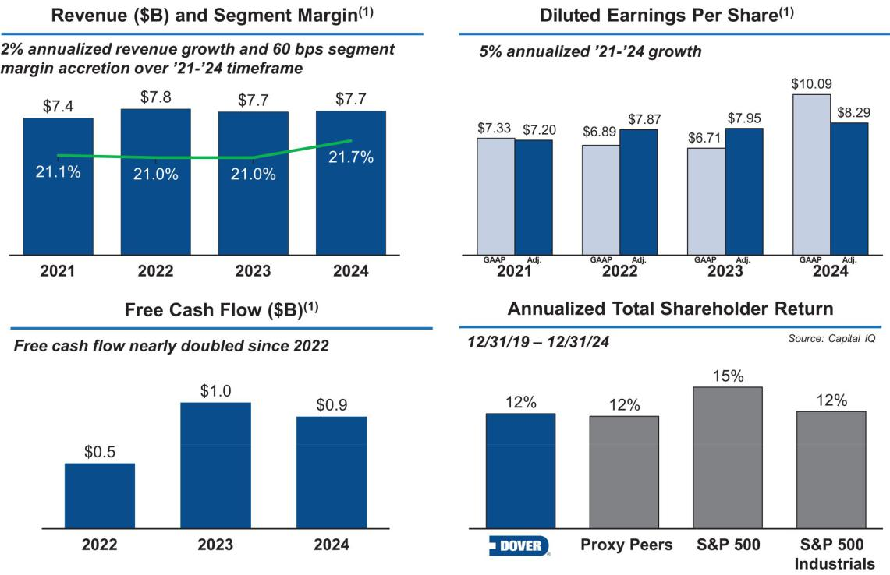

* The items herein, unless otherwise noted, relate solely to our continuing operations.

- Definitions and reconciliations of non-GAAP measures are included at the end of this proxy statement.

2024 Pay Decisions Align with Dover’s Performance

Our compensation program structure is designed to align pay outcomes with our shareholders’ experience by emphasizing variable, at-risk pay for our management team, including the NEOs, through our AIP and long-term incentive program.

For 2024, our pay decisions and outcomes were consistent with our pay-for-performance philosophy. Our NEOs made significant progress against their pre-defined individual strategic objectives as evaluated by our Compensation Committee under our AIP. As a result of strong operational achievements, the financial objective target applicable to NEO payout was 200% of target, provided that, with respect to Ms. Bors, an amount representing her AIP payout was included as part of a severance payment in accordance with our Executive Severance Plan. Due to our TSR performance relative to the companies in the S&P 500 Industrials index over the three-year performance period of 2022-2024, NEOs received long-term incentive payouts equal to 78.8% of their target PSUs.

DOVER CORPORATION – 2025 Proxy Statement 38

Table of Contents

COMPENSATION DISCUSSION AND ANALYSIS

Say on Pay Vote Results and Shareholder Engagement

94% Say on Pay support | 62% Shares Outstanding Contacted | 42% Shares Engaged

Our Board has a strong history of engaging with shareholders and soliciting feedback on a range of topics, including our executive compensation program. Historically, our program has received strong shareholder support as expressed during our one-on-one engagement discussions with shareholders and through our Say on Pay vote levels.

At our 2024 annual meeting, approximately 94% of the voting shareholders approved the compensation of the NEOs. In 2024, we continued our shareholder engagement program, reaching out to holders of approximately 62% of our outstanding shares and engaging with governance professionals and/or portfolio managers of investors holding approximately 42% of our outstanding shares. In addition to the governance topics detailed earlier in this proxy statement, we had thoughtful discussions with our shareholders regarding our compensation program. Shareholders indicated that they believe our pay aligns with performance, and expressed support for our program structure and approach, and did not share any significant concerns. The Compensation Committee will continue to consider feedback from shareholders, as well as the results from future shareholder advisory votes, in its ongoing evaluation of executive compensation programs and practices at Dover.

DOVER CORPORATION – 2025 Proxy Statement 39

Table of Contents

COMPENSATION DISCUSSION AND ANALYSIS

Dover’s Alignment with Leading Compensation Governance Practices

WHAT WE DO


✓ The majority of target NEO pay opportunity is performance based (75% for the CEO; 61% for the other NEOs)

✓ A significant portion of target NEO pay opportunity is tied to Dover stock performance (75% for the CEO; 51% for the other NEOs)

✓ Robust engagement with shareholders to seek feedback on executive compensation programs

✓ Compensation program includes ESG objectives

✓ All long-term incentives are paid in stock, not cash

✓ Executives must hold significant amounts of Dover stock: five-times salary for the CEO, three-times for other NEOs

✓ All long-term incentives are earned or vest over three years

✓ Change in control provisions require double trigger

✓ Comprehensive clawback policy

✓ Executives participate in benefit and employee programs on the same basis as other Dover employees

✓ Our Compensation Committee retains its own independent consultant

✓ Annual compensation risk assessment

WHAT WE DON’T DO


✗ No tax gross ups

✗ No repricing, reloads, or exchanges of stock-settled stock appreciation rights (“SSARs”)

✗ No SSARs granted below fair market value

✗ No hedging or pledging of Dover securities by executives, including margin loans

✗ No dividends are paid on performance shares or restricted stock units (“RSUs”) during the earning or vesting period. Dividend equivalents are accrued on RSUs, but are only paid if the RSUs vest

✗ No special executive retirement arrangements

✗ No NEO cash severance over 2.99x the sum of base salary and target bonus without shareholder approval

✗ No substantial executive perquisites, nor do we own or operate any corporate aircraft

DOVER CORPORATION – 2025 Proxy Statement 40

Table of Contents

COMPENSATION DISCUSSION AND ANALYSIS

Compensation Principles

Guiding Principles for Dover’s Executive Compensation Program
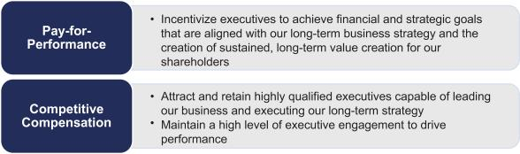

Based on these principles, these were the key elements of our executive compensation program in 2024:

- Financial metrics that are clearly linked to the creation of shareholder value: adjusted earnings, three-year relative TSR, and three-year average ROIC.

- A focus on our business strategy to ensure our long-term compensation program aligns the interests of our executives with those of our shareholders by placing an emphasis on performance-based stock compensation.

- An annual review by our Compensation Committee of executive compensation levels and the components of our program.

- A reference to the median of our peer group for total direct compensation, with consideration for internal pay equity, sustained performance, specific responsibilities, and experience with comparable market talent.

- Total compensation opportunities designed so that the large majority of compensation is variable and at-risk based on financial, strategic, operational, and share price performance.

- AIP designed to reward annual financial performance and the attainment of well-defined strategic objectives that the Board believes will assure the long-term success of Dover.

- Executive benefits and programs that are consistent with those offered to other employees. We provide no substantial executive perquisites, nor do we own or operate any corporate aircraft.

DOVER CORPORATION – 2025 Proxy Statement 41

Table of Contents

COMPENSATION DISCUSSION AND ANALYSIS

Compensation Process

Setting Executive Compensation — Roles

The process for determining our executive compensation program structure and payouts involves the dedicated participation of our Compensation Committee, the independent directors of the Board, the CEO, and our Compensation Committee’s independent consultant. The roles of each in making compensation decisions are described below:
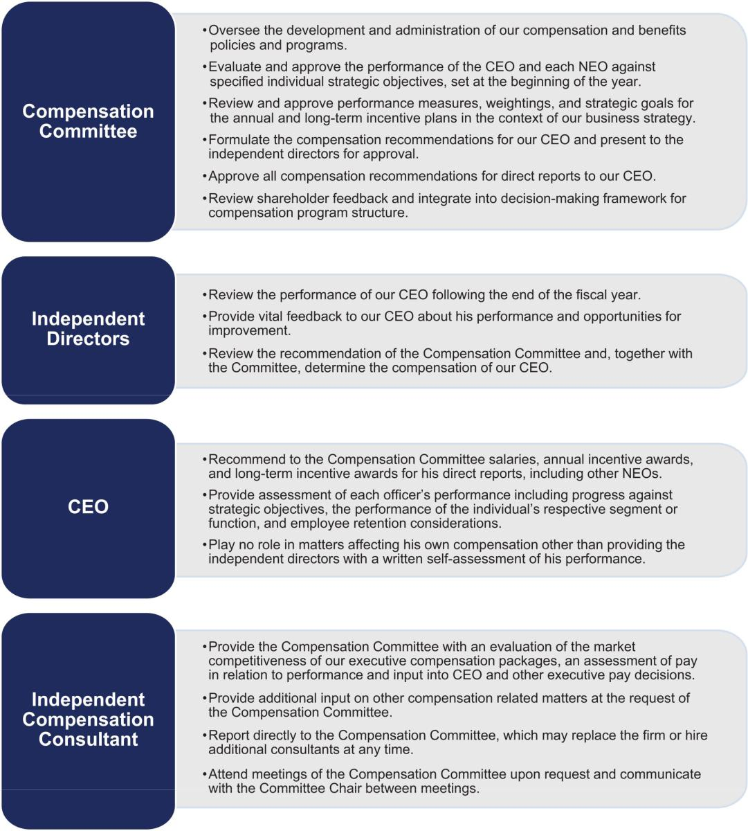

DOVER CORPORATION – 2025 Proxy Statement 42

Table of Contents

COMPENSATION DISCUSSION AND ANALYSIS

Setting Executive Compensation – Timeline

The process for making executive compensation decisions for 2024 began with goal setting at the beginning of the year and concluded with the actual compensation payout decisions in early 2025. As described below in a summary of the Compensation Committee’s process and timing for determining CEO pay, this year-long process integrates key factors, such as our business strategy, our annual budget, and market compensation data.
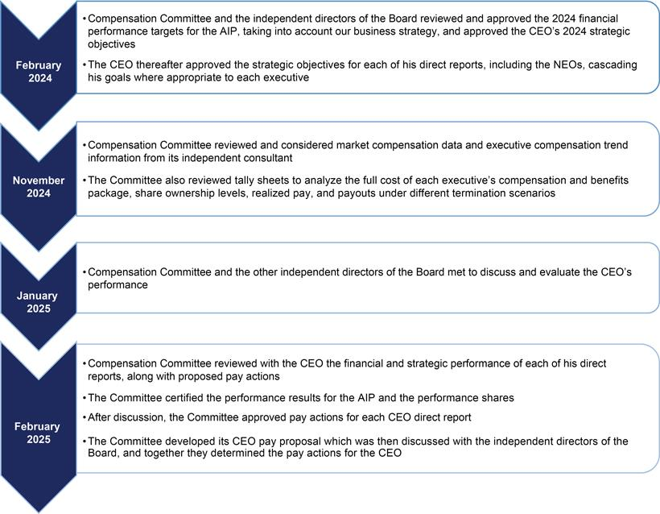

DOVER CORPORATION – 2025 Proxy Statement 43

Table of Contents

COMPENSATION DISCUSSION AND ANALYSIS

Executive Compensation Program Peer Group

Compensation levels for our named executive officers are compared to the compensation paid to comparable executives at the peer companies listed below. The Compensation Committee selected these peer companies based on their similarity to Dover in terms of end markets, complexity, revenues and market capitalization. The compensation peer group remains unchanged from the prior year.

COMPANY

AMETEK, INC.

CARLISLE COMPANIES INC.

CORNING INCORPORATED

EATON CORPORATION

EMERSON ELECTRIC CO

FLOWSERVE CORPORATION

FORTIVE CORPORATION

ILLINOIS TOOL WORKS INC.

INGERSOLL RAND INC.

PARKER-HANNIFIN CORPORATION

ROCKWELL AUTOMATION INC.

ROPER TECHNOLOGIES, INC.

SNAP-ON INCORPORATED

STANLEY BLACK & DECKER, INC.

TEXTRON INC.

XYLEM, INC.

75TH PERCENTILE

MEDIAN

25TH PERCENTILE

DOVER

 |  |  | 2024 |  |  | SAME ANALYST
 | 2024 | MARKET |  | INDUSTRY | DOVER-LIKE | SAME ANALYST
REVENUE |  |  | CAP(1) |  | STRUCTURE | COVERAGE(2)
$ | 6,941 | $ | 41,696 | Electrical | ✗ | ✗
 |  |  |  | Equipment | ✗ | ✗
$ | 5,004 | $ | 16,672 | Industrial | ✗
 |  |  |  | Conglomerate | ✗
$ | 13,118 | $ | 40,687 | Electrical
 |  |  |  | Equipment
$ | 24,878 | $ | 131,155 | Electrical | ✗ | ✗
 |  |  |  | Equipment | ✗ | ✗
$ | 17,550 | $ | 70,582 | Electrical | ✗ | ✗
 |  |  |  | Equipment | ✗ | ✗
$ | 4,558 | $ | 7,557 | Machinery |  | ✗
$ | 6,232 | $ | 26,021 | Industrial | ✗ | ✗
 |  |  |  | Machinery | ✗ | ✗
$ | 15,898 | $ | 74,876 | Machinery | ✗ | ✗
$ | 7,235 | $ | 36,457 | Machinery | ✗ | ✗
$ | 19,908 | $ | 81,870 | Machinery |  | ✗
$ | 8,093 | $ | 32,304 | Electrical |  | ✗
$ | 7,039 | $ | 55,743 | Industrial | ✗ | ✗
 |  |  |  | Conglomerate | ✗ | ✗
$ | 4,707 | $ | 17,819 | Industrial
 |  |  |  | Machinery
$ | 15,366 | $ | 12,378 | Industrial |  | ✗
 |  |  |  | Machinery |  | ✗
$ | 13,652 | $ | 14,190 | Aerospace & | ✗ | ✗
 |  |  |  | Defense | ✗ | ✗
$ | 8,562 | $ | 28,186 | Industrial |  | ✗
 |  |  |  | Machinery |  | ✗
$ | 15,499 | $ | 59,453
$ | 8,328 | $ | 34,380
$ | 6,764 | $ | 17,532
$ | 7,746 | $ | 25,737

- As of 12/31/2024.

- “Same analyst coverage” means company is covered by at least five of the analysts that cover Dover.

DOVER CORPORATION – 2025 Proxy Statement 44

Table of Contents

COMPENSATION DISCUSSION AND ANALYSIS

Role of Internal Equity in Setting Executive Compensation

Management and our Compensation Committee consider both market benchmarks (i.e., external competitiveness), as well as the impact each executive role has relative to internal peers (i.e., internal equity), in establishing the executive pay structures used to govern pay.

Retention and Independence of Compensation Consultant

Our Compensation Committee has the authority and discretion to retain external compensation consultants as it deems appropriate. Our Compensation Committee has adopted a policy to ensure the continuing independence and accountability to the committee of any advisor hired to assist the committee in the discharge of its duties. The policy formalizes the independent relationship between the Compensation Committee’s advisor and Dover, while permitting management limited ability to access the advisor’s knowledge of Dover for compensation matters. Under the policy, our Compensation Committee annually reviews and pre-approves the services that may be provided to management by the independent advisor without further Compensation Committee approval. Compensation Committee approval is required prior to Dover retaining the independent advisor for any executive compensation services or other consulting services or products above an aggregate annual limit of $50,000.

Since September 2020, our Compensation Committee has retained Meridian Compensation Partners, LLC (“Meridian”) to serve as its independent compensation consultant. Meridian does no other work for and has no other relationships with Dover. Meridian is focused on executive compensation and does not have departments, groups, or affiliates that provide services other than those related to executive compensation and benefits.

Our Compensation Committee looks to its consultant to periodically review and advise on the adequacy and appropriateness of our overall executive compensation plans, programs, and practices and, from time to time, to answer specific questions raised by our Compensation Committee or management. Compensation decisions are made by, and are the responsibility of, our Compensation Committee and our Board, and may reflect factors and considerations other than the information and recommendations provided by our Compensation Committee’s consultant.

To ensure independence of the compensation consultant, the consultant reports directly to the Chair of our Compensation Committee and works specifically for the Compensation Committee solely on compensation and benefits.

Meridian did not engage in any projects for management in 2024. Our Compensation Committee has assessed the independence of Meridian and concluded that its work for the Compensation Committee does not raise any conflict of interest.

DOVER CORPORATION – 2025 Proxy Statement 45

Table of Contents

COMPENSATION DISCUSSION AND ANALYSIS

Elements of Executive Compensation

Variable, Performance-Based Compensation Program Structure Drives Pay-For-Performance Alignment

The pay packages of Dover executives consist predominantly of incentive-based pay, both annual and long-term. Each of the compensation components has a specific role in the overall design of our executive pay program. While the components are designed to be mutually reinforcing, care is taken to minimize overlap between them. The following table provides an overview of the 2024 compensation program structure.

Component | Pay Element | 2024 Metrics & Weighting | Objectives
 |  |  | Attract and retain qualified executives
Base Salary | Cash | n/a | Benchmarked to peer group median while also
 |  |  | considering additional factors such as experience and
 |  |  | performance in role
 |  | 60% Financial Results: | Intended to drive profitability, growth, and progress
 |  | ○ Adj. Earnings (100%) | against strategy
Annual |  | 40% Individual Strategic | Individual objectives are focused on a limited and
Incentive | Cash | ○ Specific strategic initiatives deemed to be | measurable set of goals to benefit shareholders over
Plan (AIP) |  | ○ Specific strategic initiatives deemed to be | the long-term
Plan (AIP) |  | important to achieve in 2024 | the long-term
 |  | important to achieve in 2024 | Including ESG oversight in objectives establishes clear
 |  | ○ ESG oversight included in CEO and select NEO | Including ESG oversight in objectives establishes clear
 |  | ○ ESG oversight included in CEO and select NEO | tone at the top regarding the importance of ESG
 |  | individual strategic objectives | tone at the top regarding the importance of ESG
 |  | 40% LTIP weighting | Focus executives on shareholder value creation
 |  | Performance Criteria: | Focus executives on shareholder value creation
 | Performance | Performance Criteria: | Relative TSR closely aligns our executive-level
 | Shares | ○ 50% - 3-Year relative TSR with the S&P 500 | Relative TSR closely aligns our executive-level
 | Shares | ○ 50% - 3-Year relative TSR with the S&P 500 | measurement system with the experience of
 | (40%) | Industrials index companies as the comparator | measurement system with the experience of
 |  | group | shareholders
 |  | ○ 50% 3-Year average Tangible ROIC
Long-Term |  | 40% LTIP Weighting | Focus executives on share price appreciation
Incentive |  | 40% LTIP Weighting
Incentive |  |  | SSARs are an important component of our program,
Plan | SSARs | Performance Criteria: Dover stock price, exercisable | SSARs are an important component of our program,
 | SSARs | Performance Criteria: Dover stock price, exercisable | reflecting input from investors, many of whom
 | (40%) | three years after grant date and remain exercisable for | reflecting input from investors, many of whom
 |  | another seven years (subject to 10-year stock price | acknowledge the role SSARs play in emphasizing
 |  | another seven years (subject to 10-year stock price | growth and go-forward value creation
 |  | movement) | growth and go-forward value creation
 | RSUs | 20% LTIP weighting | Retention, ownership, and full alignment with the
 | RSUs | Performance Criteria: Dover stock price; awards vest | Retention, ownership, and full alignment with the
 | (20%) | Performance Criteria: Dover stock price; awards vest | shareholder experience
 |  | ratably over three years
Benefits | Consistent with other similarly situated employees
 |  |  | DOVER CORPORATION – 2025 Proxy Statement 46

Table of Contents

COMPENSATION DISCUSSION AND ANALYSIS

2024 Target Pay Mix

For 2024, the substantial majority of the CEO’s and other NEOs’ target pay mix was composed of “at risk” incentive-based pay as shown in the chart below. Additionally, the target pay mix was heavily weighted toward long-term performance and tied to share performance, with the annual incentives focused on key short-term drivers and progress on strategy.
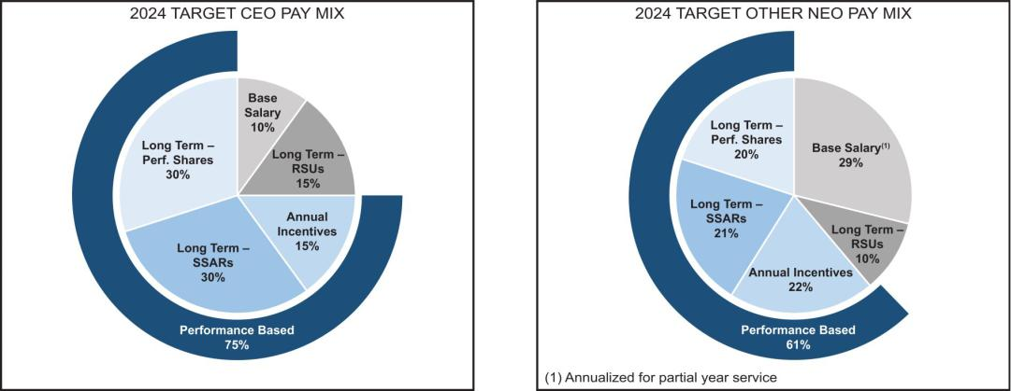

Annual Incentive Plan Compensation

An annual bonus may be earned each year based on an NEO’s performance against objectives tied to our financial performance and individual strategic goals. Each NEO’s bonus target amount is determined in reference to market benchmarking and according to the scope and complexity of the NEO’s functional responsibilities, overall impact on our results, strategic leadership, and managerial responsibility. We believe that balancing the measurement of performance for the annual bonus between financial and strategic objectives is important in mitigating risk and executing on our long-term strategy for value creation.

Each NEO is eligible for a bonus equal to his or her base salary multiplied by his or her target award percentage multiplied by the Overall Payout Factor (which is the sum of the Financial Objective Factor (weighted 60%) and the Strategic Objectives Factor (weighted 40%)).
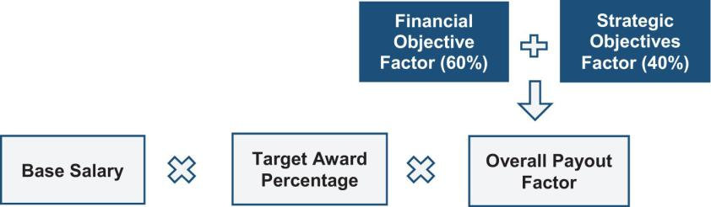

2024 AIP Financial Objective Factor – Target

The Financial Objective Factor in the 2024 AIP was calculated based on Adjusted Earnings. In setting the financial objective, our Compensation Committee considered our annual budget, operational priorities, plans for capital allocation, historical performance, and external factors, among other items. This thorough process is designed to ensure that targets are rigorous and to establish challenging but attainable goals in the context of expectations for the year on the basis of these factors. The target performance level for the financial objective was established at the beginning of the fiscal year and provided for appropriate adjustments for acquisitions and dispositions occurring during the year. For this measure, our Compensation

DOVER CORPORATION – 2025 Proxy Statement 47

Table of Contents

COMPENSATION DISCUSSION AND ANALYSIS

Committee established threshold, target, and maximum levels of performance, as well as a payout percentage curve that relates each level of performance to a payout percentage.

Threshold and maximum performance levels are set at 85% and 107%, respectively, of target. There is no payout on the Financial Objective Factor if performance is below the threshold. At threshold, the payout percentage curve begins at 50%. If performance is at the target level, the payout percentage is 100%. For performance at or above the maximum level of achievement, the payout percentage is capped at 200%.

2024 AIP Financial Objective Factor – Results

Following the end of 2024, we calculated the Financial Objective Factor as follows:

 |  | 2024 AIP FINANCIAL OBJECTIVE RESULTS (in millions)
 | TARGET | ACTUAL | PAYOUT% | WEIGHTING | WEIGHTED
 | PERFORMANCE | PERFORMANCE | (BEFORE | OF MEASURE | PAYOUT%
 | LEVEL | LEVEL | WEIGHTING)
Adjusted Earnings | $1,245.9 | $2,806.3(1) | 200.0% | 60% | 120.0%
 |  |  | Financial Objective Factor |  | 120.0%

- Adjusted earnings for purposes of the 2024 AIP metrics reflects gain on sale for the De-Sta-Co and ESG dispositions which occurred in 2024.

2024 AIP Individual Strategic Objectives Factor

The Strategic Objectives Factor is based on the achievement of individual strategic objectives designed to create long-term value for our shareholders. The strategic objectives for the CEO were developed by our Compensation Committee at the beginning of the year, approved by our independent directors, and communicated to the CEO in February. The individual strategic objectives were based on specific strategic initiatives that the Board and management agreed were important to achieve in 2024. These objectives were cascaded to the CEO’s direct reports, as appropriate, based on their responsibilities or business portfolio. The Board monitored progress on the CEO’s strategic objectives and, following the end of the year, reviewed the CEO’s performance against these objectives when determining his annual bonus.

Following the end of 2024, our Compensation Committee determined for each NEO a Strategic Objectives Factor between 0% and 200%. Our Compensation Committee believes such judgment is an important risk-mitigating element to our compensation program and provides an opportunity to further align executive compensation with long-term value creation. To make this determination, our Compensation Committee took into account each executive’s execution against his or her personal strategic objectives for the year and the executive’s overall performance for the year.

DOVER CORPORATION – 2025 Proxy Statement 48

Table of Contents

COMPENSATION DISCUSSION AND ANALYSIS

Strategic Objectives Factor — CEO

The table below summarizes the individual strategic objectives, weightings, and results the Compensation Committee considered for our CEO in determining his Strategic Objectives Factor for 2024.
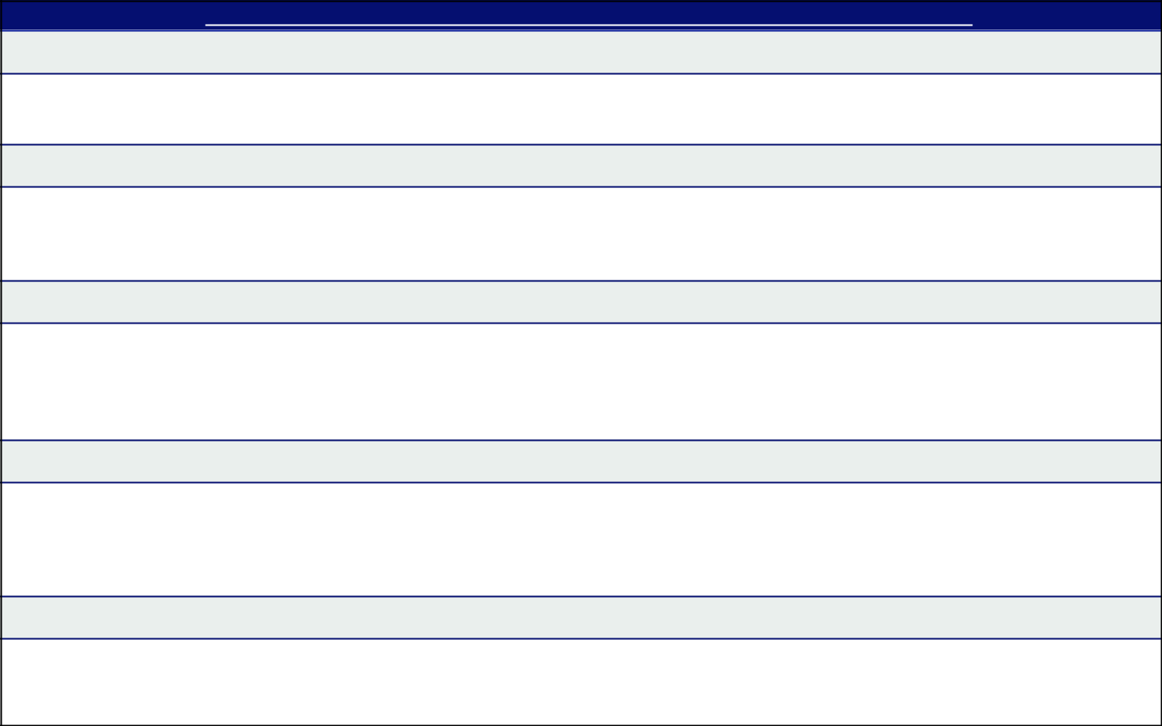

Strategic Objectives & Accomplishments – Richard J. Tobin (Chairman, President & CEO)

Three Pillars Progression (20%)

✓ Continued to progress on productivity and margin expansion initiatives to achieve strong operational results, including strengthening our core enterprise capabilities.

Capital Markets and Shareholder Engagement (20%)

- Oversaw capital structure plan, including the return of capital to shareholders.

✓ Played an important role in leading investor engagement activities, which included presenting at multiple industry conferences and meeting with shareholders on a variety of topics ranging from company strategy to our governance structure.

Portfolio Management (20%)

✓ Demonstrated strong leadership in effectively deploying capital to increase the value of our portfolio, including through organic investments and strategic acquisitions, to further expand our business into high growth, high margin platforms.
- Completed the integration of several recent acquisitions, including those in high margin, high growth platforms.

- Completed the divestitures of De-Sta-Co and Environmental Solutions Group businesses.

Talent, Succession Planning & Workforce Development (20%)

✓ Completed talent and succession planning review, providing regular updates to the Compensation Committee on executive development and succession planning for key positions and preparing the organization for a successful CFO transition.
✓ Continued to promote a culture centered on Dover’s core values, deployed related trainings and completed our second global employee engagement survey.

ESG (20%)

- Completed the second year of our second three-year ESG strategic plan.

- Reviewed progress against ESG plan with the Board, including as a member of Dover’s Sustainability Steering Committee.

Our Compensation Committee evaluated Mr. Tobin’s achievements against his strategic objectives and assigned him a Strategic Objectives Factor of 100%.

DOVER CORPORATION – 2025 Proxy Statement 49

Table of Contents

COMPENSATION DISCUSSION AND ANALYSIS

Strategic Objectives Factor — Other NEOs

The following table summarizes the individual strategic objectives and results the Compensation Committee considered for our other NEOs in determining their respective Strategic Objectives Factors for 2024.


Brad M. Cerepak (Senior Vice President & CFO)

Strategic Objectives & Accomplishments

Corporate Strategy (25%)

✓ Evaluated options for capital deployment, including this year through organic reinvestment, M&A, and returns to shareholders, including cash dividends (increased annually over each of the last 69 years).

✓ Demonstrated leadership in developing and executing ongoing portfolio actions, with Dover ending the year with a significant cash position that provides for flexibility as we pursue value-creative capital deployment.
- Mentored incoming CFO to ensure a seamless transition.

Strategic Planning Process & Control Environment (25%)

- Made improvements to business unit strategic planning process

✓ Led implementation of financial consolidation tool to reduce complexity, improve security and controls, minimize manual effort, and add greater functionality and flexibility for business units to evaluate their financial performance.

Finance Transformation and Control Environment (25%)

✓ Identified cost containment actions and opportunities to drive efficiencies, including championing further investment in Dover Business Services.

Capital Structure Analysis (25%)

- Reviewed capital structure options based on projected capital and liquidity needs.

- Refinanced Dover’s $500 million 364-day unsecured revolving credit facility with a syndicate of banks.

- Launched and completed $500 million accelerated share repurchase program.

Assigned Strategic Objectives Factor of 100%
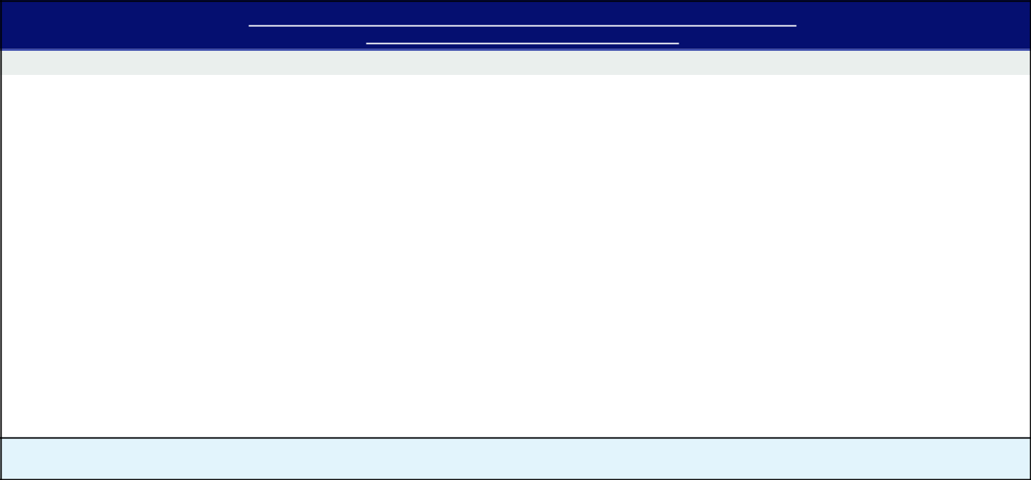

Ivonne M. Cabrera (Senior Vice President, General Counsel & Secretary)

Strategic Objectives & Accomplishments

Governance (25%)

✓ Advised our Board and management on legal and governance matters, including through strategic support and advice on our Board’s leadership structure and composition, Dover’s succession planning processes, and evolving governance best practices.

- Oversaw our robust shareholder engagement efforts.

M&A/Portfolio Management (25%)

✓ Provided strategic advice on key M&A transactions to drive value creation and proactive support to enable their successful consummation.

Intellectual Property, Commercial Contracts and Growth (25%)

✓ Managed key legal issues involving Dover, including in connection with intellectual property strategies and activities as well as commercial opportunities across high growth platforms.

ESG/Sustainability (25%)

- Provided leadership in delivering on Dover’s sustainability strategy, including as Chair of our Sustainability Steering Committee. ✓ Continued to review and enhance Dover’s public disclosures and compliance controls and procedures, taking into account external

developments such as evolving regulatory requirements pertaining to sustainability disclosures.

Assigned Strategic Objectives Factor of 100%

DOVER CORPORATION – 2025 Proxy Statement 50

Table of Contents

COMPENSATION DISCUSSION AND ANALYSIS


Girish Juneja (Senior Vice President & Chief Digital Officer)

Strategic Objectives & Accomplishments

Digital Strategy (25%)

✓ Supported our strategic initiatives and priorities by assessing the digital capabilities of acquisition targets, including strategic fit with key growth areas across our operating segments.

- Led digital transformation efforts that supported business growth across our enterprise in 2024.

- Drove digital centralization activities and increased adoption of shared services and common practices.

Digital Customer Experience (25%)

✓ Advanced customer-facing digital strategy by increasing adoption of digital commercial excellence capabilities across the enterprise, thereby making the ordering process more efficient for customers, and scaling our digital demand generation programs.

- Drove working capital benefits by enabling teams across the enterprise with advanced analytical tools.

Product Development (25%)

- Continued to drive productivity by further optimizing operations and support services across connected products.

✓ Helped drive digitization of our manufacturing operations by expanding our “connected factory” and “data quality” programs, increasing operational efficiency, safety, and quality.

IT/Data Security (25%)

✓ Controlled information technology (“IT”) costs in line with annual operating plan and deployed IT services across the global enterprise, while supporting major facility expansions and consolidations, completing a successful ERP upgrade, and providing support for engineering and automation projects.

- Oversaw continued progress on our multi-year strategy for data security.

Assigned Strategic Objectives Factor of 100%
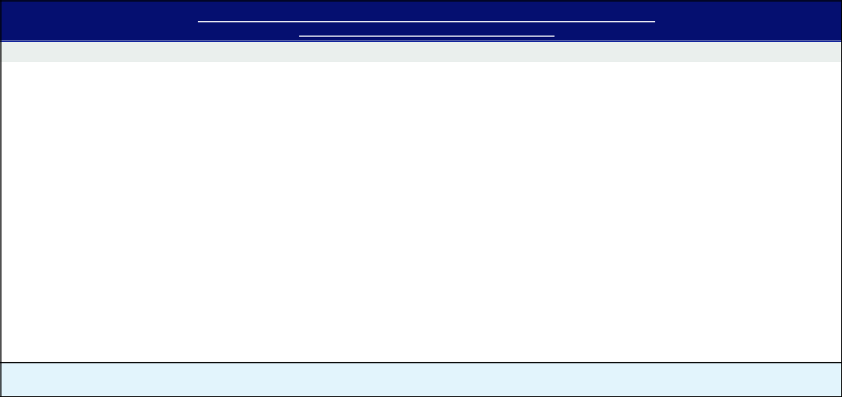

Jeffrey C. Yehle (Senior Vice President & Chief Human Resources Officer)

Strategic Objectives & Accomplishments

Enterprise Talent Management (25%)

- Continued to enhance our talent management processes, capabilities, and succession depth across the enterprise.

- Worked with the Board to review and enhance Dover’s well-designed approach to management succession planning.

Strategic HR Enterprise Initiatives (25%)

- Continued to harmonize and streamline Dover’s global benefits programs.

- Further developed global career architecture and compensation structure.

Workforce Development (25%)

- Advanced Dover’s workforce development strategy, including employee engagement and development activities.

- Continued to build our internal leadership development programs.

✓ Championed the successful completion of our second annual global engagement survey, which yielded record participation and led to the development of action plans to address feedback.

HR Transformation (25%)

✓ Continued to implement global organizational improvements to maximize operational efficiency of the HR function as we continue to centralize shared services and expand our centers of expertise.

Assigned Strategic Objectives Factor of 100%

The Overall Payout Factors resulting from the above Financial Objective Factors and Strategic Objectives Factors resulted in the payouts set forth in the 2024 Summary Compensation Table.

DOVER CORPORATION – 2025 Proxy Statement 51

Table of Contents

COMPENSATION DISCUSSION AND ANALYSIS

Kimberly K. Bors (former Senior Vice President & Chief Human Resources Officer)

Ms. Bors departed Dover as of July 8, 2024. An amount representing her AIP payout was included as part of a severance payment in accordance with our Executive Severance Plan.

Long-Term Incentive Compensation

The following table summarizes the components of awards under our LTIP and the related performance criteria for awards granted in 2024. Note that all components are paid in stock rather than cash to encourage shareholder alignment through stock ownership.

Pay Element | 2024 Weighting & Performance Criteria | Objectives
 | 40% LTIP weighting
Performance Shares | Performance Criteria: | Focus executives on shareholder value
Performance Shares | 50% 3-Year relative TSR with the S&P 500 Industrials index | Focus executives on shareholder value
Performance Shares | 50% 3-Year relative TSR with the S&P 500 Industrials index | creation
 | companies as the comparator group
 | 50% 3-Year average Tangible ROIC
Stock Settled Stock | 40% LTIP weighting
Stock Settled Stock | Performance Criteria: Dover stock price, exercisable three years after | Focus executives on share price appreciation
Appreciation Rights | grant date and remain exercisable for seven years (subject to 10-year
 | stock price movement)
Restricted Stock Units | 20% LTIP weighting | Retention and full alignment with the
Restricted Stock Units | Performance Criteria: Dover stock price; awards vest ratably over three | Retention and full alignment with the
Restricted Stock Units |  | shareholder experience
 | years | shareholder experience

Performance Shares – Overview

Beginning with grants made in 2024, performance shares will be earned based 50% on our TSR performance relative to the TSR of S&P 500 Industrials index companies and 50% on the average Tangible Return on Invested Capital (“Tangible ROIC”). Both performance metrics are measured over the three-year performance period ending December 31, 2026. The relative TSR metric provides shareholders with a transparent and straightforward measure to gauge our performance against our industry peers, aligning the interests of our executives with those of our shareholders. Tangible ROIC is a measure for evaluating investment returns on capital and operational performance and aligns our performance shares with portfolio actions and long-term business strategy.

DOVER CORPORATION – 2025 Proxy Statement 52

Table of Contents

COMPENSATION DISCUSSION AND ANALYSIS

Performance Shares Subject to Relative TSR Metric – 50% Weighting

Our NEOs may earn between 0% and 300% of their target performance shares based on our relative TSR performance, subject to a cap of 100% of target if our TSR is negative over the performance period, as illustrated in the graph below.
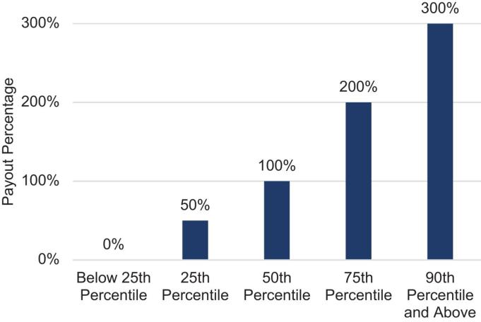

Performance Shares Subject to Tangible ROIC – 50% Weighting

Our NEOs may earn between 0% and 300% of their target performance shares, based in part on Tangible ROIC performance. Tangible ROIC is the quotient of (i) Adjusted Net Earnings and (ii) Total Tangibles. Adjusted Net Earnings refers to the

Adjusted Net Earnings for each year ended December 31 during the performance period, excluding the adjusted net earnings related to any business acquisitions or dispositions in the year each such transaction is completed. Total Tangibles refers to the total tangible assets of Dover for each year ended December 31 during the performance period, excluding the total tangible assets related to any business acquisitions or dispositions in the year each such transaction is completed. This is equal to the sum of (i) property, plant and equipment (gross), (ii) accounts receivable, (iii) total inventory (net) and (iv) accounts payable (stated as a negative number).

The graph below shows the percentage of target performance shares earned based on the level of achieved Tangible ROIC over the performance period.
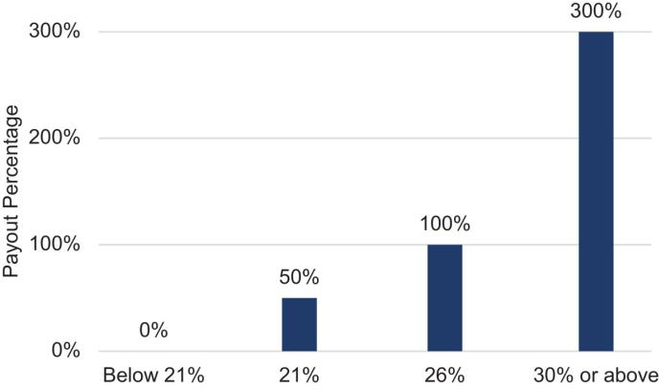

DOVER CORPORATION – 2025 Proxy Statement 53

Table of Contents

COMPENSATION DISCUSSION AND ANALYSIS

Performance Shares Vested in 2024

Prior to 2024, performance shares were earned solely based on the relative TSR metric. Accordingly, the payout of performance shares granted in 2022 for the three year performance period ended December 31, 2024 were based solely on Dover’s relative TSR over that period against the S&P 500 Industrials index companies. Consistent with our value creation over the three-year performance period, the performance shares vested in 2024 had a payout percentage of 78.8% of target for our NEOs.

 | Target # of Shares(1) | Actual Shares Awarded
Richard J. Tobin | 22,471 | 17,707
Brad M. Cerepak | 5,306 | 4,181
Ivonne M. Cabrera | 2,497 | 1,968
Girish Juneja | 1,873 | 1,476
Kimberly K. Bors | 1,323 | 1,043

(1) Mr. Yehle joined Dover in 2024 and accordingly did not have a performance share award for the period 2022-2024.

Stock Settled Stock Appreciation Rights

Stock Settled Stock Appreciation Rights (SSARs) give our NEOs the ability to participate in the price appreciation of a set number of shares of Company stock. Once SSARs vest, an NEO may exercise them any time prior to the expiration date and the proceeds from the exercise are paid to the NEO in the form of shares of Dover common stock to encourage continued share ownership and shareholder alignment. SSARs vest and become exercisable three years after the grant date and remain exercisable for seven years, which means the awards are subject to ten-year stock price movement thus aligning executive interests with those of our shareholders over the long term. Importantly, in light of our active acquisition program, SSARs’ forward-looking orientation is effective for incentivizing our newly-acquired companies and employees, who must create new value in order to realize gains. Furthermore, SSARs’ ten-year life cycle is essential to managing value creation with a business that has a portfolio of industrial companies whose economic cycles vary.

Restricted Stock Units

RSU grants attract and retain NEOs by providing them with some of the benefits associated with stock ownership during the vesting period. Executives do not actually own the shares underlying the units, nor do they enjoy the benefits of ownership such as dividends and voting, until the vesting conditions are satisfied. Once an NEO’s RSUs vest, the NEO receives a number of shares of Dover common stock equivalent in number to the vested units and receives a cash amount equal to any dividend equivalents that were accrued during the vesting period, net of withholding taxes.

Other Benefits

401(k), Pension Plan and Health & Wellness Plans

Our NEOs are able to participate in retirement and benefit plans generally available to our employees on the same terms as other employees. Dover and most of our businesses offer a 401(k) plan to substantially all U.S.-based employees and provide a Company matching contribution denominated as a percentage of the amount of salary deferred into the plan by a participant during the course of the year. Some of our U.S.-based employees also participate in a tax-qualified defined benefit pension plan. Effective December 31, 2013, we closed both our qualified and non-qualified defined benefit retirement plans to new employees. As of December 31, 2023, all benefit accruals in both plans were frozen. All of our U.S.-based employees are offered a health and wellness plan (including health, term life and disability insurance). NEOs do not receive enhanced health and wellness benefits.

Non-Qualified Retirement Plans

We offer two non-qualified plans with participation generally limited to individuals whose annual salary and bonus earnings exceed the Internal Revenue Service (“IRS”) limits applicable to our qualified plans: our Pension Replacement Plan (“PRP”)

DOVER CORPORATION – 2025 Proxy Statement 54

Table of Contents

COMPENSATION DISCUSSION AND ANALYSIS

and our deferred compensation plan. Participation in the deferred compensation plan is open to employees with an annual salary equal to or greater than $250,000 for 2024 deferral elections.

After December 31, 2009, benefits under the PRP before offsets are determined using the benefit calculation and eligibility criteria as under the pension plan, except that IRS limits on compensation and benefits do not apply. Prior to December 31, 2009, the participants in the PRP accrued benefits greater than those offered in the pension plan. Effective January 1, 2010, we modified this plan so that executives subject to IRS compensation limits will accrue future benefits that are substantially the same as benefits under the pension plan. Individuals who participated in the PRP prior to January 1, 2010 will receive benefits calculated under the prior benefit formula through December 31, 2009 and benefits calculated under the lower PRP benefit formula on and after January 1, 2010. Amounts receivable by the executives under the PRP are reduced by any amounts receivable by them under the pension plan, any qualifying profit sharing plan, Company-paid portion of social security benefits, and the amounts of the Company match in the 401(k) plan.

Effective December 31, 2013, the PRP was closed to new employees. All eligible employees as of December 31, 2013 continued to earn PRP benefits through December 31, 2023 as long as they remain employed by Dover and its affiliates. Effective December 31, 2023, Dover eliminated any benefit accruals consistent with the freezing of benefit accruals under the pension plan.

We offer a deferred compensation plan to allow participants to elect to defer their receipt of some or all of their salary, bonuses and any payout of a cash performance award. The plan permits executive officers to defer receipt of part of their compensation to later periods and facilitates tax planning for the participants. Effective January 1, 2022, the deferred compensation plan was amended to also provide for automatic Company contributions for participants who do not also participate in the PRP or have a present value benefit under the PRP of less than $100,000.

Executive Non-Change-in Control Severance Plan

All of our NEOs are eligible to participate in our severance plan. Under the plan, if we terminate an NEO’s employment without cause (as defined in the severance plan), the NEO will generally be entitled to receive twelve months of salary plus target annual cash bonus, outplacement services, and healthcare benefits continuation, and a prorated annual cash bonus and a prorated performance share award for time worked during the year. Pursuant to a policy adopted by the Compensation Committee effective February 9, 2023, cash severance benefits will be limited to no more than 2.99 times the sum of the executive officer’s base salary plus target annual bonus, unless approved by shareholders. In addition, Mr. Tobin is entitled to receive certain severance payments and benefits under his employment agreement in the event his employment is terminated by Dover without cause or by him for good reason. See “Potential Payments Upon Termination or Change in Control.”

Senior Executive Change in Control Severance Plan

Our Senior Executive Change in Control Severance Plan (the “CIC Severance Plan”) establishes the severance benefits payable to eligible executives if they are involuntarily terminated following a change in control. All of our NEOs are eligible to participate in the CIC Severance Plan. An executive eligible to participate in the CIC Severance Plan as of the date of a change in control will be entitled to receive severance payments under the plan if, within 24 months after the change in control, either the executive’s employment is terminated by the Company without “cause” or he or she terminates employment for “good reason” (as such terms are defined in the plan). The severance payments and benefits will consist of: a lump sum payment equal to 2.0 times their annual salary and target bonus, a prorated annual cash bonus at target, full acceleration of all unvested SSARs and RSUs, performance share payout at target for all in-cycle awards, outplacement services, and a lump sum payment equal to the cost of Consolidated Omnibus Budget Reconciliation Act (COBRA) health care benefit continuation of the executive and covered family members for 24 months. See “Potential Payments Upon Termination or Change in Control.” Pursuant to a policy adopted by the Compensation Committee effective February 9, 2023, cash severance benefits will be limited to no more than 2.99 times the sum of the executive officer’s base salary plus target annual bonus, unless approved by shareholder. No executive may receive severance benefits under more than one plan or arrangement. Dover does not provide tax gross-ups in the CIC Severance Plan.

DOVER CORPORATION – 2025 Proxy Statement 55

Table of Contents

COMPENSATION DISCUSSION AND ANALYSIS

Other Elements of Compensation

Clawback Policy

In May 2023, in light of new rules promulgated by NYSE and SEC requirements, the Compensation Committee adopted a new clawback and recoupment policy applicable to our executive officers, effective as of October 2, 2023 (the “Clawback Policy”) that complies with applicable standards. The Clawback Policy provides for the prompt repayment or forfeiture by current or former executive officers of certain erroneously awarded compensation (“Erroneously Awarded Compensation”) received during an applicable three-year lookback period in the event we are required to prepare an accounting restatement of all or a portion of our consolidated financial statements due to material noncompliance with any financial reporting requirement under the securities laws. Erroneously Awarded Compensation for the purposes of the Clawback Policy generally means the amount of incentive-based compensation received during the fiscal period affected by the restatement by such executive officer that exceeds the amount of incentive-based compensation that would have been received by such executive officer had it been determined based on the restated amounts, without regard to any taxes paid. Incentive-based compensation covered under the Clawback Policy generally includes any incentive-based compensation granted, vested or paid to our executive officers at any time during the performance period for the incentive-based compensation and that was received (i) on or after the effective date of the NYSE listing standard, (ii) after the person became an executive officer, and (iii) at a time that we have a class of securities listed on a national securities exchange, and such incentive-based compensation is in general limited to any compensation granted, earned, or vested based wholly or in part on the attainment of one or more financial reporting measures.

The Clawback Policy does not condition clawback on the fault of the executive officer, but we are not required to pursue forfeiture or recovery of amounts in limited circumstances where the Compensation Committee has made a determination that recovery would be impracticable and (i) we have already attempted to recover such amounts but the direct expenses paid to a third party in an effort to enforce the Clawback Policy would exceed the amount to be recovered, (ii) the recovery of amounts would violate applicable home country law, or (iii) the recovery would cause the non-compliance of a tax-qualified retirement plan under the Internal Revenue Code and applicable regulations. We may effect any such recoupment by requiring the executive officer to pay Dover the relevant amount, by set-off, by reducing future compensation or by such other means or combination of means as the Board determines to be appropriate. We may not indemnify any such executive officer against the loss of such recovered compensation.

Apart from the Clawback Policy described above, our PRP includes clawback provisions for termination for cause and the severance plan and CIC Severance Plan provide for clawback of benefits for breaches of the plan.

Insider Trading Policy

Dover has an insider trading policy governing the purchase, sale, and other dispositions of Dover securities that applies to all Dover employees and directors. Dover believes these policies and procedures are reasonably designed to promote compliance with insider trading laws, rules and regulations and applicable NYSE listing standards. A copy of the Company’s insider trading policy was filed as Exhibit 19 to its Annual Report on Form 10-K for the year ended December 31, 2024. From time to time, Dover may engage in transactions in its own securities. It is Dover’s policy to comply with all applicable securities and state laws (including appropriate approvals by the Board of Directors or appropriate committee, if required) when engaging in transactions of its securities.

Anti-hedging and Anti-pledging Policy

Our Securities Trading and Confidentiality Policy prohibits directors, executive officers and any employee who has previously received or receives any type of long-term incentive plan award, and certain persons and entities related to any such persons, from engaging in short-sales, transactions in derivative securities or any other form of hedging transaction designed to hedge or offset any decrease in the market value of Dover securities granted to or held by such persons. In addition, such persons may not hold Dover securities in a margin account or pledge securities as collateral for a loan or any other obligation.

Perquisites

We provide no substantial executive perquisites, other than the payment for executive physicals, nor does the Company own or operate any corporate aircraft. Management and our Compensation Committee believe that providing significant perquisites

DOVER CORPORATION – 2025 Proxy Statement 56

Table of Contents

COMPENSATION DISCUSSION AND ANALYSIS

to executive officers would not be consistent with our overall compensation philosophy. As a result, we do not provide executive officers with perquisites such as social club memberships, company cars or car allowances, or financial counseling.

Shareholding Guidelines

We believe that our executives will most effectively pursue the long-term interests of our shareholders if they are shareholders themselves. As a result, share ownership guidelines are in place for all NEOs (subject to exceptions that may be granted by our Compensation Committee for significant personal events or retirement planning). Our CEO is required to hold shares equal in value to five-times salary and our other NEOs are required to hold shares equal in value to three-times salary. Our policy requires that NEOs hold/retain all equity grants until the share ownership guidelines are met. Based on current share ownership, all executives serving as NEOs are currently in compliance with the guidelines. Our Compensation Committee reserves the right to provide a portion of annual bonus in stock for any officer who fails to meet or make satisfactory progress toward satisfying the guidelines.

Risk Assessment

In 2024, Dover, with the assistance of Willis Towers Watson, conducted a formal risk assessment for all our incentive compensation programs that have a material impact on our financial statements. Willis Towers Watson inventoried incentive compensation programs at the corporate and operating company levels globally and conducted in-depth reviews of financially material plans, identified based on expected spend and income statement accounts tied to the program. The reviews focused on both the plan design features as well as internal risk mitigation controls in place. Based on this assessment, we have concluded that Dover’s compensation practices and policies do not create risks that are reasonably likely to have a material adverse effect on the Company.

DOVER CORPORATION – 2025 Proxy Statement 57

Table of Contents

Compensation Committee Report


We reviewed and discussed with management the Compensation Discussion and Analysis for the year ended December 31, 2024.

Based on the review and discussions referred to above, we recommended to the Board of Directors that the Compensation Discussion and Analysis be included in this Proxy Statement and incorporated by reference in Dover’s Annual Report on Form 10-K for the year ended December 31, 2024.

Compensation Committee:

Keith E. Wandell (Chair)

Kristiane C. Graham

Michael F. Johnston

Michael Manley

This report does not constitute “soliciting material” and shall not be deemed filed or incorporated by reference into any filing under the Securities Act of 1933 or under the Securities Exchange Act of 1934, except to the extent the Company specifically incorporates this report by reference and shall not otherwise be deemed filed under such Acts.

DOVER CORPORATION – 2025 Proxy Statement 58

Table of Contents

Executive Compensation Tables

Summary Compensation Table

The Summary Compensation Table and notes show all remuneration for 2024 provided to our NEOs, consisting of the following officers:

- Our President & CEO;

- Our Senior Vice President & CFO;

- Our three other most highly compensated executive officers as of the end of 2024; and

- One former executive officer who would have been among the three other most highly compensated had she been an executive officer as of the end of 2024.

The determination of the most highly compensated executive officers is based on total compensation paid or accrued for 2024, excluding changes in the actuarial value of defined benefit plans and earnings on nonqualified deferred compensation balances.

 |  |  |  |  |  |  | Change in
 |  |  |  |  |  |  | Pension Value
 |  |  |  |  |  |  | and
 |  |  |  |  |  |  | Nonqualified
 |  |  |  |  |  | Non-Equity | Deferred
 |  |  |  | Stock | Option | Incentive Plan | Compensation | All Other
 |  | Salary | Bonus | Awards | Awards | Compensation | Earnings | Compensation
Name and Principal Position | Year | ($) | ($)(1) | ($)(2) | ($)(3) | ($)(4) | ($)(5) | ($)(6) | Total ($)
Richard J. Tobin | 2024 | 1,337,000 | 3,461,120 | 8,196,451 | 5,965,757 | 0 | 0 | 270,202 | 19,230,530
President & | 2023 | 1,292,500 | 1,999,920 | 8,086,100 | 5,209,390 | 0 | 0 | 207,191 | 16,795,101
Chief Executive Officer | 2022 | 1,261,250 | 1,951,101 | 6,213,263 | 4,201,489 | 0 | 0 | 516,149 | 14,143,252
Brad M. Cerepak | 2024 | 807,364 | 1,302,720 | 1,659,002 | 1,207,356 | 0 | 0 | 105,427 | 5,081,869
Senior Vice President & | 2023 | 781,108 | 842,357 | 1,808,578 | 1,165,253 | 0 | 471,561 | 27,179 | 5,096,036
Chief Financial Officer | 2022 | 747,448 | 771,151 | 1,467,135 | 992,011 | 0 | 0 | 27,865 | 4,005,610
Ivonne M. Cabrera | 2024 | 642,648 | 777,720 | 780,525 | 568,141 | 0 | 414,398 | 66,310 | 3,249,742
Senior Vice President & | 2023 | 621,700 | 465,105 | 851,134 | 548,379 | 0 | 255,662 | 18,437 | 2,760,417
General Counsel | 2022 | 589,400 | 460,275 | 690,353 | 466,851 | 0 | 0 | 17,484 | 2,224,363
Girish Juneja | 2024 | 546,956 | 617,792 | 585,550 | 426,144 | 0 | 0 | 52,872 | 2,229,314
Senior Vice President & | 2023 | 529,125 | 369,452 | 638,514 | 411,249 | 0 | 0 | 44,246 | 1,992,586
Chief Digital Officer | 2022 | 507,500 | 365,639 | 517,814 | 350,107 | 0 | 0 | 43,312 | 1,784,372
Jeffrey C. Yehle
Senior Vice President &
Chief Human Resources
Officer (7) | 2024 | 236,635 | 321,000 | 490,224 | 180,536 | 0 | 0 | 17,388 | 1,245,783
Kimberly K. Bors | 2024 | 259,111 | N/A | 507,435 | 369,294 | 0 | 0 | 945,108 | 2,080,948
Former Senior Vice
Former Senior Vice | 2023 | 480,900 | 335,784 | 553,324 | 356,416 | 0 | 0 | 41,402 | 1,767,826
President & Chief
Human Resources Officer (8) | 2022 | 460,125 | 332,302 | 365,896 | 247,414 | 0 | 0 | 37,616 | 1,443,353

- Bonus amounts generally represent payments under our AIP for the year indicated, for which payments are made in the first quarter of the following year. The AIP constitutes a non-equity incentive plan under FASB ASC Topic 718. Although they are based on the satisfaction of pre-established performance targets, AIP amounts are reported in the bonus column rather than the non-equity incentive plan compensation column to make clear that they are annual bonus payments for the year indicated.

- The amounts generally represent (a) the aggregate grant date fair value of performance shares granted during the year indicated, and (b) the aggregate grant date fair value of restricted stock unit awards granted during the year, in each case, calculated in accordance with FASB ASC Topic 718. The amounts set forth in the table do not correspond to the actual value that might be realized by the named executives. For 2024 performance share grants, the performance metric for 50% of the award is relative TSR, a market based metric, and that portion of the award was valued using the

DOVER CORPORATION – 2025 Proxy Statement 59

Table of Contents

EXECUTIVE COMPENSATION TABLES

Monte Carlo simulation model. The performance metric for the other 50% of the award is Tangible Return on Invested Capital and that portion of the award was valued based on the grant date stock price. For a discussion of the valuation of equity awards and related assumptions, see Note 15 to the Notes to the Financial Statements contained in our Annual Report on Form 10-K for the year ended December 31, 2024.

- The grant date fair value for the 2022 performance share awards was $196.40, the grant date fair value for the 2023 performance share awards was $249.48 and the grant date fair value for the 2024 performance share awards was $232.41 or $241.43 in the case of Mr. Yehle’s awards. The grant date fair value of the market condition portion of the 2024 performance share awards is $287.62 per share for all NEOs other than Mr. Yehle and the grant date fair value of the performance condition portion of the 2024 performance share awards is $177.19 based on Dover’s closing stock price at the date of grant. The grant date fair value of the market condition portion for Mr. Yehle’s award is $303.71 per share and the grant date fair value of the performance condition portion is $179.15 based on Dover’s closing stock price at the date of grant. The grant date fair value of 2024 RSU awards was $160.11, or $ 179.15 in the case of Mr. Yehle’s awards. All RSU grants are eligible for dividend equivalent payments which are paid upon vesting.

- The amounts represent the aggregate grant date fair value of SSAR awards granted during the year indicated, calculated in accordance with FASB ASC Topic 718, and do not correspond to the actual value that may be realized by the named executives. The grant date fair value for the 2024 SSAR awards was calculated using a Black-Scholes value of $51.17 per SSAR, or $55.98 in the case of Mr. Yehle’s awards.

- See Note (1) for a discussion of annual bonuses under the AIP as non-equity incentive plan compensation.

- Amounts represent changes in present value of accumulated benefits under the pension plan and/or PRP during the year indicated. Mr. Cerepak retired as of January 31, 2025. Accordingly, the change in his pension value for the year 2024 was negative ($135,282) and pursuant to SEC rules, the table presents the amount of the change as “0”. For more information, see “Executive Compensation Tables — Pension Benefits through 2024.”

- Amounts for 2024 represent: (i) 401(k) matching contributions of $12,075 for Messrs. Tobin and Cerepak, and Ms. Cabrera, $11,956 for

Mr. Juneja, $7,819 for Mr. Yehle and $10,558 for Ms. Bors; (ii) dividends received on RSUs in the amount of $57,737, $13,923, $5,843, $4,027 and $3,605, for Messrs. Tobin and Cerepak, Ms. Cabrera, Messrs. Juneja and Yehle and Ms. Bors, respectively, (iii) for Messrs. Tobin and Cerepak, Ms. Cabrera, Messrs. Juneja and Yehle and Ms. Bors, respectively, $200,390, $79,429, $48,392, $36,889, $9,569 and $21,704 for the 4.5% non-elective contributions in the nonqualified deferred compensation plan; and (iv) for Ms. Bors, $866,240 in severance payments (salary and bonus), $18,000 representing an estimate of the cost of COBRA healthcare and $25,000 for outplacement services under the Executive Severance Plan.

- Mr. Yehle joined Dover as of July 8, 2024 and his compensation reflects his partial year of service.

- Ms. Bors departed Dover as of July 8, 2024 and her 2024 compensation reflects her partial year of service.

CEO Employment Agreement

In connection with the hiring of Mr. Tobin as our CEO, Mr. Tobin and Dover entered into a three-year employment agreement commencing May 1, 2018, which was renewed in 2021 for a three-year period. In recognition of Mr. Tobin’s outstanding leadership and contributions to value creation, the agreement was again renewed effective March 5, 2024 for an additional three-year period ending May 30, 2027. Under the terms of the agreement,
Mr. Tobin is entitled to a minimum annual base salary of $1.2 million and a minimum target annual bonus equal to 125% of his base salary, and the receipt of an annual equity grant for each of Dover’s fiscal years ending during the term of the agreement with a grant date fair value of not less than $7 million. During the term of the agreement, Mr. Tobin will also be entitled to employee benefits on the same basis as those generally available to executive officers of Dover. Mr. Tobin is entitled to receive certain severance payments and benefits in the event his employment is terminated by Dover without cause or by him for good reason. See “Potential Payments upon Termination or Change in Control.”

At the end of the term of the agreement, Mr. Tobin will continue to be employed by Dover as an at-will employee and participate in severance and other benefit plans on the same terms as other executives.

CEO Pay Ratio

We are providing the following information about the relationship of the annual total compensation of our Chief Executive Officer and our median employee. This ratio is a reasonable estimate calculated in a manner consistent with Item 402(u) of Regulation S-K.

DOVER CORPORATION – 2025 Proxy Statement 60

Table of Contents

EXECUTIVE COMPENSATION TABLES

For purposes of identifying our global median employee, in accordance with SEC rules we used the same global median employee for calculating the 2024 ratio as we did for calculating the 2023 ratio, as we believe that there has been no material change in our employee population or the employee compensation arrangements, or in the circumstances of the median employee.

Our global headcount was 23,935 employees (11,235 U.S. and 12,700 non-U.S.) as of our December 31, 2024 determination date. Eleven countries were excluded (3.6% of the total workforce) under the permissible 5% exclusion, with employee counts as follows: Argentina (20), Colombia (3), Costa Rica

(1), Dominican Republic (82), Indonesia (4), Malaysia (134), Mexico (519), Russian Federation (4), Taiwan (18), Thailand (56), and Turkey (10). After country exclusions, our total headcount was 23,084 employees (11,235 U.S. and 11,849 non-U.S.). As is permitted under the rules, to determine our median employee, we chose “base salary” as our consistently applied compensation measure. We estimated annual base salary for hourly workers employed for the entire year using their hourly rate and a reasonable estimate of hours worked for the year. For employees who commenced work during the year, we annualized their annual base salary. We then produced a sample of employees who were paid within a 0.5% range of that median and selected an employee from within that group as our median employee. We determined that employee’s (Summary Compensation Table) total compensation was $54,842 for 2024.

We calculated 2024 annual total compensation for both our median employee and Mr. Tobin using the same methodology that we use to determine our named executive officers’ annual total compensation for the Summary Compensation Table. Mr. Tobin’s total compensation was $19,230,530 resulting in an estimated ratio of 351:1 for CEO pay to median worker pay.

DOVER CORPORATION – 2025 Proxy Statement 61

Table of Contents

EXECUTIVE COMPENSATION TABLES

Grants of Plan-Based Awards in 2024

The grant date of the AIP, SSAR and RSU awards listed in the table below was February 8, 2024 and the grant date of the performance share awards was March 29, 2024 for all NEOs other than Mr. Yehle. All of Mr. Yehle’s awards have a grant date of August 1, 2024. For a discussion of the awards, see “Compensation Discussion and Analysis – Elements of Executive Compensation.”

 |  |  |  |  |  |  |  |  |  |  |  | All Other
 |  |  |  |  |  |  |  |  |  |  |  | Stock | All Other |  | Grant
 |  |  |  |  |  |  |  |  |  |  |  | Awards: | Stock |  | Date Fair
 |  |  |  | Estimated Future Payouts |  |  |  | Estimated Future Payouts |  |  |  | Number | Awards: |  | Value of
 |  |  |  |  |  |  |  |  |  |  |  | of | Number of | Exercise | Stock
 |  |  |  | Under Non-Equity |  |  |  | Under Equity
 |  |  |  |  |  |  |  |  |  |  |  | Share of | Securities | Price of | and
 |  |  |  | Incentive Plan Awards |  |  |  | Incentive Plan Awards
 |  |  |  |  |  |  |  |  |  |  |  | Stock or | Underlying | Option | Option
 |  | Type |  | Threshold | Target | Maximum |  | Threshold | Target | Maximum |  | Units | Options | Awards | Awards
Name |  | Type | ($)(1) |  | ($) | ($) |  | (#)(1) | (#) | (#) |  | (#) | (#) | ($/Sh) | ($)
Richard J. Tobin |  | AIP (2) | 1,081,600 |  | 2,163,200 | 4,326,400
 |  | SSAR (3) |  |  |  |  |  |  |  |  |  |  | 116,587 | 160.11 | 5,965,757
 |  | Performance
 |  | Shares (4) |  |  |  |  |  |  | 26,232 | 78,696 |  |  |  |  | 6,096,448
 |  | RSU (5) |  |  |  |  |  |  |  |  |  | 13,116 |  |  | 2,100,003
Brad M. Cerepak |  | AIP (2) | 407,100 |  | 814,200 | 1,628,400
 |  | SSAR (3) |  |  |  |  |  |  |  |  |  |  | 23,595 | 160.11 | 1,207,356
 |  | Performance
 |  | Shares (4) |  |  |  |  |  |  | 5,310 | 15,930 |  |  |  |  | 1,234,071
 |  | RSU (5) |  |  |  |  |  |  |  |  |  | 2,654 |  |  | 424,932
Ivonne M. Cabrera |  | AIP (2) | 243,038 |  | 486,075 | 972,150
 |  | SSAR (3) |  |  |  |  |  |  |  |  |  |  | 11,103 | 160.11 | 568,141
 |  | Performance
 |  | Shares (4) |  |  |  |  |  |  | 2,498 | 7,494 |  |  |  |  | 580,548
 |  | RSU (5) |  |  |  |  |  |  |  |  |  | 1,249 |  |  | 199,977
Girish Juneja |  | AIP (2) | 193,060 |  | 386,120 | 772,240
 |  | SSAR (3) |  |  |  |  |  |  |  |  |  |  | 8,328 | 160.11 | 426,144
 |  | Performance
 |  | Shares (4) |  |  |  |  |  |  | 1,874 | 5,622 |  |  |  |  | 435,527
 |  | RSU (5) |  |  |  |  |  |  |  |  |  | 937 |  |  | 150,023
Jeffrey C. Yehle |  | AIP (2) | 100,313 |  | 200,625 | 401,250
 |  | SSAR (6) |  |  |  |  |  |  |  |  |  |  | 3,225 | 179.15 | 180,536
 |  | Performance
 |  | Shares (4) |  |  |  |  |  |  | 726 | 2,178 |  |  |  |  | 175,278
 |  | RSU (7) |  |  |  |  |  |  |  |  |  | 363 |  |  | 65,031
 |  | RSU (7) |  |  |  |  |  |  |  |  |  | 1,395 |  |  | 249,914
Kimberly K. Bors |  | AIP (2) | 177,165 |  | 354,330 | 708,660
 |  | SSAR (3) |  |  |  |  |  |  |  |  |  |  | 7,217 | 160.11 | 369,294
 |  | Performance
 |  | Shares (4) |  |  |  |  |  |  | 1,624 | 4,872 |  |  |  |  | 377,426
 |  | RSU (5) |  |  |  |  |  |  |  |  |  | 812 |  |  | 130,009

- Represents the minimum amount payable for a certain level of performance. Under each of our plans, there is no guaranteed minimum payment.

DOVER CORPORATION – 2025 Proxy Statement 62

Table of Contents

EXECUTIVE COMPENSATION TABLES

- The amounts shown in this row reflect the potential payouts in February 2025 for 2024 under the AIP. The bonus amount actually paid in February 2025 is disclosed in the Summary Compensation Table in the column “Bonus” for 2024 for the executive officer, other than Ms. Bors. Mr. Yehle’s bonus reflects his partial year of service.

- Represents an award of SSARs under the 2021 LTIP that will not be exercisable until February 8, 2027. The grant date fair value was calculated in accordance with FASB ASC 718, using a Black-Scholes value of $51.17 per SSAR.
- Represents an award of performance shares under the 2021 LTIP. The performance shares vest and become payable after the three-year performance period ending December 31, 2026 subject to the achievement of two equally weighted measures which are considered (i) market condition and (ii) performance condition per FASB ASC 718. The grant date fair value of the market condition portion is $287.62 per share for all NEOs other than Mr. Yehle calculated using the Monte Carlo simulation mode in accordance with FASB ASC 718 and the grant date fair value of the performance condition portion is $177.19 based on Dover’s closing stock price at the date of grant. The grant date fair value of the market condition portion for Mr. Yehle’s award is $303.71 per share calculated using the Monte Carlo simulation mode in accordance with FASB ASC 718 and the grant date fair value of the performance condition portion is $179.15 based on Dover’s closing stock price at the date of grant.

- Represents an award of RSUs under the 2021 LTIP Plan. The grant vests in three equal annual installments beginning on March 15, 2025. The grant date fair value for the awards were calculated in accordance with FASB ASC 718, using a value of $160.11 per share.
- Represents an award of SSARS under the 2021 LTIP that will not be exercisable until August 1, 2027. The grant date fair value was calculated in accordance with FASB ACS 718, using a Black-Scholes value of $55.98 per SSAR.
- Represents an award of RSUs under the 2021 LTIP Plan. The grant vests in three equal annual installments beginning on August 1, 2025. The grant date fair value for the award was calculated in accordance with FASB ASC 718, using a value of $179.15 per share.

DOVER CORPORATION – 2025 Proxy Statement 63

Table of Contents

EXECUTIVE COMPENSATION TABLES

Outstanding Equity Awards at Fiscal Year-End 2024

Awards listed below with grant dates beginning in 2013 were made under the 2012 Equity and Cash Incentive Plan (the “2012 LTIP”). All equity awards outstanding as of May 9, 2018 were adjusted as a result of the spin-off of Apergy Corporation (now known as ChampionX Corporation) to preserve the value of the awards in accordance with the Employee Matters Agreement, dated May 9, 2018, between Dover and Apergy.

Effective May 7, 2021, we adopted the 2021 LTIP. All grants of equity awards made on or after May 7, 2021 were made under the 2021 LTIP.

 | Option Awards |  |  |  |  |  | Stock Awards
 |  |  |  |  |  |  |  |  | Equity | Equity
 |  |  |  |  |  |  |  |  | Incentive Plan | Incentive Plan
 |  |  |  |  |  |  |  |  | Awards: | Awards: Market
 | Number of |  | Number of |  |  |  | Number of | Market Value | Number of | or Payout
 |  |  | Number of |  |  |  | Number of | Market Value | Unearned | Value of
 | Securities |  | Securities | Option |  |  | Shares or | of Shares or | Shares, | Unearned
 | Underlying |  | Underlying | Option | Option |  | Units of | Units of | Units or | Shares, Units
 | Unexercised |  | Unexercised | Exercise |  |  | Stock That | Stock That | Other Rights | or Other Rights
Name | Options (#) |  | Options (#) | Prices | Expiration |  | Have Not | Have Not | That Have | That Have not
Name | Exercisable |  | Unexercisable | ($) | Date |  | Vested (#) | Vested ($ ) | not Vested (#) | Vested ($)
Richard J. Tobin |  |  | 116,587 (1) | 160.11 | 2/08/2034
 |  |  | 110,205 (2) | 153.25 | 2/10/2033
 |  |  | 99,869 (3) | 160.21 | 2/11/2032
 | 123,125 | (4) |  | 122.73 | 2/12/2031
 | 118,657 | (5) |  | 119.86 | 2/14/2030
 | 184,211 | (6) |  | 91.20 | 2/15/2029
 | 210,658 | (7) |  | 79.75 | 5/23/2028
 |  |  |  |  |  |  | 13,116 (18) | 2,460,562 (22) | 26,232 (23) | 4,921,123 (26)
 |  |  |  |  |  |  | 8,266 (19) | 1,550,702 (22) | 24,796 (24) | 4,651,730 (26)
 |  |  |  |  |  |  | 3,745 (20) | 702,562 (22)
Brad M. Cerepak |  |  | 23,595 (1) | 160.11 | 2/08/2034
 |  |  | 24,651 (2) | 153.25 | 2/10/2033
 |  |  | 23,580 (3) | 160.21 | 2/11/2032
 | 30,781 | (4) |  | 122.73 | 2/12/2031
 | 29,664 | (5) |  | 119.86 | 2/14/2030
 | 52,632 | (6) |  | 91.20 | 2/15/2029
 | 58,478 | (8) |  | 82.09 | 2/9/2028
 | 71,806 | (9) |  | 66.85 | 2/10/2027
 | 31,860 (10) |  |  | 61.79 | 2/12/2025
 |  |  |  |  |  |  | 2,654 (18) | 497,890 (22) | 5,310 (23) | 996,156 (26)
 |  |  |  |  |  |  | 1,849 (19) | 346,872 (22) | 5,546 (24) | 1,040,430 (26)
 |  |  |  |  |  |  | 885 (20) | 166,026 (22)

DOVER CORPORATION – 2025 Proxy Statement 64

Table of Contents

EXECUTIVE COMPENSATION TABLES

 | Option Awards |  |  |  |  |  |  | Stock Awards
 |  |  |  |  |  |  |  |  |  |  | Equity | Equity
 |  |  |  |  |  |  |  |  |  |  | Incentive Plan | Incentive Plan
 |  |  |  |  |  |  |  |  |  |  | Awards: | Awards: Market
 | Number of |  | Number of |  |  |  |  | Number of | Market Value |  | Number of | or Payout
 | Number of |  | Number of |  |  |  |  | Number of |  |  | Unearned | Value of
 | Securities |  | Securities |  | Option |  |  | Shares or | of Shares or |  | Shares, | Unearned
 | Underlying |  | Underlying |  | Option | Option |  | Units of | Units of |  | Units or | Shares, Units
 | Unexercised |  | Unexercised |  | Exercise |  |  | Stock That | Stock That |  | Other Rights | or Other Rights
Name | Options (#) |  | Options (#) |  | Prices | Expiration |  | Have Not | Have Not |  | That Have | That Have not
Name | Exercisable |  | Unexercisable | ($) |  | Date |  | Vested (#) | Vested ($ ) |  | not Vested (#) | Vested ($)
Ivonne M. Cabrera |  | 11,103 (1) |  | 160.11 |  | 2/08/2034
 |  | 11,601 (2) |  | 153.25 |  | 2/10/2033
 |  | 11,097 (3) |  | 160.21 |  | 2/11/2032
 | 11,588 (4) |  |  | 122.73 |  | 2/12/2031
 | 11,866 (5) |  |  | 119.86 |  | 2/14/2030
 | 21,053 (6) |  |  | 91.20 |  | 2/15/2029
 | 23,391 (8) |  |  | 82.09 |  | 2/9/2028
 | 28,722 (9) |  |  | 66.85 |  | 2/10/2027
 | 39,775 (11) |  |  | 48.28 |  | 2/11/2026
 |  |  |  |  |  |  |  | 1,249 (18) | 234,312 | (22) | 2,498 (23) | 468,625 (26)
 |  |  |  |  |  |  |  | 870 (19) | 163,212 | (22) | 2,610 (24) | 489,636 (26)
 |  |  |  |  |  |  |  | 416 (20) | 78,042 | (22)
Girish Juneja |  | 8,328 (1) |  | 160.11 |  | 2/08/2034
 |  | 8,700 (2) |  | 153.25 |  | 2/10/2033
 |  | 8,322 (3) |  | 160.21 |  | 2/11/2032
 | 7,243 (4) |  |  | 122.73 |  | 2/12/2031
 | 7,416 (5) |  |  | 119.86 |  | 2/14/2030
 | 11,842 (6) |  |  | 91.20 |  | 2/15/2029
 | 11,695 (8) |  |  | 82.09 |  | 2/9/2028
 |  |  |  |  |  |  |  | 937 (18) | 175,781 | (22) | 1,874 (23) | 351,562 (26)
 |  |  |  |  |  |  |  | 653 (19) | 122,503 | (22) | 1,958 (24) | 367,321 (26)
 |  |  |  |  |  |  |  | 312 (20) | 58,531 | (22)
Jeffrey C. Yehle |  | 3,225 (12) |  | 179.15 |  | 8/01/2034
 |  |  |  |  |  |  |  | 363 (21) | 68,099 | (22)
 |  |  |  |  |  |  |  | 1,395 (21) | 261,702 | (22)
 |  |  |  |  |  |  |  |  |  |  | 726 (25) | 136,198 (26)
Kimberly K. Bors |  | 7,217 (13) |  | 160.11 |  | 7/08/2029
 |  | 7,540 (14) |  | 153.25 |  | 7/08/2029
 |  | 5,881 (15) |  | 160.21 |  | 7/08/2029
 | 7,677 (16) |  |  | 122.73 |  | 7/08/2029
 | 7,416 (17) |  |  | 119.86 |  | 7/08/2029
 |  |  |  |  |  |  |  | 812 (18) | 152,331 | (22) | 1,624 (23) | 304,662 (26)
 |  |  |  |  |  |  |  | 566 (19) | 106,182 | (22) | 1,697 (24) | 318,357 (26)
 |  |  |  |  |  |  |  | 221 (20) | 41,460 | (22)

- SSARs granted on February 8, 2024 that are not exercisable until February 8, 2027.

- SSARs granted on February 10, 2023 that are not exercisable until February 10, 2026.

- SSARs granted on February 11, 2022 that are not exercisable until February 11, 2025.

- SSARs granted on February 12, 2021 that became exercisable on February 12, 2024.

- SSARs granted on February 14, 2020 that became exercisable on February 14, 2023.

- SSARs granted on February 15, 2019 that became exercisable on February 15, 2022.

- SSARs granted on May 23, 2018 that became exercisable on May 23, 2021.

DOVER CORPORATION – 2025 Proxy Statement 65

Table of Contents

EXECUTIVE COMPENSATION TABLES

- SSARs granted on February 9, 2018 that became exercisable on February 9, 2021.

- SSARs granted on February 10, 2017 that became exercisable on February 10, 2020.

- SSARs granted on February 12, 2015 that became exercisable on February 12, 2018.

- SSARs granted on February 11, 2016 that became exercisable on February 11, 2019.

- SSARs granted on August 1, 2024 that will become exercisable on August 1, 2027.

- SSARs granted on February 8, 2024 that are not exercisable until February 8, 2027.

- SSARS granted on February 10, 2023 that are not exercisable until February 10, 2026.

- SSARS granted on February 11, 2022 that are not exercisable until February 11, 2025.

- SSARs granted on February 12, 2021 that became exercisable on February 12, 2024.

- SSARS granted on February 14, 2020 that became exercisable on February 14, 2023.

- Unvested RSUs granted on February 8, 2024. The units vest in three equal installments beginning on March 15, 2025.

- Unvested RSUs granted on February 10, 2023. The units vest in three equal annual installments beginning on March 15, 2024

- Unvested portion of RSUs granted on February 11, 2022. The units began vesting in three equal annual installments on March 15, 2023.

- Unvested RSUs granted on August 1, 2024. The units vest in three equal installments beginning on August 1, 2025.

- The amount reflects the number of units granted multiplied by $187.60, the closing price of our common stock on December 31, 2024.

- Performance shares granted on March 29, 2024 become payable after December 31, 2026 subject to the achievement of the applicable performance goal. The amount reflected in the table represents the number of shares payable based on achievement of the target level of performance (100%).
- Performance shares granted on February 10, 2023 become payable after December 31, 2025 subject to the achievement of the applicable performance goal. The amount reflected in the table represents the number of shares payable based on achievement of the target level of performance (100%).
- Performance shares granted on August 1, 2024 become payable after December 31, 2026 subject to the achievement of the applicable performance goal. The amount reflected in the table represents the number of shares payable based on achievement of the target level of performance (100%).
- The amount reflects the number of performance shares payable based on achievement of the target level of performance multiplied by $187.60, the closing price of our common stock on December 31, 2024.

Option Exercises and Stock Vested in 2024

 | Option Awards |  |  | Stock Awards
 | Number of Shares | Value Realized |  | Number of Shares | Value Realized
 | Acquired on | on Exercise |  | Acquired on | on Vesting
Name | Exercise (#)(1) | ($)(2) |  | Vesting (#)(3) | ($)(4)
Richard J. Tobin |  |  |  | 30,202 | 5,509,486
Brad M. Cerepak | 40,000 | 4,909,500 |  | 7,144 | 1,303,142
Ivonne M. Cabrera | 56,947 | 6,911,515 |  | 3,254 | 594,281
Girish Juneja |  |  |  | 2,386 | 436,206
Jeffrey C. Yehle |  |  |  | N/A | N/A
Kimberly K. Bors |  |  |  | 1,834 | 334,066

- Represents exercise of SSARs; number of shares reported as acquired is the total number of shares underlying the SSAR, rather than the net number of shares received by the NEO.
- The “value realized on exercise” provided in the table represents the difference between the average of the high and low trading price on the exercise date and the exercise or base price, multiplied by the number of shares acquired upon exercise of the award.
- This column represents the vesting of a portion of the 2021, 2022 and 2023 grants of RSUs for Messrs. Tobin and Cerepak, Ms. Cabrera,

Mr. Juneja and Ms. Bors as well as a performance share payout for the performance period ended December 31, 2024. The number of shares reported as acquired is the full number of RSUs vested or performance shares paid out, not the net number of shares received by the NEO after withholding shares for satisfaction of taxes.
- This value represents the average of the high and low trading price on the date of vesting multiplied by the number of RSUs vesting plus the number of performance shares paid for the period ended December 31, 2024 multiplied by $187.60, the closing price of our stock on December 31, 2024.

DOVER CORPORATION – 2025 Proxy Statement 66

Table of Contents

EXECUTIVE COMPENSATION TABLES

Pension Benefits through 2024

 |  |  | Number of | Normal | Present Value | Payments
 |  |  | Years Credited | Retirement | of Accumulated | During Last
Name | Plan Name |  | Service (#) | Age (#) | Benefit ($)(1) | Fiscal Year ($)
Richard J. Tobin (2) | Pension Plan |  | N/A | N/A | N/A | N/A
Richard J. Tobin (2) | PRP |  | N/A | N/A | N/A | N/A
Brad M. Cerepak |  | Pension Plan | 15.0 | 65 | 657,247 | N/A
Brad M. Cerepak |  | PRP | 14.6 | 65 | 2,835,522 | N/A
Ivonne M. Cabrera (3) | Pension Plan |  | 20.6 | 65 | 624,177 | N/A
Ivonne M. Cabrera (3) | PRP |  | 19.9 | 65 | 1,806,667 | N/A
Girish Juneja (2) |  | Pension Plan | N/A | N/A | N/A | N/A
Girish Juneja (2) |  | PRP | N/A | N/A | N/A | N/A
Jeffrey C. Yehle (2) | Pension Plan |  | N/A | N/A | N/A | N/A
Jeffrey C. Yehle (2) | PRP |  | N/A | N/A | N/A | N/A
Kimberly K. Bors (2) |  | Pension Plan | N/A | N/A | N/A | N/A
Kimberly K. Bors (2) |  | PRP | N/A | N/A | N/A | N/A

- This amount was earned by the NEOs over his or her years of service. For Mr. Cerepak and Ms. Cabrera, the present value of benefits was calculated assuming that the executive will receive a single lump sum payment upon retirement at age 65.
- Messrs. Tobin, Juneja and Yehle and Ms. Bors are not eligible to participate in the Dover pension plan or the PRP, since the pension plan and the PRP were closed to new employees on December 31, 2013.
- Ms. Cabrera is eligible to retire with the portion of her PRP benefit accrued through December 31, 2009 payable unreduced at age 62 with 10 years of service, and the portion of her PRP benefit accrued from January 1, 2010 through December 31, 2022 payable unreduced at age 65. The present value of her PRP benefits assuming age 62 retirement age is $1,809,626.

The amounts shown in the Pension Benefits table above are actuarial present values of the benefits accumulated through December 31, 2024. An actuarial present value is calculated by estimating expected future payments starting at an assumed retirement age, weighting the estimated payments by the estimated probability of surviving to each post-retirement age, and discounting the weighted payments at an assumed discount rate to reflect the time value of money. The actuarial present value represents an estimate of the amount which, if invested today at the assumed discount rate, would be sufficient on an average basis to provide estimated future payments totaling the current accumulated benefit. For purposes of the table, the assumed retirement age for each NEO is 65, the normal retirement age under each plan. Actual benefit present values will vary from these estimates depending on many factors, including an executive’s actual retirement age.

Pension Plan

We have a pension plan for which eligible Dover employees, and the salaried employees of our participating subsidiaries, were eligible to become participants after they completed one year of service. Benefits under the pension plan for Dover employees, including those for the applicable NEOs, are determined by multiplying a participant’s years of credited service (up to a maximum of 35 years) by a percentage of their final average compensation, subject to statutory limits applicable to tax-qualified pension plans. Benefits for a number of the participating subsidiaries are determined under different benefit formulae.

Pension plan participants generally vest in their benefits after five years of employment or, if earlier, upon reaching age 65, which is the normal retirement age under the plan. All NEOs who participate in the pension plan are vested in their pension plan benefits and are eligible to begin receiving reduced benefits if their employment terminates before normal retirement age.

Effective December 31, 2013, the pension plan is closed to new employees. All pension eligible employees as of December 31, 2013 continued to earn pension benefits through December 31, 2023 as long as they remained employed by an operating company participating in the plan. Dover eliminated benefit accruals effective December 31, 2023.

DOVER CORPORATION – 2025 Proxy Statement 67

Table of Contents

EXECUTIVE COMPENSATION TABLES

Pension Replacement Plan

We also maintain the PRP, which is a non-qualified plan for tax purposes, to provide benefits to certain employees whose compensation and pension plan benefits are greater than the compensation and benefit limits applicable to tax-qualified pension plans. Prior to January 1, 2010, our plan which provided non-qualified retirement benefits was the Supplemental Executive Retirement Plan (“SERP”). Effective January 1, 2010, the SERP was amended to provide reduced benefits that are more consistent with the benefits provided under the pension plan and its name was changed to the PRP.

Employees are eligible to participate in the PRP if they hold certain positions within Dover, or its subsidiaries, are U.S. taxpayers and earn more than a set percentage above the Internal Revenue Code’s compensation limits for tax-qualified pension plans. Dover’s CEO may designate other employees as eligible and may revoke the eligibility of participants.

The formula for determining benefits accrued under the PRP after December 31, 2009, before offsets, is determined using the same benefit formula as under the pension plan, except that the Internal Revenue Code’s limits on compensation and benefits applicable to tax-qualified pension plans will not apply. Benefits under the former SERP, before offsets, were determined by multiplying the participant’s years of actual service with Dover companies, plus, in limited cases, prior service credit by a percentage of the participant’s final average compensation as defined under the plan.

Benefits payable under the PRP or SERP are reduced by the amount of Company-provided benefits under any other retirement plans, including the pension plan, as well as the Company-paid portion of social security benefits. PRP participants must complete five years of service to vest in their benefits. All NEOs who participate in the PRP are fully vested in their benefits and will commence receiving benefits upon termination of employment. PRP benefits may be forfeited for “cause” (defined as conviction of a felony which places a Dover company at legal or other risk or is expected to cause substantial harm to the business of a Dover company or its relationships with employees, distributors, customers or suppliers).

Normal retirement age for purposes of the PRP is age 65. Certain employees who were participants on or before March 1, 2010 will be entitled to receive the portion of their benefits that accrued through December 31, 2009 without any reduction due to early retirement if they retire after they reach age 62 and complete 10 years of service. Generally, benefits accrued after December 31, 2009 will be subject to early retirement reduction factors consistent with the reduction factors in the pension plan.

Effective December 31, 2013, the PRP is closed to new employees. All eligible employees as of December 31, 2013 continued to earn to their PRP benefits through December 31, 2023 as long as they remained employed by Dover and its affiliates. Dover eliminated benefit accruals effective December 31, 2023, consistent with the freezing of benefit accruals under the pension plan.

Nonqualified Deferred Compensation

 |  | Executive | Registrant | Aggregate | Aggregate | Aggregate
 |  | contributions | contributions | earnings | withdrawals/ | balance
 |  | in last FY | in last FY | in last FY | Distribution | in last FYE
Name | Plan Name | ($)(1) | ($) | ($) | ($) | ($)
Richard J. Tobin | Deferred
Richard J. Tobin | Compensation Plan | N/A | 131,060 | 692,346 | 0 | 9,818,721
Brad M. Cerepak | Deferred
Brad M. Cerepak | Compensation Plan | N/A | N/A | N/A | N/A | N/A
Ivonne M. Cabrera | Deferred
Ivonne M. Cabrera | Compensation Plan | N/A | N/A | 28,568 | N/A | 231,233
Girish Juneja | Deferred
Girish Juneja | Compensation Plan | 574,823 | 25,370 | 279,078 | 0 | 4,755,015
Jeffrey C. Yehle | Deferred
Jeffrey C. Yehle | Compensation Plan | N/A | N/A | N/A | N/A | N/A
Kimberly K. Bors | Deferred
Kimberly K. Bors | Compensation Plan | 0 | 21,704 | 12,847 | 0 | 190,207

- If any amounts were shown as executive contributions in 2024, they would be included in the Summary Compensation Table in the salary or bonus columns, as appropriate, for the respective officers.

DOVER CORPORATION – 2025 Proxy Statement 68

Table of Contents

EXECUTIVE COMPENSATION TABLES

Our deferred compensation plan is a nonqualified plan that permits select key management and highly compensated employees on a U.S. payroll with an annual salary equal to or greater than $250,000 for 2024 deferrals to irrevocably elect to defer a portion of their salary and bonus. The deferred compensation plan provides participants who are not eligible to participate in the PRP with the same level of matching and other employer contributions that they would have received if certain compensation limits under our Retirement Savings plan did not apply. Prior to the freeze of the PRP as of December 31, 2023, Mr. Cerepak and Ms. Cabrera participated in the PRP and were therefore not eligible to receive matching and other employer contributions under the deferred compensation plan. The plan, as amended effective January 1, 2022, operates similar to an “excess” deferred compensation plan in that it provides for employer contributions on salary and bonuses in excess of the compensation limit permitted under the tax-qualified retirement savings plan.

Under the amended deferred compensation plan, an eligible participant’s account will be credited each year with automatic employer contributions equal to 4.5% of the amount by which the eligible participant’s salary and bonus exceed the limitation imposed under Internal Revenue Code Section 401(a)(17) for such year.

Amounts deferred under the plan are credited with hypothetical investment earnings based on the participant’s investment elections made from investment options designated under the plan. Participants are 100% vested in all amounts they defer, as adjusted for any earnings and losses on such deferred amounts. Effective as of January 1, 2010, a hypothetical investment option that tracks the value of Dover common stock, including any dividend payments, was added to the plan. This Dover stock unit fund does not actually hold any Dover stock, and participants who elect to participate in this option do not own any Dover common stock, or have any voting or other rights associated with the ownership of our common stock. Participants’ accounts are credited with the net returns of shares of our common stock equal to the number of stock units held by the participant. All distributions from the stock unit fund will be paid in cash. Balances allocated into the stock unit fund must remain in the stock unit fund for the remainder of the participant’s participation in the plan.

Generally, deferred amounts will be distributed from the plan only on account of retirement at age 65 (or age 55 with 10 years of service), disability or other termination of service, or at a scheduled in-service withdrawal date chosen by the participant.

Potential Payments upon Termination or Change in Control

The discussion and table below describe the incremental payments or values to which each of the NEOs would be entitled in the event of termination of such executive’s employment or a change in control. The only compensation plans under which an executive may be entitled to incremental payments are the severance plan, the CIC Severance Plan and the 2012 and 2021 LTIP. Mr. Tobin’s employment agreement provides for benefits similar to the severance plan, except as noted in the table below. No incremental values would be payable under the PRP, pension plan or deferred compensation plan as a result of a termination event or change in control.

Voluntary termination. If an NEO voluntarily terminates his or her employment, he or she will not be entitled to any incremental payments and unvested equity awards will be forfeited, unless the executive is eligible for normal or early retirement under the 2012 and 2021 LTIP as discussed below.

Involuntary termination without cause. If Dover terminates the employment of an NEO without cause (excluding termination due to death or disability), the

NEO will be entitled to a cash severance payment under the severance plan consisting of:

- An amount equal to base salary plus target annual cash bonus for 12 months following the date of termination;

- A pro rata portion (based on the completed calendar months worked in the year of termination) of the NEO’s target annual incentive bonus payable for the year of termination, subject to potential reduction in the discretion of the Compensation Committee based upon attainment of the applicable performance criteria;

- A pro rata performance share award granted under the 2012 or 2021 LTIP having a scheduled payment date next following the date of termination (based on the completed calendar months worked in the year of termination) based upon attainment of the performance criteria applicable to the award as determined by the Compensation Committee;

- Outplacement services, at the company’s discretion, for 12 months up to a maximum cost of $25,000; and

- A lump sum payment equal to the then cost of COBRA health continuation coverage, based on the level of health care coverage in effect on the termination date, for 12 months.

DOVER CORPORATION – 2025 Proxy Statement 69

Table of Contents

EXECUTIVE COMPENSATION TABLES

Pursuant to a policy adopted by the Compensation Committee effective February 9, 2023, cash severance benefits will be limited to no more than 2.99 times the sum of the executive officer’s base salary plus target annual bonus, unless approved by shareholders.

Unvested equity awards will be forfeited.

Retirement (for awards made in 2020 and earlier). Under the 2012 LTIP, an NEO eligible for normal or early retirement will be entitled to continued vesting of SSARs and restricted stock unit awards for 24 months in the case of early retirement under the Rule of 65, 36 months in the case of early retirement under the Rule of 70 and 60 months in the case of normal retirement at or after age 65. In the case of normal retirement, the outstanding performance share awards for the performance period ending the soonest will continue to vest, subject to the satisfaction of the applicable performance targets. In the case of early retirement under the Rule of 65 or 70, outstanding performance share awards are payable, subject to the satisfaction of the applicable performance targets, only at the Compensation Committee’s discretion.

Early retirement under the 2012 LTIP is defined as termination for any reason other than normal retirement, death, disability or cause, under one of the following circumstances applicable to the NEOs:

- The executive has at least 10 years of service with a Dover company, the sum of his or her age and years of service on the date of termination equals at least 65, and for awards granted on or after August 6, 2014, is at least 55 years old (the “Rule of 65”), and the executive complies with certain notice requirements; or

- The executive has at least 15 years of service with a Dover company, the sum of his or her age and years of service on the date of termination equals at least 70, and for awards granted on or after August 6, 2014, is at least 60 years old (the “Rule of 70”), and the executive complies with certain notice requirements.

Any person who takes early or normal retirement under the 2012 LTIP is deemed to have expressly agreed that he or she will not compete with us or any of our companies at which he or she was employed within the three years immediately prior to his or her termination, in the geographic areas in which we or that company actively carried on business at the end of the participant’s employment, for the period during which such retirement affords him or her enhanced benefits (24 months in the case of the Rule of 65, 36 months in the case of the Rule of 70 or 60 months in the case of normal retirement). If the participant fails to comply with the non-compete provision, he or she forfeits any enhanced benefits under the 2012 LTIP and must return to Dover the economic value previously realized by reason of such benefits.

Retirement (for awards made in 2021 onwards). Under the 2012 and 2021 LTIP, an NEO eligible for normal or early retirement will be entitled to continued vesting of SSARs and restricted stock unit awards for 36 months in the case of early retirement and 60 months in the case of normal retirement at or after age 62. In the case of normal retirement, the outstanding performance share awards for the performance period ending the soonest will continue to vest, subject to the satisfaction of the applicable performance targets. In the case of early retirement, outstanding performance share awards are payable, subject to the satisfaction of the applicable performance targets, only at the Compensation Committee’s discretion.

Early retirement under the 2012 and 2021 LTIP is defined as any reason other than normal retirement, death, disability or cause, under the following circumstance: The executive has at least 10 years of service with a Dover company, is at least 55 years old, and complies with certain notice requirements.

Any person who takes early or normal retirement under the 2012 or 2021 LTIP is deemed to have expressly agreed that he or she will not compete with us or any of our companies at which he or she was employed within the three years immediately prior to his or her termination, in the geographic areas in which we or that company actively carried on business at the end of the participant’s employment, for the period during which such retirement affords him or her enhanced benefits (36 months in the case of early retirement or 60 months in the case of normal retirement). If the participant fails to comply with the non-compete provision, he or she forfeits any enhanced benefits under the 2012 and 2021 LTIP and must return to Dover the economic value previously realized by reason of such benefits.

Change in Control (without termination of employment). All the change in control provisions in Dover’s compensation plans are double-trigger. Accordingly, an NEO’s compensation generally will not be affected by a change in control without termination of his or her employment. An executive will be entitled to incremental payments or values upon a change in control without

DOVER CORPORATION – 2025 Proxy Statement 70

Table of Contents

EXECUTIVE COMPENSATION TABLES

termination of employment only if an executive’s outstanding awards under the 2012 or 2021 LTIP are impaired. In that circumstance, all unvested SSARs and restricted stock units will immediately vest on the date of the change in control and outstanding performance share awards will immediately vest and become payable on the date of the change in control on a pro-rata basis for a shortened performance period.

Each person granted an award under the 2012 or 2021 LTIP is deemed to agree that, upon a tender or exchange offer, proxy solicitation or other action seeking to effect a change in control of Dover, he or she will not voluntarily terminate employment with us or any of our companies and, unless terminated by us, will continue to render services to us until the person seeking to effect a change in control of our Company has abandoned, terminated or succeeded in such person’s efforts to effect the change in control.

Under the PRP, upon a change in control, each participant will become entitled to receive the actuarial value of the participant’s benefit accrued through the date of the change in control. No additional incremental amounts are payable under the PRP upon a change in control.

Termination following a change in control. Upon the double-trigger events of a termination of employment following a change in control, an NEO may be eligible for certain cash severance payments and accelerated vesting of equity awards as described below.

An NEO will be entitled to receive severance payments if, within 24 months after the change in control, either his or her employment is terminated by Dover without “cause” or the executive terminates employment for “good reason,” under and as such terms are defined in the CIC Severance Plan. The severance payments will consist of the following:

- A lump sum payment equal to 2.0 multiplied by the sum of (i) the executive’s annual salary on the termination date or the change in control date, whichever is higher, and (ii) his or her target annual incentive bonus for the year in which the termination or the date of the change in control occurs, whichever is higher;

- A lump sum payment equal to the pro rata portion (based on the completed days worked in the year in which the date of termination occurs divided by the number of days in such year) of the NEO’s target annual incentive bonus;

- 12 months of outplacement services up to a maximum of $25,000, as adjusted upwards for inflation; and

- A lump sum payment equal to the then cost of COBRA health continuation coverage, based on the level of health care coverage in effect on the termination date, if any, for 24 months.

Pursuant to a policy adopted by the Compensation Committee effective February 9, 2023, cash severance benefits will be limited to no more than 2.99 times the sum of the executive officer’s base salary plus target annual bonus, unless approved by shareholders.

No executive may receive severance benefits under more than one plan or arrangement. If Dover determines that (i) any payment or distribution to an executive in connection with change in control, whether under the CIC Severance Plan or otherwise, would be subject to excise tax as an excess parachute payment under the Internal Revenue Code and (ii) the executive would receive a greater net-after-tax amount by reducing the amount of the severance payment, Dover will reduce the severance payments made under the CIC Severance Plan to the maximum amount that might be paid (but not less than zero) without the executive becoming subject to the excise tax. The CIC Severance Plan does not provide any gross-up for excise taxes.

In addition, if, within 24 months following a change in control of Dover (as defined in the 2012 or 2021 LTIP) the executive is either involuntarily terminated other than for cause, death or disability or an event or condition that constitutes “good reason” occurs, and the executive subsequently resigns for good reason within applicable time limits and other requirements under the 2012 or 2021 LTIP:

- All unvested SSARs and RSUs immediately vest upon the date of termination and become exercisable in accordance with the terms of the applicable award agreement; and

- All performance share awards will be deemed to have been earned “at target” as if the performance target had been achieved and such awards will immediately vest and become immediately due and payable on the date of termination

DOVER CORPORATION – 2025 Proxy Statement 71

Table of Contents

EXECUTIVE COMPENSATION TABLES

Potential Payments upon Termination or Change in Control Table. The table below shows the incremental amounts payable to each NEO if his or her employment had terminated in certain circumstances on December 31, 2024. The amounts shown assume that termination was effective as of December 31, 2024. Ms. Bors left Dover as of July 8, 2024 and, accordingly, has not been included in the table. The actual amounts to be paid out can only be determined at the time of each executive’s separation from Dover.

 |  |  |  |  |  | Involuntary or
 |  |  |  |  |  | Good Reason
 |  |  |  |  | Normal | Termination
 | Voluntary | Involuntary Not for |  | For Cause | Retirement or | following a
 | Termination | Cause Termination |  | Termination | Early Retirement | Change-in-Control
Name | ($)(1) | ($)(2) |  | ($)(3) | ($) | ($)
Richard J. Tobin
Cash severance | N/A | 5,272,800 | (4) | N/A | N/A | 7,030,400 | (9)
Performance share award | 0 | 0 |  | 0 | N/A | 9,572,853 | (10)
Stock options/SSARs | 0 | 0 |  | 0 | N/A | 9,725,930 (11)
Restricted Stock Units | 0 | 0 |  | 0 | N/A | 4,713,825 | (12)
Health and welfare benefits | 0 | 43,941 | (5) | 0 | N/A | 58,589 | (5)
Outplacement | N/A | 25,000 |  | N/A | N/A | 25,000
Total: | 0 | 5,341,741 |  | 0 | N/A | 31,126,597
Brad M. Cerepak
Cash severance | N/A | 1,628,400 | (4) | N/A | N/A | 3,256,800 | (9)
Performance share award | N/A | 1,040,430 | (6) | 0 | 1,040,430 (6) | 2,036,586 | (10)
Stock options/SSARs | N/A | 2,141,245 | (7) | 0 | 2,141,245 (7) | 2,141,245 (11)
Restricted Stock Units | N/A | 1,010,789 | (8) | 0 | 1,010,789 (8) | 1,010,789 | (12)
Health and welfare benefits | N/A | 29,294 | (5) | 0 | 0 | 58,589 | (5)
Outplacement | N/A | 25,000 |  | N/A | N/A | 25,000
Total: | N/A | 5,875,157 |  | 0 | 4,192,463 | 8,529,008
Ivonne M. Cabrera
Cash severance | N/A | 1,134,175 | (4) | N/A | N/A | 2,268,350 | (9)
Performance share award | N/A | 489,636 | (6) | 0 | 489,636 (6) | 958,261 | (10)
Stock options/SSARs | N/A | 1,007,663 | (7) | 0 | 1,007,663 (7) | 1,007,663 (11)
Restricted Stock Units | N/A | 475,566 | (8) | 0 | 475,566 (8) | 475,566 | (12)
Health and welfare benefits | 0 | 29,294 | (5) | 0 | 0 | 58,589 | (5)
Outplacement | N/A | 25,000 |  | N/A | N/A | 25,000
Total: | 0 | 3,161,334 |  | 0 | 1,972,865 | 4,793,428

DOVER CORPORATION – 2025 Proxy Statement 72

Table of Contents

EXECUTIVE COMPENSATION TABLES

 |  |  |  |  | Involuntary or
 |  |  |  |  | Good Reason
 |  |  |  | Normal | Termination
 | Voluntary | Involuntary Not for | For Cause | Retirement or | following a
 | Termination | Cause Termination | Termination | Early Retirement | Change-in-Control
Name | ($)(1) | ($)(2) | ($)(3) | ($) | ($)
Girish Juneja
Cash severance | N/A | 937,720 (4) | N/A | N/A | 1,875,440 | (9)
Performance share award | 0 | 0 | 0 | N/A | 718,883 | (10)
Stock options/SSARs | 0 | 0 | 0 | N/A | 755,721 (11)
Restricted Stock Units | 0 | 0 | 0 | N/A | 356,815 | (12)
Health and welfare benefits | 0 | 21,211 (5) | 0 | N/A | 42,422 | (5)
Outplacement | N/A | 25,000 | N/A | N/A | 25,000
Total: |  | 983,931 | 0 | N/A | 3,774,282
Jeffrey C. Yehle
Cash severance | N/A | 936,250 (4) | N/A | N/A | 1,872,500 | (9)
Performance share award | 0 | 0 | 0 | N/A | 136,198 | (10)
Stock options/SSARs | 0 | 0 | 0 | N/A | 27,251 (11)
Restricted Stock Units | 0 | 0 | 0 | N/A | 329,801 | (12)
Health and welfare benefits | 0 | 14,454 (5) | 0 | N/A | 28,908 | (5)
Outplacement | N/A | 25,000 | N/A | N/A | 25,000
Total | 0 | 975,704 | 0 | N/A | 2,419,658

- Mr. Cerepak is eligible for early retirement for grants awarded through 2020 and normal retirement for grants awarded 2021 onwards. Ms. Cabrera is eligible for early retirement for grants under the 2012 and 2021 LTIP. Accordingly, we have assumed that Mr. Cerepak would take early retirement for his grants awarded through 2020 and normal retirement for his grants awarded 2021 onwards, and Ms. Cabrera would take early retirement, rather than voluntary termination.

- Dover anticipates allowing anyone eligible for normal retirement or early retirement under the 2012 and 2021 LTIP to take normal or early retirement in the event of involuntary termination. Accordingly, for Mr. Cerepak, this column reflects the applicable early retirement treatment of his performance shares, RSUs, and SSARs, for grants awarded through 2020 and normal retirement treatment for grants awarded 2021 onwards, and for Ms. Cabrera, this column reflects the applicable early retirement treatment of her performance shares, RSUs, and SSARs that would vest within 24 months for grants awarded through 2020 and early retirement treatment of her performance shares, RSUs and SSARs that would vest within 36 months for grants awarded 2021 onwards.

- A NEO whose employment is terminated by us for cause will forfeit all outstanding cash and equity awards, whether or not vested or exercisable. The executive will also forfeit benefits under the PRP in accordance with the PRP terms.
- For Mr. Tobin, the amount is equal to 1.5 times the sum of his annual salary plus target bonus per his employment agreement; for the other NEOs, the amounts represent 12-month salary continuation and an annual incentive bonus at target.
- Represents COBRA health continuation coverage costs under the severance plan or CIC Severance Plan as applicable. Under the Severance Plan, an executive is entitled to a lump sum payment equal to the then cost of COBRA health continuation coverage for 12 months. Mr. Tobin would receive 18 months COBRA per his employment agreement; under the CIC Severance Plan, the COBRA lump sum payments for Mr. Tobin and all the NEOs would receive 24 months.
- Represents payout at target of performance share awards granted under the 2021 LTIP for the 2023-2025 performance period, using $187.60 per share, market closing price on December 31, 2024. This calculation assumes that the Compensation Committee approves payout for the performance period for Mr. Cerepak and Ms. Cabrera.

DOVER CORPORATION – 2025 Proxy Statement 73

Table of Contents

EXECUTIVE COMPENSATION TABLES

- Reflects for Mr. Cerepak the value of unvested SSARs that would vest within 60 months for SSARs granted in 2022, 2023 and 2024; for Ms. Cabrera, the value of unvested SSARs that would vest within 36 months for SSARs granted in 2022, 2023 and 2024.
- For Mr. Cerepak the amount reflects the value of unvested RSUs as of December 31, 2024 that will vest within 60 months for RSUs granted in 2022, 2023 and 2024. For Ms. Cabrera the amount reflects the value of unvested RSUs as of December 31, 2024 that will vest within the following 36 months for RSUs granted in 2022, 2023 and 2024.
- Represents a payment equal to 2 times the sum of (i) the executive’s annual salary on the termination date or the change in control date, whichever is higher, and (ii) his or her target annual incentive bonus for the year in which the termination or the date of the change in control occurs, whichever is higher.
- Represents payout at target of performance share awards granted under the 2021 LTIP for the 2023-2025 performance period and under the 2021 LTIP for the 2024-2026 performance period, using $187.60 per share, market closing price on December 31, 2024.
- Represents acceleration of vesting of unvested SSAR awards granted under the 2021 LTIP, calculated as the difference between the closing price of $187.60 per share of our common stock on December 31, 2024, and the exercise price of each unvested SSAR award multiplied by the number of shares covered by such award.
- Represents acceleration of vesting of unvested RSUs granted under the 2021 LTIP.

Dover’s Equity Grant Practices for Senior Executives

Annual grants of equity awards, including SSARs, to our NEOs and other Section 16 officers are approved during the regularly scheduled meeting of our Compensation Committee in February after the release of our fiscal year-end earnings and upcoming fiscal year end guidance. We typically release such information in late January and our trading window period opens two business days after the release. We typically do not grant equity awards to executives during other times of the year except in the case of a new hire or promotion to executive officer. Neither our Board nor our Compensation Committee takes material non-public information into account when determining the timing of equity awards, nor do we time the disclosure of material non-public information for the purpose of impacting the value of executive compensation.

In accordance with rules adopted by the SEC the following table provides certain information about our February 2024 SSAR grants made within four business days prior to the date on which we filed our 2024 Annual Report on Form 10-K with the SEC. The exercise price is the closing price of our common stock on the NYSE on the date of grant.

 |  | Number of | Exercise | Grant
 |  | Number of | price of | Grant
 | Grant | securities | price of | date fair
Name | Grant | securities | the | date fair
Name | date | underlying | the | value of
 | date | underlying | award | value of
 |  | the award | award | the award
 |  | the award | ($/Sh) | the award

Percentage change in the closing market price of the securities underlying the award between the trading day ending immediately prior to the disclosure of material nonpublic information and the trading day beginning immediately following the disclosure of material nonpublic information

Richard J. Tobin | 2/8/2024 | 116,587 | 160.11 | 5,965,757 | 1%
Brad M. Cerepak | 2/8/2024 | 23,595 | 160.11 | 1,207,356 | 1%
Ivonne M. Cabrera | 2/8/2024 | 11,103 | 160.11 | 568,141 | 1%
Girish Juneja | 2/8/2024 | 8,328 | 160.11 | 426,144 | 1%
Jeffrey C. Yehle | — | — | — |  | —
Kimberly K. Bors | 2/8/2024 | 7,217 | 160.11 | 369,294 | 1%

DOVER CORPORATION – 2025 Proxy Statement 74

Table of Contents

EXECUTIVE COMPENSATION TABLES

Pay versus Performance

The following table shows the total compensation for our NEOs for the past four fiscal years as set forth in the Summary Compensation Table, the “compensation actually paid” to our Principal Executive Officer (“PEO”) and, on an average basis, our other NEOs (in each case, as determined under Item 402(v) of Regulation S-K), our total shareholder return (“TSR”), the TSR of the S&P 500 Industrials Index over the same period (which is the “Peer Group” in the Pay versus Performance Table below), our net income, and our adjusted earnings.

For purposes of the Pay Versus Performance Table, Richard Tobin is the only principal executive officer represented. For fiscal 2024, Messrs. Cerepak, Juneja, and Yehle and Mses. Cabrera and Bors are the other named officers reflected in the Pay versus Performance Table. For fiscal 2023 through 2021, Messrs. Cerepak and Juneja and Mses. Cabrera and Bors are the other named executive officers reflected in the Pay versus Performance Table. For fiscal 2020, Messrs. Cerepak and Juneja, and David Malinas and Ms. Cabrera are the other named executive officers reflected in the Pay versus Performance Table.

Pay versus Performance Table

 |  |  | Average
 |  |  | Summary | Average
 | Summary |  | Compensation | Compensation
 | Compensation | Compensation | Table Total for | Actually Paid
 | Table Total | Actually Paid | Non-PEO | to Non-PEO
 | for PEO | to PEO | NEOs | NEOs
Year | ($) | ($)(1) | ($) | ($)(1)

Value of $100 Investment

based on:

 |  |  | Adjusted
 | Peer Group |  | Adjusted
Total | Total |  | Earnings
Shareholder | Shareholder | Net Income | ($) (in
Return | Return | ($) (in | millions)
($) | ($) | millions) | (2)(3)

2024 | 19,230,530 | 30,226,001 | 2,777,531 | 3,718,086 | 175 |  | 176 |  | 2,697 |  | 2,806
2023 | 16,795,101 | 16,472,170 | 2,904,216 | 2,784,284 | 142 |  | 150 |  | 1,057 |  | 1,237
2022 | 14,143,252 | (13,748,922) | 2,364,424 | (619,414) | 123 |  | 127 |  | 1,065 |  | 1,213
2021 | 14,085,860 | 56,156,068 | 2,449,002 | 6,425,459 | 163 |  | 135 |  | 1,124 |  | 1,109
2020 | 11,982,338 | 9,059,384 | 2,443,822 | 2,590,438 | 112 |  | 111 |  | 683 |  | 824

- The table below provides the adjustments required by Item 402(v) to be made to the Summary Compensation Table totals to determine “compensation actually paid” as reported in the Pay versus Performance Table. “Compensation actually paid” does not necessarily represent cash and/or equity value transferred to the applicable NEO without restriction, but rather is a value calculated under applicable SEC rules.

DOVER CORPORATION – 2025 Proxy Statement 75

Table of Contents

EXECUTIVE COMPENSATION TABLES

 | Subtract |  |  |  |  | Increase
 | amounts |  |  |  |  | for Service
 | reported in the |  |  |  | Subtract | Cost
 | “Stock |  |  | Change in | Change in | and, if
 | Awards” and |  | Change in | Value as of | Actuarial | applicable,
 | “Option | YE Value of | Value as of YE | Vesting Date | Value of | Prior
 | Awards” | Current Year | for Prior Year | for Prior Year | Pension | Service
 | columns in | Awards | Awards | Awards That | Benefits | Cost for
 | the SCT for | Outstanding | Outstanding | Vested During | During | pension | Total
 | applicable FY | as of YE | as of YE | the Year | Year | plans | Adjustments
CEO
2024 | ($14,162,208) | $16,676,943 | $5,699,375 | $2,781,362 | $0 | $0 | $10,995,472
2023 | ($13,295,490) | $11,363,301 | $1,044,413 | $564,844 | $0 | $0 | ($322,931)
2022 | ($10,414,752) | $7,113,700 | ($13,168,694) | ($11,422,428) | $0 | $0 | ($27,892,174)
2021 | ($9,388,609) | $20,394,184 | $20,486,457 | $10,578,176 | $0 | $0 | $42,070,208
2020 | ($8,698,666) | $9,339,279 | $4,438,218 | ($8,001,785) | $0 | $0 | ($2,922,954)
Avg. Other NEOs
2024 | ($1,354,841) | $1,563,051 | $547,013 | $268,211 | ($82,880) | $0 | $940,555
2023 | ($1,583,212) | $1,353,124 | $120,430 | $70,125 | ($181,806) | $101,407 | ($119,932)
2022 | ($1,274,395) | $870,461 | ($1,541,476) | ($1,164,392) | $0 | $125,964 | ($2,983,839)
2021 | ($1,092,135) | $2,372,348 | $2,192,026 | $417,286 | ($45,668) | $132,600 | $3,976,457
2020 | ($1,019,375) | $1,094,445 | $418,328 | ($137,024) | ($324,462) | $114,705 | $146,616

- 2020-2023 Adjusted Net Earnings have not been recast to reflect the impact of discontinued operations resulting from the sale of ESG in 2024.

- Adjusted Earnings for 2024 reflects the after-tax gain on sale for the De-Sta-Co and ESG dispositions which occurred in 2024.

The table above reconciles Summary Compensation Table pay to Compensation Actually Paid in accordance with the required methodology, meaning that outstanding awards have been valued prior to vesting based on fair values. The change in fair values of RSUs across measurement dates is attributable to the change in stock prices. The change in the fair values of SSARs is measured using a Black-Scholes model and is driven by changes in stock price and the expected life of the SSARs as well as the prevailing stock price volatility, risk-free rate, and dividend yield at the measurement date.

The change in the fair values of the PSUs, for which the performance metric is internal TSR, reflects our projected payout factors relative to the performance metric and stock price as at fiscal year-end.

The change in the fair values of PSUs, for which the performance metric is relative TSR, is measured using a Monte Carlo model and is driven by stock price volatility (for Dover and our peer group), the correlation coefficients between Dover and each peer company, and prevailing dividend yields and risk-free rates.

The change in the fair values of PSUs, for which 50% of the performance metric is relative TSR and 50% is Tangible ROIC, is measured: (i) for the portion based on relative TSR, using a Monte Carlo model and is driven by stock price volatility (for Dover and our peer group), the correlation coefficients between Dover and each peer company, and prevailing dividend yields and risk-free rates; and (ii) for the portion based on Tangible ROIC, is driven by the change in adjusted net earnings over total tangibles.

Relationship Between Compensation Actually Paid and Performance Measures

We believe the Pay versus Performance Table shows the alignment between compensation actually paid to the NEOs and the Company’s performance, consistent with our compensation philosophy. Specifically, a significant portion of target NEO pay opportunity is tied to Dover stock performance. Accordingly, the compensation actually paid to the NEOs for the past three fiscal years presented in the Pay versus Performance table was aligned with our TSR performance, increasing when our TSR performance increased and declining when our TSR performance declined.

DOVER CORPORATION – 2025 Proxy Statement 76

Table of Contents

EXECUTIVE COMPENSATION TABLES

The charts below illustrate, for the past three fiscal years, the relationship between compensation actually paid to the CEO and the average other NEOs and the financial metrics disclosed in the Pay versus Performance Table.
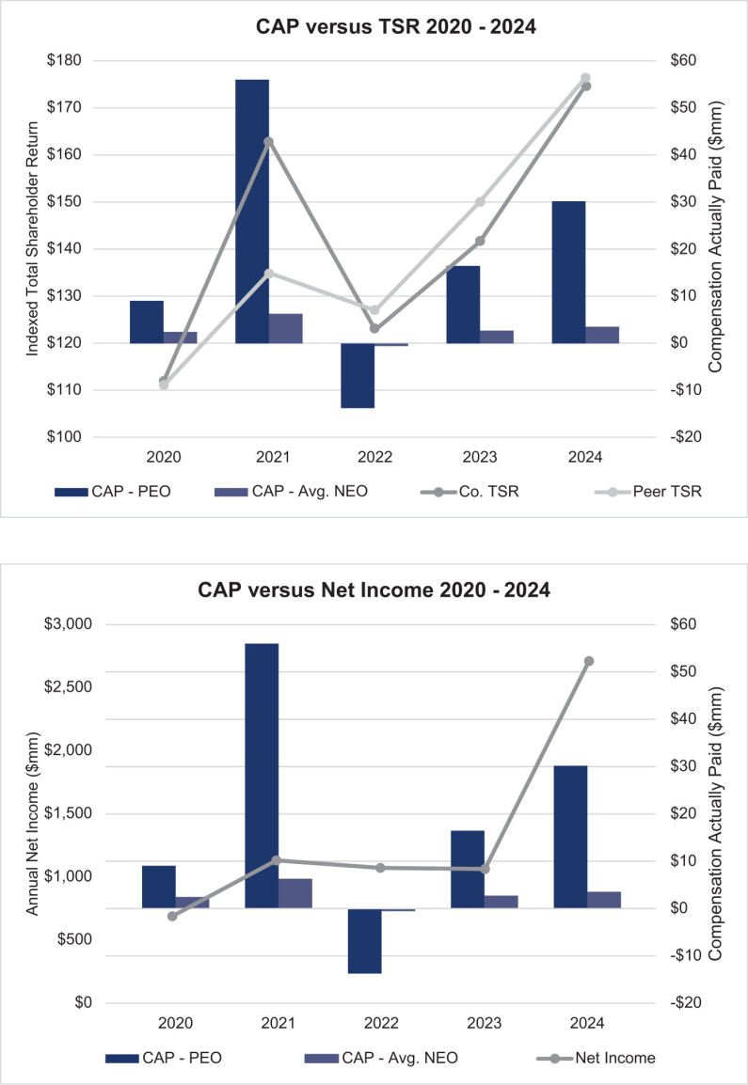

DOVER CORPORATION – 2025 Proxy Statement 77

Table of Contents

EXECUTIVE COMPENSATION TABLES
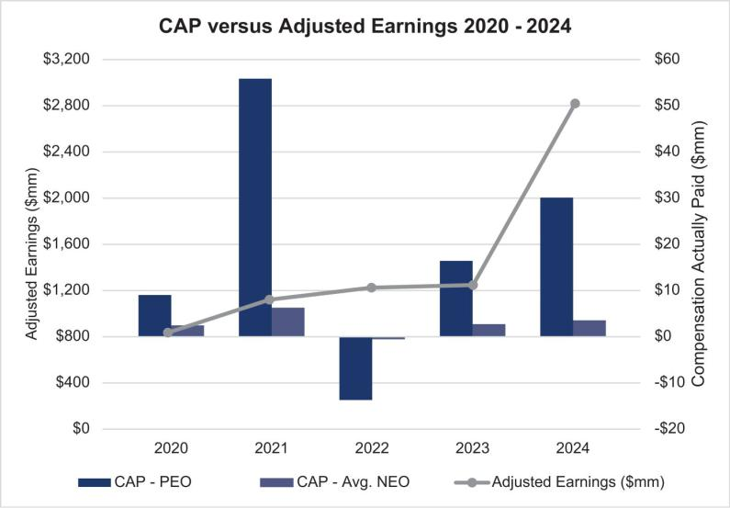

2024 Most Important Performance Measure

In addition to TSR, which is already included in the PVP table, we believe the following measure is the most important financial performance measure used to link compensation actually paid to the NEOs to Company performance.

Adjusted Earnings

DOVER CORPORATION – 2025 Proxy Statement 78

Table of Contents

Proposal 3 — Advisory Resolution to Approve Named Executive Officer Compensation

Each year, we offer our shareholders an opportunity to vote to approve, on an advisory and nonbinding basis, the compensation of our NEOs as disclosed in this Proxy Statement in accordance with Section 14A of the Exchange Act.

We are asking our shareholders to indicate their support for our NEO compensation as described in this Proxy Statement. This proposal, commonly known as a “Say on Pay” proposal, gives our shareholders the opportunity to express their views on our NEOs’ compensation. We believe that our compensation programs are well designed and reinforce our strategic focus on continued revenue and profit growth.

Our Board has a strong history of engaging with shareholders and soliciting feedback on a range of topics, including our executive compensation program. Historically, our program has received strong shareholder support as expressed during our one-on-one engagement discussions with shareholders and through our Say on Pay vote levels. At each of our 2024 and 2023 annual meetings, approximately 94% of the voting shareholders approved the compensation of the NEOs. The Compensation Committee will continue to consider feedback from shareholders, as well as the results from future shareholder advisory votes, in its ongoing evaluation of executive compensation programs and practices at Dover.

This vote is not intended to address any specific item of compensation but rather the overall compensation of our NEOs and the philosophy, policies and practices described in this Proxy Statement. Accordingly, we ask our shareholders to vote “FOR” the following resolution at the Annual Meeting:

“RESOLVED, that Dover’s shareholders approve, on an advisory basis, the compensation of the named executive officers, as disclosed in Dover’s Proxy Statement for the 2025 Annual Meeting of Shareholders pursuant to the compensation disclosure rules of the Securities and Exchange Commission, including the Compensation Discussion and Analysis, the Summary Compensation Table and the other related tables and disclosures.”

The Say on Pay vote is advisory and therefore not binding on Dover, our Compensation Committee or our Board. Our Board and our Compensation Committee value the opinions of our shareholders and, to the extent there is any significant vote against the NEO compensation as disclosed in this Proxy Statement, we will consider our shareholders’ concerns and the Compensation Committee will evaluate whether any actions are necessary to address those concerns.

THE BOARD RECOMMENDS A VOTE “FOR” THE APPROVAL OF THE COMPENSATION OF

OUR NEOs, AS DISCLOSED IN THIS PROXY STATEMENT.

DOVER CORPORATION – 2025 Proxy Statement 79

Table of Contents

Proposal 4 — Shareholder Proposal Requesting an Independent Board Chair

John Chevedden, 2215 Nelson Avenue, No. 205, Redondo Beach, CA 90278, beneficial owner of no fewer than 50 shares of Dover’s common stock, has given notice that he intends to present a proposal for consideration at the Annual Meeting. In accordance with SEC rules, John Chevedden’s proposed resolution and supporting statement are printed verbatim below. The Board accepts no responsibility for the content or accuracy of the proposal and the supporting statement.

Proposal 4 – Independent Board Chairman
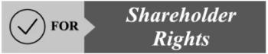

Shareholders request that the Board of Directors adopt an enduring policy, and amend the governing documents as necessary in order that 2 separate people hold the office of the Chairman and the office of the CEO as follows:

Selection of the Chairman of the Board the Board requires the separation of the offices of the Chairman of the Board and the Chief Executive Officer.

Whenever possible, the Chairman of the Board shall be an Independent Director.

The Board has the discretion to select a Temporary Chairman of the Board who is not an Independent Director to serve while the Board is seeking an Independent Chairman of the Board on an accelerated basis. This policy could be phased in when there is a contract renewal for our current CEO or for the next CEO transition.

A lead director is no substitute for an independent board chairman. A lead director cannot call a special shareholder meeting and cannot even call a special meeting of the board. A lead director can delegate most of his lead director duties to others and then simply rubber-stamp it. There is no way shareholders can be sure of what goes on.

With the current CEO serving as Chair this means giving up a substantial check and balance safeguard that can only occur with an independent Board Chairman.

Please vote yes:

Independent Board Chairman - Proposal 4

DOVER CORPORATION – 2025 Proxy Statement 80

Table of Contents

PROPOSAL 4 — SHAREHOLDER PROPOSAL REQUESTING AN INDEPENDENT BOARD CHAIR

Opposition Statement of the Board of Directors

THE BOARD OF DIRECTORS RECOMMENDS A VOTE “AGAINST” THE PROPOSAL FOR THE FOLLOWING REASONS:

The Board is committed to strong corporate governance and responsiveness to Dover’s shareholders and believes in maintaining policies and practices that serve the best interests of all shareholders. After careful consideration, the Board has determined that the proposal is not in the best interests of Dover and its shareholders. The Board believes it is critically important to maintain the flexibility to implement the leadership structure best suited to meet the needs of Dover and its shareholders at any given time. The Board does not believe that adopting a policy to separate the roles of Chairman and CEO is necessary or that such a mandatory separation would be in the best interests of Dover and its shareholders.

A flexible leadership structure is the most effective for Dover and our shareholders.

The Board considers it critically important to maintain the flexibility to select the leadership structure best suited to meet the needs of Dover and our shareholders at any given time. Currently, our Corporate Governance Guidelines provide the Board with the flexibility to determine the optimal leadership structure, including separating the positions of Chair and CEO if circumstances warrant. In the event the Chair is not an independent director, the independent directors will appoint an independent director as Lead Independent Director. The Board generally will assess and review its leadership structure from time to time.

The Board’s independent directors, with their diverse backgrounds and multi-industry experience, have deep knowledge about the company, our industry, and the functioning of the Board. Therefore, they are best positioned to evaluate the Board’s optimal leadership structure. The Board believes the leadership structure best suited to meet the needs of Dover and our shareholders should be based on the particular circumstances and challenges confronting the Board and the company at any given time, as well as the individual skills and experiences that may be required for an effective Chair. Given the dynamic and competitive environment in which we operate, the Board believes that the right leadership structure may vary as circumstances warrant, and it does not view any one particular Board leadership structure as preferred.

In early 2024, the Board unanimously appointed Richard J. Tobin, our President and CEO, as Board Chair. The Board’s decision to combine the roles of Chair and CEO under Mr. Tobin reflects the Board’s strong belief that he has demonstrated the leadership and strategic vision necessary to lead the Board and the Company. The Board believes that this leadership structure promotes efficient Board functioning, fosters a constructive and cooperative relationship between the Board and senior management and, together with an experienced Lead Independent Director, is the appropriate leadership structure for Dover at this time.

Our Lead Independent Director provides strong, independent leadership.

In connection with the Board’s decision to appoint Mr. Tobin as Chair, the Board amended Dover’s Corporate Governance Guidelines to provide that whenever the Board Chair is not an independent director, the independent directors shall appoint an independent director to serve as Lead Independent Director. The independent directors appointed Michael F. Johnston, who led the Board as Chair from 2016 to 2024, as the Lead Independent director in February 2024. Mr. Johnston is not standing for re-election at the Annual Meeting, and his service as Lead Independent Director will cease at that time. The Board has appointed Keith E. Wandell as Lead Independent Director effective upon his re-election at the Annual Meeting.

In making the determination to appoint Mr. Wandell as the next Lead Independent Director, the independent directors took into consideration

Mr. Wandell’s tenure, knowledge of Dover’s business and strategy, and demonstrated independent voice in the boardroom. The Board concluded that Mr. Wandell, who has served on the Board since 2015 and who also has experience as lead independent director of another Fortune 500 company, is well positioned to provide independent leadership to the Board as it carries out its oversight responsibilities.

Dover’s Corporate Governance Guidelines set forth the significant authority and well-defined responsibilities of the Lead Independent Director, which include:

- Presiding at all meetings of the Board at which the Board Chair is not present, including executive sessions of the independent directors;

- Coordinating the activities of the independent directors, including having the authority to call meetings of the independent directors;

DOVER CORPORATION – 2025 Proxy Statement 81

Table of Contents

PROPOSAL 4 — SHAREHOLDER PROPOSAL REQUESTING AN INDEPENDENT BOARD CHAIR

- Establishing the agenda for executive sessions of the independent directors;

- In consultation with the Board Chair and senior management, establishing the agenda for each Board meeting and ensuring that information provided to the Board is timely and appropriate;

- Facilitating communications between Board members, including serving as principal liaison between the independent directors and the Board Chair;

- Consulting with the Board Chair on such other matters as are pertinent to the Board and the Company;

- If appropriate, and in coordination with executive management, being available for consultation and direct communication with significant stakeholders; and

- Performing such other duties as may be specified by the Board.

Dover’s strong shareholder rights and governance practices support independent Board oversight.

Apart from the Chairman and CEO, Mr. Tobin, the Board consists entirely of independent directors and exercises a strong, independent oversight function. This independence is further enhanced by the composition of our Audit, Compensation, Governance & Nominating and Finance Committees, which are composed entirely of independent directors.

In addition, we believe that Dover’s existing shareholder rights and exemplary corporate governance policies, including the annual election of directors, a majority vote standard in uncontested director elections, special meeting rights and proxy access, already provide a strong structure for ensuring independent Board oversight of the Company and for effectively challenging and overseeing management, including the CEO.

Our corporate governance policies are bolstered by the Board’s practices, including regular executive sessions of the independent directors, which are led by our Lead Independent Director and take place at least quarterly, to discuss matters that fall under their purview as independent directors.

Furthermore, the Board’s independent oversight is enhanced by the Board’s ongoing refreshment. Since 2021, Dover has elected four new independent directors who bring fresh and diverse perspectives to the Board.

The Board of Directors believes it is best positioned to determine its optimal leadership structure to meet the needs of Dover and its shareholders at any given time. In light of our strong corporate governance structure and majority independent Board, the Board believes that adoption of the shareholder proposal is unnecessary and not in the best interests of Dover and its shareholders.

THE BOARD RECOMMENDS A VOTE “AGAINST” THE SHAREHOLDER PROPOSAL

REQUESTING AN INDEPENDENT BOARD CHAIR.

DOVER CORPORATION – 2025 Proxy Statement 82

Table of Contents

Share Ownership Information

Security Ownership of Certain Beneficial Owners and Management

The following table sets forth certain information regarding the beneficial ownership, as of March 10, 2025 (except as otherwise stated), of our common stock by the following:

- Each director and each of our executive officers named in the Summary Compensation Table under “Executive Compensation Tables”;

- All of the directors and executive officers as a group including the NEOs; and

- Each person known to us to own beneficially more than 5% of our outstanding common stock.

The beneficial ownership set forth in the table is determined in accordance with the rules of the SEC. The percentage of beneficial ownership for directors and executive officers is based on 137,062,270 shares of common stock outstanding on March 10, 2025. Unless otherwise indicated in the footnotes below, the persons and entities named in the table have sole voting and investment power as to all shares beneficially owned.

NAME OF BENEFICIAL OWNER |  |  | Number of
 |  |  | Shares(1) | Percentage(1)
DIRECTORS (EXCEPT MR. TOBIN):
 |  | DEBORAH L. DEHAAS (2) | 3,987 | *
 |  | H. JOHN GILBERTSON, JR. | 7,093 | *
 |  | KRISTIANE C. GRAHAM (3) | 215,663 | *
 |  | MARC A. HOWZE (4) | 1,062 | *
 |  | MICHAEL F. JOHNSTON (5) | 23,407 | *
 |  | MICHAEL MANLEY (6) | 1,932 | *
 |  | DANITA K. OSTLING | 1,362
 |  | ERIC A. SPIEGEL (7) | 10,959 | *
 |  | KEITH E. WANDELL | 8,664 | *
NEOS:
 |  | RICHARD J. TOBIN (8) | 1,001,822 | *
 |  | BRAD M. CEREPAK (9) | 271,415 | *
 |  | IVONNE M. CABRERA (10) | 183,214 | *
 |  | GIRISH JUNEJA (11) | 55,760 | *
 |  | JEFFREY C. YEHLE(12) | 98 | *
 |  | KIMBERLY K. BORS (13) | 38,416 | *
DIRECTORS AND EXECUTIVE OFFICERS AS A GROUP (16 PERSONS) (14) |  |  | 1,596,515 | 1.2%
5% BENEFICIAL OWNERS:
 |  | BLACKROCK, INC. (15) |  | 7.1%
 |  | JPMORGAN CHASE & CO. (16) |  | 7.2%
 |  | THE VANGUARD GROUP (17) |  | 11.8%

- Less than one percent.

DOVER CORPORATION – 2025 Proxy Statement 83

Table of Contents

SHARE OWNERSHIP INFORMATION

- In computing the number of shares beneficially owned by an executive officer and the percentage ownership of such executive officers, we have included (i) shares of common stock subject to stock-settled appreciation rights (“SSARs”) held by that person that are currently exercisable or exercisable within 60 days of March 10, 2025 and (ii) shares of common stock subject to restricted stock units that are scheduled to vest within 60 days of March 10, 2025, including shares to be withheld of tax purposes. Such shares, however, are not deemed to be outstanding for purposes of computing the percentage ownership of any other person. Information about shares held through Dover’s 401(k) plan is as of March 10, 2025; fractional shares held in 401(k) accounts have been rounded down. In computing the number of shares beneficially owned by a director and the percentage ownership of such director, we have included shares of common stock subject to deferred stock units which become payable upon the director’s termination of service. Such shares, however, are not deemed to be outstanding for purposes of computing the percentage ownership of any other person.

- Reflects 3,987 deferred stock units.

- Includes 17,347 deferred stock units and 29,262 shares held by a charitable foundation of which Ms. Graham is a director.

- Reflects 1,062 deferred stock units.

- Includes 19,407 deferred stock units.

- Reflects 1,932 deferred stock units.

- Includes 8,594 deferred stock units.

- Includes 3,126 deferred stock units, 736,520 shares in respect of vested SSARs, 12,250 shares in respect of restricted stock units scheduled to vest on March 15, 2025 and 548 shares held in our 401(k) plan.

- Reflects direct holdings as of January 31, 2025, the last day on which he served as an executive officer; also includes 266,941 shares in respect of vested SSARs, 2,693 shares in respect of restricted stock units scheduled to vest on March 15, 2025 and 4,474 shares held in our 401(k) plan.

- Includes 147,492 shares in respect of vested SSARs, 1,267 shares in respect of restricted stock units scheduled to vest on March 15, 2025 and 2,097 shares held in our 401(k) plan.

- Includes 46,518 shares in respect of vested SSARs, 950 shares in respect of restricted stock units scheduled to vest on March 15, 2025 and 609 shares held in our 401(k) plan.

- Reflects 98 shares held in our 401(k) plan.

- Reflects direct holdings as of July 8, 2024, the last day on which she served as an executive officer of the Company;, also includes 20,974 shares in respect of vested SSARs and 774 shares in respect of restricted stock units scheduled to vest on March 15, 2025.

- Excludes shares of Mr. Cerepak and Ms. Bors; includes 55,455 deferred stock units, 1,002,710 shares in respect of vested SSARs, 19,698 shares in respect of restricted stock units scheduled to vest on March 15, 2025 and 5,876 shares held in our 401(k) plan.

- Number of shares beneficially owned and percentage ownership based on information contained in a Schedule 13G/A filed with the SEC on January 26, 2024 by BlackRock, Inc. with respect to beneficial ownership of Dover common stock as of December 31, 2023. BlackRock reported sole voting power with regard to 8,894,175 of the shares and sole dispositive power with regard to 9,869,911 of such shares. BlackRock, Inc.’s offices are located at 50 Hudson Yards, New York, NY 10001.

- Number of shares beneficially owned and percentage ownership based on information contained in a Schedule 13G/A filed with the SEC on October 10, 2024 by JPMorgan Chase & Co. with respect to beneficial ownership of Dover common stock as of September 30,2024. JPMorgan Chase & Co. reported sole voting power with regard to 8,776,999 of the shares, shared voting power with regard to 33,049 of the shares, sole dispositive power with regard to 9,985,347 of the shares and shared dispositive power with regard to 36,901 of the shares. JPMorgan Chase & Co.’s address is 383 Madison Avenue, New York, NY 100179.

- Number of shares beneficially owned and percentage ownership based on information contained in a Schedule 13G/A filed with the SEC on February 13, 2024 by The Vanguard Group with respect to beneficial ownership of Dover common stock as of December 31, 2023. The Vanguard Group reported sole voting power with regard to none of the shares, shared voting power with regard to 176,131 of the shares, sole dispositive power with regard to 15,904,015 of the shares and shared dispositive power with regard to 592,957 of the shares. The Vanguard Group’s address is 100 Vanguard Blvd., Malvern, PA 19355.

DOVER CORPORATION – 2025 Proxy Statement 84

Table of Contents

SHARE OWNERSHIP INFORMATION

Stock Ownership Guidelines

Our Board has adopted a policy that directors are expected to hold at any time a number of shares at least equal to the aggregate number of shares they received as the stock portion of their annual retainer during the past five years, net of an assumed 30% tax rate.

Executive officers are expected to hold a number of shares with a value at least equal to a multiple of their annual salary. For a discussion of the executive officer share ownership guidelines, see “Compensation Discussion and Analysis — Other Elements of Compensation” on page 56.

DOVER CORPORATION – 2025 Proxy Statement 85

Table of Contents

General Information About the Annual Meeting

We are providing this Proxy Statement to our shareholders in connection with the solicitation of proxies by the Board for use at the Annual Meeting. We are mailing this Notice of Annual Meeting and Proxy Statement beginning on or about March 20, 2025.

Record Date

The record date for determining shareholders eligible to vote at the Annual Meeting is March 10, 2025. As of the close of business on that date, we had outstanding 137,062,270 shares of common stock. Each share of common stock is entitled to one vote on each matter.

Electronic Delivery of Proxy Materials

As permitted under SEC rules, we are making this Proxy Statement and our Annual Report to Shareholders (which includes our Annual Report on Form 10-K for the year ended December 31, 2024) available to shareholders electronically via the internet. We believe electronic delivery expedites receipt of our proxy materials by shareholders, while lowering the costs and reducing the environmental impact of the Annual Meeting. If you receive a notice of internet availability of proxy materials by mail, you will not receive a printed copy of the proxy materials by mail unless you specifically request them. Instead, the notice of internet availability will provide instructions as to how you may review the proxy materials and submit your voting instructions over the internet. If you receive the notice by mail and would like to receive a printed copy of the proxy materials, you should follow the instructions in the notice of internet availability for requesting a printed copy. In addition, the proxy card contains instructions for electing to receive proxy materials over the internet or by mail in future years.

Shareholders of Record; Beneficial Owners

Most holders of our common stock hold their shares beneficially through a broker, bank or other nominee rather than of record directly in their own name.

As summarized below, there are some differences in the way to vote shares held of record and those owned beneficially.

If your shares are registered directly in your name with our transfer agent, you are considered the shareholder of record of those shares, and the notice of internet availability or proxy materials are being sent directly to you. As a shareholder of record, you have the right to grant your voting proxy directly to the persons named as proxy holders or to vote in person at the Annual Meeting. If you received or requested printed copies of the proxy materials, Dover has enclosed a proxy card for you to use. You may also submit your proxy on the internet or by telephone as described in the proxy card.

If your shares are held in a brokerage account or by a bank or other nominee, you are considered the beneficial owner of the shares held in “street name,” and these proxy materials are being forwarded to you by your broker or nominee who is considered the shareholder of record of those shares. As the beneficial owner, you generally have the right to direct your broker on how to vote and are also invited to attend the Annual Meeting. However, since you are not the shareholder of record, you may not vote those shares in person at the Annual Meeting unless you have a proxy, executed in your favor, from the holder of record of your shares. Your broker or nominee has enclosed a voting instruction card for you to use in directing your broker or nominee as to how to vote your shares. We strongly encourage you to instruct your broker or nominee how you wish to vote.

Vote Required; Abstentions and Broker Non-Votes; Quorum

For Proposal 1, a majority of the votes cast at the Annual Meeting is required to elect each of the directors. This means that the number of votes cast “FOR” a director must exceed the number of votes cast “AGAINST” that director in order for that director to be elected. Our organizational documents do not provide for cumulative voting.

Proposal 2 will require the affirmative vote of at least a majority of shares present in person or represented by proxy and entitled to vote thereon.

Proposal 3 is a nonbinding, advisory resolution so its ultimate adoption is at the discretion of the Board. The affirmative vote of a majority of shares present in person or by proxy and entitled to vote at the Annual Meeting will be deemed to be approval by the shareholders of Proposal 3.

Proposal 4 is a nonbinding, advisory resolution so its ultimate adoption is at the discretion of the Board. The affirmative vote of a majority of shares present in person or by proxy and entitled to vote at the Annual Meeting will be deemed to be approval by the shareholders of Proposal 4.

DOVER CORPORATION – 2025 Proxy Statement 86

Table of Contents

GENERAL INFORMATION ABOUT THE ANNUAL MEETING

If you are a shareholder of record and you sign and return your proxy card or vote electronically without making any specific selection, then your shares will be voted FOR all director nominees listed in Proposal 1, and FOR Proposals 2 and 3, and AGAINST Proposal 4.

If you specify that you wish to “ABSTAIN” from voting on an item, then your shares will not be voted on that particular item. Abstentions will not affect the outcome of the vote on Proposal 1. However, they will have the same effect as a vote against Proposals 2, 3, and 4.

If you are a beneficial owner and hold your shares through a broker or other nominee and do not provide your broker or nominee with voting instructions, the broker or nominee will have discretionary authority to vote your shares on routine matters only and will not vote your shares on non-routine matters. This is generally referred to as a “broker non-vote.” Only Proposal 2 will be considered a routine matter for the Annual Meeting. Accordingly, a broker or other nominee will not be able to vote on Proposals 1, 3, and 4 without voting instructions. Broker non-votes will not affect the outcome of the vote on Proposals 1 but will have the same effect as a vote against Proposals 3 and 4.

For purposes of the Annual Meeting, there will be a quorum if the holders of a majority of the outstanding shares of our common stock entitled to vote at the Annual Meeting are present in person or represented by proxy. Abstentions and broker non-votes will be counted for purposes of determining if a quorum is present.

Voting Procedures

If you are a shareholder of record, you may vote in person at the Annual Meeting or submit your proxy or voting instruction form over the internet, by telephone or by mail by following the instructions provided in our notice of internet availability, in the proxy materials or in the voting instruction form. If you hold your shares beneficially in “street name” through a broker or other nominee, you must follow the instructions provided by your broker or nominee to vote your shares.

Revoking Your Proxy/Changing Your Voting Instructions

If you are a shareholder of record, whether you give your proxy over the internet, by telephone or by mail, you may revoke it at any time before it is exercised. You may submit a new proxy by using the internet or the telephone or by mailing a new proxy card bearing a later date so long as it is received before the Annual Meeting. You may also revoke your proxy by attending the Annual Meeting and voting in person, although attendance at the Annual Meeting will not, by itself, revoke your proxy. If you hold your shares beneficially in “street name” through a broker or other nominee, you must follow the instructions provided by your broker or nominee as to how you may change your voting instructions.

Shareholders Sharing the Same Address

SEC rules permit us to deliver one copy of the Proxy Statement or a notice of internet availability of the Proxy Statement to multiple shareholders of record who share the same address and have the same last name, unless we have received contrary instructions from one or more of such shareholders. This delivery method, called “householding,” reduces our printing and mailing costs. Shareholders who participate in householding will continue to receive or have internet access to separate proxy cards.

If you are a shareholder of record subject to householding and wish to receive a separate copy of the Proxy Statement or notice of internet availability of the proxy materials, now or in the future, at the same address or if you are currently receiving multiple copies of such materials at the same address and wish to receive only a single copy, please write to or call the Corporate Secretary, Dover Corporation, 3005 Highland Parkway, Downers Grove, Illinois 60515, telephone: (630) 541-1540.

Beneficial owners sharing an address who are currently receiving multiple copies of the proxy materials or notice of internet availability of the proxy materials and wish to receive only a single copy in the future, or who currently receive a single copy and wish to receive separate copies in the future, should contact their bank, broker or other holder of record to request that only a single copy or separate copies, as the case may be, be delivered to all shareholders at the shared address in the future.

Proxy Solicitation Costs

We will pay the reasonable and actual costs of printing, mailing and soliciting proxies, but we will not pay a fee to any of our officers or employees or to officers or employees of any of our subsidiaries as compensation for soliciting proxies. We have retained Sodali & Co. LLC to solicit brokerage houses and other custodians, nominees or fiduciaries, and to send proxies and proxy materials to the beneficial owners of such shares, for a fee of approximately $13,000 plus expenses.

DOVER CORPORATION – 2025 Proxy Statement 87

Table of Contents

GENERAL INFORMATION ABOUT THE ANNUAL MEETING

Other Matters

Our Board and management have not received notice of, and are not aware of, any business to come before the Annual Meeting other than the agenda items referred to in this Proxy Statement. If, however, any other business properly comes before the meeting, the persons named as proxies will use their best judgment in voting the proxies.

Shareholder Proposals and Director Nominations for 2026 Annual Meeting

In order for shareholder proposals to be included in our proxy statement for the Annual Meeting of Shareholders to be held in 2026 (the “2026 Annual Meeting”), they must be received by our Corporate Secretary at our principal executive offices, 3005 Highland Parkway, Downers Grove, Illinois, 60515, no later than the close of business on November 20, 2025.

In 2016, we adopted a proxy access right to permit a shareholder or a group of up to 20 shareholders owning 3% or more of our outstanding common stock continuously for at least three years to nominate and include in our proxy materials director candidates constituting up to the greater of two individuals or 20% of the Board, provided that the shareholder(s) and the nominee(s) satisfy the requirements specified in our by-laws. In order to be timely, notice of proxy access director nominees must be received by our Corporate Secretary at our principal executive offices at the address above no earlier than the open of business on October 21, 2025 and no later than the close of business on November 20, 2025 being, respectively, 150 days and 120 days prior to the first anniversary of the date we first distributed this proxy statement.

All other shareholder nominations and proposals, in order to be voted on at the 2026 Annual Meeting, including any notice of director nominees submitted under the universal proxy card voting rules, must be received by us no earlier than the open of business on January 2, 2026, and no later than the close of business on February 1, 2026 being, respectively, 120 days and 90 days prior to the date of the first anniversary of the 2025 Annual Meeting.

Where You Can Find Additional Information

Our website is located at www.dovercorporation.com. You can view additional information on our website, such as:

- Charters of our Board committees

- Corporate Governance Guidelines

- Code of Conduct

- Related Person Transactions Policy

- Standards for Director Independence

- Other governance materials and reports that we file with the SEC. Copies of these documents also may be obtained free of charge by writing or calling the Corporate Secretary, Dover Corporation, 3005 Highland Parkway, Downers Grove, Illinois 60515, telephone: (630) 541-1540.

All Dover Corporation website addresses contained in this proxy statement are intended to be inactive, textual references only. The information on, or accessible through, any such website identified in this proxy statement is not a part of, and is not incorporated by reference into, this proxy statement.

Caution Concerning Forward-Looking Statements

This proxy statement contains forward-looking statements that are inherently subject to uncertainties and risks. We caution investors to be guided in their analysis of Dover by referring to the documents we file with the SEC, including our Annual Report on Form 10-K for 2024, for a list of factors that could cause our results to differ from those anticipated in any such forward-looking statements.

DOVER CORPORATION – 2025 Proxy Statement 88

Table of Contents

GENERAL INFORMATION ABOUT THE ANNUAL MEETING

Non-GAAP Disclosures

In an effort to provide investors with additional information regarding our results as determined by accounting principles generally accepted in the United States of America (“GAAP”), we also disclose non-GAAP information that we believe provides useful information to investors. Adjusted net earnings from continuing operations, adjusted diluted earnings per share from continuing operations, total segment earnings, total segment earnings margin, free cash flow, free cash flow as a percentage of revenue, and organic revenue growth are not financial measures under GAAP and should not be considered as a substitute for earnings from continuing operations, diluted net earnings per share from continuing operations, cash flows from operating activities, or revenue as determined in accordance with GAAP, and they may not be comparable to similarly titled measures reported by other companies.

Adjusted Diluted Earnings per Share from Continuing Operations

(in millions, except per share data) |  | 2024 |  | 2023 |  | 2022 |  | 2021
Adjusted earnings from continuing operations:
Earnings from continuing operations | $ | 1,400 | $ | 944 | $ | 990 | $ | 1,065
Purchase accounting expenses, pre-tax ¹ |  | 186 |  | 159 |  | 174 |  | 138
Purchase accounting expenses, tax impact ² |  | (41) |  | (35) |  | (40) |  | (34)
Restructuring and other costs, pre-tax ³ |  | 85 |  | 63 |  | 36 |  | 37
Restructuring and other costs, tax impact ² |  | (18) |  | (13) |  | (8) |  | (7)
Disposition costs, pre-tax ⁴ |  | — |  | 1 |  | — |  | —
Disposition costs, tax impact ² |  | — |  | — |  | — |  | —
Gain on dispositions, pre-tax ⁵ |  | (598) |  | — |  | — |  | (206)
Gain on dispositions, tax-impact ² |  | 135 |  | — |  | — |  | 53
Tax Cuts and Jobs Act ⁶ |  | — |  | — |  | (23) |  | —
Adjusted earnings from continuing operations | $ | 1,150 | $ | 1,118 | $ | 1,130 | $ | 1,046
Diluted average shares outstanding
Diluted average shares outstanding |  | 139 |  | 141 |  | 144 |  | 145
Adjusted diluted earnings per share from continuing operations*:
Diluted earnings per share from continuing operations | $ | 10.09 | $ | 6.71 | $ | 6.89 | $ | 7.33
Purchase accounting expenses, pre-tax ¹ |  | 1.34 |  | 1.13 |  | 1.21 |  | 0.95
Purchase accounting expenses, tax impact ² |  | (0.30) |  | (0.25) |  | (0.28) |  | (0.23)
Restructuring and other costs, pre-tax ³ |  | 0.61 |  | 0.45 |  | 0.25 |  | 0.26
Restructuring and other costs, tax impact ² |  | (0.13) |  | (0.09) |  | (0.05) |  | (0.05)
Disposition costs, pre-tax ⁴ |  | — |  | 0.01 |  | — |  | —
Disposition costs, tax impact ² |  | — |  | — |  | — |  | —
Gain on dispositions, pre-tax ⁵ |  | (4.31) |  | — |  | — |  | (1.42)
Gain on dispositions, tax-impact ² |  | 0.98 |  | — |  | — |  | 0.37
Tax Cuts and Jobs Act ⁶ |  | — |  | — |  | (0.16) |  | —
Adjusted diluted earnings per share from continuing operations
 | $ | 8.29 | $ | 7.95 | $ | 7.87 | $ | 7.20

- Purchase accounting expenses are primarily comprised of amortization of acquired intangible assets and charges related to fair value step-ups for acquired inventory sold during the period. FY 2022 includes $20.0 million of amortization of inventory step-up primarily related to the Q4 2021 acquisitions within our Clean Energy & Fueling segment.
- Adjustments were tax effected using the statutory tax rates in the applicable jurisdictions or the effective tax rate, where applicable, for each period.

DOVER CORPORATION – 2025 Proxy Statement 89

Table of Contents

GENERAL INFORMATION ABOUT THE ANNUAL MEETING

- Restructuring and other costs relate to actions taken for headcount reductions, facility consolidations and site closures, product line exits, and other asset charges. FY 2024 includes $3.4 million and FY 2023 includes $3.3 million of non-cash asset impairment charges for our Climate & Sustainability Technologies segment. FY 2022 includes $5.5 million of non-cash foreign currency translation losses reclassified to earnings and $2.1 million related to the write-off of assets due to an exit from certain Latin America countries for our Climate & Sustainability Technologies segment. FY 2021 includes a $12.1 million other-than-temporary impairment charge related to an equity method investment and a $6.1 million write-off of assets incurred in connection with an exit from certain Latin America countries for our Climate & Sustainability Technologies segment. Additionally, FY 2021 includes a $9.1 million payment received for previously incurred restructuring costs related to a product line exit in our Engineered Products segment.

- FY 2023 disposition costs relate to the sale of De-Sta-Co in our Engineered Products segment

- Gain on dispositions represents a gain of $530.3 million recorded in FY 2024 on the disposition of De-Sta-Co in the Engineered Products segment and a gain of $67.5 million from a minority-owned equity method investment in the Climate & Sustainability Technologies segment. This includes post-closing adjustments recorded throughout the year. FY 2021 represents gain on dispositions of $181.6 million and $24.7 million due to the sales of Unified Brands in our Climate & Sustainability Technologies segment and Race Winning Brands equity method investment in our Engineered Products segment, respectively.
- FY 2022 represent a reduction to income taxes previously recorded related to the Tax Cuts and Jobs Act.

- Per share data and totals may be impacted by rounding.

Total Segment Earnings Margin

(in thousands) | 2024 | 2023 | 2022 | 2021
Earnings from continuing operations | 1,400 | 944 | 990 | 1,065
Provision for income taxes | 357 | 179 | 200 | 260
Earnings before provision for income taxes | 1,757 | 1,123 | 1,190 | 1,325
Interest income | (37) | (13) | (4) | (4)
Interest expense | 131 | 131 | 116 | 106
Corporate expense / other ¹ | 156 | 151 | 136 | 156
Disposition costs | — | 1 | — | —
Gain on dispositions ² | (598) | — | — | (206)
Restructuring and other costs ³ | 85 | 63 | 36 | 37
Purchase accounting expenses ⁴ | 186 | 159 | 174 | 138
Total segment earnings | 1,680 | 1,615 | 1,649 | 1,552
Total segment earnings margin | 21.7% | 21.0% | 21.0% | 21.1%

- Certain expenses are maintained at the corporate level and not allocated to the segments. These expenses include executive and functional compensation costs, non-service pension costs, non-operating insurance expenses, shared business services overhead costs, deal-related expenses and various administrative expenses relating to the corporate headquarters.
- Gain on dispositions includes working capital adjustments related to dispositions.

- Restructuring and other costs relate to actions taken for headcount reductions, facility consolidations and site closures, exit costs, and other asset charges.
- Purchase accounting expenses are primarily comprised of amortization of intangible assets and charges related to fair value step-ups for acquired inventory sold during the period.

DOVER CORPORATION – 2025 Proxy Statement 90

Table of Contents

GENERAL INFORMATION ABOUT THE ANNUAL MEETING

Free Cash Flow

Free cash flow represents net cash provided by operating activities minus capital expenditures as follows:

(in thousands) | 2024 | 2023 | 2022
Cash flow from operating activities ¹ | $1,087,833 | $1,219,546 | $ 746,754
Less: Capital expenditures | (167,533) | (183,406) | (211,082)
Free cash flow | 920,300 | 1,036,140 | 535,672
Free cash flow as a percentage of revenue | 11.9% | 13.5% | 6.8%

- FY 2024 includes income tax payments of $103.4 million and $20.4 million, related to the gain on disposition of De-Sta-Co and a minority owned equity method investment, respectively.

Organic Revenue Growth Factor

 | 2024
 | Full Year
Organic | —%
Acquisitions | 3.0%
Dispositions | (2.0)%
Currency translation | (0.2)%
Total | 0.8%

Non-GAAP Disclosures

Adjusted earnings from continuing operations represents earnings from continuing operations adjusted for the effect of purchase accounting expenses, restructuring and other costs/benefits, disposition costs, gain on dispositions and Tax Cuts and Jobs Act. Purchase accounting expenses are primarily comprised of amortization of intangible assets. We exclude after-tax purchase accounting expenses because the amount and timing of such charges are significantly impacted by the timing, size, number and nature of the acquisitions the Company consummates. While we have a history of acquisition activity, our acquisitions do not happen in a predictive cycle. Exclusion of purchase accounting expenses facilitates more consistent comparisons of operating results over time. We believe it is important to understand that such intangible assets were recorded as part of purchase accounting and contribute to revenue generation. We exclude the other items because they occur for reasons that may be unrelated to the Company’s commercial performance during the period and/or management believes they are not indicative of the Company’s ongoing operating costs or gains in a given period.

Adjusted diluted earnings per share from continuing operations or adjusted earnings per share from continuing operations represents diluted earnings from continuing operations per share adjusted for the effect of purchase accounting expenses, restructuring and other costs/benefits, disposition costs and Tax Cuts and Jobs Act.

Total segment earnings is defined as the sum of earnings before purchase accounting expenses, restructuring and other costs/benefits, disposition costs, gain on dispositions, corporate expenses/other, interest expense, interest income and provision for income taxes for all segments. Total segment earnings margin is defined as total segment earnings divided by revenue.

Management believes the non-GAAP measures above are useful to investors to better understand the Company’s ongoing profitability as they better reflect the Company’s core operating results, offer more transparency and facilitate easier comparability to prior and future periods and to its peers.

Free cash flow represents net cash provided by operating activities minus capital expenditures. Free cash flow as a percentage of revenue equals free cash flow divided by revenue. Management believes that free cash flow and free cash flow ratios are important measures of liquidity because they provide management and investors a measurement of cash generated from operations that is available for mandatory payment obligations and investment opportunities, such as funding acquisitions, paying dividends, repaying debt and repurchasing our common stock.

Management believes that reporting organic revenue growth, which excludes the impact of foreign currency exchange rates and the impact of acquisitions and dispositions, provides a useful comparison of our revenue performance and trends between periods.

DOVER CORPORATION – 2025 Proxy Statement 91

Table of Contents



DOVER CORPORATION
3005 HIGHLAND PARKWAY
DOWNERS GROVE, IL 60515



VOTE BY INTERNET - www.proxyvote.com or scan the QR Barcode above Use the Internet to transmit your voting instructions and for electronic delivery of information. Vote by 11:59 p.m. Eastern Time on May 1, 2025 for shares held directly and by 11:59 p.m. Eastern Time on April 29, 2025 for shares held in a Plan. Have your proxy card in hand when you access the website and follow the instructions to obtain your records and to create an electronic voting instruction form.

ELECTRONIC DELIVERY OF FUTURE PROXY MATERIALS

If you would like to reduce the costs incurred by our company in mailing proxy materials, you can consent to receiving all future proxy statements, proxy cards and annual reports electronically via e-mail or the Internet. To sign up for electronic delivery, please follow the instructions above to vote using the Internet and, when prompted, indicate that you agree to receive or access proxy materials electronically in future years.

VOTE BY PHONE - 1-800-690-6903

Use any touch-tone telephone to transmit your voting instructions. Vote by 11:59 p.m. Eastern Time on May 1, 2025 for shares held directly and by 11:59 p.m. Eastern Time on April 29, 2025 for shares held in a Plan. Have your proxy card in hand when you call and then follow the instructions.

VOTE BY MAIL

Mark, sign and date your proxy card and return it in the postage-paid envelope we have provided or return it to Vote Processing, c/o Broadridge, 51 Mercedes Way, Edgewood, NY 11717.

TO VOTE, MARK BLOCKS BELOW IN BLUE OR BLACK INK AS FOLLOWS:

V64071-P25596-Z89345 KEEP THIS PORTION FOR YOUR RECORDS

— — — — — — — — — — — — — — — — — — — — — — — — — — — — — — — — — — — — — — — — — — — — — — — — — — — — — —

DETACH AND RETURN THIS PORTION ONLY
THIS PROXY CARD IS VALID ONLY WHEN SIGNED AND DATED.


DOVER CORPORATION

The Board of Directors recommends a vote FOR each

director under Item 1:

1. Election of Directors. |  |  |  | For | Against | Abstain
1a. D. L. DeHaas |  |  |  | ☐ | ☐ | ☐ | The Board of Directors recommends a vote FOR Items 2 and 3:
1b. H. J. Gilbertson, Jr. |  |  |  | ☐ | ☐ | ☐ | 2. To ratify the appointment of PricewaterhouseCoopers LLP as our independent
1c. K. C. Graham |  |  |  | ☐ | ☐ | ☐ | registered public accounting firm for 2025.
1d. M. A. Howze |  |  |  | ☐ | ☐ | ☐ | 3. To approve, on an advisory basis, named executive officer compensation.
1e. M. Manley |  |  |  | ☐ | ☐ | ☐ | The Board of Directors recommends a vote | AGAINST |  | Item 4:
1f. D. K. Ostling |  |  |  | ☐ | ☐ | ☐ | 4. To consider a shareholder proposal requesting an independent board chair.
1g. E. A. Spiegel |  |  |  | ☐ | ☐ | ☐
1h. R. J. Tobin |  |  |  | ☐ | ☐ | ☐ | NOTE: Such other business as may properly come before the meeting or any
1i. K. E. Wandell |  |  |  | ☐ | ☐ | ☐ | adjournment thereof.

Please sign exactly as your name(s) appear(s) hereon. When signing as attorney, executor, administrator, or other fiduciary, please give full title as such. Joint owners should each sign personally. All holders must sign. If a corporation or partnership, please sign in full corporate or partnership name by authorized officer.

Signature [PLEASE SIGN WITHIN Date | Signature (Joint Owners) | Date
BOX]

For Against Abstain

☐ ☐ ☐

☐ ☐ ☐

For Against Abstain

☐ ☐ ☐

Table of Contents

WE ENCOURAGE YOU TO TAKE ADVANTAGE OF INTERNET OR TELEPHONE VOTING,

BOTH ARE AVAILABLE 24 HOURS A DAY, 7 DAYS A WEEK.

Internet and telephone voting are available through 11:59 PM Eastern Time

the day before the annual meeting date.

Your Internet or telephone vote authorizes the named proxies to vote these shares in the

same manner as if you marked, signed and returned your proxy card.


 | INTERNET |  | OR | TELEPHONE
 | http://www.proxyvote.com |  |  | 1-800-690-6903
Use the Internet to vote your proxy. |  |  |  | Use any touch-tone telephone to
Have your proxy card in hand when |  |  |  | vote your proxy. Have your proxy
 | you access the website. |  |  | card in hand when you call.

If you vote your proxy by Internet or telephone, you do NOT need to mail back your proxy card.

To vote by mail, sign and date your proxy card and return it in the enclosed postage-paid envelope.

Important Notice Regarding the Availability of Proxy Materials for the Annual Meeting:

The Notice and Proxy Statement and Annual Report are available at www.proxyvote.com.

— — — — — — — — — — — — — — — — — — — — — — — — — — — — — — — — — — — — — — — — — — — — — — — — — — — — — —

V64072-P25596-Z89345


PROXY

DOVER CORPORATION
PROXY SOLICITED BY BOARD OF DIRECTORS FOR ANNUAL MEETING
MAY 2, 2025

The undersigned hereby appoints Richard J. Tobin, Christopher B. Woenker, Ivonne M. Cabrera and John C. Nelson, and each of them, as the undersigned’s proxy or proxies, each with full power of substitution, to vote all shares of Common Stock of Dover Corporation which the undersigned is entitled to vote at the Annual Meeting of Shareholders to be held in Houston, TX on May 2, 2025 at 9:00 A.M., local time, and any adjournments thereof, as fully as the undersigned could if personally present, upon the proposals set forth on the reverse side hereof, revoking any proxy or proxies heretofore given. For participants in the Company’s Retirement Savings Plan, this proxy will govern the voting of stock held for the account of the undersigned in the Plan.

IMPORTANT - You have the option of voting these shares by returning the enclosed proxy card, voting via Internet or by using a toll-free telephone number above and on the reverse side. On the reverse side of this proxy card are instructions on how to vote via the Internet or by telephone. If you vote by either of these methods, your vote will be recorded as if you mailed in your proxy card. If you vote by returning this proxy card, you must sign and date this proxy on the reverse side.

THIS PROXY WILL BE VOTED IN ACCORDANCE WITH THE SPECIFICATIONS MADE ON THE REVERSE SIDE, BUT IF NO CHOICES ARE INDICATED, THIS PROXY WILL BE VOTED FOR ALL NOMINEES LISTED ON THE REVERSE SIDE AND FOR PROPOSALS 2 AND 3, AND AGAINST PROPOSAL 4.

Continued and to be signed on reverse side

