Table of Contents

UNITED STATES

SECURITIES AND EXCHANGE COMMISSION

Washington, D.C. 20549

SCHEDULE 14A

(Rule 14a-101)

INFORMATION REQUIRED IN PROXY STATEMENT

SCHEDULE 14A INFORMATION

PROXY STATEMENT PURSUANT TO SECTION 14(a) OF THE

SECURITIES EXCHANGE ACT OF 1934
(AMENDMENT NO. )

Filed by the Registrant ☒

Filed by a Party other than the Registrant ☐

Check the appropriate box:

- Preliminary Proxy Statement

- Confidential, for Use of the Commission Only (as permitted by Rule 14a-6(e)(2))

- Definitive Proxy Statement

- Definitive Additional Materials

- Soliciting Material under Section 240.14a-2.


(Name of Registrant as Specified In Its Charter)

(Name of Person(s) Filing Proxy Statement, if other than Registrant)

Payment of Filing Fee (Check the appropriate box):

- No fee required.

- Fee computed on table below per Exchange Act Rules 14a-6(i)(1) and 0-11.

  - Title of each class of securities to which transaction applies:

  - Aggregate number of securities to which transaction applies:

  - Per unit price or other underlying value of transaction computed pursuant to Exchange Act Rule 0-11 (Set forth the amount on which the filing fee is calculated and state how it was determined):

  - Proposed maximum aggregate value of transaction:

  - Total fee paid:

- Fee paid previously with preliminary materials.

- Check box if any part of the fee is offset as provided by Exchange Act Rule 0-11(a)(2) and identify the filing for which the offsetting fee was paid previously. Identify the previous filing by registration statement number, or the Form or Schedule and the date of its filing.

  - Amount Previously Paid:

  - Form, Schedule or Registration Statement No.:

  - Filing Party:

  - Date Filed:

Table of Contents
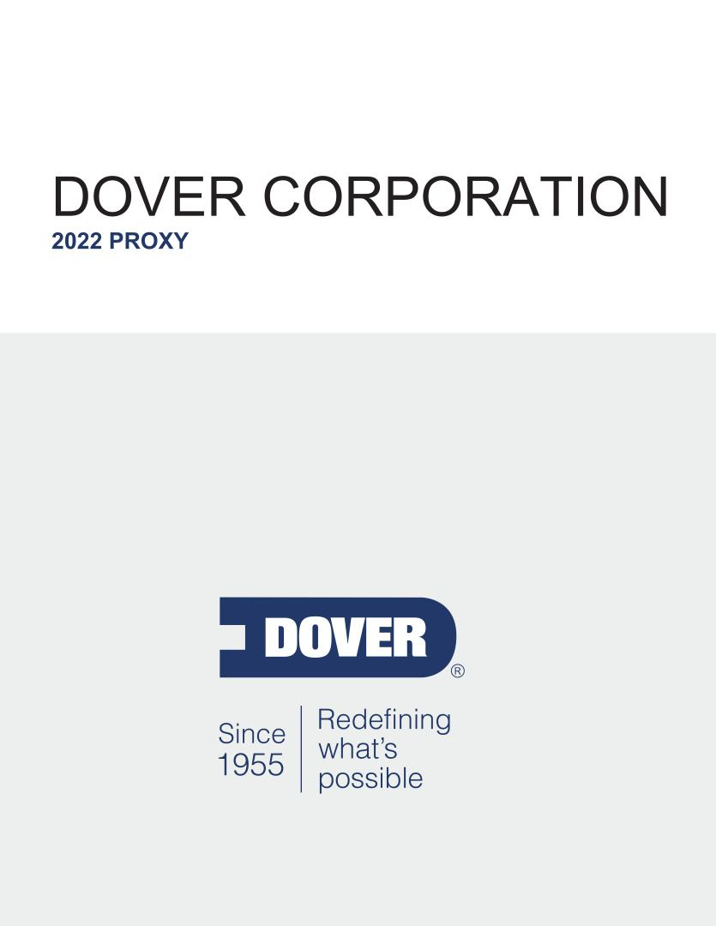

Table of Contents

Notice of 2022 Annual Meeting of Shareholders

May 6, 2022
9:00 a.m. Central Time
Dover Corporation Headquarters
3005 Highland Parkway

Downers Grove, Illinois 60515

Dear Fellow Shareholder:

You are cordially invited to attend the Annual Meeting of Shareholders (the “Annual Meeting”) of Dover Corporation (“Dover” or the “Company”) at our headquarters on May 6, 2022 at 9:00 a.m., Central Time, to be held for the following purposes:

- To elect ten directors.

- To ratify the appointment of PricewaterhouseCoopers LLP (“PwC”) as our independent registered public accounting firm for 2022.

- To approve, on an advisory basis, named executive officer (“NEO”) compensation.

- To consider a shareholder proposal regarding the right to allow shareholders to act by written consent, if properly presented.

- To consider such other business as may properly come before the Annual Meeting, including any adjournments or postponements thereof.

All holders of record at the close of business on March 9, 2022 are entitled to notice of and to vote at the Annual Meeting or any adjournments or postponements thereof. Whether or not you plan to attend the Annual Meeting, we urge you to vote your shares as soon as possible.

March 17, 2022

By authority of the Board of Directors,

Ivonne M. Cabrera
Secretary

Table of Contents

TABLE OF CONTENTS

Notice of 2022 Annual Meeting of Shareholders
Proxy Statement Summary |  |  |  |  |  |  |  |  |  |  |  |  |  |  |  |  |  |  |  |  |  |  |  |  |  |  |  |  |  |  |  |  |  | 1
 |  |  |  |  |  |  |  |  |  |  |  |  |  |  |  |  |  |  |  |  |  |  |  |  |  |  |  |  |  |  |  |  |  | 1
 | Annual Meeting Information |  |  |  |  |  |  |  |  |  |  |  |  |  |  |  |  |  |  |  |  |  |  |  |  |  |  |  |  |  |  |  |  | 1
 | Items of Business |  |  |  |  |  |  |  |  |  |  |  |  |  |  |  |  |  |  |  |  |  |  |  |  |  |  |  |  |  |  |  |  | 1
 | How to Submit Your Proxy |  |  |  |  |  |  |  |  |  |  |  |  |  |  |  |  |  |  |  |  |  |  |  |  |  |  |  |  |  |  |  |  | 1
 | Company Overview |  |  |  |  |  |  |  |  |  |  |  |  |  |  |  |  |  |  |  |  |  |  |  |  |  |  |  |  |  |  |  |  | 2
 | 2021 Performance Overview |  |  |  |  |  |  |  |  |  |  |  |  |  |  |  |  |  |  |  |  |  |  |  |  |  |  |  |  |  |  |  |  | 4
 | Governance Highlights |  |  |  |  |  |  |  |  |  |  |  |  |  |  |  |  |  |  |  |  |  |  |  |  |  |  |  |  |  |  |  |  | 7
 | Shareholder Engagement |  |  |  |  |  |  |  |  |  |  |  |  |  |  |  |  |  |  |  |  |  |  |  |  |  |  |  |  |  |  |  |  | 7
 | Executive Compensation |  |  |  |  |  |  |  |  |  |  |  |  |  |  |  |  |  |  |  |  |  |  |  |  |  |  |  |  |  |  |  |  | 8
 | Director Nominees |  |  |  |  |  |  |  |  |  |  |  |  |  |  |  |  |  |  |  |  |  |  |  |  |  |  |  |  |  |  |  |  | 9
 | Board Composition |  |  |  |  |  |  |  |  |  |  |  |  |  |  |  |  |  |  |  |  |  |  |  |  |  |  |  |  |  |  |  |  | 10
Proposal 1 — Election of Directors |  |  |  |  |  |  |  |  |  |  |  |  |  |  |  |  |  |  |  |  |  |  |  |  |  |  |  |  |  |  |  |  |  | 11
 |  |  |  |  |  |  |  |  |  |  |  |  |  |  |  |  |  |  |  |  |  |  |  |  |  |  |  |  |  |  |  |  |  | 11
 | Criteria for Director Nominees |  |  |  |  |  |  |  |  |  |  |  |  |  |  |  |  |  |  |  |  |  |  |  |  |  |  |  |  |  |  |  |  | 11
 | Director Nomination Process |  |  |  |  |  |  |  |  |  |  |  |  |  |  |  |  |  |  |  |  |  |  |  |  |  |  |  |  |  |  |  |  | 12
 | 2022 Director Nominees |  |  |  |  |  |  |  |  |  |  |  |  |  |  |  |  |  |  |  |  |  |  |  |  |  |  |  |  |  |  |  |  | 13
 |  |  |  |  |  |  |  |  |  |  |  |  |  |  |  |  |  |  |  |  |  |  |  |  |  |  |  |  |  |  |  |  |  | 23
 | Board Oversight and Governance Practices |  |  |  |  |  |  |  |  |  |  |  |  |  |  |  |  |  |  |  |  |  |  |  |  |  |  |  |  |  |  |  |  | 23
 |  |  |  |  |  |  |  |  |  |  |  |  |  |  |  |  |  |  |  |  |  |  |  |  |  |  |  |  |  |  |  |  |  | 31
 | Shareholder Engagement and History of Board Responsiveness |  |  |  |  |  |  |  |  |  |  |  |  |  |  |  |  |  |  |  |  |  |  |  |  |  |  |  |  |  |  |  |  | 31
 | Environmental, Social, and Governance Oversight (ESG) |  |  |  |  |  |  |  |  |  |  |  |  |  |  |  |  |  |  |  |  |  |  |  |  |  |  |  |  |  |  |  |  | 33
 | Directors’ Compensation |  |  |  |  |  |  |  |  |  |  |  |  |  |  |  |  |  |  |  |  |  |  |  |  |  |  |  |  |  |  |  |  | 35
Proposal 2 — Ratification of Appointment of Independent Registered Public Accounting Firm |  |  |  |  |  |  |  |  |  |  |  |  |  |  |  |  |  |  |  |  |  |  |  |  |  |  |  |  |  |  |  |  |  | 37
 | Audit Committee Report |  |  |  |  |  |  |  |  |  |  |  |  |  |  |  |  |  |  |  |  |  |  |  |  |  |  |  |  |  |  |  |  | 38
 |  |  |  |  |  |  |  |  |  |  |  |  |  |  |  |  |  |  |  |  |  |  |  |  |  |  |  |  |  |  |  |  |  | 39
 | Fees Paid to Independent Registered Public Accounting Firm |  |  |  |  |  |  |  |  |  |  |  |  |  |  |  |  |  |  |  |  |  |  |  |  |  |  |  |  |  |  |  |  | 39
 | Pre-Approval of Services Provided by Independent Registered Public Accounting Firm |  |  |  |  |  |  |  |  |  |  |  |  |  |  |  |  |  |  |  |  |  |  |  |  |  |  |  |  |  |  |  |  | 39
Compensation Discussion and Analysis |  |  |  |  |  |  |  |  |  |  |  |  |  |  |  |  |  |  |  |  |  |  |  |  |  |  |  |  |  |  |  |  |  | 40
 | Executive Summary |  |  |  |  |  |  |  |  |  |  |  |  |  |  |  |  |  |  |  |  |  |  |  |  |  |  |  |  |  |  |  |  | 40
 | Say on Pay Vote Results and Shareholder Engagement |  |  |  |  |  |  |  |  |  |  |  |  |  |  |  |  |  |  |  |  |  |  |  |  |  |  |  |  |  |  |  |  | 42
 | Dover’s Alignment with Leading Compensation Governance Practices |  |  |  |  |  |  |  |  |  |  |  |  |  |  |  |  |  |  |  |  |  |  |  |  |  |  |  |  |  |  |  |  | 43
 | Compensation Principles |  |  |  |  |  |  |  |  |  |  |  |  |  |  |  |  |  |  |  |  |  |  |  |  |  |  |  |  |  |  |  |  | 44
 | Compensation Process |  |  |  |  |  |  |  |  |  |  |  |  |  |  |  |  |  |  |  |  |  |  |  |  |  |  |  |  |  |  |  |  | 45
 | Elements of Executive Compensation |  |  |  |  |  |  |  |  |  |  |  |  |  |  |  |  |  |  |  |  |  |  |  |  |  |  |  |  |  |  |  |  | 49
 | Other Benefits |  |  |  |  |  |  |  |  |  |  |  |  |  |  |  |  |  |  |  |  |  |  |  |  |  |  |  |  |  |  |  |  | 58
 |  |  |  |  |  |  |  |  |  |  |  |  |  |  |  |  |  |  |  |  |  |  |  |  |  |  |  |  |  |  |  |  |  | 60
 | Other Elements of Compensation |  |  |  |  |  |  |  |  |  |  |  |  |  |  |  |  |  |  |  |  |  |  |  |  |  |  |  |  |  |  |  |  | 60
 |  |  |  |  |  |  |  |  |  |  |  |  |  |  |  |  |  |  |  |  |  |  |  |  |  |  |  |  |  |  |  |  |  | 61
 | Compensation Committee Report |  |  |  |  |  |  |  |  |  |  |  |  |  |  |  |  |  |  |  |  |  |  |  |  |  |  |  |  |  |  |  |  | 61
 | Executive Compensation Tables |  |  |  |  |  |  |  |  |  |  |  |  |  |  |  |  |  |  |  |  |  |  |  |  |  |  |  |  |  |  |  |  | 62
 | Summary Compensation Table |  |  |  |  |  |  |  |  |  |  |  |  |  |  |  |  |  |  |  |  |  |  |  |  |  |  |  |  |  |  |  |  | 62
 |  |  |  |  |  |  |  |  |  |  |  |  |  |  |  |  |  |  |  |  |  |  |  |  |  |  |  |  |  |  |  |  |  | 64
 | Grants of Plan-Based Awards in 2021 |  |  |  |  |  |  |  |  |  |  |  |  |  |  |  |  |  |  |  |  |  |  |  |  |  |  |  |  |  |  |  |  | 64
 |  |  |  |  |  |  |  |  |  |  |  |  |  |  |  |  |  |  |  |  |  |  |  |  |  |  |  |  |  |  |  |  |  | 66
 | Outstanding Equity Awards at Fiscal Year-End 2021 |  |  |  |  |  |  |  |  |  |  |  |  |  |  |  |  |  |  |  |  |  |  |  |  |  |  |  |  |  |  |  |  | 66
 | Option Exercises and Stock Vested in 2021 |  |  |  |  |  |  |  |  |  |  |  |  |  |  |  |  |  |  |  |  |  |  |  |  |  |  |  |  |  |  |  |  | 67
 | Pension Benefits through 2021 |  |  |  |  |  |  |  |  |  |  |  |  |  |  |  |  |  |  |  |  |  |  |  |  |  |  |  |  |  |  |  |  | 68

DOVER CORPORATION – 2022 Proxy Statement i

Table of Contents

TABLE OF CONTENTS
 | Nonqualified Deferred Compensation in 2021 |  |  |  |  |  |  |  |  | 69
 | Potential Payments upon Termination or Change in Control |  |  |  |  |  |  |  |  | 70
Proposal 3 — Advisory Resolution to Approve Named Executive Officer Compensation |  |  |  |  |  |  |  |  |  | 76
Shareholder Proposal |  |  |  |  |  |  |  |  |  | 77
 |  |  |  |  |  |  |  |  |  | 77
 | Proposal 4 – Shareholder Proposal Regarding the Right to Act by Written Consent |  |  |  |  |  |  |  |  | 77
Share Ownership Information |  |  |  |  |  |  |  |  |  | 80
 | Security Ownership of Certain Beneficial Owners and Management |  |  |  |  |  |  |  |  | 80
General Information About the Annual Meeting |  |  |  |  |  |  |  |  |  | 82

DOVER CORPORATION – 2022 Proxy Statement ii

Table of Contents


PROXY STATEMENT SUMMARY

Annual Meeting Information

Date:

May 6, 2022

Time:

9:00 a.m., Central Time

Record Date:

March 9, 2022

Location:

Dover Corporation Headquarters

3005 Highland Parkway

Downers Grove, Illinois 60515

For additional information about our Annual Meeting, please see “General Information About the Annual Meeting”. We are first mailing this Notice of Annual Meeting and Proxy Statement beginning on or about March 17, 2022.

Items of Business

There are four proposals to be voted on at the Annual Meeting:

ITEM |  | Board Voting | Page
ITEM | Proposal | Recommendation | Reference
ITEM 1 | The election of ten nominees for director | FOR each director | 11
ITEM 1 | The election of ten nominees for director | nominee | 11
ITEM 2 | The ratification of the appointment of PwC as our independent registered public accounting | FOR | 37
 | firm for 2022 | FOR | 37
ITEM 3 | An advisory resolution to approve NEO compensation | FOR | 76
ITEM 4 | A shareholder proposal regarding the right to allow shareholders to act by written consent, | AGAINST | 77
 | if properly presented | AGAINST | 77

How to Submit Your Proxy

Even if you plan to attend the Annual Meeting in person, please submit your proxy as soon as possible using one of the following methods:

- Via internet by visiting www.proxyvote.com

- Via telephone by calling 1-800-690-6903

- Via mail by marking, signing and dating your proxy card or voting instruction form (if you received proxy materials by mail) and returning it to the address listed therein

DOVER CORPORATION – 2022 Proxy Statement 1

Table of Contents

PROXY STATEMENT SUMMARY
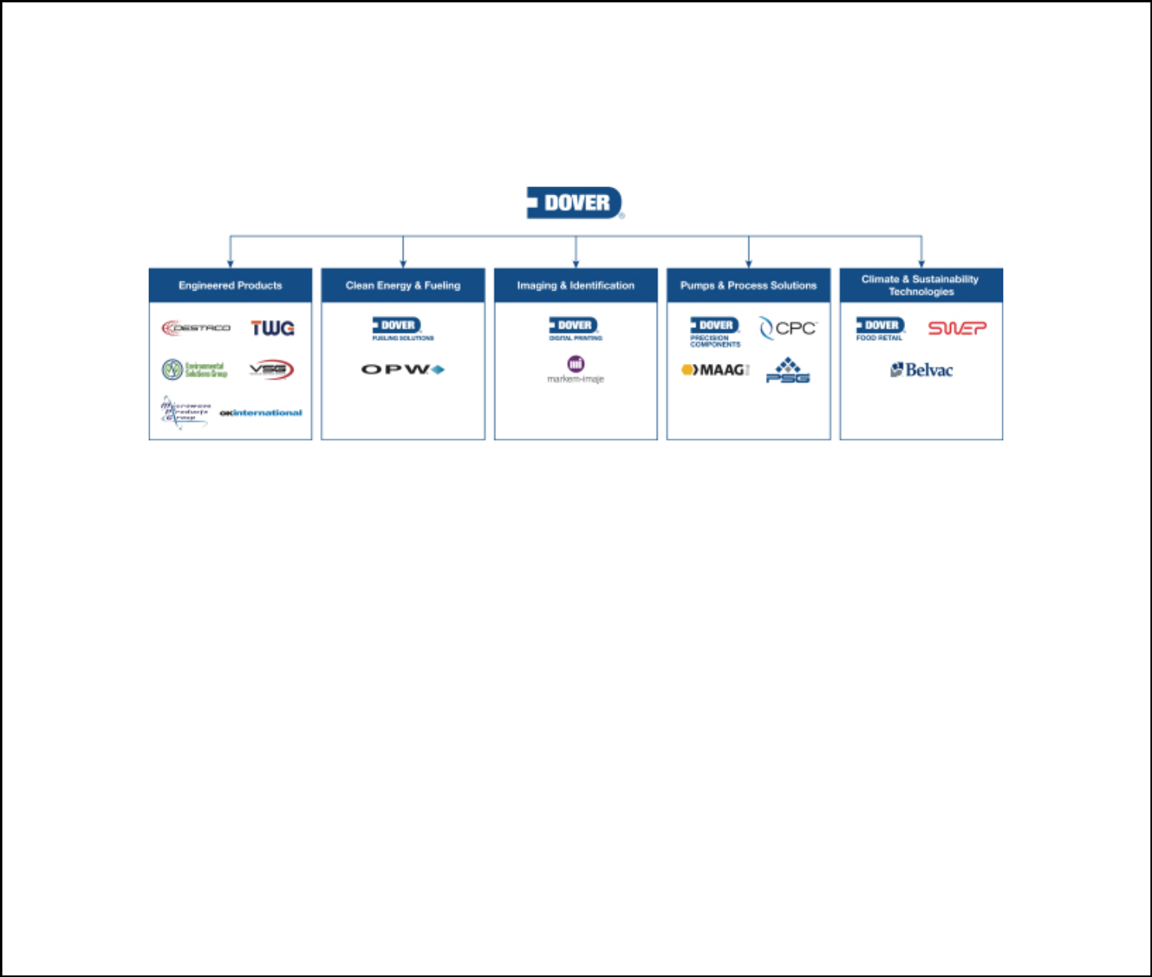

Company Overview

Dover is a diversified global manufacturer and solutions provider delivering innovative equipment and components, consumable supplies, aftermarket parts, software and digital solutions, and support services through five operating segments: Engineered Products, Clean Energy & Fueling, Imaging & Identification, Pumps & Process Solutions, and Climate & Sustainability Technologies. We combine global scale, operational agility, world-class engineering capability, and customer intimacy to lead the markets we serve. Recognized for our entrepreneurial approach for over 60 years, our team of over 25,000 employees takes an ownership mindset, collaborating with customers to redefine what’s possible.

Management Philosophy

- Our executive management team is committed to steadily creating shareholder value through a combination of sustained long-term profitable growth, operational excellence, superior free cash flow generation, and productive capital re-deployment while adhering to a conservative financial policy.

- Our businesses seek to be leaders in a diverse set of growing markets where customers are loyal to trusted partners and suppliers, and value product performance and differentiation driven by superior engineering, manufacturing precision, total solution development, and excellent supply chain performance.

- Our companies are long-time leaders in their respective markets and are known for their innovation, engineering capability, and customer service excellence.

- Our sustainable business practices are focused on reducing environmental impact and developing products that help our customers meet their sustainability goals.

- Our operating structure of five business segments allows for differentiated acquisition focus consistent with our portfolio and capital allocation priorities which, coupled with functional expertise at our corporate center, presents opportunities to identify and capture operating synergies, such as global sourcing and supply chain integration, shared services, and manufacturing practices.

- Our executive management team sets strategic direction, initiatives and goals, provides oversight of strategy execution and achievement of these goals for our business segments, and with oversight from our Board of Directors (our “Board”), makes capital allocation decisions, including organic investment initiatives, major capital projects, acquisitions, and the return of capital to our shareholders.

- Our operating culture fosters high ethical and performance standards, values accountability, rigor, trust, inclusion, respect, and open communications, and is designed to encourage individual growth and operational effectiveness.

DOVER CORPORATION – 2022 Proxy Statement 2

Table of Contents

PROXY STATEMENT SUMMARY


Company Goals

We are committed to driving superior shareholder return through three key tenets of our corporate strategy.

We are committed to achieving organic sales growth above global gross domestic product growth (greater than GDP or 3% to 5% annually on average) over a long-term business cycle, absent prolonged adverse economic conditions, complemented by growth through strategic acquisitions.

We are focused on improving returns on capital, as well as segment and corporate earnings margins by enhancing our operational capabilities and making investments across the organization in digital capabilities, automation, operations management, information technology, shared services, and talent. We also focus on continuous, effective cost management and productivity initiatives, including automation and digitally-supported manufacturing, supply chain optimization, e-commerce and digital go-to-market, restructuring activities, improved footprint utilization, strategic pricing and portfolio management.

We aim to generate strong and growing free cash flow and earnings per share (“EPS”) through strong earnings performance, productivity improvements, and active working capital management.

We support achievement of these goals by aligning management compensation with strategic and financial objectives, actively managing our portfolio to increase enterprise scale, improve business mix over time, and pursuing acquisitions that fit the characteristics of an ideal Dover business, and investing in talent development programs.

2021 Financial Results

In 2021, we continued our long track record of delivering value to our shareholders, despite an operational environment that continues to present challenges due to the COVID-19 pandemic.

US GAAP | FY2021 | FY2020
Revenue ($M) | 7,907 | 6,684 | 18%
Net earnings ($M)⁽¹⁾ | 1,124 | 683 | 64%
Diluted EPS ($) | 7.74 | 4.70 | 65%
Non-GAAP⁽²⁾
Organic revenue change |  |  | 15%
Adjusted net earnings ($M)⁽³⁾ | 1,109 | 824 | 35%
Adjusted diluted EPS ($) | 7.63 | 5.67 | 35%

(1)Full year 2021 and 2020 net earnings include rightsizing and other costs of $31.1 million and $40.7 million, respectively. Full year 2020 also includes a $3.9 million non-cash gain on the sale of AMS Chino, and full year 2021 also includes a $135.1 million gain on the sale of Unified Brands and a $18.0 million gain related to the sale of our Race Winning Brands equity method investment.

(2)Definitions and reconciliations of non-GAAP measures are included at the end of this proxy statement.

(3)Full year 2021 and 2020 adjusted net earnings exclude acquisition-related amortization costs of $107.2 million and $104.1 million, respectively, and rightsizing and other costs of

$31.1 million and $40.7 million, respectively. Full year 2020 also excludes a $3.9 million non-cash gain on the sale of AMS Chino, and full year 2021 also excludes a $135.1 million gain on the sale of Unified Brands and a $18.0 million gain related to the sale of our Race Winning Brands equity method investment.

DOVER CORPORATION – 2022 Proxy Statement 3

Table of Contents

PROXY STATEMENT SUMMARY

 | 2021 Performance Overview
 |  | • In 2021, we completed 9 acquisitions. The acquisitions of Acme Cryogenics, Inc. (“Acme
 |  | Cryogenics”), Engineered Controls International, LLC (“RegO”) and LIQAL B.V. (“LIQAL”) within the
 |  | Clean Energy & Fueling segment complement our existing operations and expand our evolving
 |  | fueling portfolio toward clean energy.
 | Portfolio & Strategic Actions | • As part of the regular review of our portfolio and the fit of our businesses, we completed the sale of
 | Portfolio & Strategic Actions | Unified Brands within the Climate & Sustainability Technologies segment and our Race Winning Brands
 |  | equity method investment within the Engineered Products segment.
 |  | • In recognition of recent portfolio changes, we recently changed the name of the Fueling Solutions
 |  | segment to “Clean Energy & Fueling,” and the Refrigeration & Food Equipment segment to “Climate &
 |  | Sustainability Technologies” to better reflect the markets and customers served by the businesses
 |  | within these segments.
 |  | • Increased revenue, profitability, and earnings per share despite a challenging global business
 |  | environment caused by COVID-19.
 |  | • We continued to execute on our broad-based multi-year efficiency and margin expansion
 |  | program, designed to reduce our selling, general and administrative cost base and rationalize our
 | Strong Operational Execution | manufacturing and supply chain footprint across the portfolio.
 | Strong Operational Execution | • Continuing to build upon our four enterprise capabilities in support of margin expansion initiatives.
 | and
 | and | - We are continuing to (1) leverage our Digital Labs team to improve our internal and market-
 | Profitability
 |  | facing digital capabilities, (2) improve utilization and optimization of our manufacturing
 |  | footprint through centralized resources and investment, (3) further centralize shared
 |  | services under Dover Business Services, and (4) invest in our India Innovation Center shared
 |  | services with a focus on engineering capabilities.
 |  | • Synergy capture from recent acquisitions presents additional margin upside.
 |  | • We made 9 strategic bolt-on acquisitions — the most since 2016 — for an aggregate consideration
 |  | of $1,125.1 million, net of cash acquired and including contingent consideration, that enhance our
 | Disciplined | businesses with new capabilities and attractive end-market exposures.
 | Disciplined | • We continued our history of providing regular capital returns to shareholders by increasing our
 | Capital
 | Allocation | quarterly dividend, marking our 66th consecutive year of dividend increases.
 |  | • We made $171.5 million in capital expenditures in 2021, representing 2.2% of revenue, in line with our
 |  | priority of organic reinvestment to grow and strengthen our existing businesses.
 |  | DOVER CORPORATION – 2022 Proxy Statement 4

Table of Contents

PROXY STATEMENT SUMMARY


2021 Performance Overview, cont.

Cash Flow | • We generated free cash flow(1) of $944 million, representing 11.9% of revenue and 84.0% of net earnings
Cash Flow | as a result of broad-based cost-control efforts and proactive working capital management. Cash flow
Generation
Generation | provided by operating activities was $1,115.9 million.
 | • We made progress on several fronts in line with our three-year plan to expand the scope and robustness of
 | our environmental, social, and governance (“ESG”) practices and disclosures.
 | - We announced science-based targets to reduce our greenhouse gas (“GHG”) emissions,
 | including an absolute reduction of scope 1 and scope 2 market-based GHG emissions of 30 percent by
 | 2030 (from a 2019 baseline year), and an absolute reduction of scope 3 GHG emissions of 15 percent
 | by 2030 (from a 2019 baseline year).
ESG | - Given the increasing focus on climate risk, we conducted a climate risk assessment and scenario
Initiative | analysis aligned with the Task Force on Climate-related Financial Disclosures (“TCFD”) reporting
 | framework and published a summary of the results to further improve transparency regarding our ESG
 | areas of focus.

  - We established a working group with four of our largest operating companies by emissions designed to embed sustainability considerations into product development in 2021.

  - We announced a goal of reducing Total Recordable Injury Rate (“TRIR”) by 40% by 2025 (from a 2019 baseline year).

- Definitions and reconciliations of non-GAAP measures are included at the end of this proxy statement.

DOVER CORPORATION – 2022 Proxy Statement 5

Table of Contents

PROXY STATEMENT SUMMARY
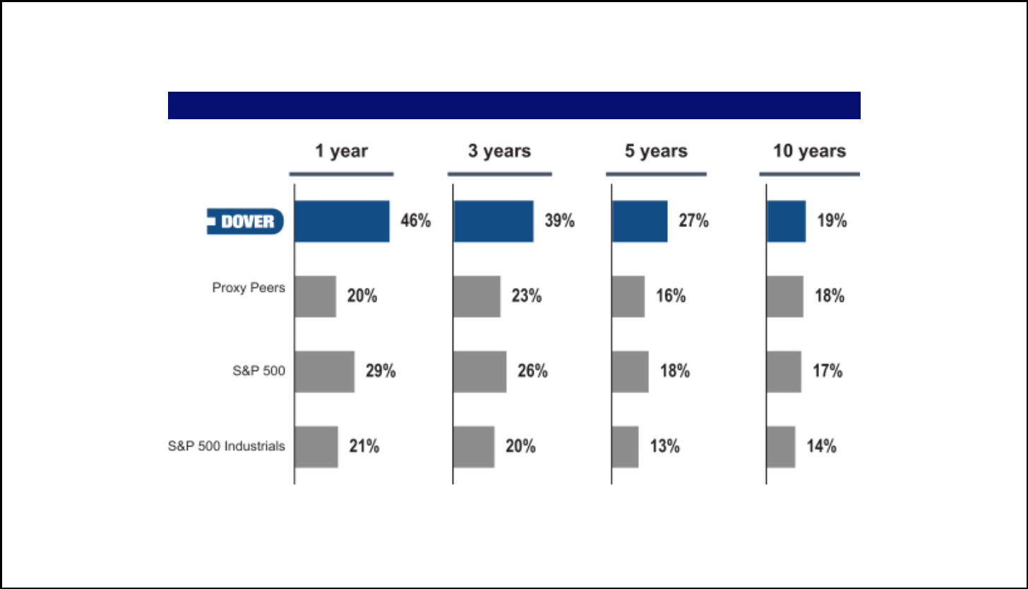

Total Shareholder Return

In 2021, we continued our long track record of delivering superior value-creation to our shareholders.

Total Shareholder Return^{1,2}

Note : These figures represent annualized returns.

- End date for returns periods is December 31, 2021.
- Annualized Total Shareholder Return including dividends and spin-offs. Fortive Corporation went public in July 2016 and Ingersoll-Rand merged with Gardner Denver in March 2020. Both stocks are excluded from periods prior to go public / merger dates. Source: Capital IQ

DOVER CORPORATION – 2022 Proxy Statement 6

Table of Contents

PROXY STATEMENT SUMMARY


Governance Highlights

Our Board is committed to sound governance practices designed to promote the long-term interests of shareholders and strengthen Board and management accountability. Highlights include:

BOARD OF DIRECTORS | GOVERNANCE HIGHLIGHTS
✓ Independent Board leadership | ✓ In 2019, achieved removal of all remaining supermajority
 | voting provisions in our charter

- In 2020, adopted a diversity search policy for external director
and Chief Executive Officer (“CEO”) searches conducted by | ✓ In February 2020, reduced ownership threshold required to
third-party search firms | call a special meeting of shareholders to 15% from 25%
✓ All directors are independent, other than the CEO | ✓ Proxy access right at 3%/3 years/2 or 20% of Board/20
✓ Annual election of directors | shareholder aggregation allowance
✓ Annual election of directors | ✓ Strong share retention guidelines for directors and executive
✓ Majority voting for directors and director resignation policy in
 | officers
uncontested elections | ✓ Executive compensation driven by pay-for-performance
✓ Comprehensive annual individual evaluations of one-third of the | ✓ Executive compensation driven by pay-for-performance
 | philosophy
directors | ✓ Executive officers not permitted to hedge or pledge company
✓ Regular executive sessions of independent directors
✓ Regular executive sessions of independent directors | shares
✓ Robust succession planning

Shareholder Engagement

We encourage feedback from shareholders and have a strong history of engaging with investors on a range of topics, including our executive compensation program, evolving trends and best practices. In 2021, we continued our focus on regularly engaging with shareholders. We reached out to holders of approximately 60% of our shares outstanding, and engaged with governance professionals and/or portfolio managers at investors holding approximately 31% of our shares outstanding. During these discussions, we discussed many key topics, including our commitment to diversity and inclusion, progress on our ESG program and disclosures, our executive compensation program, and our corporate governance practices. Investors continued to express broad support for our governance structures and executive compensation program, including the changes implemented in 2020 in response to shareholder feedback, and shared their views on matters related to diversity and inclusion and our independent, well-qualified Board. Further, investors highlighted the importance of continuing our ongoing engagement with them in the future on long-term corporate strategy and ESG initiatives. For more detailed information regarding these discussions, please see “Shareholder Engagement and History of Board Responsiveness” on page 31.

DOVER CORPORATION – 2022 Proxy Statement 7

Table of Contents

PROXY STATEMENT SUMMARY
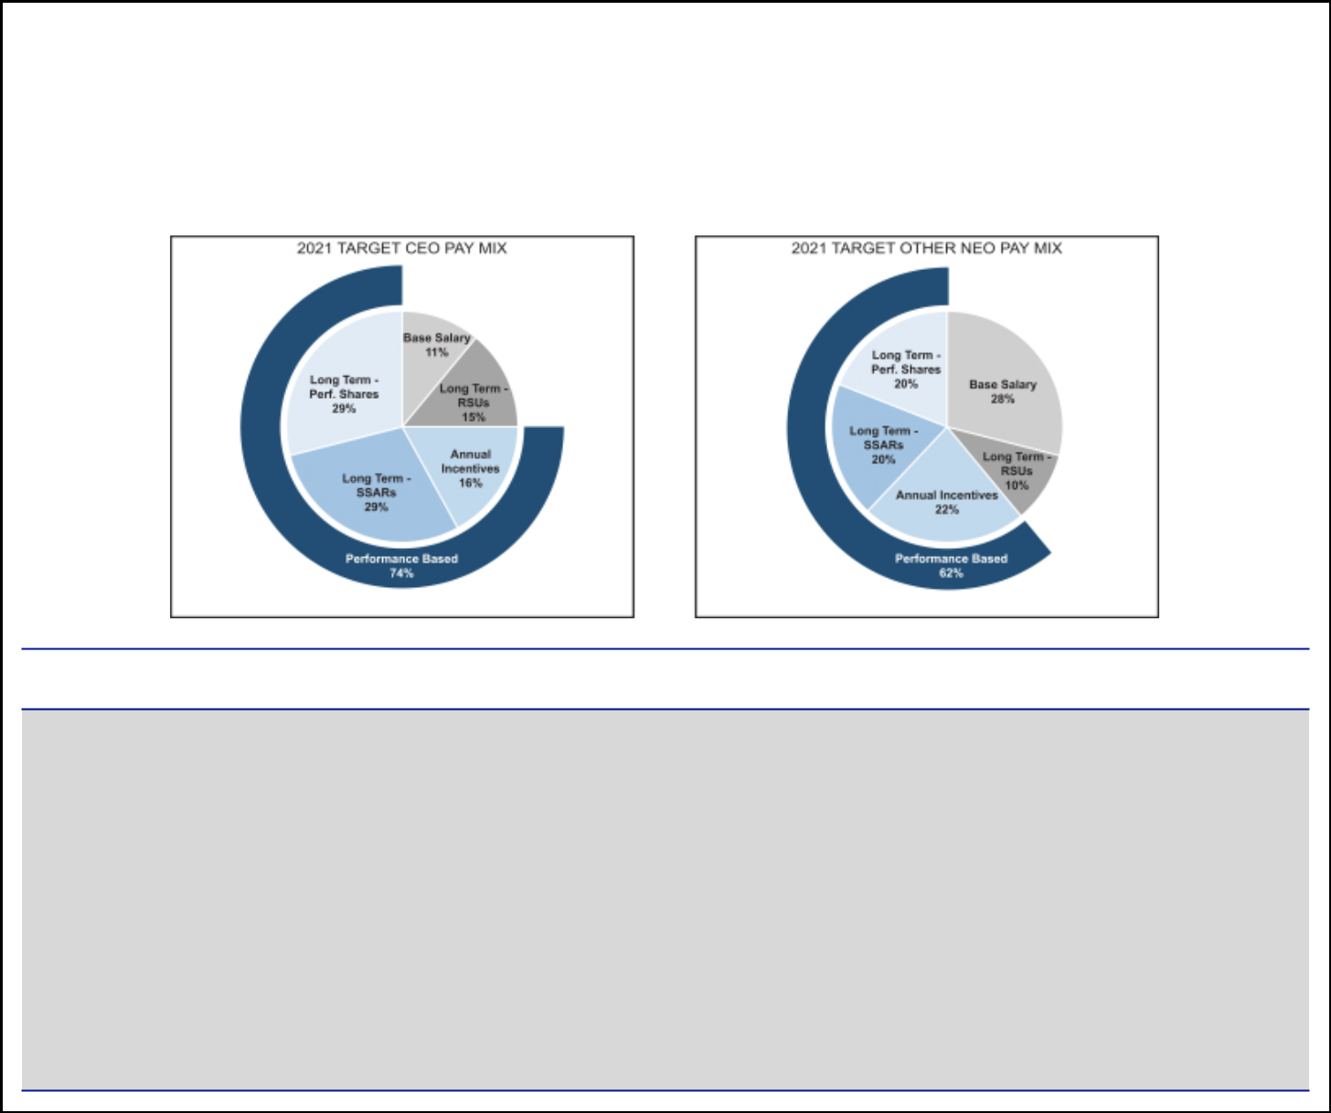

Executive Compensation

Our compensation program for executive officers is designed to emphasize performance-based compensation in alignment with our business strategy.

2021 Executive Compensation

The following table summarizes pay mix for our CEO and other NEOs, which is highly performance-based.

EXECUTIVE COMPENSATION PROGRAM HIGHLIGHTS

- Pay-for-performance philosophy — a substantial majority of NEO pay is performance-based and tied to Dover’s stock price performance

- Significant portion of long-term compensation is performance-based, with long-term incentives vesting over three years subject to rigorous three-year performance period

- Strong share ownership guidelines for NEOs

- Equity awards with anti-hedging and anti-pledging provisions

- Investors provided with clear disclosure regarding the individual strategic objectives and financial metrics in our Executive Officer Annual Incentive Plan (“AIP”)

- ESG oversight incorporated into our CEO’s individual strategic objectives in the AIP

- Robust clawback structure

DOVER CORPORATION – 2022 Proxy Statement 8

Table of Contents

PROXY STATEMENT SUMMARY
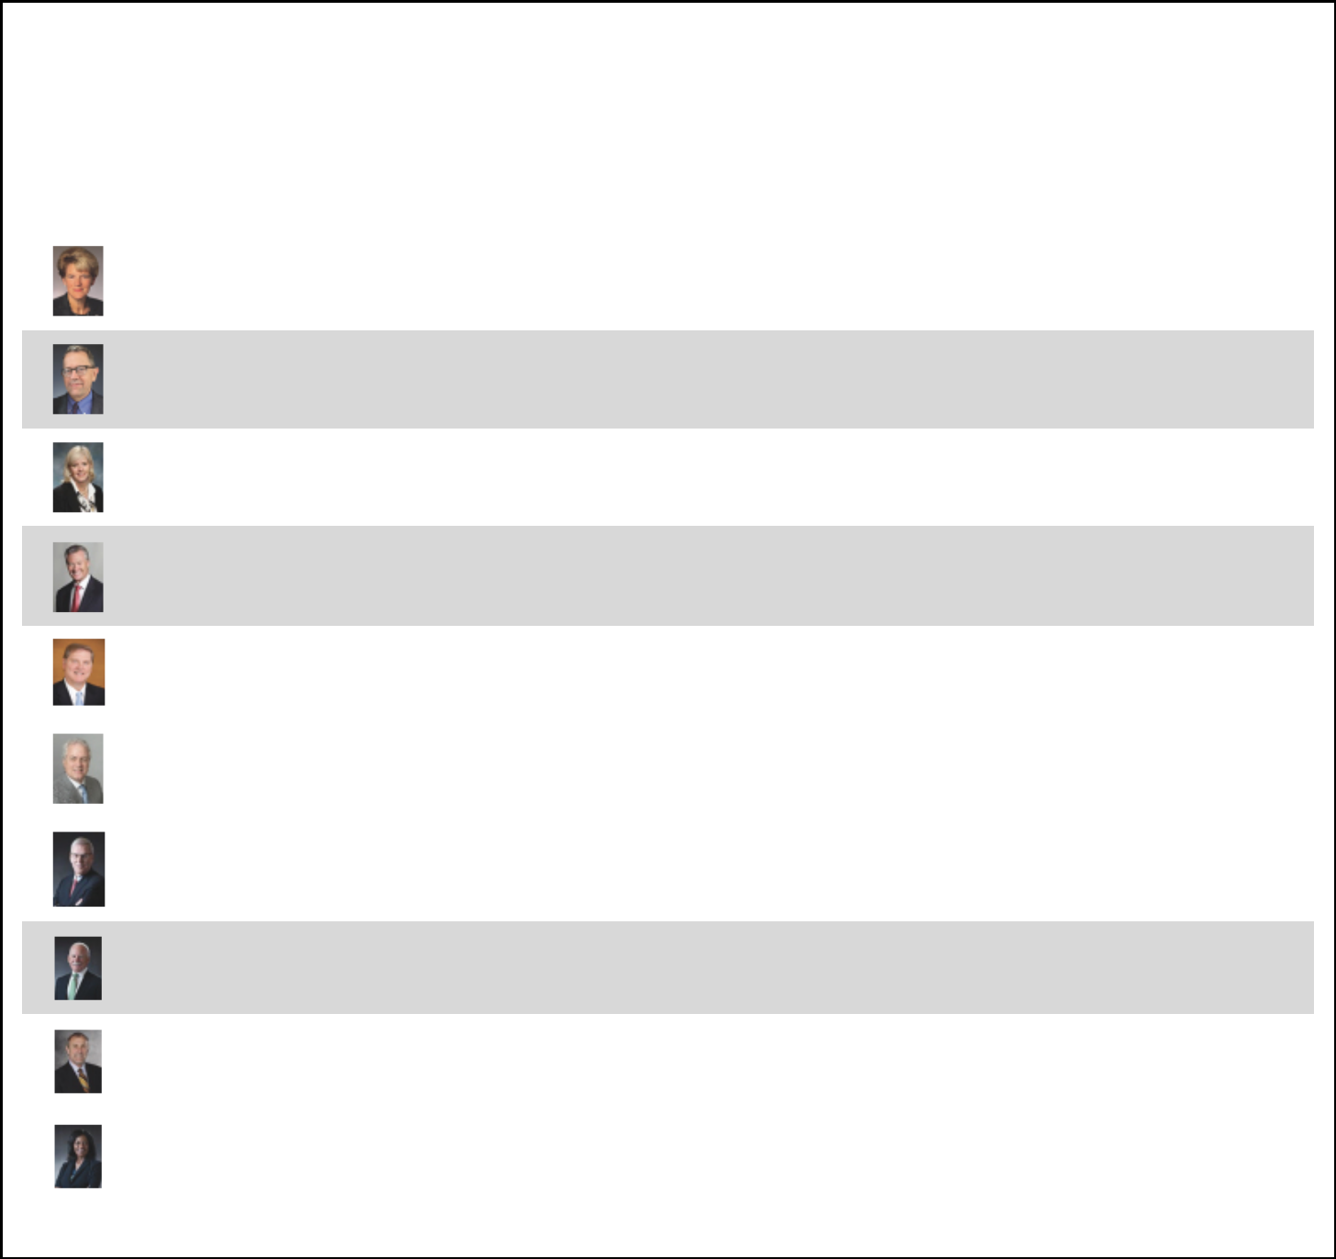

Director Nominees

Our Governance and Nominating Committee maintains an active and engaged Board through a robust refreshment process, which focuses on ensuring our Board has a diverse skill set that benefits from both the industry- and company-specific knowledge of our longer-tenured directors, as well as the fresh perspectives brought by our newer directors.

 |  |  |  | OTHER PUBLIC
 |  |  | COMMITTEES | COMPANY
NAME | OCCUPATION | INDEPENDENT | MEMBERSHIPS* | BOARDS

Deborah L. DeHaas
Age: 62
Director Since: 2021

H. John Gilbertson, Jr.

Age: 65
Director Since: 2018

Kristiane C. Graham
Age: 64
Director Since: 1999

Michael F. Johnston
Chair of the Board
Age: 74
Director Since: 2013

Eric A. Spiegel
Age: 64
Director Since: 2017

CEO of the Corporate Leadership Center; Former Vice Chairman of Deloitte and Managing Partner of the Center for Board Effectiveness

Retired Managing Director at Goldman Sachs

Private Investor

Retired CEO of Visteon Corporation

Former President and CEO of Siemens USA; Special Advisor at Brighton Park Capital

✓

✓

✓

✓

✓

- 1

A, F | 1
C, G | 0
C, G | 1
A, F (Chair) | 1

Richard J. Tobin
Age: 58 | President and CEO of Dover | No | — | 1
Director Since: 2016 | President and CEO of Dover | (CEO of Dover) | — | 1

Stephen M. Todd
Age: 73
Director Since: 2010

Stephen K. Wagner

Age: 74
Director Since: 2010

Former Global Vice Chairman of Assurance Professional Practice of Ernst & Young Global Limited

Former Senior Adviser, Center for Corporate Governance, Deloitte & Touche LLP

✓

✓

A (Chair) | 1
A, G (Chair) | 1

 | Keith E. Wandell |  | ✓
 | Age: 72 | Former President and CEO of Harley-Davidson, Inc. | ✓ | C (Chair), F | 1
 | Director Since: 2015 | Former President and CEO of Harley-Davidson, Inc. |  | C (Chair), F | 1
 | Mary A. Winston | President of WinsCo Enterprises Inc.; Former Executive Vice | ✓
 | Age: 60 | President of WinsCo Enterprises Inc.; Former Executive Vice | ✓ | C, F | 3
 | Age: 60 | President and Chief Financial Officer (“CFO”) of Family Dollar | ✓ | C, F | 3
 | Director Since: 2005 | Stores, Inc. | ✓

*A = Audit Committee; C = Compensation Committee; G = Governance and Nominating Committee; F = Finance Committee

DOVER CORPORATION – 2022 Proxy Statement 9

Table of Contents

PROXY STATEMENT SUMMARY
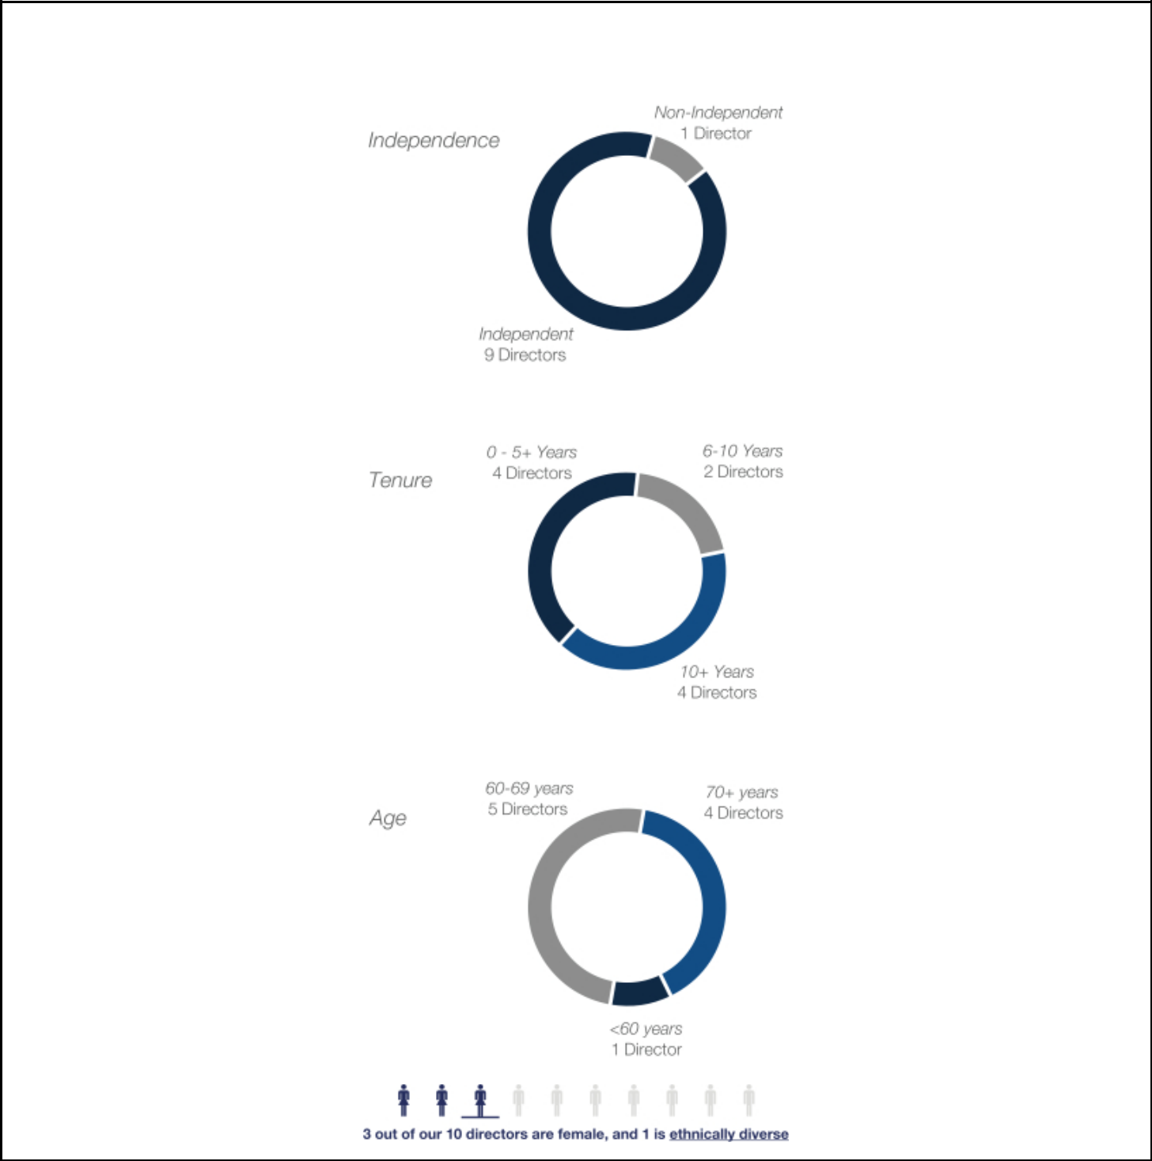

Board Composition

Our Board has the following composition:

DOVER CORPORATION – 2022 Proxy Statement 10

Table of Contents

Proposal 1 — Election of Directors

Criteria for Director Nominees

The Board seeks to recommend qualified director nominees who, in the opinion of the Board, demonstrate the highest personal and professional integrity as well as exceptional ability and judgment, who can serve as a sounding board for our CEO on planning and policy, and who will be most effective, together with the other nominees to the Board, in collectively serving the long-term interests of all our shareholders.

Key areas of expertise for director nominees, which are reflected in our current director nominees, include:

- Strategic M&A

- Global Operations & Management

- Capital Markets Expertise

- Strategy Development & Execution

- Risk Management Expertise

- Audit & Corporate Governance Matters

- Human Capital Management

- Sustainability

- Executive Leadership Experience

Experience with international acquisitions, post-merger integration, and portfolio restructuring

Experience with cross-border transactions, global market entry and expansion, and implementation of operational efficiency

Experience with capital markets and complex financing transactions

Experience with diversified manufacturing in many of the markets and product areas relevant to Dover’s businesses

Experience evaluating risk management policies and procedures

Experience with assurance and audit, regulation, and financial reporting

Experience attracting, developing and retaining talent and building strong cultures

Experience creating long-term value by embracing opportunities and managing risks deriving from ESG developments

Leadership experience as former CEOs and CFOs of global public companies

Diversity. In considering diversity in selecting director nominees, the Governance and Nominating Committee gives weight to the extent to which candidates would increase the effectiveness of the Board by broadening the mix of experience, knowledge, backgrounds, skills, ages, and tenures represented among its members. In 2020, our Board adopted a policy reflected in our Corporate Governance Guidelines requiring that the initial list of potential director and external CEO candidates presented by third-party search firms include qualified candidates who reflect diverse backgrounds, including diversity of gender and race or ethnicity. Our Board believes that diverse perspectives enhance its decision-making and contribute to the success of Dover.

Skills Aligned with Dover’s Strategy. The Governance and Nominating Committee also considers our current Board composition and the projected retirement date of current directors, as well as such other factors it may deem to be in the best interests of Dover and its shareholders, including a director nominee’s leadership and operating experience (particularly as a CEO), financial and investment expertise, and strategic planning experience. We believe that our current director nominees possess the right mix of skills and backgrounds to enable us to achieve our strategic goals.

DOVER CORPORATION – 2022 Proxy Statement 11

Table of Contents

PROPOSAL 1 — ELECTION OF DIRECTORS

Independence & Depth of Experience. The Board prefers nominees to be independent but believes it is desirable to have our CEO on the Board as a representative of current management. Given the global reach and broad array of the types of businesses operated by Dover, the Governance and Nominating Committee highly values director nominees with multi-industry and multi-geographic experience.

Director Nomination Process

Whenever the Governance and Nominating Committee concludes that a new nominee to our Board is required or advisable, it will consider recommendations from directors, management, shareholders and, if it deems appropriate, consultants retained for that purpose. In such circumstances, it will evaluate individuals recommended by shareholders in the same manner as nominees recommended from other sources.

Shareholder Nominations for Director

Shareholders who wish to recommend an individual for nomination should send that person’s name and supporting information to the Governance and Nominating Committee, in care of the Corporate Secretary at our principal executive offices, 3005 Highland Parkway, Downers Grove, Illinois, 60515, or through our communications coordinator. Shareholders who wish to directly nominate an individual for election as a director, without going through the Governance and Nominating Committee, must comply with the procedures in our by-laws. Please see “General Information About the Annual Meeting” for nomination deadlines.

Proxy Access Shareholder Right

Following extensive engagement with our shareholders, our Board determined to adopt proxy access in February 2016, permitting a shareholder or group of up to 20 shareholders holding 3% of our outstanding shares of common stock for at least three years to nominate a number of directors constituting the greater of two directors or 20% of the number of directors on our Board, as set forth in detail in our by-laws.

DOVER CORPORATION – 2022 Proxy Statement 12

Table of Contents

PROPOSAL 1 — ELECTION OF DIRECTORS

2022 Director Nominees

There are ten nominees for election to our Board at this Annual Meeting, each to serve until the next annual meeting of shareholders or his or her earlier removal, resignation or retirement. All of the nominees currently serve on our Board and are being proposed for re-election by our Board.

If any nominee for election becomes unavailable or unwilling to serve as a director before the Annual Meeting, an event which we do not anticipate, the persons named as proxies will vote for a substitute nominee or nominees as may be designated by our Board, or the Board may reduce the number of directors. Directors will be elected by a majority of the votes cast in connection with their election.

Deborah L. DeHaas
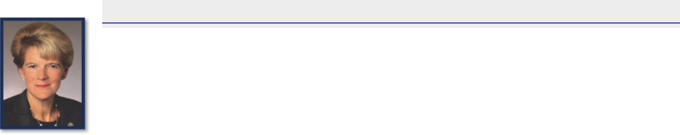

Independent Director Nominee

Director since: 2021

Age: 62

Committees: Audit

Skills and Qualifications:

- Significant leadership, financial and corporate governance expertise garnered from her nearly 40 years of experience at major audit, assurance and consulting firms

- Certified public accountant (“CPA”) and has extensive experience with financial, accounting, internal controls, and enterprise risk management

- Has deep expertise on governance, both as a topic and discipline, developed during her career at Deloitte

- As a member of the Value Reporting Foundation Board (formerly the SASB Foundation Board), contributes valuable and well-informed insights on a variety of ESG matters

- Brings relevant public company board service, serving on the board of CF Industries Holdings, Inc.

- Brings experience and perspective on matters regarding human capital and culture, including diversity and inclusion

- Holds a bachelor’s degree in management science and accounting from Duke University

- Included in the National Association of Corporate Directors (“NACD”) Directorship 100 from 2015-2020, recognizing influential leaders in corporate governance and is also an NACD Board Leadership Fellow

Business Experience:

- CEO of the Corporate Leadership Center, a non-profit leadership development forum

- Former Vice Chairman and National Managing Partner of the Center for Board Effectiveness at Deloitte

  - Former member of the U.S. Executive Committee

  - Former Vice Chairman and Chief Inclusion Officer

  - Former member of the U.S. Board of Directors

  - Former Vice Chairman and Central Region Managing Partner

  - Former Vice Chairman and Midwest Regional Managing Partner

  - Former Regional Managing Partner, Strategic Clients

- Former positions of increasing responsibility at Arthur Andersen, an audit, financial advisory, tax and consulting firm, most recently as Managing Partner & Business Advisory Assurance, Central Region

Other Board Experience:

- CF Industries Holdings, Inc.

DOVER CORPORATION – 2022 Proxy Statement 13

Table of Contents

PROPOSAL 1 — ELECTION OF DIRECTORS

H. John Gilbertson, Jr.
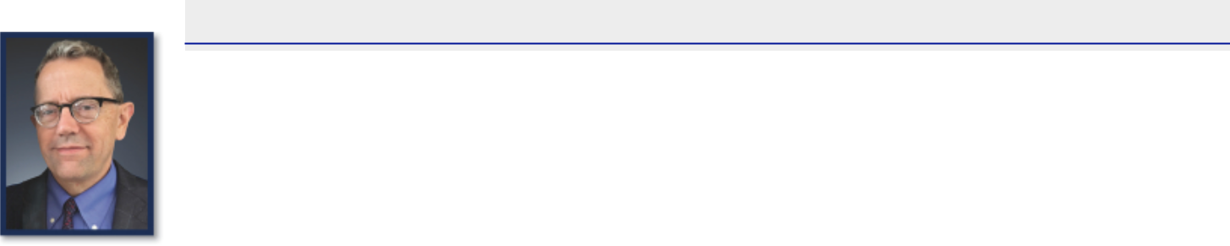

Independent Director Nominee

Director since: 2018

Age: 65

Committees: Audit, Finance

Skills and Qualifications:

- Extensive experience in corporate finance, capital markets, and mergers and acquisitions

- Served as a strategic and financial advisor to his clients, forming deep relationships with companies in a range of industries

- Has nearly four decades of experience in the professional and financial services industry

- Deep expertise in financial management, coupled with his analytical and collaborative mindset, allows him to make invaluable contributions to our Board

- Strong background in senior leadership development, succession planning, and organizational culture development

- Brings to the Board considerable expertise in financial risk oversight and capital allocation

- Bachelor’s degree in political economy from Dartmouth College and an MBA from Harvard University

Business Experience:

- Retired Managing Director at Goldman Sachs

- Served as Advisory Director and Partner-in-Charge, Midwest Region Investment Banking Services

- Served as Managing Director at Travelers Group Inc.

- Former Associate, Mergers and Acquisitions at Morgan Stanley

- Former Consultant, Corporate Strategy at Bain & Company

- Former Assistant Treasurer, Corporate Banking at Chase Manhattan Bank

- Former News Reporter at The Providence Journal Company

Other Board Experience:

- Director and Chair of Audit Committee of Meijer, Inc. (“Meijer”)

- Director of AAR Corp.

DOVER CORPORATION – 2022 Proxy Statement 14

Table of Contents

PROPOSAL 1 — ELECTION OF DIRECTORS

Kristiane C. Graham
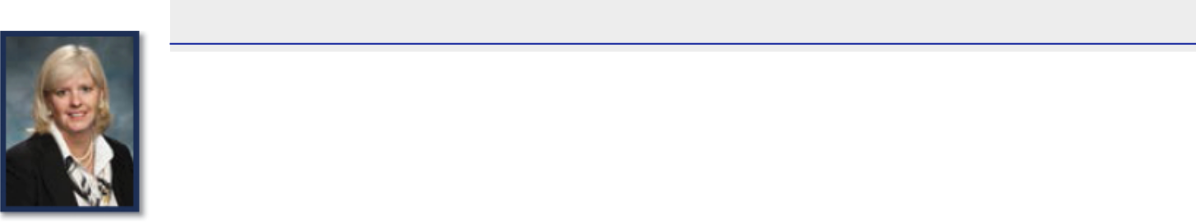

Independent Director Nominee

Director since: 1999

Age: 64

Committees: Compensation, Governance and Nominating

Skills and Qualifications:

- Experience as a private investor with substantial holdings of Dover stock and her shared interests in Dover, including interests through charitable organizations of which she is a director, makes her a good surrogate for our individual and retail investors

- Experience with a commercial bank, primarily as a loan officer; founded and operated an advisory company and a publication regarding international thoroughbred racing and now co-manages her family’s investments

- Actively works with and has served on the boards of various organizations to support the objectives of local communities, affordable housing, education, and health

- Currently serves on the Board of Directors for the Walter N. Ridley Scholarship Fund at the University of Virginia

- Serves as an Emeritus Trustee of the College Foundation of the University of Virginia and has previously served on the Advisory Board of the University of Virginia School of Nursing

- Brings valuable insights on the development of our policies and strategies relating to talent, leadership, and culture, with a focus on diversity and inclusion

- Devoted substantial time to monitoring the development of Dover operating company leaders, enabling her to provide the Board valuable insights regarding management succession

- As a member of one of the founding families of Dover, Ms. Graham also brings to the Board a sense of Dover’s historical values, culture and strategic vision which the Board believes is beneficial as it considers various strategic planning alternatives for shaping Dover’s future

Business Experience:

- Private Investor

DOVER CORPORATION – 2022 Proxy Statement 15

Table of Contents

PROPOSAL 1 — ELECTION OF DIRECTORS

Michael F. Johnston
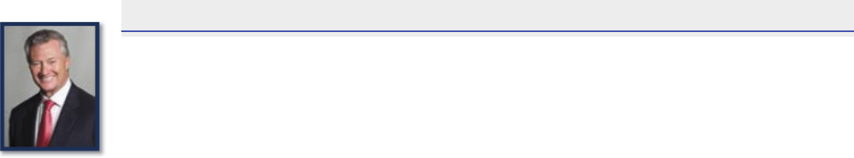

Independent Board Chair; Independent Director Nominee

Director since: 2013

Age: 74

Committees: Compensation, Governance and Nominating

Skills and Qualifications:

- Brings industry insight, financial expertise and leadership experience garnered from his 17 years on the boards of global companies

- Served as CEO of an $18 billion global manufacturer

- Mr. Johnston also brings valuable corporate governance perspectives from his prior board service, including as a lead Director and Chair of other major public companies

- Brings deep operations experience has helped him gain knowledge and a deep understanding in manufacturing, design, innovation, engineering, accounting and finance and capital structure

- Brings nearly two decades of experience in building businesses in emerging economies

- Bachelor’s degree in industrial management from the University of Massachusetts and an MBA from Michigan State University

Business Experience:

- Former CEO and President of Visteon Corporation (“Visteon”)

- Former Chief Operating Officer of Visteon

- Former President of North America/Asia Pacific, Automotive Systems Group, of Johnson Controls, Inc. (“Johnson Controls”)

- Former President of Americas Automotive Group of Johnson Controls

Other Board Experience:

- Director of Armstrong Flooring, Inc.

- Former Chairman and Director of Visteon

- Former Director of Armstrong World Industries, Flowserve Corporation, and Whirlpool Corporation

DOVER CORPORATION – 2022 Proxy Statement 16

Table of Contents

PROPOSAL 1 — ELECTION OF DIRECTORS

Eric A. Spiegel
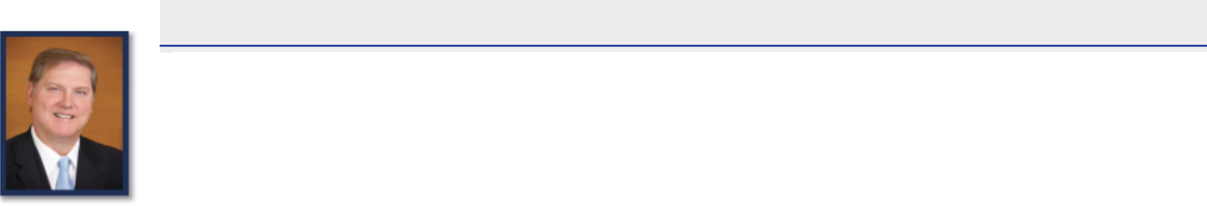

Independent Director Nominee

Director since: 2017

Age: 64

Committees: Audit, Finance (Chair)

Skills and Qualifications:

- Experienced business leader with diversified, global experience who brings deep and valuable expertise in strategy development, corporate restructuring, portfolio management and M&A to our Board

- 40+ years of experience working with large, global companies in the energy and industrial markets, mostly recently as President & CEO of Siemens

USA

- At Siemens, he led strategic reviews across a portfolio of ~45 businesses in the company’s largest market with over $22 billion in revenue, 50,000 employees and over 60 manufacturing facilities

- Led the acquisition, divestiture, joint venture and carve-out of over 30 business units and segments

- Executed Siemens’ “Vision 2020” initiative to optimize growth and margins in the U.S., across all sectors

- Prior to Siemens, Mr. Spiegel was a global consultant at Booz Allen Hamilton focused on complex organizations in the energy, power, chemical, water, industrial and automotive fields

- At Booz, he worked with major energy clients globally on projects around corporate strategy, M&A, major capital projects, cost restructuring, margin enhancement and supply chain re-design and was also closely involved with the government sector

- An expert on the global energy industry, Mr. Spiegel co-authored the book Energy Shift: Game-changing Options for Fueling the Future

- Holds a bachelor’s degree in economics from Harvard University and an MBA from the Tuck School of Business at Dartmouth College

Business Experience:

- Special Advisor at Brighton Park Capital, a private equity firm, where he supports the firm’s sector investment teams and portfolio companies by providing strategic counsel on industry trends and growth strategies

- Former President and CEO of Siemens USA

- Former Managing Partner, Global Energy, Chemicals, and Power, and Managing Partner, Washington, D.C. office, and other roles at Booz & Company, Inc. (now known as Strategy&) and Booz Allen Hamilton, Inc., global consulting firms

- Former Associate, Energy and Industrials Practice, at Temple, Barker & Sloane, Inc. (now known as Oliver Wyman)

- Former Marketing and Strategy Manager at Brown Boveri & Cie (now known as ABB), a Swiss group of electrical engineering companies

- In connection with his position at Brighton Park Capital, Mr. Spiegel serves as Chair of Relatient, Inc.

Other Board Experience:

- Director and Audit Committee Chair of Liberty Mutual Holding Company, Inc.

- Director and Audit Committee Chair of Project Energy Reimagined Acquisition Corp.

DOVER CORPORATION – 2022 Proxy Statement 17

Table of Contents

PROPOSAL 1 — ELECTION OF DIRECTORS

Richard J. Tobin
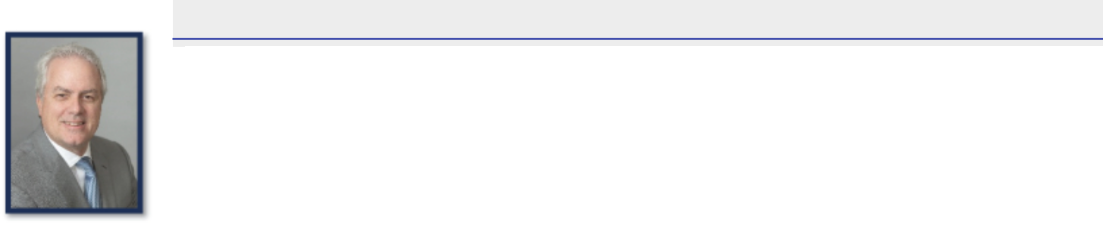

Chief Executive Officer

Director since: 2016

Age: 58

Committees: None

Skills and Qualifications:

- Mr. Tobin is Dover’s current CEO. The Board believes it is desirable to have one active management representative on the Board to facilitate its access to timely and relevant information and its oversight of management’s long-term strategy, planning, and performance

- Has a broad range of industry and functional experiences acquired through regional and global leadership positions

- Former CEO of CNH Industrial, a complex international industrial company, where he led efforts to increase efficiencies, innovate through new technologies, expand geographically, and maximize the company’s portfolio of businesses

- Gained extensive experience in international finance, operations, management, and information technology in his prior roles

- Developed deep expertise with global capital markets through his international finance leadership roles

- Prior to beginning his business career, Mr. Tobin was an officer in the United States Army

- Member of the Board of Trustees of the John G. Shedd Aquarium in Chicago

- Formerly served on the U.S. Chamber of Commerce Board of Directors, and is a former member of the Business Roundtable

- Holds a bachelor of arts from Norwich University and an MBA from Drexel University

Business Experience:

- President and CEO of Dover

- Former CEO of CNH Industrial NV (“CNH Industrial”)

- Former Group Chief Operating Officer of Fiat Industrial S.p.A

- Former President and CEO of CNH Global NV

- Former CFO of CNH Global NV

- Former Chief Finance Officer & Head of Information Technology of SGS Group

- Former Chief Operating Officer for North America of SGS Group

Other Board Experience:

- Director of KeyCorp.

- Former director of CNH Industrial

DOVER CORPORATION – 2022 Proxy Statement 18

Table of Contents

PROPOSAL 1 — ELECTION OF DIRECTORS

Stephen M. Todd
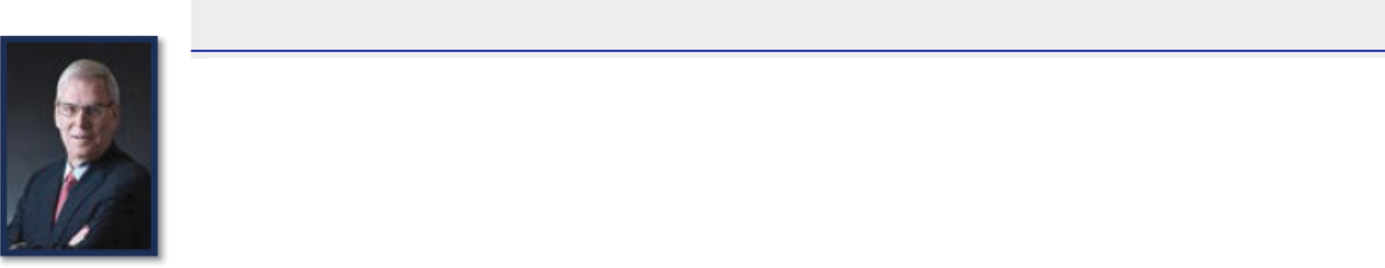

Independent Director Nominee

Director since: 2010

Age: 73

Committees: Audit (Chair)

Skills and Qualifications:

- Extensive accounting and financial experience in both domestic and international business developed during a four decade career at Ernst & Young where he specialized in assurance and audit

- Brings unique insights into accounting and financial issues relevant to multinational companies like Dover

- Brings the perspective of an outside auditor to the Audit Committee

- Brings leadership and financial strategy experience as developer and director of Ernst & Young’s Global Capital Markets Centers, which provides accounting, regulatory, internal control and financial reporting services to multinational companies in connection with cross-border debt and equity securities transactions and acquisitions

Business Experience:

- Former Global Vice of Assurance Professional Practice of Ernst & Young Global Limited, London, UK; and prior thereto, various positions with Ernst & Young

Other Board Experience:

- Director and Audit Committee member of ChampionX Corporation (formerly known as Apergy Corporation)

- Former member of the Board of Trustees of PNC Funds

DOVER CORPORATION – 2022 Proxy Statement 19

Table of Contents

PROPOSAL 1 — ELECTION OF DIRECTORS

Stephen K. Wagner
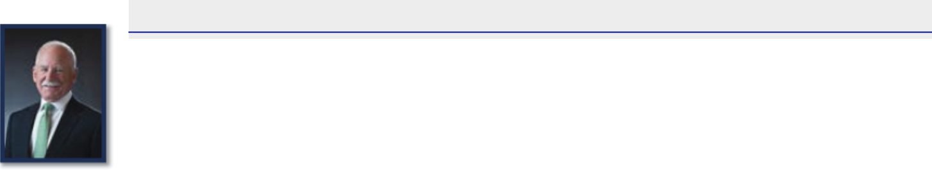

Independent Director Nominee

Director since: 2010

Age: 74

Committees: Audit, Governance and Nominating (Chair)

Skills and Qualifications:

- Mr. Wagner’s over 30 years of experience in accounting make him a valuable resource for the Board and the Audit Committee

- His work with Sarbanes-Oxley and other corporate governance regulations, including his years as Managing Partner at Deloitte & Touche’s Center for Corporate Governance, makes him well suited to advise the Board on financial, auditing and finance-related corporate governance matters as well as risk management

- Expert in risk oversight and co-authored a book on risk management entitled Surviving and Thriving in Uncertainty: Creating the Risk Intelligent Enterprise

- Brings to the Board an outside auditor’s perspective on matters involving audit committee procedures, internal control and accounting and financial reporting matters

Business Experience:

- Former Senior Advisor, Center for Corporate Governance, of Deloitte & Touche LLP (“Deloitte”)

- Former Managing Partner, Center for Corporate Governance of Deloitte

- Former Deputy Managing Partner, Innovation, Audit and Enterprise Risk, United States of Deloitte

- Former Co-Leader, Sarbanes-Oxley Services, of Deloitte

Other Board Experience:

• Director and Audit Committee member of ChampionX Corporation (formerly known as Apergy Corporation)

DOVER CORPORATION – 2022 Proxy Statement 20

Table of Contents

PROPOSAL 1 — ELECTION OF DIRECTORS

Keith E. Wandell
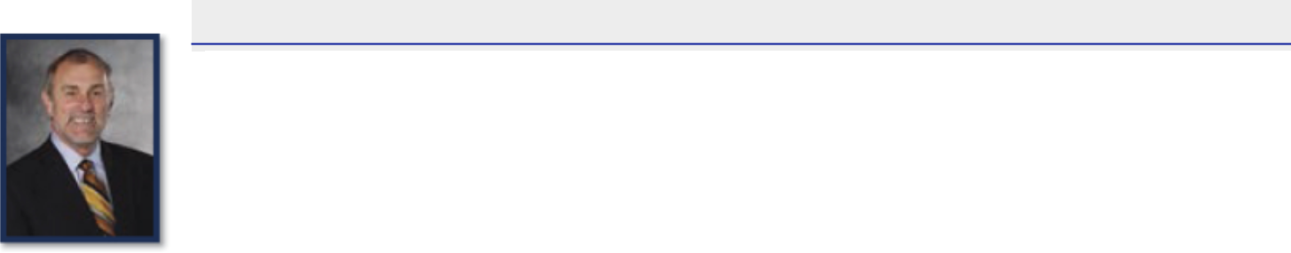

Independent Director Nominee

Director since: 2015

Age: 72

Committees: Compensation (Chair), Finance

Skills and Qualifications:

- Mr. Wandell brings to the Board the valuable perspective of a strategic, experienced leader with a strong record focused on growth, profitability, international expansion and innovation.

- Has over 30 years of experience in diversified manufacturing businesses, most recently as the former Chairman and CEO of Harley-Davidson, Inc. (“Harley-Davidson”) where he led transformation efforts across the company’s product development, manufacturing and retail functions, focused on international expansion and implemented a restructuring plan

- Prior to joining Harley-Davidson, Mr. Wandell served as President and Chief Operating Officer of Johnson Controls, Inc. (“Johnson Controls”) and helped manage the company’s entry into the Chinese car-battery market as well as its subsequent joint venture with China’s largest battery manufacturer

- Gained valuable insights into the effective development of executive leadership capabilities and strong corporate cultures through his experience as a senior leader at various companies

- Served on the boards of four other public companies, including the two on which he currently serves

- Holds a bachelor’s degree in business administration from Ohio University and an MBA from the University of Dayton

Business Experience:

- Former President and CEO of Harley-Davidson

- Former President and Chief Operating Officer of Johnson Controls

- Former Executive Vice President of Johnson Controls

- Former Corporate Vice President of Johnson Controls

- Former President of the Automotive Experience business of Johnson Controls

- Former President of the Power Solutions business of Johnson Controls

Other Board Experience:

- Director of Dana Incorporated. Former Chairman of Harley-Davidson

- Former Director of Constellation Brands, Inc. and Clarcor, Inc.

DOVER CORPORATION – 2022 Proxy Statement 21

Table of Contents

PROPOSAL 1 — ELECTION OF DIRECTORS

Mary A. Winston

Independent Director Nominee

Director since: 2005

Age: 60

Committees: Compensation, Finance

Skills and Qualifications:

- Ms. Winston brings to the Board valuable experience and expertise based on her years of broad financial management and broad executive leadership experience.

- Started her career as a CPA with Arthur Andersen & Co, and has extensive experience with financial, accounting and internal control matters for large public companies.

- Served as CFO of three large companies: Family Dollar Stores, Inc., Giant Eagle, Inc. and Scholastic, Inc., as well as prior global finance leadership roles (prior to 2004) at Visteon Corporation and Pfizer, Inc.

  - Developed deep expertise in capital markets, M&A, capital structure matters, capital allocation, financial risk management, real estate financing transactions, dividend and stock repurchase programs, and investor relations

- Ms. Winston’s background and experience make her a valuable contributor to the Board on matters involving risk oversight and capital allocation, as well as executive compensation and general corporate governance matters

- Holds a bachelor’s degree in accounting from the University of Wisconsin and an MBA from Northwestern University’s Kellogg School of Management

- Designated as a Board Leadership Fellow by the NACD and serves on the national board of the NACD

Business Experience:

- President of WinsCo Enterprises Inc

- Former Interim CEO, Bed Bath & Beyond Inc.

- Former Executive Vice President and CFO of Family Dollar Stores, Inc.

- Former Senior Vice President and CFO of Giant Eagle, Inc.

- Former President of WinsCo Financial LLC

- Former Executive Vice President and CFO of Scholastic Corporation

Other Board Experience:

- Director of Bed Bath & Beyond, Inc., Chipotle Mexican Grill, and Acuity Brands, Inc.

- Former Director of Domtar Corporation, SUPERVALU INC., and Plexus Corporation

THE BOARD RECOMMENDS A VOTE “FOR” THE ELECTION OF EACH

OF THE NOMINEES NAMED ABOVE.

DOVER CORPORATION – 2022 Proxy Statement 22

Table of Contents

PROPOSAL 1 — ELECTION OF DIRECTORS

Board Oversight and Governance Practices

Our Board is responsible for, and committed to, overseeing our long-term strategic development as well as managing the principal and most significant risks that we face. In carrying out this duty, our Board advises senior management to help drive long-term value creation for our shareholders. The Board delegates specific areas of responsibility to relevant Board committees, as detailed below under the heading “Overview of Committee Responsibilities”, who report on their deliberations to the Board. The following summarizes our Board’s key areas of oversight responsibility.

Board Oversight


KEY AREAS OF BOARD OVERSIGHT

Long-Term | • One of the primary responsibilities of our Board is the oversight of management’s long-term strategy and
Long-Term | planning. Accordingly, our Board maintains a deep level of engagement with management in setting and
Business Strategy
Business Strategy | overseeing Dover’s long-term business strategy.
 | • Our Board is focused on the efficient allocation of capital to drive growth and provide returns to our
 | shareholders. Our capital allocation priorities are organic investments, strategic acquisitions, and the return
 | of capital to our shareholders.
 | • We consistently return cash to shareholders by paying dividends, which have increased annually over
 | each of the last 66 years.
Capital Allocation | • We also undertake opportunistic share repurchases as part of our capital allocation strategy, completing
Capital Allocation | $21.6 million of share repurchases in 2021 and $106.3 million in 2020.
 | • We made $171.5 million in capital expenditures in 2021, representing 2.2% of revenue, and $165.7 million in
 | capital expenditures in 2020, representing 2.5% of revenue, in line with our priority of organic reinvestment
 | to grow and strengthen our existing businesses.
 | • We employ a prudent financial policy to support our capital allocation strategy, which includes maintaining
 | an investment grade credit rating.
 | • Businesses in our portfolio are continually evaluated for strategic fit.
 | • We seek to deploy capital in acquisitions in attractive growth areas across our five segments. We
 | focus primarily on bolt-on acquisitions, applying strict selection criteria of market attractiveness
 | (including growth, market landscape, and performance-based competition), business fit (including
 | sustained leading position, revenue visibility, and favorable customer value-add versus switching cost or
Portfolio | risk) and financial return profile (accretive growth and margins and double-digit return on invested capital).
Portfolio | • We have sold or divested some of our businesses based on changes in specific market outlook,
Management
Management | structural changes in financial performance, value-creation potential, or for other strategic considerations,
 | which included an effort to reduce our exposure to cyclical markets or focus on our higher margin growth
 | spaces.
 | • In recognition of recent portfolio changes, we recently changed the name of the Fueling Solutions segment
 | to “Clean Energy & Fueling,” and the Refrigeration & Food Equipment segment to “Climate & Sustainability
 | Technologies” to better reflect the markets and customers served by the businesses within these segments.
 | DOVER CORPORATION – 2022 Proxy Statement 23

Table of Contents

PROPOSAL 1 — ELECTION OF DIRECTORS

 | KEY AREAS OF BOARD OVERSIGHT
 | • Our Board has established a comprehensive enterprise risk management process to identify and
 | manage risks, and periodically reviews the processes established by management to identify and manage
 | risks and communicates with management about these processes.
Risk | • We have established a risk assessment team consisting of senior executives, which annually, with the
Management | assistance of a consultant, oversees a risk assessment made at the corporate center, segment and
 | operating company levels and, with that information in mind, performs an assessment of the overall risks our
 | company may face and reports to the Board on that assessment. Each quarter, this team reassesses the
 | risks, the severity of these risks, and the status of efforts to mitigate them.
 | • The full Board has oversight of ESG matters and is regularly briefed on strategic planning, risks, and
ESG | opportunities related to ESG by senior management, including our CEO.
ESG | • Our Compensation Committee has integrated ESG oversight responsibility into our CEO’s individual
 | strategic objectives within the AIP.
 | • Our entrepreneurial culture depends upon an inclusive approach that values employees’ diversity and
 | contributions.
 | • We foster an operating culture with high ethical standards that values accountability, rigor, trust,
 | inclusion, respect, and open communication and is designed to encourage individual growth and operational
Culture & Human | effectiveness. We continue to make significant investments in talent development, including in the areas of
Culture & Human | digital applications and operational management, and recognize that the growth and development of our
Capital
Capital | employees is essential for our continued success.
Management | employees is essential for our continued success.
Management | • As part of our commitment to strong corporate governance practices, we maintain an active and robust
 | ethics program. Our Code of Business Conduct & Ethics (“Code of Conduct”) applies to all employees and
 | directors of Dover and its subsidiaries. We enforce our Code of Conduct fairly and consistently, regardless of
 | one’s position in Dover, and will not tolerate retaliation against those who report suspected misconduct in
 | good faith.
 | • Another of the Board’s primary responsibilities is overseeing a sound Board and management
 | succession process. The Board has developed a comprehensive plan to address management
 | succession — both over the long term and for emergency purposes. The framework for the long-term plan
Succession | includes thoughtful, deliberate monitoring of management beyond our top executives to ensure Dover
Planning | continues to build a deep internal bench of talent.
 | • Our Board is also focused on its own succession plan, which drives not only our director selection efforts,
 | but also how we approach Board and committee leadership structure and membership, with a focus on
 | critical board skills, diversity, and independence.
 | • The full Board is briefed on enterprise-wide cybersecurity risk management and the overall cybersecurity
 | risk environment, and oversees major tasks related to cybersecurity risk management, periodically reviews
Cybersecurity | our response capabilities, and meets with the Chief Information Security Officer on at least an annual basis.
Cybersecurity | • Dover employs the National Institute of Standards & Technology Framework for Improving Critical
 | Infrastructure Cybersecurity (The NIST Framework). This voluntary guidance developed with much private
 | sector input provides a framework and a toolkit for organizations to manage cybersecurity risk.
 | DOVER CORPORATION – 2022 Proxy Statement 24

Table of Contents

PROPOSAL 1 — ELECTION OF DIRECTORS

Board Committees

Our Board has four standing committees — the Audit Committee, the Compensation Committee, the Governance and Nominating Committee, and the Finance Committee. The table below sets forth a summary of our committee structure and membership information.
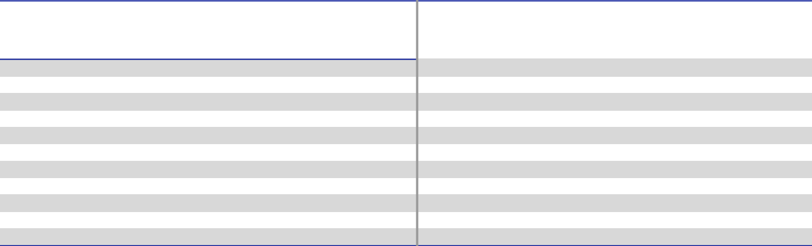

DIRECTOR

DEBORAH L. DEHAAS

H. JOHN GILBERTSON, JR.

KRISTIANE C. GRAHAM

MICHAEL F. JOHNSTON

ERIC A. SPIEGEL

RICHARD J. TOBIN

STEPHEN M. TODD

STEPHEN K. WAGNER

KEITH E. WANDELL

MARY A. WINSTON

MEETINGS HELD IN 2021

 |  | Governance
 |  | and
Audit | Compensation | Nominating | Finance
Committee | Committee | Committee | Committee
✓
✓ | ✓ | ✓ | ✓
✓ | ✓ | ✓ | ✓ (Chair)

- (Chair)

✓ | ✓ (Chair) | ✓ (Chair) | ✓
 | ✓ |  | ✓
8 | 5 | 4 | 9

DOVER CORPORATION – 2022 Proxy Statement 25

Table of Contents

PROPOSAL 1 — ELECTION OF DIRECTORS

Overview of Committee Responsibilities


Audit Committee

Stephen M. Todd (Chair)

Deborah L. DeHaas H. John Gilbertson, Jr. Eric A. Spiegel Stephen K. Wagner

Key Responsibilities

- Selecting and engaging our independent registered public accounting firm (“independent auditors”)

- Overseeing the work of our independent auditors and our internal audit function

- Approving in advance all services to be provided by, and all fees to be paid to, our independent auditors, who report directly to the committee

- Reviewing with management and the independent auditors the audit plan and results of the auditing engagement

- Reviewing with management and our independent auditors the quality and adequacy of our internal control over financial reporting

The Audit Committee holds regular quarterly meetings at which it meets separately with each of our independent registered public accounting firm, PwC, our internal audit function, financial management and our general counsel to assess certain matters including the status of the independent audit process, management’s assessment of the effectiveness of internal control over financial reporting and the operation and effectiveness of our compliance program. In addition, the Audit Committee, as a whole, reviews and meets to discuss the contents of each Form 10-Q and Form 10-K (including the financial statements) prior to its filing with the SEC.

Our Board has determined that all members of the Audit Committee qualify as “audit committee financial experts” as defined in the SEC rules.

The Audit Committee’s responsibilities and authority are described in greater detail in its written charter.


Compensation Committee

Keith E. Wandell (Chair)

Kristiane C. Graham Michael F. Johnston Mary A. Winston

Key Responsibilities

The Compensation Committee, together with our independent directors, approves compensation for the CEO of

Dover. The functions of the Compensation Committee also include:

- Approving compensation for executive officers who report directly to the CEO (together with the CEO, “senior executive officers”)

- Granting awards and approving payouts under our 2012 Equity and Cash Incentive Plan (the “2012 LTIP”), our 2021 Omnibus Incentive Plan (the “2021 LTIP”). and our AIP

- Approving changes to our executive compensation plans

- Reviewing and recommending compensation for the Board

- Overseeing succession planning and management development programs

The Compensation Committee’s responsibilities and authority are described in greater detail in its written charter.

DOVER CORPORATION – 2022 Proxy Statement 26

Table of Contents

PROPOSAL 1 — ELECTION OF DIRECTORS

 |  | Governance and Nominating Committee
Stephen K. Wagner (Chair) |  | Key Responsibilities
Kristiane C. Graham |  | • Developing and recommending corporate governance principles to our Board
Michael F. Johnston |  | • Annually reviewing the requisite skills and characteristics of board members as well as the size,
 |  | composition, functioning and needs of our Board as a whole
 |  | • Considering and recommending to the Board nominees for election to, or for filling any vacancy on, our
 |  | Board in accordance with our by-laws, our governance guidelines, and the committee’s charter
 |  | • Identifying and recommending to our Board any changes it believes desirable in the size and composition of
 |  | our Board
 |  | • Recommending to our Board any changes it believes desirable in structure and membership of our Board’s
 |  | committees
 |  | • Providing oversight of Dover’s practices on political contributions and lobbying expenses and reviewing
 |  | annually Dover’s political contributions and lobbying expenses
 |  | The Governance and Nominating Committee’s responsibilities and authority are described in greater detail in its
 |  | written charter.

 |  |  | Finance Committee
Eric A. Spiegel (Chair) |  | Key Responsibilities
H. John Gilbertson, Jr. |  | • Reviewing and recommending for approval by the Board proposed changes to dividend policies, stock splits,
Keith E. Wandell |  | and repurchase programs
Mary A. Winston |  | • Reviewing our capital structure, liquidity, and financing plans
 |  | • Reviewing and approving the registration and issuance of debt or equity securities
 |  | • Subject to thresholds determined from time to time by the Board, reviewing and approving, or reviewing and
 |  | recommending for Board approval, capital expenditures
 |  | • Subject to thresholds determined from time to time by the Board, reviewing and approving, or reviewing and
 |  | recommending for Board approval, M&A transactions
 |  | • Oversight of treasury, insurance, and tax planning matters
 |  | The Finance Committee’s responsibilities and authority are described in greater detail in its written charter.
 |  |  | DOVER CORPORATION – 2022 Proxy Statement 27

Table of Contents

PROPOSAL 1 — ELECTION OF DIRECTORS

Corporate Governance

Our Board is committed to sound governance practices and regularly reviews and refines our profile to reflect evolving best practices and matters raised by our shareholders. The following summarizes key aspects of our governance framework.

 | GOVERNANCE HIGHLIGHTS
Independent | • All directors are independent, other than our CEO, and our Board has leadership that is independent from
Board of Directors | management, by way of an independent Chair.
Commitment to | • In 2020, our Board adopted a policy reflected in our Corporate Governance Guidelines requiring that the initial list of
Commitment to | potential director and external CEO candidates presented by third-party search firms include qualified candidates
Diversity
Diversity | who reflect diverse backgrounds, including diversity of gender and race or ethnicity.
Special | • In 2020, we amended our by-laws to reduce the ownership threshold required to call a special meeting of
Shareholder | shareholders to 15% or more of the voting power of our outstanding stock from 25%.
Meetings
Elimination of
Super-majority | • All of the supermajority voting provisions in our charter were eliminated in 2019.
Provisions
Board Committee | • Our Board periodically reviews committee composition and chair positions, seeking the appropriate blend of
Refreshment | continuity and fresh perspectives on committees.
Annual Majority | • All of our directors are elected annually by our shareholders.
Annual Majority | • Our directors must receive a majority of the votes cast in uncontested elections to be elected.
Vote Director
Elections & | • We have a director resignation policy that requires a director to tender an irrevocable resignation letter to the Board
Mandatory | prior to being nominated, contingent on the director not receiving a majority of the votes cast in an uncontested election
Resignation Policy | and the Board’s acceptance of the resignation. The Governance and Nominating Committee will recommend to the full
 | Board whether to accept the resignation or whether to take other action.
 | • Our by-laws permit a shareholder or a group of up to 20 shareholders owning 3% or more of our outstanding
Proxy Access | common stock continuously for at least three years to nominate and include in our proxy materials director candidates
Proxy Access | constituting up to the greater of two individuals or 20% of the Board, provided that the shareholder(s) and the
 | nominee(s) satisfy the requirements specified in our by-laws.

Board Leadership Structure

We believe that having an independent leader of the Board is important to the Board’s oversight role and decision-making involving corporate strategy, performance, succession, and other critical matters. Under our current Board leadership structure, our Board has leadership that is independent from management by way of an independent Chair. Our CEO is also a member of the Board as a management representative. We believe this is important to make information and insight directly available to the directors in their deliberations. In our view, this board leadership structure gives us an appropriate, well-functioning balance between non-management and management directors that combines experience, accountability and effective risk oversight.

Board, Committee and Individual Director Evaluations

Our Board and its committees conduct robust annual self-evaluations of their performance. In addition, our Board evaluates one-third of our directors on a rotating individual basis each year with the purpose of assisting each director to be a more effective member of the Board. New directors undergo the evaluation process in each of their first two years on the Board. Our directors believe the rotational nature of our evaluation process enables a more in-depth, comprehensive evaluation for each of our directors.

DOVER CORPORATION – 2022 Proxy Statement 28

Table of Contents

PROPOSAL 1 — ELECTION OF DIRECTORS

Directors’ Meetings and Attendance

During 2021, the Board met seven times. No director attended less than 75% of the board and standing committee meetings held while he or she was a member of the Board and relevant standing committee. Average board attendance was over 97% in 2021. Our independent directors meet at regularly scheduled executive sessions at least quarterly without management representatives or non-independent directors present. The Chair of the Board presides at these sessions. We expect our directors to attend the Annual Meeting. All directors attended the 2021 Annual Meeting.

Our directors also regularly engage with management and outside subject matter experts outside of formal meetings. Examples include developing agendas and reviewing the content of materials in advance of meetings, calls, or in-person meetings with members of management to prepare for meetings, receiving periodic updates from management on significant operational or strategic developments between meetings, and, from time to time, engaging with shareholders.

Management Meetings and Site Visits

We encourage our directors to meet with senior managers throughout the enterprise and attend management’s strategic planning sessions. When considering businesses to visit, priority goes to those businesses identified as strategically important as well as those that were recently acquired. From time to time, the Board makes on-site visits to our businesses to tour the manufacturing facilities and meet face-to-face with company management and employees. These visits serve as an important tool in the Board’s succession planning process for our senior leadership team and enable a deeper understanding of our businesses and our culture. In 2021, these types of opportunities for engagement were largely conducted virtually rather than in-person.

Director Orientation and Education

All new directors participate in our director orientation program. New directors meet with senior corporate leaders to review and discuss our businesses, operations, strategy, end markets, governance, internal controls, and culture. We believe that our on-boarding approach, coupled with participation in regular Board and committee meetings, as well as additional exposure to our business through participation in management meetings and site visits, whether virtually or in-person, provides new directors a strong foundation in our businesses and accelerates their effectiveness to fully engage in Board deliberations.

Our Board also encourages directors to participate annually in continuing director education programs outside of the Boardroom, and we reimburse directors for their expenses associated with this participation.

Director Independence

Our Board has determined that each of the current members of the Board, except for Richard J. Tobin, who is our CEO, has no material relationship with Dover and satisfies all the criteria for being “independent” members of our Board. This includes the criteria established by the U.S. Securities and Exchange Commission (“SEC”) and the New York Stock Exchange (“NYSE”) listing standards, as well as our standards for classification as an independent director which are available on our website at www.dovercorporation.com. Our Board makes an annual determination of the independence of each nominee for director prior to his or her nomination for re-election. No director may be deemed independent unless the Board determines that he or she has no material relationship with Dover, directly or as an officer, shareholder or partner of an organization that has a material relationship with Dover.

Majority Standard for Election of Directors and Mandatory Resignation Policy

Under our by-laws and corporate governance guidelines, the voting standard in director elections is a majority of the votes cast. Under this majority of the votes cast standard, a director must receive more votes in favor of his or her election than votes against his or her election. Abstentions and broker non-votes do not count as votes cast with respect to a director’s election. In contested director elections (where there are more nominees than available seats on the board), the plurality standard will apply. Under the plurality standard, the nominees who receive the most “for” votes are elected to the Board until all seats are filled.

For an incumbent director to be nominated for re-election, he or she must submit an irrevocable resignation letter. The resignation will be contingent on the nominee not receiving a majority of the votes cast in an uncontested election and on the Board’s acceptance of the resignation. If an incumbent director fails to receive a majority of the votes cast in an uncontested

DOVER CORPORATION – 2022 Proxy Statement 29

Table of Contents

PROPOSAL 1 — ELECTION OF DIRECTORS

election, the Governance and Nominating Committee will make a recommendation to our Board concerning whether to accept or reject the resignation or whether other action should be taken. Our Board will act on the resignation within 90 days following certification of the election results, taking into account the committee’s recommendation. The Board will publicly announce its decision and, if the resignation is rejected, the rationale for its decision.

Governance Guidelines and Code of Ethics

Our Board long ago adopted written corporate governance guidelines that set forth the responsibilities of our Board and the qualifications and independence of its members and the members of its standing committees. The Board reviews these guidelines at least annually, in light of evolving best practices, shareholder feedback and the evolution of our business. In 2020, the Board amended the guidelines to require that initial lists of potential director and external CEO candidates presented by third-party search firms include qualified candidates who reflect diverse backgrounds, including diversity of gender and race or ethnicity. In addition, our Board has a long-standing Code of Conduct setting forth standards applicable to all of our companies and their employees, a code of ethics for our CEO and senior financial officers, and charters for each of its standing committees. All of these documents (referred to collectively as “governance materials”) are available on our website at www.dovercorporation.com.

Procedures for Approval of Related Person Transactions

We generally do not engage in transactions in which our senior executive officers or directors, any of their immediate family members or any of our 5% shareholders have a material interest. Should a proposed transaction or series of similar transactions involve any such persons and an amount that exceeds $120,000, it would be subject to review and approval by the Governance and Nominating Committee in accordance with a written policy and the procedures adopted by our Board, which are available with the governance materials on our website.

Under the procedures, management determines whether a proposed transaction requires review under the policy and, if so, presents the transaction to the Governance and Nominating Committee. The Governance and Nominating Committee reviews the relevant facts and circumstances of the transaction and approves or rejects the transaction. If the proposed transaction is immaterial or it is impractical or undesirable to defer the proposed transaction until the next committee meeting, the Chair of the committee decides whether to (i) approve the transaction and report the transaction at the next meeting or (ii) call a special meeting of the committee to review and approve the transaction. Should the proposed transaction involve the CEO or enough members of the Governance and Nominating Committee to prevent a quorum, the disinterested members of the committee will review the transaction and make a recommendation to the Board, and the disinterested members of the Board will then approve or reject the transaction. No director may participate in the review of any transaction in which he or she is a related person.

Communication with Directors

The Audit Committee has established procedures for (i) the receipt, retention and treatment of complaints regarding accounting, internal accounting controls or auditing matters (“accounting matters”) and (ii) the confidential, anonymous submission by employees of concerns regarding questionable accounting matters. Such complaints or concerns may be submitted to Dover, care of our Corporate Secretary or through the communications coordinator, an external service provider, by mail, fax, telephone, or via the internet as published on our website. The communications coordinator forwards such communications to Dover without disclosing the identity of the sender if anonymity is requested.

Shareholders and other interested persons may also communicate with our Board and the non-management directors in any of these same manners.

Such communications are forwarded to the Chair of the Governance and Nominating Committee.

DOVER CORPORATION – 2022 Proxy Statement 30

Table of Contents

PROPOSAL 1 — ELECTION OF DIRECTORS

Shareholder Engagement and History of Board Responsiveness

Shareholder Engagement

In 2021, we continued our focus on regularly engaging with our shareholders. We reached out to holders of approximately 60% of our shares outstanding, and engaged with governance professionals and/or portfolio managers at investors holding approximately 31% of our shares outstanding. Our shareholder engagement team consists of senior management and has also included our Chair from time to time. We also participate in various governance forums with our shareholders and regularly engage with shareholders through industry conferences and meetings.

We received feedback from investors on a range of topics, including corporate governance topics such as the right of shareholders to act by written consent. We are pleased with the feedback we received with investors on the topics we discussed, and look forward to ongoing engagement with our shareholders in order to continue to incorporate their views into our Board’s decision-making process. We aim to have best-in-class governance and compensation structures at Dover.

 | KEY ITEMS OF DISCUSSION AND FEEDBACK
Performance & | • We reviewed our portfolio of businesses, performance, strategic priorities, and focus on continuing to deliver long-
Long-Term | term value to shareholders despite a challenging operating environment caused by the COVID-19 pandemic.
Strategy
Capital Allocation | • We discussed how our balance sheet strength and history of prudent capital allocation served as differentiating factors
Capital Allocation | that allowed us to remain flexible during the market dislocation caused by the COVID-19 pandemic.
 | • We discussed how we are taking a thoughtful approach to developing a center-led approach to human capital
 | management and diversity and inclusion.
Diversity & | • Shareholders expressed appreciation for the new transparency on the sustainability portion of our website regarding
Inclusion | workforce demographics (gender, ethnicity, age).
 | • We also discussed the diversity & inclusion goals we set in 2021 related to conducting an engagement survey to
 | establish a baseline measure of inclusivity, and implementing unconscious bias training for employees with direct reports.
 | • We discussed ESG program, including our recently announced goals to reduce our GHG emissions by 2030, the results
 | of our climate risk assessment and scenario analysis aligned with the TCFD reporting framework, the extensive disclosures
ESG | available on the sustainability portion of our website, and our SASB and GRI-aligned disclosures.
 | • We also discussed that, in 2022, we plan to continue to make progress in several key priority areas in line with our
 | three-year plan to expand the scope and robustness of our ESG practices and disclosures.
 | • Shareholders expressed strong support for the meaningful changes implemented to our executive compensation
 | program in 2020. They expressed appreciation for the additional detail presented in our proxy statement regarding the
Executive | weighting, nature and performance outcomes for the individual strategic objectives in our AIP, as well as improved
Executive | disclosure regarding the threshold, target and maximum levels for the financial goals in our AIP. For LTIP awards made
Compensation | in 2020, they also supported the increase in the proportion of awards dedicated to performance shares and the shift to
 | relative TSR from internal TSR as the performance metric for performance shares. In addition, shareholders expressed
 | support for continuing to include the effective oversight and management of ESG matters as a strategic objective for
 | our CEO under the AIP and welcomed our recent adoption of a comprehensive clawback policy.
 | • Our shareholders continued to express their broad support for our governance practices and shareholder rights,
 | including special meeting right, use of annual director elections, and independent Board leadership structure, and thoughtful
Corporate | and active refreshment process.
Corporate | • Many of our shareholders continued to express the view that the right to act by written consent is unnecessary in light of
Governance
 | our shareholders’ existing right to call special meetings. Moreover, to the extent some shareholders desired greater
 | rights, the feedback was that our adoption of a 15% ownership threshold in 2020 for special meetings was preferable
 | to a written consent right.
 | DOVER CORPORATION – 2022 Proxy Statement 31

Table of Contents

PROPOSAL 1 — ELECTION OF DIRECTORS

History of Board Responsiveness

We are committed to being responsive to our shareholders as demonstrated by the number of changes we have made over the years based on their input. In direct response to shareholder feedback, over the past 8 years, Dover has adopted and amended our special meeting right, adopted proxy access, implemented meaningful changes to our executive compensation program, removed all our super-majority voting provisions in our charter, adopted a robust clawback policy, and enhanced our disclosures to investors. The table below highlights many of the changes to our governance structures and compensation program that have been implemented over the past several years informed by shareholder feedback. These changes specifically address shareholders’ areas of focus and input gathered through our extensive shareholder engagements and outreach efforts.

Year | % of Outstanding Shares | Actions in Response to Shareholder Feedback
Year | Outreached /Engaged | Actions in Response to Shareholder Feedback
2022 | Lead-up to 2022 AGM: | ✓ Currently engaging with shareholders on corporate governance, executive compensation and sustainability
2022 | Ongoing | ahead of the 2022 Annual Meeting
 |  | ✓ Continued to maintain a refreshed and diverse board by appointing an additional female director
 |  | ✓ Made several ESG accomplishments including:
 |  | ✓ Announcing goals to reduce our GHG emissions by 2030
2021 | 59% / 31% | ✓ Undertaking a climate risk assessment aligned with the TCFD reporting framework
2021 | 59% / 31% | ✓ Setting new diversity & inclusion goals
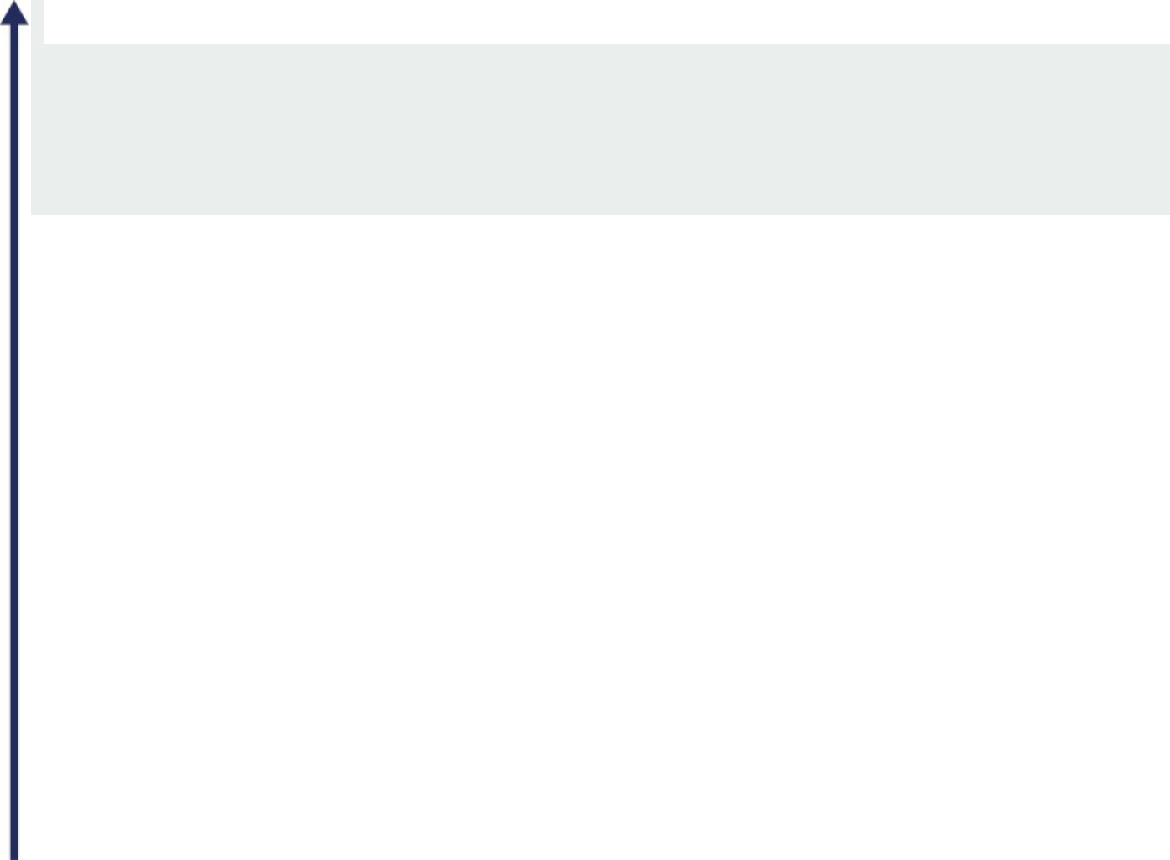
✓ Establishing a working group of operating companies with a goal of embedding sustainability considerations into product development

Winter: 65% / 15%

Lead-up to 2020 AGM:
²⁰²⁰ 51% / 12% Fall: 59% / 38%

- Implemented for 2020 executive compensation program:

  - Increased proportion of LTIP dedicated to performance shares and shifted from internal TSR to relative TSR as metric for performance shares
  - Reduced maximum payout ceiling from 400% to 300% in LTIP

- Reduced ownership threshold required to call a special meeting of shareholders to 15% from 25%

- Adopted a diversity search policy for external director and CEO searches conducted by third-party search firms
- Made several ESG accomplishments including:

  - A robust materiality assessment to help identify go-forward focus areas

  - The launch of the sustainability portion of our website

  - Publication of SASB and GRI indices

  - Release of an “investor tear sheet” covering key ESG highlights

  - Increased transparency into workforce demographics

Lead-up to 2019 AGM:

₂₀₁₉ 63% / 37% Fall: 63% / 41%

- Achieved removal of all supermajority provisions through submission of management proposal and comprehensive retail investor campaign
- Enhanced disclosure regarding individual strategic objectives and financial metrics in AIP

- Adopted comprehensive clawback policy

- Incorporated ESG oversight into CEO’s individual strategic objectives in AIP

2018 | 51% | / 32% | ✓ Put forth management proposal to remove supermajority voting provisions alongside comprehensive
2018 | 51% | / 32% | campaign with retail investors to build support – did not pass
2017 | 53% | / 33% | ✓ Updated AIP to 60% financial metrics / 40% strategic objectives from 50% / 50%
2017 | 53% | / 33% | ✓ Put forth management proposal to remove supermajority voting provisions – did not pass
2016 | 60% | / 28% | ✓ Adoption of proxy access
2016 | 60% | / 28% | ✓ Put forth management proposal to provide shareholders with written consent right – did not pass
2015 | 39% | / 24% | ✓ Launch of governance-focused shareholder engagement program
2014 | - | / - | ✓ Adoption of special meeting right

DOVER CORPORATION – 2022 Proxy Statement 32

Table of Contents

PROPOSAL 1 — ELECTION OF DIRECTORS

Environmental, Social, and Governance Oversight (ESG)

Throughout our history, our commitment to corporate responsibility and sustainability has created significant value for our shareholders and stakeholders. Across our portfolio of businesses and our team of employees, we remain focused on operating and innovating sustainably to help meet the goals of our customers, realize the full potential of our employees through a culture that supports and values their efforts, and make the communities in which we operate stronger. For more information on our initiatives and accomplishments, please visit https://www.dovercorporation.com/sustainability/overview.

Materiality Analysis

We conducted a materiality analysis in 2020 to identify the ESG issues most important to our business and stakeholders. Please see below for the specific areas of focus identified through the analysis. The findings from the materiality analysis were used by our Sustainability Steering Committee, comprised of our corporate and business leaders, to identify the ESG topics that are most critical to the company. These ESG areas of focus will guide our sustainability strategy moving forward as we implement a three-year ESG plan. For each sustainability topic, we are applying our resources, expertise, and innovation to improve outcomes and drive results.
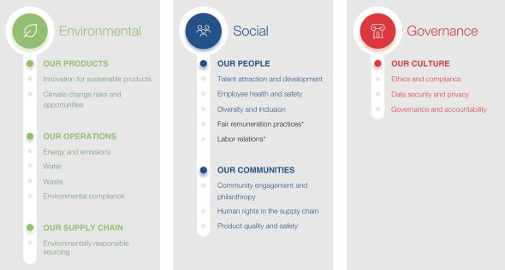

- Dover progress information to be provided on these topics in 2022

Governance Oversight of ESG

Our governance framework serves as a strong foundation to promote the long-term interests of our shareholders. Our Board oversees our long-term strategic development and enterprise risk, including ESG risks. The Board’s oversight spans a wide array of ESG issues, including those related to climate change, health and safety, diversity and inclusion, ethics and compliance, and long-term environmental protection. As part of its continued focus on sustainability, our Board incorporates ESG oversight into the CEO’s annual performance and compensation evaluation as one of the CEO’s strategic objectives. The Board also has established a comprehensive enterprise risk management process to identify and manage risks, including any risks related to environmental and social issues.

Additionally, our cross-functional Sustainability Steering Committee was established in 2020 to manage ESG issues, meets at least four times per year, and provides an update to the Board at least annually. The Committee is responsible for guiding our sustainability strategy, initiatives, target-setting, performance, and reporting.

DOVER CORPORATION – 2022 Proxy Statement 33

Table of Contents

PROPOSAL 1 — ELECTION OF DIRECTORS

Progress Toward Goals

In 2021, we made progress on a number of fronts in line with our three-year ESG plan. We formalized our commitment to science-based emissions targets by announcing a goal of reducing scope 1 and scope 2 market-based GHG emissions of 30 percent by 2030 (from a 2019 baseline year) and reducing scope 3 GHG emissions of 15 percent by 2030 (from a 2019 baseline year). We also conducted a TCFD-aligned climate risk assessment and scenario analysis and recently published a summary of the results on our website to further improve transparency regarding our ESG areas of focus. Also, as part of our efforts around increasing our focus on developing products that help our customers meet their sustainability goals, we engaged with some of our operating companies during 2021 regarding innovation for sustainable products. Finally, we announced new goals regarding diversity & inclusion and TRIR reduction.

DOVER CORPORATION – 2022 Proxy Statement 34

Table of Contents

PROPOSAL 1 — ELECTION OF DIRECTORS

Directors’ Compensation

Our non-employee directors’ annual compensation is payable partly in cash and partly in common stock in an allocation our Board may adjust from time to time. If any director serves for less than a full calendar year, the compensation to be paid to that director for the year will be pro-rated as deemed appropriate by our Compensation Committee.

Our Board has adopted a policy that directors are expected to hold at any time a number of shares at least equal to the aggregate number of shares they received as the stock portion of their annual retainer during the past five years, net of an assumed 30% tax rate.

FOR 2021, NON-EMPLOYEE DIRECTOR COMPENSATION WAS AS FOLLOWS:

Annual retainer of $270,000, payable $150,000 in common stock and $120,000 in cash

Audit Committee Chair — additional annual cash retainer of $30,000

Compensation Committee Chair — additional annual cash retainer of $20,000

Governance and Nominating Committee Chair and Finance Committee Chair — additional annual cash retainer of $15,000

Board Chair — additional annual retainer of $170,000, payable $130,000 in cash and $40,000 in common stock

Under our 2021 LTIP, each non-employee director can elect to defer the receipt of 0%, 50%, or 100% of the equity compensation payable in a year until termination of services as a non-employee director. Shares deferred are converted into deferred stock units representing the right to receive one share of our common stock for each unit held at the end of the deferral period. Dividend equivalents are credited on deferred stock units and will be distributed in cash at the time that shares are distributed in settlement of deferred stock units. Messrs. Johnston, Spiegel, Todd, and Wagner and Mses. Graham and DeHaas elected to defer receipt of their 2021 equity compensation and received deferred stock units.

The table below sets forth the compensation paid to our directors for services in 2021.

 | FEES EARNED | STOCK
 | OR PAID | AWARDS ($) | TOTAL
NAME | IN CASH ($)(1) | (2) | ($)
DEBORAH L. DEHAAS⁽³⁾ | 106,521 | 133,075 | 239,595
H. JOHN GILBERTSON, JR | 120,000 | 150,078 | 270,078
KRISTIANE C. GRAHAM | 120,000 | 150,078 | 270,078
MICHAEL F. JOHNSTON | 250,000 | 189,983 | 439,983
ERIC A. SPIEGEL | 135,000 | 150,078 | 285,078
STEPHEN M. TODD | 150,000 | 150,078 | 300,078
STEPHEN K. WAGNER | 135,000 | 150,078 | 285,078
KEITH E. WANDELL | 140,000 | 150,078 | 290,078
MARY A. WINSTON | 120,000 | 150,078 | 270,078
- Amounts include the standard annual cash retainer, the Chair’s additional cash retainer, and the additional annual cash retainer for committee Chairs.
- On November 15, 2021, each of Messrs. Gilbertson and Wandell and Ms. Winston received 865 shares of common stock with an aggregate grant date fair market value of $150,078, Messrs. Spiegel, Todd and Wagner and Ms. Graham each received 865 deferred stock units with an aggregate grant date fair market value of $150,078, and Mr. Johnston received 1,095 deferred stock units with an aggregate grant date fair market value of $189,983, which included his additional compensation as Board Chair.
- Ms. DeHaas was first elected to the Board on February 11, 2021 and accordingly received pro-rata cash and equity in 2021. Ms. DeHaas received 767 deferred stock units on November 15, 2021 with an aggregate grant date fair market value of $133,075.

Our Compensation Committee reviews our non-employee director compensation policy biennially and proposes changes to the Board, as appropriate. In reviewing the non-employee director compensation policy in 2022, our Compensation Committee

DOVER CORPORATION – 2022 Proxy Statement 35

Table of Contents

worked with its independent compensation consultant to assess the competitiveness of our non-employee director compensation policy based on benchmark information from peer companies and relevant compensation surveys. Based on its review, our Compensation Committee proposed and the Board adopted the following change to our non-employee director compensation policy to be effective in 2022: an increase by $15,000 of the annual retainer for non-employee directors, payable in common stock.

DOVER CORPORATION – 2022 Proxy Statement 36

Table of Contents

Proposal 2 — Ratification of Appointment of Independent Registered Public Accounting Firm

The Audit Committee has appointed the independent registered public accounting firm of PwC to audit the annual accounts of Dover and its subsidiaries for 2022. PwC has audited the financial statements for the Company since 1995. Representatives of PwC are not expected to be present at the Annual Meeting.

Although shareholder ratification of PwC’s appointment is not required by Dover’s by-laws or otherwise, our Board is submitting the ratification of PwC’s appointment for the year 2022 to Dover’s shareholders. If the shareholders do not ratify the appointment of PwC, the Audit Committee will reconsider whether or not to retain PwC as Dover’s independent registered public accounting firm for the year 2022 but will not be obligated to terminate the appointment. Even if the shareholders ratify the appointment of PwC, the Audit Committee in its discretion may direct the appointment of a different independent registered public accounting firm at any time during the year if the Audit Committee determines that such a change would be in Dover’s interests.

THE BOARD RECOMMENDS A VOTE “FOR” RATIFICATION OF THE APPOINTMENT

OF PWC AS OUR INDEPENDENT REGISTERED PUBLIC ACCOUNTING FIRM FOR THE YEAR 2022.

DOVER CORPORATION – 2022 Proxy Statement 37

Table of Contents

PROPOSAL 2 — RATIFICATION OF APPOINTMENT OF INDEPENDENT REGISTERED PUBLIC ACCOUNTING FIRM

Audit Committee Report


The Audit Committee is composed of directors who, in the opinion of the Board, are independent and financially literate under NYSE rules and qualify as audit committee financial experts as defined by the SEC. Information concerning the credentials of the Audit Committee members can be found in the section of this proxy statement entitled “Proposal 1 — Election of Directors”.

The Audit Committee operates under a written charter adopted by the Board and available on Dover’s website. The Audit Committee assists the Board in overseeing the quality and integrity of Dover’s financial statements, compliance with legal and regulatory requirements, the qualifications, performance and independence of the independent auditors, and the performance of the internal audit function.

Among other things, the Audit Committee appoints the Company’s independent auditors and is directly involved in the selection of the lead audit engagement partner, discusses with the internal audit function and independent auditors the overall scope and plans for their respective audits, reviews the Company’s accounting policies and system of internal controls, reviews significant financial transactions, discusses with management and with the Board processes relating to risk management, pre-approves audit and permissible non-audit services provided by the independent auditors, and approves all fees paid to the independent auditors for such services.

For 2021, the Audit Committee engaged the independent registered public accounting firm PwC as Dover’s independent auditor. In selecting PwC, the Audit Committee considered, among other things: the experience and qualifications of the lead audit partner and other senior members of the PwC team; PwC’s historical performance on Dover’s audit and the quality of its communications with the Audit Committee; the results of the most recent internal quality control review or Public Company Accounting Oversight Board (“PCAOB”) inspection; PwC’s independence; its reputation for integrity and competence in the fields of accounting and auditing; the appropriateness of its fees; and its tenure as Dover’s independent auditors, including its understanding of the Company’s global businesses, accounting policies and practices, and internal control over financial reporting.

The Audit Committee discussed with PwC the overall scope and plans for the audit of Dover’s 2021 financial statements. The Audit Committee met with PwC, with and without management present, to discuss the results of PwC’s examination, their assessment of internal controls and the overall quality of financial reporting.

The Audit Committee reviewed and discussed, with both the management of Dover and PwC, Dover’s 2021 audited financial statements, including a discussion of critical accounting policies, the quality, not just the acceptability, of the accounting principles followed, the reasonableness of significant judgments reflected in such financial statements and the clarity of disclosures in the financial statements. The Audit Committee met a total of eight times in 2021 and 2022 to discuss 2021 quarterly and full-year financial results and related disclosures.

The Audit Committee has received the written disclosures and the Rule 3526 letter from PwC required by the applicable requirements of PCAOB regarding the independent auditor’s communications with the Audit Committee concerning independence, and discussed with PwC its independence, including the impact of any relationships or permitted non-auditing services on PwC’s independence. The Audit Committee also discussed with PwC the matters required to be discussed under PCAOB Auditing Standard No. 1301. The Audit Committee has also received written materials addressing PwC’s internal control procedures and other matters required by NYSE listing standards.

Based upon the review and discussions referred to above, the Audit Committee recommended that the audited financial statements for the year ended December 31, 2021 be included in Dover’s Annual Report on Form 10-K.

Audit Committee:

Stephen M. Todd (Chair)

Deborah L. DeHaas

H. John Gilbertson, Jr.

Eric A. Spiegel

Stephen K. Wagner

This report does not constitute “soliciting material” and shall not be deemed filed or incorporated by reference into any filing under the Securities Act of 1933 or under the Securities Exchange Act of 1934, except to the extent we specifically incorporate this report by reference, and shall not otherwise be deemed filed under such Acts.

DOVER CORPORATION – 2022 Proxy Statement 38

Table of Contents

PROPOSAL 2 — RATIFICATION OF APPOINTMENT OF INDEPENDENT REGISTERED PUBLIC ACCOUNTING FIRM

Fees Paid to Independent Registered Public Accounting Firm

Fees paid to, or accrued for, PwC for services to us and our subsidiaries for 2021 and 2020 (including reimbursable expenses) were as follows:

 |  |  | 2021 |  |  | 2020
AUDIT FEES | $ |  | 7,487,600 | $ |  | 7,697,324
AUDIT-RELATED FEES | $ |  | 55,870 | $ |  | 41,880
TAX FEES | $ |  | 182,323 | $ |  | 173,305
ALL OTHER FEES | $ |  | 900 | $ |  | 12,476
TOTAL |  |  | 7,726,693 |  |  | 7,924,985
 | $ |  |  | $

Audit Fees. Audit fees include fees for audit or review services in accordance with generally accepted auditing standards of our consolidated financial statements (including internal control over financial reporting), statutory and subsidiary audits and review of documents filed with the SEC.

Audit-Related Fees. Audit-related fees include fees for assurance and related services that are reasonably related to the audit of our financial statements, including system implementation assessments.

Tax Fees. Tax fees include fees for services that are performed by professional tax staff other than in connection with the audit. These services include tax compliance, consulting and advisory services.

All Other Fees. Other fees include fees for non-audit services not listed above that do not impair the independence of the auditor and are not prohibited by the SEC or PCAOB.

Pre-Approval of Services Provided by Independent Registered Public Accounting Firm

Consistent with its charter and applicable SEC rules, our Audit Committee pre-approves all audit and permissible non-audit services provided by PwC to us and our subsidiaries. With respect to certain services which PwC has traditionally provided, the Audit Committee has adopted specific pre-approval policies and procedures. In developing these policies and procedures, the Audit Committee considered the need to ensure the independence of PwC while recognizing that, in certain situations, PwC may possess the expertise and be in the best position to advise us and our subsidiaries on issues and matters other than accounting and auditing.

The policies and procedures adopted by the Audit Committee allow the pre-approval by the Audit Committee of permissible audit-related services, non-audit-related services and tax services. Under the policies and procedures, pre-approval is generally provided for up to one year and any general pre-approval is detailed as to the particular services or category of services and is subject to a specific budget for each of them. The policies and procedures require that any other services be expressly and separately approved by the Audit Committee prior to such services being performed by the independent auditors. In addition, pre-approved services which are expected to exceed the budgeted amount included in a general pre-approval require separate, specific pre-approval. For each proposed service, the independent auditors and management are required to provide detailed information to the Audit Committee at the time of approval. The Audit Committee considers whether each pre-approved service is consistent with the SEC’s rules and regulations on auditor independence.

All audit-related and non-audit-related services of PwC during 2021 listed above under “Fees Paid to Independent Registered Public Accounting Firm” were pre-approved specifically or pursuant to the procedures outlined above. With respect to any tax services provided by PwC, PwC provided to the Audit Committee the communications required under PCAOB Rule 3524.

DOVER CORPORATION – 2022 Proxy Statement 39

Table of Contents

Compensation Discussion and Analysis

This Compensation Discussion and Analysis (“CD&A”) describes our compensation program and how it operates for our NEOs. Our NEOs for 2021 are:

 | NAMED EXECUTIVE OFFICERS
RICHARD J. TOBIN | President & CEO
BRAD M. CEREPAK | Senior Vice President & CFO
GIRISH JUNEJA | Senior Vice President & Chief Digital Officer
IVONNE M. CABRERA | Senior Vice President & General Counsel
KIMBERLY K. BORS | Senior Vice President & Chief Human Resource Officer

Executive Summary

Our compensation program is based on a pay-for-performance philosophy and is designed to incent executives to achieve financial and strategic goals that are aligned with the Company’s long-term business strategy and the creation of sustained, long-term value for our shareholders.

2021 Performance & Results

In 2021, despite the COVID-related challenges we continued to face, including increased material, labor and logistics costs, we delivered strong financial results, made advancements in organic investments and productivity initiatives, and deployed capital in a disciplined manner, in keeping with our return-seeking strategic priorities.

- Generated revenue of $7.9 billion, up 18% (+15% organic) compared to the prior year

- Increased GAAP earnings by 64% and adjusted earnings by 35%

- Increased GAAP earnings per share by 65% and adjusted earnings per share by 35%

- Generated free cash flow of $944.4 million, an increase of $5.3 million compared to the prior year, representing 11.9% of revenue. Cash flow provided by operating activities was $1,115.9 million.

- Continued to evolve our operating model to include center-led value capture from digital opportunities, and continued to invest in growth and productivity initiatives, including automation, capacity expansion, and the implementation of common corporate systems and measurement tools.

- Increased our quarterly dividend, marking our 66th consecutive year of dividend increases

- Acquired nine businesses for total consideration of $1,125.1 million, net of cash acquired and including contingent consideration

DOVER CORPORATION – 2022 Proxy Statement 40

Table of Contents

COMPENSATION DISCUSSION AND ANALYSIS

Success on Key Metrics (2019-2021)
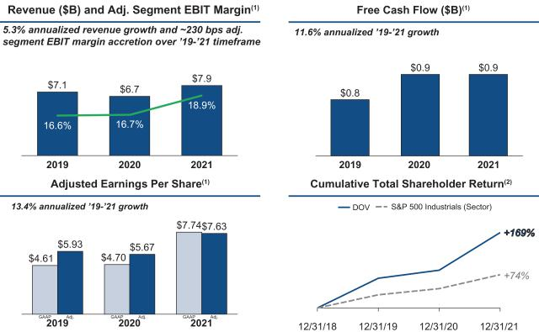

- Definitions and reconciliations of non-GAAP measures are included at the end of this proxy statement.
- Source: Capital IQ

2021 Pay Decisions Align with Dover’s Performance

Our compensation program structure is designed to align pay outcomes with our shareholders’ experience by emphasizing variable, at-risk pay for our management team, including the NEOs, through our AIP and long-term incentive program.

For 2021, our pay decisions and outcomes were consistent with our pay-for-performance philosophy. Our financial performance was strong in 2021, and we exceeded the financial performance target under our AIP. In addition, our NEOs made significant progress against their pre-defined individual strategic objectives as evaluated by our Compensation Committee under our AIP. Consistent with our value creation over the three-year performance period of 2019-2021, the performance shares for that period, which vested at the end of 2021 and were based on our historic internal TSR metric, had a payout percentage of 300% for our NEOs.

DOVER CORPORATION – 2022 Proxy Statement 41

Table of Contents

COMPENSATION DISCUSSION AND ANALYSIS

Say on Pay Vote Results and Shareholder Engagement

93% Say on Pay support | 60% Shares Outstanding Contacted | 31% Shares Engaged

Our Board has a strong history of engaging with shareholders and soliciting feedback on a range of topics, including our executive compensation program. Historically, our program has received strong shareholder support as expressed during our one-on-one engagement discussions with shareholders and through our Say on Pay vote levels.

At our 2021 annual meeting, approximately 93% of the voting shareholders approved the compensation of the NEOs. At our 2020 annual meeting, over approximately 96% of the voting shareholders approved the compensation of the NEOs. In 2021, we continued our shareholder engagement program. We reached out to holders of approximately 60% of our outstanding shares and engaged with governance professionals and/or portfolio managers of investors holding approximately 31% of our outstanding shares. In addition to the governance topics detailed earlier in this proxy statement, we had thoughtful discussions with our shareholders regarding our compensation program. Shareholders told us they believe our pay practices are aligned with our pay-for-performance philosophy. The Compensation Committee will continue to consider feedback from shareholders, as well as the results from future shareholder advisory votes, in its ongoing evaluation of executive compensation programs and practices at Dover.

DOVER CORPORATION – 2022 Proxy Statement 42

Table of Contents

COMPENSATION DISCUSSION AND ANALYSIS

Dover’s Alignment with Leading Compensation Governance Practices

WHAT WE DO

- The majority of target NEO pay opportunity is performance based (74% for the CEO; 62% for the other NEOs)

- A significant portion of target NEO pay opportunity is tied to Dover stock performance (73% for the CEO; 50% for the other NEOs)

- Robust engagement with shareholders to seek feedback on executive compensation programs

- Compensation program includes ESG objectives

- All long-term incentives are paid in stock, not cash

- Executives must hold significant amounts of Dover stock: five-times salary for the CEO, three-times for other NEOs

- All long-term incentives are earned or vest over three years

- Change in control provisions require double trigger

- Comprehensive clawback policy

WHAT WE DON’T DO

- No tax gross ups

- No repricing, reloads, or exchanges of SSARs

- No SSARs granted below fair market value

- No hedging or pledging of Dover securities by executives, including margin loans

- No dividends are paid on performance shares or RSUs during the earning or vesting period. Dividend equivalents are accrued on RSUs, but are only paid if the RSUs vest

- No special executive retirement arrangements

- No substantial executive perquisites, nor do we own or operate any corporate aircraft

- Executives participate in benefit and employee programs on the same basis as other Dover employees

- Our Compensation Committee retains its own independent consultant

- Annual compensation risk assessment

DOVER CORPORATION – 2022 Proxy Statement 43

Table of Contents

COMPENSATION DISCUSSION AND ANALYSIS

Compensation Principles

Guiding Principles for Dover’s Executive Compensation Program
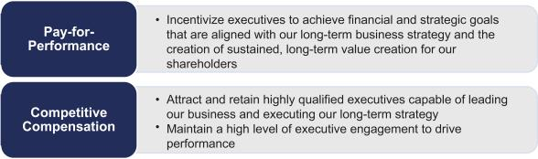

Based on these principles, these were the key elements of our program in 2021:

- Financial metrics that are clearly linked to the creation of shareholder value: adjusted earnings and three-year relative TSR.

- A focus on our business strategy to ensure our long-term compensation program aligns the interests of our executives with those of our shareholders by placing an emphasis on performance-based stock compensation.

- An annual review by our Compensation Committee of executive compensation levels and the components of our program.

- A reference to the median of our peer group for total direct compensation, with consideration for internal pay equity, sustained performance, specific responsibilities, and experience with comparable market talent.

- Total compensation opportunities designed so that the large majority of compensation is variable and at-risk based on financial, strategic, operational, and share price performance.

- An annual cash bonus plan (the AIP) designed to reward annual financial performance and the attainment of well-defined strategic objectives that the Board believes will assure the long-term success of Dover.

- Executive benefits and programs that are consistent with those offered to other employees. We provide substantially no executive perquisites, nor do we own or operate any corporate aircraft.

DOVER CORPORATION – 2022 Proxy Statement 44

Table of Contents

COMPENSATION DISCUSSION AND ANALYSIS

Compensation Process

Setting Executive Compensation — Roles

The process for determining our compensation program structure and payouts involves the dedicated participation of our Compensation Committee, the independent directors of the Board, the CEO, and our Compensation Committee’s independent consultant. The roles of each in making compensation decisions are:
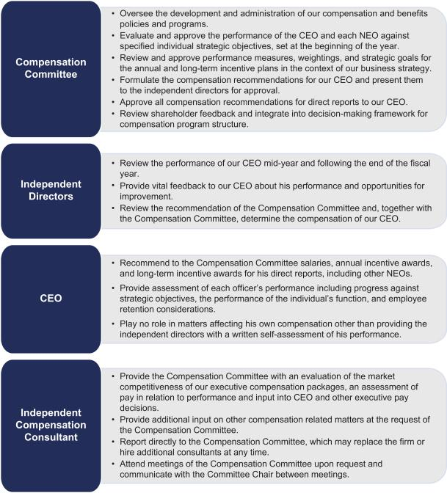

DOVER CORPORATION – 2022 Proxy Statement 45

Table of Contents

COMPENSATION DISCUSSION AND ANALYSIS

Setting Executive Compensation – Timeline

The process for making executive compensation decisions for 2021 began with goal setting at the beginning of the year and concluded with the actual compensation payout decisions in early 2022. As described below, this year-long process integrates key factors, such as Dover’s business strategy, our annual budget, and market compensation data.
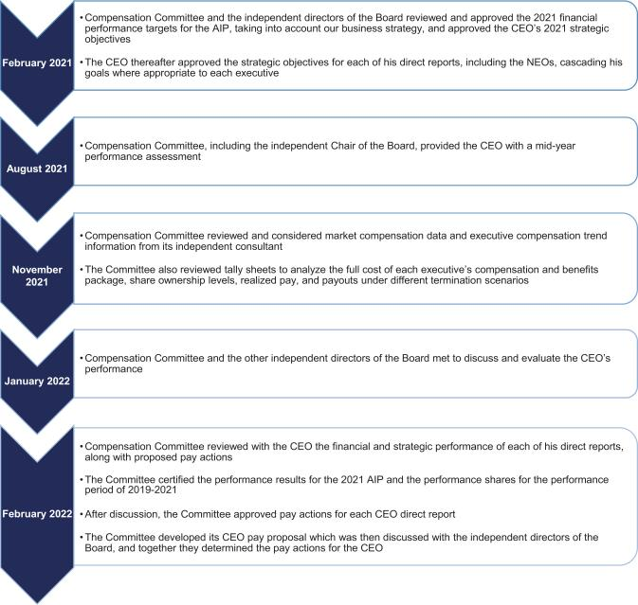

DOVER CORPORATION – 2022 Proxy Statement 46

Table of Contents

COMPENSATION DISCUSSION AND ANALYSIS

Executive Compensation Program Peer Group

For assessing executive pay programs and levels, the Compensation Committee selected a group of companies that are similar to Dover in terms of end markets, complexity, revenues and market capitalization. In 2021, with the help of its independent consultant, the Compensation Committee reviewed the peer group and made no changes to the group.

FINANCIAL CONSIDERATIONS

(IN USD MILLIONS) QUALITATIVE CONSIDERATIONS

COMPANY

CARLISLE COMPANIES


COLFAX CORPORATION

CORNING INCORPORATED

EATON CORPORATION

EMERSON ELECTRIC CO.


FLOWSERVE CORPORATION

FORTIVE CORPORATION

ILLINOIS TOOL WORKS INC.

INGERSOLL-RAND PLC

PARKER-HANNIFIN CORPORATION

ROCKWELL AUTOMATION INC.

ROPER INDUSTRIES INC.

SNAP-ON INCORPORATED

STANLEY BLACK & DECKER, INC.

TEXTRON INC.

XYLEM, INC.

75TH PERCENTILE

MEDIAN

25TH PERCENTILE

DOVER

 |  |  | 2021 |  | >20%
 | 2021 | MARKET |  | INDUSTRY | GLOBAL | DOVER-LIKE | SAME ANALYST
REVENUE |  |  | CAP(1) | INDUSTRY | REVENUES | STRUCTURE | COVERAGE(2)
$ | 4,810 | $ | 12,932 | Industrial | ✗ | ✗
 |  |  |  | Conglomerates
$ | 3,854 | $ | 7,115 | Industrial | ✗ | ✗ | ✗
 |  |  |  | Machinery
$ | 14,082 | $ | 31,772 | Electrical | ✗ |  | ✗
 |  |  |  | Equipment
$ | 19,628 | $ | 68,886 | Electrical | ✗ | ✗ | ✗
 |  |  |  | Equipment
$ | 18,236 | $ | 55,308 | Electrical | ✗ | ✗ | ✗
 |  |  |  | Equipment
$ | 3,541 | $ | 3,986 | Machinery | ✗ |  | ✗
$ | 5,255 | $ | 27,356 | Industrial | ✗ | ✗ | ✗
 |  |  |  | Machinery
$ | 14,455 | $ | 77,466 | Machinery | ✗ | ✗ | ✗
$ | 5,152 | $ | 25,217 | Machinery | ✗ | ✗ | ✗
$ | 14,348 | $ | 40,883 | Machinery | ✗ |  | ✗
$ | 6,997 | $ | 40,471 | Electrical | ✗ |  | ✗
 |  |  |  | Equipment
$ | 5,778 | $ | 51,884 | Industrial | ✗ | ✗ | ✗
 |  |  |  | Conglomerates
$ | 4,602 | $ | 11,530 | Industrial | ✗
 |  |  |  | Machinery
$ | 15,617 | $ | 30,751 | Industrial | ✗ |  | ✗
 |  |  |  | Machinery
$ | 12,382 | $ | 17,017 | Aerospace & | ✗ | ✗
 |  |  |  | Defense
$ | 5,195 | $ | 21,625 | Industrial | ✗ |  | ✗
 |  |  |  | Machinery
$ | 14,374 | $ | 43,633
$ | 6,388 | $ | 29,054
$ | 5,067 | $ | 15,996
$ | 7,907 | $ | 26,148

- As of 12/31/2021.

- “Same analyst coverage” means company is covered by at least five of the analysts that cover Dover.

DOVER CORPORATION – 2022 Proxy Statement 47

Table of Contents

COMPENSATION DISCUSSION AND ANALYSIS

Role of Internal Equity in Setting Executive Compensation

Management and our Compensation Committee consider both market benchmarks (i.e., external competitiveness), as well as the impact each executive role has relative to internal peers (i.e., internal equity), in establishing the executive pay structures used to govern pay.

Role of the Independent Compensation Consultant

Our Compensation Committee has the authority and discretion to retain external compensation consultants as it deems appropriate. Our Compensation Committee has adopted a policy to ensure the continuing independence and accountability to the committee of any advisor hired to assist the committee in the discharge of its duties. The policy formalizes the independent relationship between the Compensation Committee’s advisor and Dover, while permitting management limited ability to access the advisor’s knowledge of Dover for compensation matters. Under the policy, our Compensation Committee will annually review and pre-approve the services that may be provided to management by the independent advisor without further Compensation Committee approval. Compensation Committee approval is required prior to Dover retaining the independent advisor for any executive compensation services or other consulting services or products above an aggregate annual limit of $50,000.

Since September 2020, our Compensation Committee has retained Meridian Compensation Partners, LLC (“Meridian”) to serve as its independent compensation consultant. Meridian does no other work for and has no other relationships with Dover. Meridian is focused on executive compensation and does not have departments, groups, or affiliates that provide services other than those related to executive compensation and benefits.

Our Compensation Committee looks to its consultant to periodically review and advise regarding the adequacy and appropriateness of our overall executive compensation plans, programs, and practices and, from time to time, to answer specific questions raised by our Compensation Committee or management. Compensation decisions are made by, and are the responsibility of, our Compensation Committee and our Board, and may reflect factors and considerations other than the information and recommendations provided by our Compensation Committee’s consultant.

To ensure independence of the compensation consultant, the consultant reports directly to the Chair of our Compensation Committee and works specifically for the Compensation Committee solely on compensation and benefits.

Meridian did not engage in any projects for management in 2021. Our Compensation Committee has assessed the independence of Meridian and concluded that its work for the Compensation Committee does not raise any conflict of interest.

DOVER CORPORATION – 2022 Proxy Statement 48

Table of Contents

COMPENSATION DISCUSSION AND ANALYSIS

Elements of Executive Compensation

Variable, Performance-Based Compensation Program Structure Drives Pay-For-Performance Alignment

The pay packages of Dover executives consist predominantly of incentive-based pay, both annual and long-term. Each of the compensation components has a specific role in the overall design of our executive pay program. While the components are designed to be mutually reinforcing, care is taken to minimize overlap between them. The following table provides an overview of the 2021 compensation program structure.

Component | Pay Element | 2021 Metrics & Weighting | Objectives
 |  |  | Attract and retain qualified executives
Base Salary | Cash | n/a | Benchmarked to peer group median while also
 |  |  | considering additional factors such as experience and
 |  |  | performance in role
 |  |  | Intended to drive profitability, growth, and progress
 |  | 60% Financial Results: | against strategy
 |  | 60% Financial Results: | Individual objectives are focused on a limited and
Annual Incentive |  | ○ Adj. Earnings (100%) | Individual objectives are focused on a limited and
Annual Incentive | Cash | ○ Adj. Earnings (100%) | measurable set of goals to benefit shareholders over
Plan (AIP) |  | 40% Individual Strategic Objectives | the long-term
 |  | ○ ESG oversight included in CEO and select NEO | Including ESG oversight in objectives establishes
 |  | individual strategic objectives | clear tone at the top regarding the importance of ESG
 |  | 40% LTIP weighting | Focus executives on shareholder value creation
 |  | 40% LTIP weighting | Relative TSR closely aligns our executive-level
 | Performance Shares | Performance Criteria: 3-Year relative TSR with the | Relative TSR closely aligns our executive-level
 | Performance Shares | Performance Criteria: 3-Year relative TSR with the | measurement system with the experience of
 |  | S&P 500 Industrials index companies as the | measurement system with the experience of
 |  | S&P 500 Industrials index companies as the | shareholders
 |  | comparator group | shareholders
 |  | 40% LTIP Weighting | Focus executives on share price appreciation
Long-Term |  | 40% LTIP Weighting
Long-Term |  | Performance Criteria: Dover stock price, exercisable | SSARs are an important component of our program,
Incentive | SSARs | Performance Criteria: Dover stock price, exercisable | reflecting input from investors, many of whom
Incentive | SSARs | three years after grant date and remain exercisable for | reflecting input from investors, many of whom
Plan | SSARs | three years after grant date and remain exercisable for | reflecting input from investors, many of whom
Plan |  | another seven years (subject to 10-year stock price | acknowledge the role SSARs play in emphasizing
 |  | another seven years (subject to 10-year stock price | growth and go-forward value creation
 |  | movement) | growth and go-forward value creation
 |  | 20% LTIP weighting | Retention, ownership, and full alignment with the
 | RSUs | Performance Criteria: Dover stock price; awards vest | Retention, ownership, and full alignment with the
 | RSUs | Performance Criteria: Dover stock price; awards vest | shareholder experience
 |  | ratably over three years | shareholder experience
Benefits | Consistent with other similarly situated employees

DOVER CORPORATION – 2022 Proxy Statement 49

Table of Contents

COMPENSATION DISCUSSION AND ANALYSIS

2021 Target Pay Mix

The ratio between fixed and variable pay varies by executive level, but for the CEO and his direct reports, including the NEOs, we believe it is appropriate that the vast majority of the compensation should be “at risk” incentive-based pay as shown in the chart below. Additionally, we believe that incentive pay should be heavily weighted toward long-term performance and tied to share performance, with the annual incentives focused on key short-term drivers and progress on strategy.
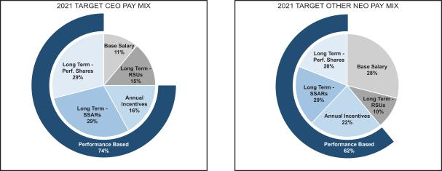

DOVER CORPORATION – 2022 Proxy Statement 50

Table of Contents

COMPENSATION DISCUSSION AND ANALYSIS

Pay-for-Performance Philosophy

Our Compensation Committee remains fully committed to its pay-for-performance philosophy. Dover’s record of long-term value creation is shown in the graphs below.

Total Shareholder Return^{1,2}
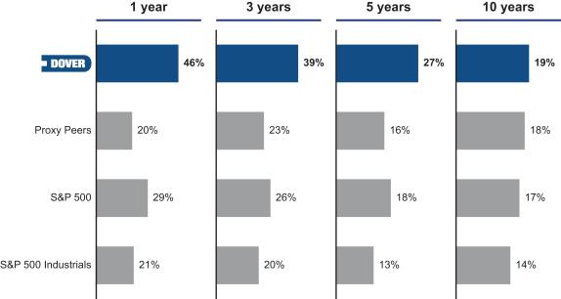

Note: These figures are annualized returns.

- End date for returns period is December 31, 2021.
- Annualized Total Shareholder Return including dividends and spin-offs. Fortive Corporation went public in July 2016 and Ingersoll Rand merged with Gardner Denver in March 2020. Both stocks are excluded from periods prior to go public / merger dates. Source: Capital IQ

DOV TSR vs. Proxy Peer Group (12/31/18 – 12/31/21)¹
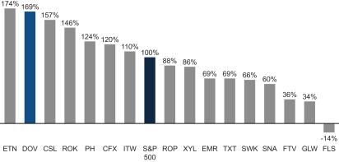

Note: These figures are annualized returns. Source: Capital IQ.

- Ingersoll Rand merged with Gardner Denver in March 2020 and is excluded from this analysis.

DOVER CORPORATION – 2022 Proxy Statement 51

Table of Contents

COMPENSATION DISCUSSION AND ANALYSIS

Annual Incentive Plan Compensation

An annual bonus may be earned each year based on an NEO’s performance against objectives tied to our financial performance as well as individual strategic goals. Each NEO’s bonus target amount is determined in reference to market benchmarking and according to the scope and complexity of the NEO’s functional responsibilities, overall impact on our results, strategic leadership, and managerial responsibility. We believe that balancing the measurement of performance for the annual bonus between financial and strategic objectives is important in mitigating risk and executing on our long-term strategy for value creation.

Each executive officer is eligible for a bonus equal to his or her base salary multiplied by his or her target award percentage multiplied by the Overall Payout Factor (which is the sum of the Financial Objective Factor (weighted 60%) and the Strategic Objectives Factor (weighted 40%)).
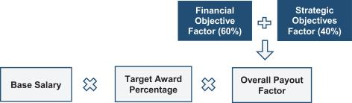

2021 AIP Financial Objective Factor – Target

The Financial Objective Factor in the 2021 AIP was calculated based on Adjusted Earnings. In setting the financial objective, our Compensation Committee considered our annual budget, operational priorities, plans for capital allocation, historical performance, and external factors, among other items. The target performance level for the financial objective was established at the beginning of the fiscal year and provided for appropriate adjustments for acquisitions and dispositions occurring during the year. For this measure, our Compensation Committee established threshold, target, and maximum levels of performance, as well as a payout percentage curve that relates each level of performance to a payout percentage.

Threshold and maximum performance levels are set at 85% and 107%, respectively, of target. The threshold and maximum performance levels were narrowed around target in 2021 to increase the performance sensitivity of the AIP. There is no payout on the Financial Objective Factor if performance is below the threshold. At threshold, the payout percentage curve begins at 50%. If performance is at the target level, the payout percentage is 100%. For performance at or above the maximum level of achievement, the payout percentage is capped at 200%.

The financial objective measure as originally established was adjusted to exclude forecasted performance contributions from Unified Brands following its sale on December 1, 2021, and to include forecasted contributions from the acquisitions of Innovative Control Systems, Inc. on December 30, 2020, AvaLAN Wireless Systems, Incorporated on April 19, 2021, Quantex Arc Limited on June 23, 2021, Blue Bite LLC on June 24, 2021, CDS Visual, Inc. on July 23, 2021, The Espy Corporation on September 15, 2021, LIQAL B.V. on October 15, 2021, Acme Cryogenics, Inc. on December 16, 2021, and Engineered Controls International, LLC on December 28, 2021.

DOVER CORPORATION – 2022 Proxy Statement 52

Table of Contents

COMPENSATION DISCUSSION AND ANALYSIS

2021 AIP Financial Objective Factor – Results

Following the end of 2021, we calculated the Financial Objective Factor as follows:

 |  | 2021 AIP FINANCIAL OBJECTIVE RESULTS (in millions)
 | TARGET | ACTUAL | PAYOUT% | WEIGHTING | WEIGHTED
 | PERFORMANCE | PERFORMANCE | (BEFORE | OF MEASURE | PAYOUT%
 | LEVEL | LEVEL | WEIGHTING)
Adjusted Earnings⁽¹⁾ | $902 | $1,109 | 200%⁽²⁾ | 60% | 120%
 |  |  | Financial Objective Factor |  | 120%
Performance Payout Curve
 |  |  |  | PERFORMANCE | PAYOUT
 |  |  |  | LEVEL | PERCENTAGE
 |  |  | Threshold | 85% | 50%
 |  |  | Target | 100% | 100%
 |  |  | Maximum | 107% | 200%

- Definitions and reconciliations of non-GAAP measures are included at the end of this proxy statement.

- The payout percentage for the Adjusted Earnings Financial Objective Factor would also have been at the maximum performance level using the performance levels in effect in 2020.

2021 AIP Individual Strategic Objectives Factor

The Strategic Objectives Factor is based on the achievement of individual strategic objectives designed to create long-term value for our shareholders. The strategic objectives for the CEO were developed by our Compensation Committee at the beginning of the year, approved by our independent directors, and communicated to the CEO in February. The individual strategic objectives were based on specific strategic initiatives that the Board and management agreed were important to achieve in 2021. These objectives were cascaded to the CEO’s direct reports, as appropriate, based on their responsibilities or business portfolio. The Board monitored progress on the CEO’s strategic objectives and, following the end of the year, reviewed the CEO’s performance against these objectives when determining his annual bonus.

Following the end of 2021, our Compensation Committee determined for each NEO a Strategic Objectives Factor between 0% and 200%. Our Compensation Committee believes such judgment is an important risk-mitigating element to our compensation program and provides an opportunity to further align executive compensation with long-term value creation. To make this determination, our Compensation Committee took into account each executive’s execution against his or her personal strategic objectives for the year and the executive’s overall performance for the year.

DOVER CORPORATION – 2022 Proxy Statement 53

Table of Contents

COMPENSATION DISCUSSION AND ANALYSIS

Strategic Objectives Factor — CEO

The table below summarizes the individual strategic objectives, weightings, and results the Compensation Committee considered for our CEO in determining his Strategic Objectives Factor for 2021.
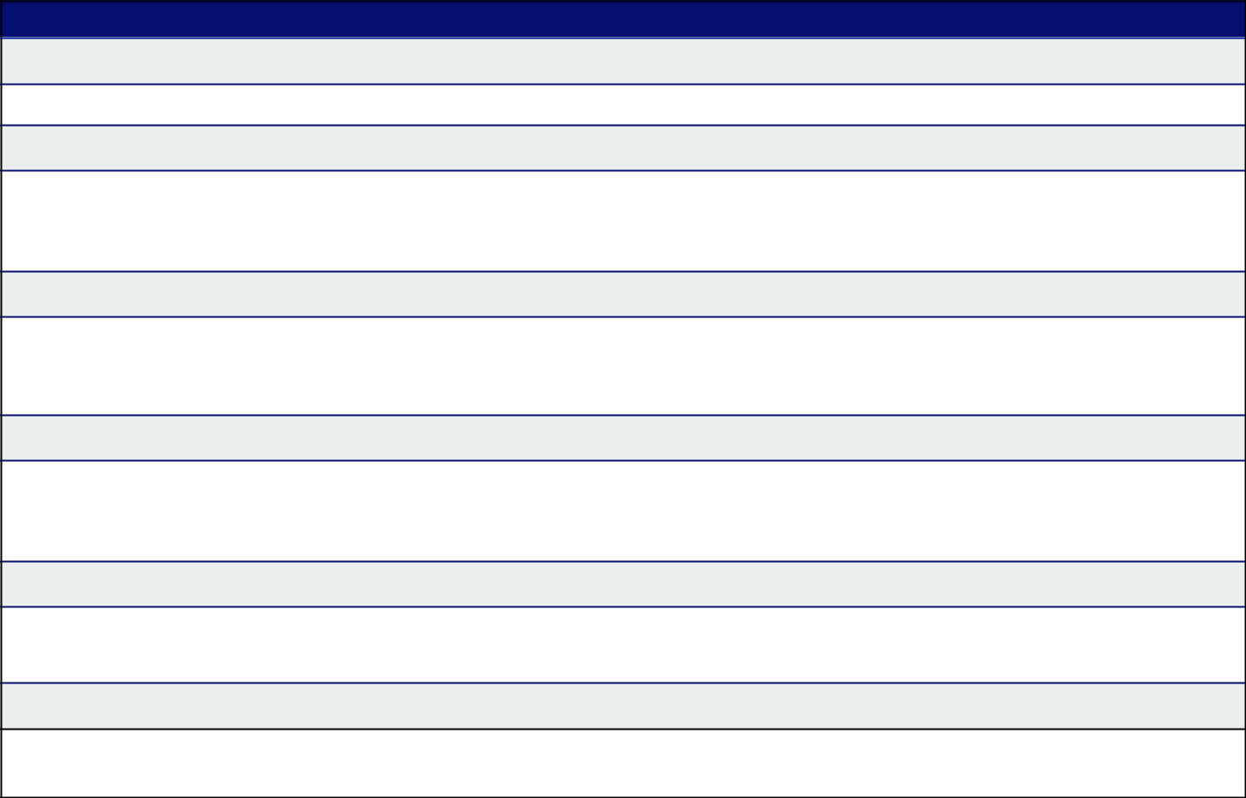

Strategic Objectives & Accomplishments – Richard J. Tobin (President & CEO)

Capital Markets (16.67%)

- Pursued active engagement with investors regarding our long-term strategy execution and value-creation priorities

Portfolio Management (16.67%)

- Continued to effectively deploy capital to increase the value of our portfolio including through acquisitions and investments in organic growth
- Successfully oversaw the integration of several recent acquisitions

Organic Investment and Capital Spending Program (16.67%)

- Made progress on three-year capital structure plan to support our capital allocation priorities (organic investments, strategic acquisitions, and the return of capital to our shareholders) including in presentations to investors regarding our long-term strategy execution and value-creation priorities

Talent, Succession Planning & Workforce Diversity (16.67%)

- Completed several objectives in the multi-year strategy to help ensure that our culture continues to take an inclusive approach that values diversity
- Completed talent and succession planning review

ESG (16.67%)

- Successfully implemented the second year of a multi-year ESG strategic plan by further improving transparency and setting public facing goals on ESG topics, including GHG emissions.

Three Pillars Progression (16.67%)

- Continued to make progress on margin expansion initiatives.

Our Compensation Committee evaluated Mr. Tobin’s achievements against his strategic objectives and assigned him a Strategic Objectives Factor of 100%.

DOVER CORPORATION – 2022 Proxy Statement 54

Table of Contents

COMPENSATION DISCUSSION AND ANALYSIS

Strategic Objectives Factor — Other NEOs

The following table summarizes the individual strategic objectives the Compensation Committee considered for our other NEOs in determining their respective Strategic Objectives Factors for 2021.


Brad M. Cerepak (Senior Vice President & CFO)

Mr. Cerepak’s strategic objectives were focused on corporate strategy (25% weighting), capital structure analysis (25%), finance transformation and control environment (25% weighting), and audit plan initiatives (25% weighting). Our Compensation Committee considered his: (1) role in assessing our portfolio of businesses and evaluating options for capital deployment; (2) support on aligning key metrics and market positions to drive shareholder communications; (3) efforts to support the preparation of our three-year capital structure plan; (4) continued commitment to optimizing the structure of our finance team and improving process efficiency of shared services; and (5) enhancements to our internal controls environment; and (6) role in improving our audit plan structure.

Girish Juneja (Senior Vice President & Chief Digital Officer)

Mr. Juneja’s strategic objectives were focused on strategic digital initiatives (35% weighting), digital customer experience (25% weighting), data security (25% weighting), and product development (15% weighting). Our Compensation Committee considered his: (1) role in supporting our strategic initiatives and priorities by assessing the digital capabilities of acquisition targets and driving adoption of shared services; (2) continued support in building common platforms to enhance the customer experience and in delivering efficiencies by enabling automated transactions; (3) efforts related to our enterprise-wide strategy to improve data and identity security; (4) progress on our information technology centralization initiatives; and (5) expansion of connected software and machine learning augmented solutions built to integrate and work with our equipment and component offerings.

Ivonne M. Cabrera (Senior Vice President, General Counsel & Secretary)

Ms. Cabrera’s strategic objectives were focused on ESG (34% weighting), legal spend optimization (33% weighting), and intellectual property (33% weighting). Our Compensation Committee considered her: (1) participation on our Sustainability Steering Committee and key role in driving initiatives and communications aligned with our three-year plan to expand the scope of our ESG practices and disclosures; (2) continuing guidance on legal issues related to the COVID-19 pandemic, including regulatory and legislative developments, government relief measures, and matters impacting our employees and customers; (3) progress in expanding the use of technology to collect and leverage data to drive optimization initiatives and maximize the value of strategic legal advice and counseling provided to the business; and (4) efforts to improve how we capture and protect intellectual property across the enterprise.

Kimberly K. Bors (Senior Vice President & Chief Human Resource Officer)

Ms. Bors’ strategic objectives were focused on the global HR operating model (25% weighting), enterprise talent management (25% weighting), strategic HR project initiatives (25% weighting), and ESG/Diversity & Inclusion (25%). Our Compensation Committee considered her: (1) role in developing the global operating model designed to expand shared services and centers of expertise, and improve operational effectiveness of the human resources function; (2) continuing progress to enhance talent management processes, capabilities and succession depth across the enterprise; (3) efforts to develop and launch a global career architecture and compensation structure, and a comprehensive Diversity & Inclusion roadmap; (4) successfully streamlining, outsourcing, and offshoring several HR processes to achieve cost reductions; (5) continuing role in the COVID-19 pandemic response and guidance for employee protocols; and (6) membership on the Sustainability Steering Committee and, in connection therewith, role in establishing goals and execution plans related to both an employee engagement survey with inclusivity index and unconscious bias training for employees with direct reports.

Our Compensation Committee assigned an average Strategic Objectives Factor of 100% to the non-CEO NEOs.

The Overall Payout Factors resulting from the above Financial Objective Factors and the Strategic Objectives Factors resulted in the payouts set forth in the 2021 Summary Compensation Table.

DOVER CORPORATION – 2022 Proxy Statement 55

Table of Contents

COMPENSATION DISCUSSION AND ANALYSIS

Long-Term Incentive Compensation

The following table summarizes the components of awards under our LTIP and the related performance criteria for awards granted in 2021. Note that all components are paid in stock rather than cash to encourage shareholder alignment through stock ownership.

Pay Element | 2021 Weighting & Performance Criteria | Objectives
Performance Shares | 40% LTIP weighting | Focus executives on shareholder value
Performance Shares | Performance Criteria: 3-Year relative TSR with the S&P 500 Industrials | Focus executives on shareholder value
Performance Shares |  | creation
 | index companies as the comparator group
Stock Settled Stock Appreciation | 40% LTIP weighting
Stock Settled Stock Appreciation | Performance Criteria: Dover stock price, exercisable three years after | Focus executives on share price appreciation
Rights | grant date and remain exercisable for seven years (subject to 10-year | Focus executives on share price appreciation
 | stock price movement)
Restricted Stock Units | 20% LTIP weighting | Retention and full alignment with the
Restricted Stock Units | Performance Criteria: Dover stock price; awards vest ratably over three | Retention and full alignment with the
 | years | shareholder experience

Performance Shares Granted in 2020 and 2021 – Relative TSR Metric

Beginning with grants made in 2020, performance shares are earned based on our relative TSR performance against the S&P 500 Industrials index companies. The relative TSR metric provides shareholders with a transparent and simple measure to gauge our performance against companies in our industry, and aligns the interests of our executives with our shareholders. The relative TSR targets for our performance shares are highly competitive. Awards are earned three years after the grant, provided relative TSR exceeds a threshold level with a maximum payout capped at 300% of target. Performance share payouts will be capped at 100% if absolute TSR is negative over the performance period.

For performance share grants made in 2020 and after, payouts will be made on a sliding scale using the following formula based on our relative TSR performance:
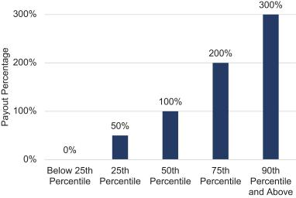

DOVER CORPORATION – 2022 Proxy Statement 56

Table of Contents

COMPENSATION DISCUSSION AND ANALYSIS

Performance Shares Granted Prior to 2020 – Internal TSR Metric

The performance shares that vested in 2021 are based on the three-year performance period of 2019-2021, and the performance is based on our historic internal TSR metric, which is described below. Consistent with our value creation over the three-year performance period, the performance shares that vested in 2021 had a payout percentage of 300% for our NEOs.

 | Target # of Shares | Actual Shares Awarded
Richard J. Tobin | 15,351 | 46,053
Brad M. Cerepak | 4,386 | 13,158
Girish Juneja | 987 | 2,961
Ivonne M. Cabrera | 1,754 | 5,262
Kimberly K. Bors | N/A | 0

Definition of Internal TSR. The performance shares granted to NEOs for the performance period of 2019-2021 are measured based on internal TSR, which, by definition, is a measure of value creation for our business segments and operating companies. The key components of internal TSR are EBITDA Growth and Free Cash Flow. Based on rigorous testing over time, internal TSR is:

- highly correlated with long-term shareholder value creation for a multi-industry company such as Dover,

- highly correlated with the combination of return on invested capital and organic growth, and

- effective in driving behaviors because it measures outcomes that are more within management’s control, such as revenue growth (organic and acquisition), and margin improvements.

Internal TSR measures the change in enterprise value over a three-year period. EBITDA is assigned a multiple based on prevailing market multiples among industrial companies. Internal TSR tracks the change in that EBITDA-based value, along with Free Cash Flow generated during the three-year performance period. The two together work similarly to an external TSR measure: the EBITDA-based value becomes a proxy for share price, and Free Cash Flow becomes a proxy for dividends. Further, EBITDA Growth and Free Cash Flow together focus our business leaders on growing our business, investing in continuing operations, and shaping our portfolio with capital-effective acquisitions and dispositions.
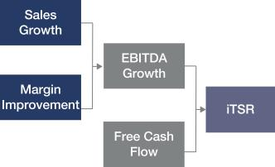

- EBITDA Growth — We believe that EBITDA is useful for purposes of evaluating our ongoing operating profitability as it excludes the depreciation and amortization expense related primarily to capital expenditures and acquisitions that occurred in prior years, as well as in evaluating our operating performance in relation to our competitors.

- Free Cash Flow — Free Cash Flow is operating cash flow less capital spending, less cash used for acquisitions, plus cash received from divestitures. We believe that Free Cash Flow is an important measure of our operating performance as it provides a measurement of cash generated from operations that is available for mandatory payment obligations and investment opportunities, such as funding acquisitions, paying dividends, repaying debt and repurchasing our common stock.

DOVER CORPORATION – 2022 Proxy Statement 57

Table of Contents

COMPENSATION DISCUSSION AND ANALYSIS

Safeguards. Since internal TSR is an absolute measure of value creation, we have implemented safeguards to substantially eliminate large payouts resulting solely from economic cycles. Further, payouts under the program are in shares, and our shareholding requirements ensure that executives are exposed to the same stock price changes as our shareholders, including external stock market factors. Dividends are not accrued or paid on performance shares during the performance period.

Rigorous Internal TSR Targets, Threshold and Cap Levels. Internal TSR targets for our performance shares are demanding and were rigorously back-tested to confirm that they are set to tie performance share payouts with comparable relative TSR performance levels. Awards are earned three years after the grant, provided internal TSR exceeds a threshold level. No payouts will be made unless internal TSR equals or exceeds 5%. The payout to any individual may not exceed 500,000 shares.

For performance share grants made in 2019, payouts were made on a sliding scale using the following formula with a maximum payout at 300% of target:
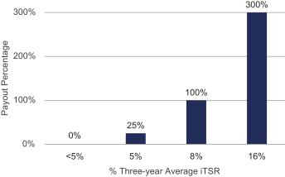

Stock Settled Stock Appreciation Rights

Stock Settled Stock Appreciation Rights (SSARs) give our NEOs the ability to participate in the price appreciation of a set number of shares of Company stock. Once SSARs vest, an NEO may exercise them any time prior to the expiration date and the proceeds from the exercise are paid to the NEO in the form of shares of Dover common stock to encourage continued share ownership and shareholder alignment. SSARs vest and are exercisable 3 years after grant date and remain exercisable for seven years, which means the awards are subject to 10-year stock price movement thus aligning executive interests with shareholder interests over the long term. Importantly, in light of our active acquisition program, SSARs’ forward-looking orientation is effective for incentivizing our newly-acquired companies and employees, who must create new value in order to realize gains. Furthermore, SSARs’ 10-year life cycle is essential to managing value creation with a business that has a portfolio of industrial companies whose economic cycles vary.

Restricted Stock Units

RSU grants attract and retain NEOs by providing them with some of the benefits associated with stock ownership during the vesting period. Executives do not actually own the shares underlying the units, nor do they enjoy the benefits of ownership such as dividends and voting, until the vesting conditions are satisfied. Once vested, the NEO receives shares of Dover stock equivalent in number to the vested units and receives a cash amount equal to accrued dividends during the vesting period, net of withholding taxes.

Other Benefits

401(k), Pension Plan and Health & Wellness Plans

Our executive officers are able to participate in retirement and benefit plans generally available to our employees on the same terms as other employees. Dover and most of our businesses offer a 401(k) plan to substantially all U.S.-based employees

DOVER CORPORATION – 2022 Proxy Statement 58

Table of Contents

COMPENSATION DISCUSSION AND ANALYSIS

and provide a Company matching contribution denominated as a percentage of the amount of salary deferred into the plan by a participant during the course of the year. Some of our U.S.-based employees also participate in a tax-qualified defined benefit pension plan. Effective December 31, 2013, we closed both our qualified and non-qualified defined benefit retirement plans to new employees. We intend to freeze any future benefit accruals in both plans effective December 31, 2023. All of our U.S.-based employees are offered a health and wellness plan (including health, term life and disability insurance). NEOs do not receive enhanced health and wellness benefits.

Non-Qualified Retirement Plans

We offer two non-qualified plans with participation generally limited to individuals whose annual salary and bonus earnings exceed the Internal Revenue Service (“IRS”) limits applicable to our qualified plans: our Pension Replacement Plan (“PRP”) and our deferred compensation plan. Participation in the deferred compensation plan is open to employees with an annual salary equal to or greater than $175,000 for 2021 deferral elections and $250,000 for 2022 deferral elections.

After December 31, 2009, benefits under the PRP before offsets are determined using the benefit calculation and eligibility criteria as under the pension plan, except that IRS limits on compensation and benefits do not apply. Prior to December 31, 2009, the participants in the PRP accrued benefits greater than those offered in the pension plan. Effective January 1, 2010, we modified this plan so that executives subject to IRS compensation limits will accrue future benefits that are substantially the same as benefits under the pension plan. Individuals who participated in the PRP prior to January 1, 2010 will receive benefits calculated under the prior benefit formula through December 31, 2009 and benefits calculated under the lower PRP benefit formula on and after January 1, 2010. Amounts receivable by the executives under the PRP are reduced by any amounts receivable by them under the pension plan, any qualifying profit sharing plan, Company-paid portion of social security benefits, and the amounts of the Company match in the 401(k) plan.

Effective December 31, 2013, the PRP was closed to new employees. All eligible employees as of December 31, 2013 will continue to earn PRP benefits through December 31, 2023 as long as they remain employed by Dover and its affiliates. Effective December 31, 2023, Dover intends to eliminate any future benefit accruals consistent with the freezing of benefit accruals under the pension plan.

We offer a deferred compensation plan to allow participants to elect to defer their receipt of some or all of their salary, bonuses and any payout of a cash performance award. The plan permits executive officers to defer receipt of part of their compensation to later periods and facilitates tax planning for the participants. Effective January 1, 2022, the deferred compensation plan was amended to also provide for automatic Company contributions for participants who do not also participate in the PRP or have a present value benefit under the PRP of less than $100,000.

Executive Severance

All of our NEOs are eligible to participate in our severance plan. Under the plan, if we terminate an NEO’s employment without cause (as defined in the severance plan), the NEO will generally be entitled to receive twelve months of salary plus target annual cash bonus, outplacement services, and healthcare benefits continuation, and a prorated annual cash bonus and a prorated performance share award for time worked during the year. In addition, Mr. Tobin is entitled to receive certain severance payments and benefits under his employment agreement in the event his employment is terminated by Dover without cause or by him for good reason. See “Potential Payments Upon Termination or Change in Control.”

Senior Executive Change in Control Severance Plan

Our Senior Executive Change in Control Severance Plan (the “CIC Severance Plan”) establishes the severance benefits payable to eligible executives if they are involuntarily terminated following a change in control. All of our NEOs are eligible to participate in the CIC Severance Plan. An executive eligible to participate in the CIC Severance Plan as of the date of a change in control will be entitled to receive severance payments under the plan if, within 24 months after the change in control, either the executive’s employment is terminated by the Company without “cause” or he or she terminates employment for “good reason” (as such terms are defined in the plan). The severance payments and benefits will consist of: a lump sum payment equal to 2.0 times their annual salary and target bonus, a prorated annual cash bonus at target, full acceleration of all unvested SSARs and RSUs, performance share payout at target for all in-cycle awards, outplacement services, and a lump sum payment equal to the cost of Consolidated Omnibus Budget Reconciliation Act (COBRA) health care benefit continuation of the executive and covered family members for 24 months. See “Potential Payments Upon Termination or Change in Control.”

DOVER CORPORATION – 2022 Proxy Statement 59

Table of Contents

COMPENSATION DISCUSSION AND ANALYSIS

No executive may receive severance benefits under more than one plan or arrangement. Dover does not provide tax gross-ups in the CIC Severance Plan.

Other Elements of Compensation

Clawback Policy

In 2019, we adopted a formal clawback and recoupment policy applicable to our executive officers. If our Board determines, in its sole discretion acting in good faith, that any executive officer has engaged in fraud or intentional misconduct that caused or was a significant contributing factor to a material restatement of all or a portion of our consolidated financial statements, the Board may, to the extent permitted by law, and to the extent it determines that it is in Dover’s best interest, require reimbursement to Dover for, or reduce or cancel, any incentive compensation paid, granted or credited to such executive officer on or after November 7, 2019. We may effect any such recoupment by requiring the executive officer to pay Dover the relevant amount, by set-off, by reducing future compensation or by such other means or combination of means as the Board determines to be appropriate.

Apart from the clawback policy described above, our PRP includes clawback provisions for termination for cause and the severance plan and CIC Severance Plan provide for clawback of benefits for breaches of the plan.

Anti-hedging and Anti-pledging Policy

Our Securities Trading and Confidentiality Policy prohibits directors, executive officers and any employee who has previously received or receives any type of long-term incentive plan award, and certain persons and entities related to any such persons, from engaging in short-sales, transactions in derivative securities or any other form of hedging transaction designed to hedge or offset any decrease in the market value of Dover securities granted to or held by such persons. In addition, such persons may not hold Dover securities in a margin account or pledge securities as collateral for a loan or any other obligation.

Perquisites

We provide substantially no executive perquisites, nor does the Company own or operate any corporate aircraft. Management and our Compensation Committee believe that providing significant perquisites to executive officers would not be consistent with our overall compensation philosophy. As a result, we do not provide executive officers with perquisites such as social club memberships, company cars or car allowances, or financial counseling. Except for executive physicals, our NEOs participate only in programs generally available to Dover employees.

Shareholding Guidelines

We believe that our executives will most effectively pursue the long-term interests of our shareholders if they are shareholders themselves. As a result, share ownership guidelines are in place for all NEOs (subject to exceptions that may be granted by our Compensation Committee for significant personal events or retirement planning). Our CEO is required to hold shares equal in value to five-times salary and our other NEOs are required to hold shares equal in value to three-times salary. Our policy requires that NEOs hold/retain all equity grants until the share ownership guidelines are met. Based on current share ownership, all executives serving as NEOs are currently in compliance with the guidelines. Our Compensation Committee reserves the right to provide a portion of annual bonus in stock for any officer who fails to meet or make satisfactory progress toward satisfying the guidelines.

Risk Assessment

In 2021, Dover, with the assistance of Willis Towers Watson, updated the formal risk assessment that was conducted in 2020 for all our incentive compensation programs that have material impact on our financial statements. Willis Towers Watson inventoried incentive compensation programs at the corporate and operating company levels globally and conducted in-depth reviews of financially material plans, identified based on expected spend and income statement accounts tied to the program. The reviews focused on both the plan design features as well as internal risk mitigation controls in place. Based on this assessment, we have concluded that Dover’s compensation practices and policies do not create risks that are reasonably likely to have a material adverse effect on the Company.

DOVER CORPORATION – 2022 Proxy Statement 60

Table of Contents

Compensation Committee Report


We reviewed and discussed with management the Compensation Discussion and Analysis for the year ended December 31, 2021.

Based on the review and discussions referred to above, we recommended to the Board of Directors that the Compensation Discussion and Analysis be included in this Proxy Statement and incorporated by reference in Dover’s Annual Report on Form 10-K for the year ended December 31, 2021.

Compensation Committee:

Keith E. Wandell (Chair)

Kristiane C. Graham

Michael F. Johnston

Mary A. Winston

This report does not constitute “soliciting material” and shall not be deemed filed or incorporated by reference into any filing under the Securities Act of 1933 or under the Securities Exchange Act of 1934, except to the extent the Company specifically incorporates this report by reference, and shall not otherwise be deemed filed under such Acts.

DOVER CORPORATION – 2022 Proxy Statement 61

Table of Contents

Executive Compensation Tables

Summary Compensation Table

The Summary Compensation Table and notes show all remuneration for 2021 provided to our NEOs, consisting of the following officers:

- Our President & CEO;

- Our Senior Vice President & CFO; and

- Our three other most highly compensated executive officers as of the end of 2021.

The determination of the most highly compensated executive officers is based on total compensation paid or accrued for 2021, excluding changes in the actuarial value of defined benefit plans and earnings on nonqualified deferred compensation balances.

 |  |  |  |  |  |  | Change in
 |  |  |  |  |  |  | Pension Value
 |  |  |  |  |  |  | and
 |  |  |  |  |  |  | Nonqualified
 |  |  |  |  |  | Non-Equity | Deferred
 |  |  |  | Stock | Option | Incentive Plan | Compensation | All Other | Total
 |  | Salary | Bonus | Awards | Awards | Compensation | Earnings | Compensation | Total
Name and Principal Position | Year | ($) | ($)(1) | ($)(2) | ($)(3) | ($)(4) | ($)(5) | ($)(6) | ($)
Richard J. Tobin | 2021 | 1,235,000 | 2,964,000 | 5,808,134 | 3,580,475 | 0 | 0 | 498,251 | 14,085,860
President & Chief | 2020 | 1,217,500 | 1,722,825 | 6,024,137 | 2,674,529 | 0 | 0 | 343,347 | 11,982,338
Executive Officer | 2019 | 1,200,000 | 1,665,000 | 2,800,022 | 3,232,903 | 0 | 0 | 251,150 | 9,149,075
Brad M. Cerepak | 2021 | 731,000 | 1,169,600 | 1,452,071 | 895,111 | 0 | 182,670 | 29,577 | 4,460,029
Senior Vice President & | 2020 | 718,000 | 679,830 | 1,505,922 | 668,627 | 0 | 649,315 | 35,329 | 4,257,023
Chief Financial Officer | 2019 | 705,000 | 740,250 | 800,006 | 923,692 | 0 | 553,203 | 37,166 | 3,759,317
Girish Juneja | 2021 | 500,000 | 560,000 | 341,738 | 210,626 | 0 | 0 | 51,884 | 1,664,248
Senior Vice President & | 2020 | 491,404 | 325,500 | 376,533 | 167,157 | 0 | 0 | 38,967 | 1,399,561
Chief Digital Officer
Ivonne M. Cabrera | 2021 | 560,000 | 627,200 | 546,632 | 336,979 | 0 | 0 | 17,922 | 2,088,733
Senior Vice President & | 2020 | 550,000 | 364,560 | 602,459 | 267,460 | 0 | 648,534 | 21,616 | 2,454,629
General Counsel
General Counsel | 2019 | 540,000 | 396,900 | 319,930 | 369,480 | 0 | 408,519 | 23,238 | 2,058,067
Kimberly K. Bors | 2021 | 450,000 | 504,000 | 362,136 | 223,247 | 0 | 0 | 43,615 | 1,582,998
Senior Vice President &
Chief Human Resource Officer

- Bonus amounts generally represent payments under our AIP for the year indicated, for which payments are made in the first quarter of the following year. The AIP constitutes a non-equity incentive plan under FASB ASC Topic 718. Although they are based on the satisfaction of pre-established performance targets, AIP amounts are reported in the bonus column rather than the non-equity incentive plan compensation column to make clear that they are annual bonus payments for the year indicated.

- The amounts generally represent (a) the aggregate grant date fair value of performance shares granted during the year indicated, and (b) the aggregate grant date fair value of restricted stock unit awards granted during the year, in each case, calculated in accordance with FASB ASC Topic 718. The amounts set forth in the table do not correspond to the actual value that might be realized by the named executives. The grant date fair value of the performance share awards granted in 2020 and 2021 is higher than the grant date fair values of the awards granted in 2019 because of the transition from attainment based on internal TSR to attainment based on relative TSR. As market condition awards, the performance share awards granted in 2020 and 2021 were valued using the Monte Carlo simulation model. For a discussion of the assumptions relating to calculation of the cost of equity awards, see Note 15 to the Notes to the Financial Statements contained in our Annual Report on Form 10-K for the year ended December 31, 2021.

Under FASB ASC Topic 718, the 2019, 2020 and 2021 performance share awards are considered performance and service conditioned. The grant date fair value for the 2019 performance share awards was $91.20, the grant date fair value for the 2020 performance share awards was $165.71 and the grant date fair value for the 2021 performance share awards was $148.29. The grant date fair value of 2021 RSU awards was $122.73. All RSU grants are eligible for dividend equivalent payments which are paid upon vesting.

DOVER CORPORATION – 2022 Proxy Statement 62

Table of Contents

EXECUTIVE COMPENSATION TABLES

- The amounts represent the aggregate grant date fair value of SSAR awards granted during the year indicated, calculated in accordance with FASB ASC Topic 718, and do not correspond to the actual value that may be realized by the named executives. The grant date fair value for the 2021 SSAR awards was calculated using a Black-Scholes value of $29.08 per SSAR.

- See Note (1) for a discussion of annual bonuses under the AIP as non-equity incentive plan compensation.

- Amounts represent changes in present value of accumulated benefits under the pension plan and/or PRP during the year indicated. For more information, see “Executive Compensation Tables — Pension Benefits through 2021.”

- Amounts for 2021 represent: (i) 401(k) matching contributions of $10,150 for Mr. Cerepak and Ms. Cabrera and $13,050 for Messrs. Tobin and Juneja, and Ms. Bors, (ii) dividends received on RSUs in the amount of $309,296, $19,427, $4,184 and $7,772 and $685 for Messrs. Tobin, Cerepak, Juneja and Mses. Cabrera and Bors respectively, and (iii) for Messrs. Tobin and Juneja, and Ms. Bors, respectively, $136,815 of nonqualified deferred compensation match and $39,090 of 1% automatic contributions in the nonqualified deferred compensation plan; $26,950 of nonqualified deferred compensation match and $7,700 of 1% automatic contributions in the nonqualified deferred compensation plan; and $23,240 of nonqualified deferred compensation match and $6,640 of 1% automatic contributions in the nonqualified deferred compensation plan, since they do not participate in the PRP.

CEO Employment Agreement

In connection with the hiring of Mr. Tobin as our CEO, Mr. Tobin and Dover entered into a three-year employment agreement commencing May 1, 2018. In recognition of Mr. Tobin’s outstanding leadership and contributions to value creation, the agreement was renewed for a three-year period ending May 1, 2024. Under the terms of the agreement, Mr. Tobin is entitled to a minimum annual base salary of $1.2 million and a minimum target annual bonus equal to 125% of his base salary, and the receipt of an annual equity grant for each of Dover’s fiscal years ending during the term of the agreement with a grant date fair value of not less than $7 million. During the term of the agreement, Mr. Tobin will also be entitled to employee benefits on the same basis as those generally available to executive officers of Dover.

In connection with his hiring, Mr. Tobin received a one-time make-whole equity grant consisting of 75,971 performance shares, and 164,603 RSUs.

Mr. Tobin also received a one-time make-whole cash payment of $1,000,000.

Mr. Tobin is entitled to receive certain severance payments and benefits in the event his employment is terminated by Dover without cause or by him for good reason. See “Potential Payments upon Termination or Change in Control”.

At the end of the term of the agreement, Mr. Tobin will continue to be employed by Dover as an at-will employee and participate in severance and other benefit plans on the same terms as other executives.

CEO Pay Ratio

We are providing the following information about the relationship of the annual total compensation of our Chief Executive Officer and our median employee. This ratio is a reasonable estimate calculated in a manner consistent with Item 402(u) of Regulation S-K.

Under the rules, we are permitted to use the same median employee in calculating the pay ratio as the median employee we identified in fiscal year 2020 for up to three years if there have been no changes that we reasonably believe would significantly affect this pay ratio disclosure and are permitted to substitute another employee for the median employee in certain circumstances. We believe that there have been no changes to our employee population or compensation arrangements that would result in a significant change to the pay ratio disclosure. However, in fiscal year 2021, there were significant changes in the circumstances of the median employee identified in fiscal year 2020 that we reasonably believe would result in a significant change in our pay ratio disclosure. Therefore, to calculate the pay ratio disclosure for fiscal year 2021, we are using another employee whose compensation is substantially similar to last year’s median employee using the same compensation measure we used to determine the fiscal year 2020 median employee. The date chosen for identifying the median employee was December 31, 2021.

For purposes of this analysis, our global headcount was 24,946 employees (12,984 U.S. and 11,962 non-U.S) as of our December 31, 2021 determination date. Eleven countries were excluded (2.1% of the total workforce) under the permissible

DOVER CORPORATION – 2022 Proxy Statement 63

Table of Contents

EXECUTIVE COMPENSATION TABLES

5% exclusion, with employee counts as follows: Argentina (22), Colombia (4), Costa Rica (4), Dominican Republic (53), Indonesia (6), Malaysia (125), Mexico (102), Russian Federation (39), Taiwan (19), Thailand (134), and Turkey (10). After country exclusions, our total headcount was 24,428 employees (12,984 U.S. and 11,444 non-U.S.). As permitted under SEC rules, the global headcount does not include employees from the following companies acquired in December 2021: Acme Cryogenics, Inc. (205 employees) and Engineered Controls International, LLC (725 employees). As is permitted under the rules, to determine our median employee, we chose “base salary” as our consistently applied compensation measure. We estimated annual base salary for hourly workers employed for the entire year using their hourly rate and a reasonable estimate of hours worked for the year. For employees who commenced work during 2021, we annualized their annual base salary. We then produced a sample of employees who were paid within a 0.5% range of that median and selected an employee from within that group as our median employee. We determined that employee’s (Summary Compensation Table) total compensation was $48,794 for 2021.

We calculated 2021 annual total compensation for both our median employee and Mr. Tobin using the same methodology that we use to determine our named executive officers’ annual total compensation for the Summary Compensation Table. Mr. Tobin’s total compensation was $14,085,860 resulting in an estimated ratio of 289:1 for CEO pay to median worker pay.

Grants of Plan-Based Awards in 2021

All awards listed in the table below have a grant date of February 12, 2021 for all executive officers. For a discussion of the awards, see “Compensation Discussion and Analysis – Elements of Executive Compensation”.

 |  |  |  |  |  |  |  |  |  |  | All Other
 |  |  |  |  |  |  |  |  |  |  | Stock | All Other |  | Grant
 |  |  | Estimated Future Payouts |  |  |  | Estimated Future Payouts |  |  |  | Awards: | Stock |  | Date Fair
 |  |  |  |  |  |  |  |  |  |  | Number | Awards: |  | Value of
 |  |  | Under Non-Equity |  |  |  | Under Equity |  |  |  | Number | Awards: |  | Value of
 |  |  |  |  |  |  |  |  |  |  | of | Number of | Exercise | Stock
 |  |  | Incentive Plan Awards |  |  |  | Incentive Plan Awards
 |  |  |  |  |  |  |  |  |  |  | Share of | Securities | Price of | and
 |  |  |  |  |  |  |  |  |  |  | Stock or | Underlying | Option | Option
 |  |  | Threshold | Target | Maximum |  | Threshold | Target | Maximum |  | Units | Options | Awards | Awards
Name | Type | ($)(1) |  | ($) | ($) |  | (#)(1) | (#) | (#) |  | (#) | (#) | ($/Sh) | ($)
Richard J. Tobin | AIP (2) | 926,250 |  | 1,852,500 | 3,705,000
 | SSAR (3) |  |  |  |  |  |  |  |  |  |  | 123,125 | 122.73 | 3,580,475
 | Performance
 | Shares (4) |  |  |  |  |  |  | 27,703 | 83,109 |  |  |  |  | 4,108,078
 | RSU (5) |  |  |  |  |  |  |  |  |  | 13,852 |  |  | 1,700,056
Brad M. Cerepak | AIP (2) | 365,500 |  | 731,000 | 1,462,000
 | SSAR (3) |  |  |  |  |  |  |  |  |  |  | 30,781 | 122.73 | 895,111
 | Performance
 | Shares (4) |  |  |  |  |  |  | 6,926 | 20,778 |  |  |  |  | 1,027,057
 | RSU (5) |  |  |  |  |  |  |  |  |  | 3,463 |  |  | 425,014
Girish Juneja | AIP (2) | 175,000 |  | 350,000 | 700,000
 | SSAR (3) |  |  |  |  |  |  |  |  |  |  | 7,243 | 122.73 | 210,626
 | Performance
 | Shares (4) |  |  |  |  |  |  | 1,630 | 4,890 |  |  |  |  | 241,713
 | RSU (5) |  |  |  |  |  |  |  |  |  | 815 |  |  | 100,025
Ivonne M. Cabrera | AIP (2) | 196,000 |  | 392,000 | 784,000
 | SSAR (3) |  |  |  |  |  |  |  |  |  |  | 11,588 | 122.73 | 336,979
 | Performance
 | Shares (4) |  |  |  |  |  |  | 2,607 | 7,821 |  |  |  |  | 386,592
 | RSU (5) |  |  |  |  |  |  |  |  |  | 1,304 |  |  | 160,040

DOVER CORPORATION – 2022 Proxy Statement 64

Table of Contents

EXECUTIVE COMPENSATION TABLES

 |  |  |  |  |  |  |  |  |  |  |  |  |  | Grant
 |  |  |  |  |  |  |  |  |  |  | All Other |  |  | Date
 |  | Estimated Future Payouts |  |  |  |  | Estimated Future Payouts |  |  |  | Stock | All Other |  | Fair
 |  |  |  |  |  |  |  |  |  |  | Awards: | Stock |  | Value
 |  | Under Non-Equity |  |  |  |  | Under Equity |  |  |  | Number | Awards: |  | of
 |  | Incentive Plan Awards |  |  |  |  | Incentive Plan Awards |  |  |  | of | Number of | Exercise | Stock
 |  |  |  |  |  |  |  |  |  |  | Share of | Securities | Price of | and
 |  |  |  |  |  |  |  |  |  |  | Stock or | Underlying | Option | Option
 |  | Thresh-old |  | Target | Maximum |  | Thresh-old | Target | Maximum |  | Units | Options | Awards | Awards
Name | Type | ($)(1) |  | ($) | ($) |  | (#)(1) | (#) | (#) |  | (#) | (#) | ($/Sh) | ($)
Kimberly K. Bors | AIP (2) | 157,500 |  | 315,000 | 630,000
 | SSAR (3) |  |  |  |  |  |  |  |  |  |  | 7,677 | 122.73 | 223,247
 | Performance
 | Shares (4) |  |  |  |  |  |  | 1,727 | 5,181 |  |  |  |  | 256,097
 | RSU (5) |  |  |  |  |  |  |  |  |  | 864 |  |  | 106,039

- Represents the minimum amount payable for a certain level of performance. Under each of our plans, there is no guaranteed minimum payment.
- The amounts shown in this row reflect the potential payouts in February 2022 for 2021 under the AIP. The bonus amount actually paid in February 2022 is disclosed in the Summary Compensation Table in the column “Bonus” for 2021 for the executive officer.
- Represents an award of SSARs under the 2012 LTIP that will not be exercisable until February 12, 2024. The grant date fair value was calculated in accordance with FASB ASC 718, using a Black-Scholes value of $29.08 per SSAR.
- Represents an award of performance shares under the 2012 LTIP. The performance shares vest and become payable after the three-year performance period ending December 31, 2023 subject to the achievement of the applicable performance goal. The performance share awards are considered market condition awards per FASB ASC 718 and the grant date fair value for the awards was $148.29 per share, calculated using the Monte Carlo simulation model in accordance with FASB ASC 718.

- Represents an award of RSUs under the 2012 LTIP made on February 12, 2021. The grant vests in three equal annual installments beginning on March 15, 2022. The grant date fair value for the awards were calculated in accordance with FASB ASC 718, using a value of $122.73 per share.

DOVER CORPORATION – 2022 Proxy Statement 65

Table of Contents

EXECUTIVE COMPENSATION TABLES

Outstanding Equity Awards at Fiscal Year-End 2021

Awards listed below with grant dates beginning in 2013 were made under the 2012 LTIP. All equity awards outstanding as of May 9, 2018 were adjusted as a result of the spin-off of Apergy to preserve the value of the awards in accordance with the Employee Matters Agreement, dated May 9, 2018, between Dover and Apergy.

Effective May 7, 2021, we adopted the 2021 LTIP. All future grants of equity awards will be made under the 2021 LTIP.

 | Option Awards |  |  |  |  | Stock Awards
 |  |  |  |  |  |  |  | Equity | Equity
 |  |  |  |  |  |  |  | Incentive Plan | Incentive Plan
 |  |  |  |  |  |  |  | Awards: | Awards: Market
 |  |  |  |  |  |  |  | Number of | or Payout
 | Number of | Number of |  |  |  | Number of |  | Unearned | Value of
 | Securities | Securities |  |  |  | Shares or | Market Value of | Shares, | Unearned
 | Underlying | Underlying | Option |  |  | Units of | Shares or Units | Units or | Shares, Units
 | Unexercised | Unexercised | Exercise | Option |  | Stock That | of Stock That | Other Rights | or Other Rights
 | Options (#) | Options (#) | Prices | Expiration |  | Have Not | Have Not | That Have | That Have not
Name | Exercisable | Unexercisable | ($) | Date |  | Vested (#) | Vested ($) | not Vested (#) | Vested ($)
Richard J. Tobin |  | 123,125 (1) | 122.73 | 2/12/2031
 |  | 118,657 (2) | 119.86 | 2/14/2030
 |  | 184,211 (3) | 91.20 | 2/15/2029
 | 210,658 (4) |  | 79.75 | 5/23/2028 |  | 13,852 (11) | 2,515,523 (15) | 27,703 (16) | 5,030,865 (18)
 |  |  |  |  |  | 8,900 (12) | 1,616,240 (15) | 26,698 (17) | 4,848,357 (18)
 |  |  |  |  |  | 5,117 (13) | 929,247 (15)
 |  |  |  |  |  | 32,923 (14) | 5,978,817 (15)
Brad M. Cerepak |  | 30,781 (1) | 122.73 | 2/12/2031
 |  | 29,664 (2) | 119.86 | 2/14/2030
 |  | 52,632 (3) | 91.20 | 2/15/2029
 | 58,478 (5) |  | 82.09 | 2/9/2028
 | 71,806 (6) |  | 66.85 | 2/10/2027
 | 91,981 (7) |  | 48.28 | 2/11/2026
 | 71,860 (8) |  | 61.79 | 2/12/2025
 |  |  |  |  |  | 3,463 (11) | 628,881 (15) | 6,926 (16) | 1,257,762 (18)
 |  |  |  |  |  | 2,225 (12) | 404,060 (15) | 6,674 (17) | 1,211,998 (18)
 |  |  |  |  |  | 1,462 (13) | 265,499 (15)
Girish Juneja |  | 7,243 (1) | 122.73 | 2/12/2031
 |  | 7,416 (2) | 119.86 | 2/14/2030
 |  | 11,842 (3) | 91.20 | 2/15/2029
 | 11,695 (5) |  | 82.09 | 2/9/2028 |  | 815 (11) | 148,004 (15) | 1,630 (16) | 296,008 (18)
 |  |  |  |  |  | 556 (12) | 100,970 (15) | 1,669 (17) | 303,090 (18)
 |  |  |  |  |  | 329 (13) | 59,746 (15)
Ivonne M. Cabrera |  | 11,588 (1) | 122.73 | 2/12/2031
 |  | 11,866 (2) | 119.86 | 2/14/2030
 |  | 21,053 (3) | 91.20 | 2/15/2029
 | 23,391 (5) |  | 82.09 | 2/9/2028
 | 28,722 (6) |  | 66.85 | 2/10/2027
 | 39,775 (7) |  | 48.28 | 2/11/2026
 | 31,074 (8) |  | 61.79 | 2/12/2025
 | 25,873 (9) |  | 69.57 | 3/10/2024
 | 28,841 (10) |  | 53.40 | 2/14/2023
 |  |  |  |  |  | 1,304 (11) | 236,806 (15) | 2,607 (16) | 473,431 (18)
 |  |  |  |  |  | 890 (12) | 161,624 (15) | 2,670 (17) | 484,872 (18)
 |  |  |  |  |  | 585 (13) | 106,236 (15)
Kimberly K. Bors |  | 7,677 (1) | 122.73 | 2/12/2031
 |  | 7,416 (2) | 119.86 | 2/14/2030
 |  |  |  |  |  | 864 (11) | 156,902 (15) | 1,727 (16) | 313,623 (18)
 |  |  |  |  |  | 556 (12) | 100,970 (15) | 1,669 (17) | 303,090 (18)

DOVER CORPORATION – 2022 Proxy Statement 66

Table of Contents

EXECUTIVE COMPENSATION TABLES

- SSARs granted on February 12, 2021 that are not exercisable until February 12, 2024.

- SSARs granted on February 14, 2020 that are not exercisable until February 14, 2023.

- SSARs granted on February 15, 2019 that became exercisable on February 15, 2022.

- SSARs granted on May 23, 2018 that became exercisable on May 23, 2021.

- SSARs granted on February 9, 2018 that became exercisable on February 9, 2021.

- SSARs granted on February 10, 2017 that became exercisable on February 10, 2020.

- SSARs granted on February 11, 2016 that became exercisable on February 11, 2019.

- SSARs granted on February 12, 2015 that became exercisable on February 12, 2018.

- SSARs granted on March 10, 2014 that became exercisable on March 10, 2017.

- SSARs granted on February 14, 2013 that became exercisable on February 14, 2016.

- Unvested RSUs granted on February 12, 2021. The units vest in three equal annual installments beginning on March 15, 2022

- Unvested portion of RSUs granted on February 14, 2020. The units vest in three equal annual installments beginning on March 15, 2021

- Unvested portion of RSUs granted on February 15, 2019. The units vest in three equal annual installments beginning on March 15, 2020.

- Unvested portion of RSUs granted on May 23, 2018. The units vest in five equal annual installments beginning on December 15, 2018.

- The amount reflects the number of units granted multiplied by $181.60, the closing price of our common stock on December 31, 2021.

- Performance shares granted on February 12, 2021 become payable after December 31, 2023 subject to the achievement of the applicable performance goal. The amount reflected in the table represents the number of shares payable based on achievement of the target level of performance (100%).
- Performance shares granted on February 14, 2020 become payable after December 31, 2022 subject to the achievement of the applicable performance goal. The amount reflected in the table represents the number of shares payable based on achievement of the target level of performance (100%).
- The amount reflects the number of performance shares payable based on achievement of the target level of performance multiplied by $181.60, the closing price of our common stock on December 31, 2021.

Option Exercises and Stock Vested in 2021

 | Number of Shares | Value Realized | Number of Shares | Value Realized
 | Number of Shares | on Exercise | Acquired on | on Vesting
 | Acquired on | on Exercise | Acquired on | on Vesting
 | Acquired on | ($)(2) | Vesting (#)(3) | ($)(4)
Name | Exercise (#)(1) | ($)(2) | Vesting (#)(3) | ($)(4)
Richard J. Tobin |  |  | 94,449 | 16,041,842
Brad M. Cerepak | 60,371 | 6,409,891 | 17,357 | 2,954,804
Girish Juneja |  |  | 3,893 | 663,193
Ivonne M. Cabrera | 9,880 | 784,423 | 6,942 | 1,181,758
Kimberly K. Bors |  |  | 278 | 37,427

- Represents exercise of SSARs; number of shares reported as acquired is the total number of shares underlying the SSAR, rather than the net number of shares received by the NEO.

- The “value realized on exercise” provided in the table represents the difference between the average of the high and low trading price on the exercise date and the exercise or base price, multiplied by the number of shares acquired upon exercise of the award.
- This column represents the vesting of a portion of the 2018, 2019, and 2020 grants of RSUs for Messrs. Tobin, Cerepak, and Juneja, and Ms. Cabrera as well as a performance share payout for the performance period ended December 31, 2021. This column also represents the vesting of a portion of the 2020 grants of RSUs for Ms. Bors. For Mr. Tobin, this column also represents the vesting of a portion of the May 23, 2018 one-time make-whole grant of RSUs. The number of shares reported as acquired is the full number of RSUs vested or performance shares paid out, not the net number of shares received by the NEO after withholding shares for satisfaction of taxes.
- This value represents the average of the high and low trading price on the date of vesting multiplied by the number of RSUs vesting plus the number of performance shares paid for the period ended December 31, 2021 multiplied by $181.60, the closing price of our stock on December 31, 2021.

DOVER CORPORATION – 2022 Proxy Statement 67

Table of Contents

EXECUTIVE COMPENSATION TABLES

Pension Benefits through 2021

 |  |  |  |  |  | Payments
 |  |  | Number of | Normal | Present Value | During Last
 |  |  | Years Credited | Retirement | of Accumulated | Fiscal Year
Name |  | Plan Name | Service (#) | Age (#) | Benefit ($)(1) | ($)
Richard J. Tobin (2) |  | Pension Plan | N/A | N/A | N/A | N/A
Richard J. Tobin (2) |  | PRP | N/A | N/A | N/A | N/A
Brad M. Cerepak |  | Pension Plan | 13.0 | 65 | 659,470 | N/A
Brad M. Cerepak |  | PRP | 12.6 | 65 | 2,594,332 | N/A
Girish Juneja (2) |  | Pension Plan | N/A | N/A | N/A | N/A
Girish Juneja (2) |  | PRP | N/A | N/A | N/A | N/A
Ivonne M. Cabrera (3) |  | Pension Plan | 18.6 | 65 | 730,962 | N/A
Ivonne M. Cabrera (3) |  | PRP | 17.9 | 65 | 1,555,674 | N/A
Kimberly K. Bors |  | Pension Plan | N/A | N/A | N/A | N/A
Kimberly K. Bors |  | PRP | N/A | N/A | N/A | N/A

- This amount was earned by the NEOs over his or her years of service. For Mr. Cerepak and Ms. Cabrera, the present value of benefits was calculated assuming that the executive will receive a single lump sum payment upon retirement at age 65.

- Mr. Tobin, Mr. Juneja and Ms. Bors are not eligible to participate in the Dover pension plan or the PRP, since the pension plan and the PRP were closed to new employees on December 31, 2013.
- Ms. Cabrera is eligible to retire with the portion of her PRP benefit accrued through December 31, 2009 payable unreduced at age 62 with 10 years of service, and the portion of her PRP benefit accrued from January 1, 2010 through December 31, 2021 payable unreduced at age 65. The present value of her PRP benefits assuming age 62 retirement age is $1,772,744.

The amounts shown in the Pension Benefits table above are actuarial present values of the benefits accumulated through December 31, 2021. An actuarial present value is calculated by estimating expected future payments starting at an assumed retirement age, weighting the estimated payments by the estimated probability of surviving to each post-retirement age, and discounting the weighted payments at an assumed discount rate to reflect the time value of money. The actuarial present value represents an estimate of the amount which, if invested today at the assumed discount rate, would be sufficient on an average basis to provide estimated future payments totaling the current accumulated benefit. For purposes of the table, the assumed retirement age for each NEO is 65, the normal retirement age under each plan. Actual benefit present values will vary from these estimates depending on many factors, including an executive’s actual retirement age.

Pension Plan

We have a pension plan for which eligible Dover employees, and the salaried employees of our participating subsidiaries, were eligible to become participants after they completed one year of service. Benefits under the pension plan for Dover employees, including those for the applicable NEOs, are determined by multiplying a participant’s years of credited service (up to a maximum of 35 years) by a percentage of their final average compensation, subject to statutory limits applicable to tax-qualified pension plans. Benefits for a number of the participating subsidiaries are determined under different benefit formulae.

Pension plan participants generally vest in their benefits after five years of employment or, if earlier, upon reaching age 65, which is the normal retirement age under the plan. All NEOs who participate in the pension plan are vested in their pension plan benefits and are eligible to begin receiving reduced benefits if their employment terminates before normal retirement age.

Effective December 31, 2013, the pension plan is closed to new employees. All pension eligible employees as of December 31, 2013 will continue to earn pension benefits through December 31, 2023 as long as they remain employed by an operating company participating in the plan. It is Dover’s present intention to eliminate any future benefit accruals after December 31, 2023.

DOVER CORPORATION – 2022 Proxy Statement 68

Table of Contents

EXECUTIVE COMPENSATION TABLES

Pension Replacement Plan

We also maintain the PRP, which is a non-qualified plan for tax purposes, to provide benefits to certain employees whose compensation and pension plan benefits are greater than the compensation and benefit limits applicable to tax-qualified pension plans. Prior to January 1, 2010, our plan which provided non-qualified retirement benefits was the Supplemental Executive Retirement Plan (“SERP”). Effective January 1, 2010, the SERP was amended to provide reduced benefits that are more consistent with the benefits provided under the pension plan and its name was changed to the PRP.

Employees are eligible to participate in the PRP if they hold certain positions within Dover, or its subsidiaries, are U.S. taxpayers and earn more than a set percentage above the Internal Revenue Code’s compensation limits for tax-qualified pension plans. Dover’s CEO may designate other employees as eligible and may revoke the eligibility of participants.

The formula for determining benefits accrued under the PRP after December 31, 2009, before offsets, is determined using the same benefit formula as under the pension plan, except that the Internal Revenue Code’s limits on compensation and benefits applicable to tax-qualified pension plans will not apply. Benefits under the former SERP, before offsets, were determined by multiplying the participant’s years of actual service with Dover companies, plus, in limited cases, prior service credit by a percentage of the participant’s final average compensation as defined under the plan.

Benefits payable under the PRP or SERP are reduced by the amount of Company-provided benefits under any other retirement plans, including the pension plan, as well as the Company-paid portion of social security benefits. PRP participants must complete five years of service to vest in their benefits. All NEOs who participate in the PRP are fully vested in their benefits and will commence receiving benefits upon termination of employment. PRP benefits may be forfeited for “cause” (defined as conviction of a felony which places a Dover company at legal or other risk or is expected to cause substantial harm to the business of a Dover company or its relationships with employees, distributors, customers or suppliers).

Normal retirement age for purposes of the PRP is age 65. Certain employees who were participants on or before March 1, 2010 will be entitled to receive the portion of their benefits that accrued through December 31, 2009 without any reduction due to early retirement if they retire after they reach age 62 and complete 10 years of service. Generally, benefits accrued after December 31, 2009 will be subject to early retirement reduction factors consistent with the reduction factors in the pension plan.

Effective December 31, 2013, the PRP is closed to new employees. All eligible employees as of December 31, 2013 will continue to earn to their PRP benefits through December 31, 2023 as long as they remain employed by Dover and its affiliates. It is Dover’s intention to eliminate any future benefit accruals after December 31, 2023, consistent with the freezing of benefit accruals under the pension plan.

Nonqualified Deferred Compensation in 2021

 |  | Executive | Registrant | Aggregate | Aggregate | Aggregate
 |  | contributions | contributions | earnings | withdrawals/ | balance
 |  | in last FY | in last FY | in last FY | distributions | at last FYE
Name | Plan Name | ($)(1) | ($) | ($) | ($) | ($)
Richard J. Tobin | Deferred
Richard J. Tobin | Compensation Plan | 1,048,206 | 116,845 | 47,504 | N/A | 2,978,962
Brad M. Cerepak | Deferred
Brad M. Cerepak | Compensation Plan | N/A | N/A | N/A | N/A | N/A
Girish Juneja | Deferred
Girish Juneja | Compensation Plan | 564,108 | 20,604 | 57,348 | N/A | 2,208,499
Ivonne M. Cabrera | Deferred
Ivonne M. Cabrera | Compensation Plan | N/A | N/A | 40,416 | N/A | 212,351
Kimberly K. Bors | Deferred
Kimberly K. Bors | Compensation Plan | 44,577 | 1,477 | 2,620 | N/A | 75,289

- If any amounts were shown as executive contributions in 2021, they would be included in the Summary Compensation Table in the salary or bonus columns, as appropriate, for the respective officers.

DOVER CORPORATION – 2022 Proxy Statement 69

Table of Contents

EXECUTIVE COMPENSATION TABLES

Our deferred compensation plan is a nonqualified plan that permits select key management and highly compensated employees on a U.S. payroll with an annual salary equal to or greater than $175,000 for 2021 deferrals and $250,000 for 2022 deferrals to irrevocably elect to defer a portion of their salary and bonus. The deferred compensation plan provides participants who are not eligible to participate in the PRP with the same level of matching and other employer contributions that they would have received if certain compensation limits under our Retirement Savings plan did not apply. Only Mr. Cerepak and Ms. Cabrera participate in the PRP and are therefore not eligible to receive matching and other employer contributions under the deferred compensation plan. The plan, as amended effective January 1, 2022, operates similar to an “excess” deferred compensation plan in that it provides for employer contributions on salary and bonuses in excess of the compensation limit permitted under the tax-qualified retirement savings plan.

Under the amended deferred compensation plan, an eligible participant’s account will be credited each year with automatic employer contributions equal to 4.5% of the amount by which the eligible participant’s salary and bonus exceed the limitation imposed under Internal Revenue Code Section 401(a)(17) for such year

Amounts deferred under the plan are credited with hypothetical investment earnings based on the participant’s investment elections made from investment options designated under the plan. Participants are 100% vested in all amounts they defer, as adjusted for any earnings and losses on such deferred amounts. Effective as of January 1, 2010, a hypothetical investment option that tracks the value of Dover common stock, including any dividend payments, was added to the plan. This Dover stock unit fund does not actually hold any Dover stock, and participants who elect to participate in this option do not own any Dover common stock, or have any voting or other rights associated with the ownership of our common stock. Participants’ accounts are credited with the net returns of shares of our common stock equal to the number of stock units held by the participant. All distributions from the stock unit fund will be paid in cash. Balances allocated into the stock unit fund must remain in the stock unit fund for the remainder of the participant’s participation in the plan.

Generally, deferred amounts will be distributed from the plan only on account of retirement at age 65 (or age 55 with 10 years of service), disability or other termination of service, or at a scheduled in-service withdrawal date chosen by the participant.

Potential Payments upon Termination or Change in Control

The discussion and table below describe the incremental payments or values to which each of the NEOs would be entitled in the event of termination of such executive’s employment or a change in control. The only compensation plans under which an executive may be entitled to incremental payments are the severance plan, the CIC Severance Plan and the 2012 and 2021 LTIP. No incremental values would be payable under the PRP, pension plan or deferred compensation plan as a result of a termination event or change in control.

Voluntary termination. If an NEO voluntarily terminates his or her employment, he or she will not be entitled to any incremental payments and unvested equity awards will be forfeited, unless the executive is eligible for normal or early retirement under the 2012 and 2021 LTIP as discussed below.

Involuntary termination without cause. If Dover terminates the employment of an NEO without cause (excluding termination due to death or disability), the

NEO will be entitled to a cash severance payment under the severance plan consisting of:

- An amount equal to base salary plus target annual cash bonus for 12 months following the date of termination;

- A pro rata portion (based on the completed calendar months worked in the year of termination) of the NEO’s target annual incentive bonus payable for the year of termination, subject to potential reduction in the discretion of the Compensation Committee based upon attainment of the applicable performance criteria;

- A pro rata performance share award granted under the 2012 or 2021 LTIP having a scheduled payment date next following the date of termination (based on the completed calendar months worked in the year of termination) based upon attainment of the performance criteria applicable to the award as determined by the Compensation Committee;

- Outplacement services, at the company’s discretion, for 12 months up to a maximum cost of $25,000; and

DOVER CORPORATION – 2022 Proxy Statement 70

Table of Contents

EXECUTIVE COMPENSATION TABLES

- A lump sum payment equal to the then cost of COBRA health continuation coverage, based on the level of health care coverage in effect on the termination date, for 12 months.

Unvested equity awards will be forfeited.

Retirement (for awards made in 2020 and earlier). Under the 2012 LTIP, an NEO eligible for normal or early retirement will be entitled to continued vesting of SSARs and restricted stock unit awards for 24 months in the case of early retirement under the Rule of 65, 36 months in the case of early retirement under the Rule of 70 and 60 months in the case of normal retirement at or after age 65. In the case of normal retirement, the outstanding performance share awards for the performance period ending the soonest will continue to vest, subject to the satisfaction of the applicable performance targets. In the case of early retirement under the Rule of 65 or 70, outstanding performance share awards are payable, subject to the satisfaction of the applicable performance targets, only at the Compensation Committee’s discretion.

Early retirement under the 2012 LTIP is defined as termination for any reason other than normal retirement, death, disability or cause, under one of the following circumstances applicable to the NEOs:

- The executive has at least 10 years of service with a Dover company, the sum of his or her age and years of service on the date of termination equals at least 65, and for awards granted on or after August 6, 2014, is at least 55 years old (the “Rule of 65”), and the executive complies with certain notice requirements; or

- The executive has at least 15 years of service with a Dover company, the sum of his or her age and years of service on the date of termination equals at least 70, and for awards granted on or after August 6, 2014, is at least 60 years old (the “Rule of 70”), and the executive complies with certain notice requirements.

Any person who takes early or normal retirement under the 2012 LTIP is deemed to have expressly agreed that he or she will not compete with us or any of our companies at which he or she was employed within the three years immediately prior to his or her termination, in the geographic areas in which we or that company actively carried on business at the end of the participant’s employment, for the period during which such retirement affords him or her enhanced benefits (24 months in the case of the Rule of 65, 36 months in the case of the Rule of 70 or 60 months in the case of normal retirement). If the participant fails to comply with the non-compete provision, he or she forfeits any enhanced benefits under the 2012 LTIP and must return to Dover the economic value previously realized by reason of such benefits.

Retirement (for awards made in 2021 onwards). Under the 2012 and 2021 LTIP, an NEO eligible for normal or early retirement will be entitled to continued vesting of SSARs and restricted stock unit awards for 36 months in the case of early retirement and 60 months in the case of normal retirement at or after age 62. In the case of normal retirement, the outstanding performance share awards for the performance period ending the soonest will continue to vest, subject to the satisfaction of the applicable performance targets. In the case of early retirement, outstanding performance share awards are payable, subject to the satisfaction of the applicable performance targets, only at the Compensation Committee’s discretion.

Early retirement under the 2012 and 2021 LTIP is defined as any reason other than normal retirement, death, disability or cause, under the following circumstance: The executive has at least 10 years of service with a Dover company, is at least 55 years old, and complies with certain notice requirements.

Any person who takes early or normal retirement under the 2012 or 2021 LTIP is deemed to have expressly agreed that he or she will not compete with us or any of our companies at which he or she was employed within the three years immediately prior to his or her termination, in the geographic areas in which we or that company actively carried on business at the end of the participant’s employment, for the period during which such retirement affords him or her enhanced benefits (36 months in the case of early retirement or 60 months in the case of normal retirement). If the participant fails to comply with the non-compete provision, he or she forfeits any enhanced benefits under the 2012 and 2021 LTIP and must return to Dover the economic value previously realized by reason of such benefits.

Change in Control (without termination of employment). All the change in control provisions in Dover’s compensation plans are double-trigger. Accordingly, an NEO’s compensation generally will not be affected by a change in control without termination of his or her employment. An executive will be entitled to incremental payments or values upon a change in control without termination of employment only if an executive’s outstanding awards under the 2012 or 2021 LTIP are impaired. In that circumstance, all unvested SSARs and restricted stock units will immediately vest on the date of the change in control and

DOVER CORPORATION – 2022 Proxy Statement 71

Table of Contents

EXECUTIVE COMPENSATION TABLES

outstanding performance share awards will immediately vest and become payable on the date of the change in control on a pro-rata basis for a shortened performance period.

Each person granted an award under the 2012 or 2021 LTIP is deemed to agree that, upon a tender or exchange offer, proxy solicitation or other action seeking to effect a change in control of Dover, he or she will not voluntarily terminate employment with us or any of our companies and, unless terminated by us, will continue to render services to us until the person seeking to effect a change in control of our Company has abandoned, terminated or succeeded in such person’s efforts to effect the change in control.

Under the PRP, upon a change in control, each participant will become entitled to receive the actuarial value of the participant’s benefit accrued through the date of the change in control. No additional incremental amounts are payable under the PRP upon a change in control.

Termination following a change in control. Upon the double-trigger events of a termination of employment following a change in control, an NEO may be eligible for certain cash severance payments and accelerated vesting of equity awards as described below.

An NEO will be entitled to receive severance payments if, within 24 months after the change in control, either his or her employment is terminated by Dover without “cause” or the executive terminates employment for “good reason,” under and as such terms are defined in the CIC Severance Plan. The severance payments will consist of the following:

- A lump sum payment equal to 2.0 multiplied by the sum of (i) the executive’s annual salary on the termination date or the change in control date, whichever is higher, and (ii) his or her target annual incentive bonus for the year in which the termination or the date of the change in control occurs, whichever is higher;

- A lump sum payment equal to the pro rata portion (based on the completed days worked in the year in which the date of termination occurs divided by the number of days in such year) of the NEO’s target annual incentive bonus;

- 12 months of outplacement services up to a maximum of $25,000, as adjusted upwards for inflation; and

- A lump sum payment equal to the then cost of COBRA health continuation coverage, based on the level of health care coverage in effect on the termination date, if any, for 24 months.

No executive may receive severance benefits under more than one plan or arrangement. If Dover determines that (i) any payment or distribution to an executive in connection with change in control, whether under the CIC Severance Plan or otherwise, would be subject to excise tax as an excess parachute payment under the Internal Revenue Code and (ii) the executive would receive a greater net-after-tax amount by reducing the amount of the severance payment, Dover will reduce the severance payments made under the CIC Severance Plan to the maximum amount that might be paid (but not less than zero) without the executive becoming subject to the excise tax. The CIC Severance Plan does not provide any gross-up for excise taxes.

In addition, if, within 24 months following a change in control of Dover (as defined in the 2012 or 2021 LTIP) the executive is either involuntarily terminated other than for cause, death or disability or an event or condition that constitutes “good reason” occurs, and the executive subsequently resigns for good reason within applicable time limits and other requirements under the 2012 or 2021 LTIP:

- All unvested SSARs and RSUs immediately vest upon the date of termination and become exercisable in accordance with the terms of the applicable award agreement; and

- All performance share awards will be deemed to have been earned “at target” as if the performance target had been achieved and such awards will immediately vest and become immediately due and payable on the date of termination

DOVER CORPORATION – 2022 Proxy Statement 72

Table of Contents

EXECUTIVE COMPENSATION TABLES

Potential Payments upon Termination or Change in Control Table. The table below shows the incremental amounts payable to each NEO if his or her employment had terminated in certain circumstances on December 31, 2021. The amounts shown assume that termination was effective as of December 31, 2021. The actual amounts to be paid out can only be determined at the time of each executive’s separation from Dover.

 |  |  |  | Normal | Involuntary or
 |  |  |  | Retirement or | Good Reason
 |  |  |  | Early Retirement | Termination
 | Voluntary | Involuntary Not for | For Cause | under | following a
 | Termination | Cause Termination | Termination | Rule 65 or 70 | Change-in-Control
Name | ($) (1) | ($) (2) | ($) (3) | ($) | ($)
Richard J. Tobin
Cash severance | N/A | 4,631,250 (5) | N/A | N/A | 6,175,000 | (6)
Performance share award | 0 | 0 | 0 | N/A | 9,879,222 | (8)
Stock options/SSARs | 0 | 0 | 0 | N/A | 31,226,926 | (9)
Restricted Stock Units | 0 | 5,978,817 (10) | 0 | N/A | 11,039,827 (11)
Health and welfare benefits | 0 | 40,613 (12) | 0 | N/A | 54,150 (12)
Outplacement | N/A | 25,000 | N/A | N/A | 25,000
Total: | 0 | 10,675,679 | 0 | N/A | 58,400,125
Brad M. Cerepak
Cash severance | N/A | 1,462,000 (5) | N/A | N/A | 2,924,000 | (6)
Performance share award | N/A | 1,211,998 (7) | 0 | 1,211,998 (7) | 2,469,760 | (8)
Stock options/SSARs | N/A | 8,401,466 (4) | 0 | 8,401,466 (4) | 8,401,466 | (9)
Restricted Stock Units | N/A | 1,298,440 (10) | 0 | 1,298,440 (10) | 1,298,440 (11)
Health and welfare benefits | N/A | 27,075 (12) | 0 | 0 | 54,150 (12)
Outplacement | N/A | 25,000 | N/A | N/A | 25,000
Total: | N/A | 12,425,979 | 0 | 10,911,904 | 15,172,815
Girish Juneja
Cash severance | N/A | 850,000 (5) | N/A | N/A | 1,700,000 | (6)
Performance share award | 0 | 0 | 0 | N/A | 599,098 | (8)
Stock options/SSARs | 0 | 0 | 0 | N/A | 1,954,776 | (9)
Restricted Stock Units | 0 | 0 | 0 | N/A | 308,720 (11)
Health and welfare benefits | 0 | 13,047 (12) | 0 | N/A | 26,094 (12)
Outplacement | N/A | 25,000 | N/A | N/A | 25,000
Total: | 0 | 888,047 | 0 | N/A | 4,613,689

DOVER CORPORATION – 2022 Proxy Statement 73

Table of Contents

EXECUTIVE COMPENSATION TABLES

 |  |  |  |  | Normal | Involuntary or
 |  |  |  |  | Retirement or | Good Reason
 |  |  |  |  | Early Retirement | Termination
 | Voluntary | Involuntary Not for |  | For Cause | under | following a
 | Termination | Cause Termination |  | Termination | Rule 65 or 70 | Change-in-Control
Name | ($)(1) | ($)(2) |  | ($)(3) | ($) | ($)
Ivonne M. Cabrera
Cash severance | N/A | 952,000 | (5) | N/A | N/A | 1,904,000 | (6)
Performance share award | N/A | 484,872 | (7) | 0 | 484,872 (7) | 958,303 | (8)
Stock options/SSARs | N/A | 3,317,984 | (4) | 0 | 3,317,984 (4) | 3,317,984 | (9)
Restricted Stock Units | N/A | 504,666 | (10) | 0 | 504,666 (10) | 504,666 | (11)
Health and welfare benefits | N/A | 27,075 | (12) | 0 | 0 | 54,150 | (12)
Outplacement | N/A | 25,000 |  | N/A | N/A | 25,000
Total: |  | 5,311,597 |  | 0 | 4,307,522 | 6,764,103
Kimberly K. Bors
Cash severance | N/A | 765,000 | (5) | N/A | N/A | 1,530,000 | (6)
Performance share award | 0 | 0 |  | 0 | N/A | 616,714 | (8)
Stock options/SSARs | 0 | 0 |  | 0 | N/A | 909,809 | (9)
Restricted Stock Units | 0 | 0 |  | 0 | N/A | 257,872 | (11)
Health and welfare benefits | 0 | 13,934 | (12) | 0 | N/A | 27,868 | (12)
Outplacement | N/A | 25,000 |  | N/A | N/A | 25,000
Total | 0 | 803,934 |  | 0 | N/A | 3,367,263

- Mr. Cerepak is eligible for early retirement for grants awarded through 2020 and normal retirement for grants awarded 2021 onwards, and

Ms. Cabrera is eligible for early retirement for grants under the 2012 and 2021 LTIP. Accordingly, we have assumed that Mr. Cerepak would take early retirement for his grants awarded through 2020 and normal retirement for his grants awarded 2021 onwards, and Ms. Cabrera would take early retirement, rather than voluntary termination.
- Dover anticipates allowing anyone eligible for normal retirement or early retirement under the Rule of 65 or the Rule of 70 under the 2012 and 2021 LTIP to take normal or early retirement in the event of involuntary termination. Accordingly, for Mr. Cerepak, this column reflects the applicable early retirement treatment of his performance shares, RSUs, and SSARs, for grants awarded through 2020 and normal retirement treatment for grants awarded 2021 onwards, and for Ms. Cabrera, this column reflects the applicable early retirement treatment of her performance shares, RSUs, and SSARs that would vest within 24 months for grants awarded through 2020 and early retirement treatment of her performance shares, RSUs and SSARs that would vest within 36 months for grants awarded 2021 onwards.

- A NEO whose employment is terminated by us for cause will forfeit all outstanding cash and equity awards, whether or not vested or exercisable. The executive will also forfeit benefits under the PRP in accordance with the PRP terms.
- Reflects for Mr. Cerepak the value of unvested SSARs that would vest within 24 months for SSARs granted in 2019 and 2020, and within 60 months for SSARs granted in 2021; for Ms. Cabrera, the value of unvested SSARs that would vest within 24 months for SSARs granted in 2019 and 2020 and within 36 months for SSARs granted in 2021.
- For Mr. Tobin, the amount is equal to 1.5 times the sum of his annual salary plus target bonus; for the other NEOs, the amounts represent 12 month salary continuation and an annual incentive bonus at target.
- Represents a payment equal to 2 times the sum of (i) the executive’s annual salary on the termination date or the change in control date, whichever is higher, and (ii) his or her target annual incentive bonus for the year in which the termination or the date of the change in control occurs, whichever is higher,
- Represents payout at target of performance share awards granted under the 2012 LTIP for the 2020-2022 performance period, using $181.60 per share, market closing price on December 31, 2021. This calculation assumes that the Compensation Committee approves payout for the performance period for Mr. Cerepak and Ms. Cabrera.
- Represents payout at target of performance share awards granted under the 2012 LTIP for the 2020-2022 and 2021-2023 performance periods, using $181.60 per share, market closing price on December 31, 2021.

DOVER CORPORATION – 2022 Proxy Statement 74

Table of Contents

EXECUTIVE COMPENSATION TABLES

- Represents acceleration of vesting of unvested SSAR awards granted under the 2012 LTIP, calculated as the difference between the closing price of $181.60 per share of our common stock on December 31, 2021, and the exercise price of each unvested SSAR award multiplied by the number of shares covered by such award.
- For Mr. Cerepak the amount reflects the value of unvested RSUs as of December 31, 2021 that will vest within the following 24 months for RSUs granted in 2019 and 2020 and 60 months for RSUs granted in 2021. For Ms. Cabrera the amount reflects the value of unvested RSUs as of December 31, 2021 that will vest within the following 24 months for RSUs granted in 2019 and 2020 and 36 months for RSUs granted in 2021. Mr. Tobin is eligible per his employment agreement to fully vest all sign-on RSUs, and the amount shown represents the one remaining tranche that vests in 2022.
- Represents acceleration of vesting of unvested RSUs granted under the 2012 LTIP.

- Represents COBRA health continuation coverage costs under the severance plan or CIC Severance Plan as applicable. Under the Severance Plan, an executive is entitled to a lump sum payment equal to the then cost of COBRA health continuation coverage for 12 months. Mr. Tobin would receive 18 months COBRA per his employment agreement; under the CIC Severance Plan, the COBRA lump sum payments for Mr. Tobin and all the NEOs would receive 24 months.

DOVER CORPORATION – 2022 Proxy Statement 75

Table of Contents

Proposal 3 — Advisory Resolution to Approve Named Executive Officer Compensation

Each year, we offer our shareholders an opportunity to vote to approve, on an advisory and nonbinding basis, the compensation of our NEOs as disclosed in this Proxy Statement in accordance with Section 14A of the Exchange Act.

We are asking our shareholders to indicate their support for our NEO compensation as described in this Proxy Statement. This proposal, commonly known as a “Say on Pay” proposal, gives our shareholders the opportunity to express their views on our NEOs’ compensation. We believe that our compensation programs are well designed and reinforce our strategic focus on continued revenue and profit growth.

Our Board has a strong history of engaging with shareholders and soliciting feedback on a range of topics, including our executive compensation program. Historically, our program has received strong shareholder support as expressed during our one-on-one engagement discussions with shareholders and through our Say on Pay vote levels. At our 2021 annual meeting, approximately 93% of the voting shareholders approved the compensation of the NEOs. At our 2020 annual meeting, over approximately 96% of the voting shareholders approved the compensation of the NEOs. The Compensation Committee will continue to consider feedback from shareholders, as well as the results from future shareholder advisory votes, in its ongoing evaluation of executive compensation programs and practices at Dover.

This vote is not intended to address any specific item of compensation but rather the overall compensation of our NEOs and the philosophy, policies and practices described in this Proxy Statement. Accordingly, we ask our shareholders to vote “FOR” the following resolution at the Annual Meeting:

“RESOLVED, that Dover’s shareholders approve, on an advisory basis, the compensation of the named executive officers, as disclosed in Dover’s Proxy Statement for the 2022 Annual Meeting of Shareholders pursuant to the compensation disclosure rules of the Securities and Exchange Commission, including the Compensation Discussion and Analysis, the Summary Compensation Table and the other related tables and disclosures.”

The Say on Pay vote is advisory and therefore not binding on Dover, our Compensation Committee or our Board. Our Board and our Compensation Committee value the opinions of our shareholders and, to the extent there is any significant vote against the NEO compensation as disclosed in this Proxy Statement, we will consider our shareholders’ concerns and the Compensation Committee will evaluate whether any actions are necessary to address those concerns.

THE BOARD RECOMMENDS A VOTE “FOR” THE APPROVAL OF THE COMPENSATION OF

OUR NEOs, AS DISCLOSED IN THIS PROXY STATEMENT.

DOVER CORPORATION – 2022 Proxy Statement 76

Table of Contents

Shareholder Proposal

Proposal 4 — Shareholder Proposal Regarding the Right to Act by Written Consent

John Chevedden, 2215 Nelson Avenue, No. 205, Redondo Beach, California 90278, beneficial owner of no fewer than 50 shares of Dover’s common stock, has given notice that he intends to present a proposal for consideration at the Annual Meeting. In accordance with SEC rules, John Chevedden’s proposed resolution and supporting statement are printed verbatim below. The Board accepts no responsibility for the content or accuracy of the proposal and the supporting statement.

Proposal 4 — Shareholder Right to Act by Written Consent

Shareholders request that our board of directors take the necessary steps to permit written consent by the shareholders entitled to cast the minimum number of votes that would be necessary to authorize an action at a meeting at which all shareholders entitled to vote thereon were present and voting. This includes that one shareholder shall be able to perform the ministerial function of asking for a record date.

This proposal is on the ballot because management used misleading statements to resist this proposal in 2021. Thus the 2021 shareholder vote on this proposal topic was tainted by Dover management’s use of misleading statements.

Dover management claimed that with written consent shareholders would not receive ample advance notice. This is misleading because written consent can be structured so that all shareholders receive ample advance notice.

Dover management also clamed that Dover had a “robust shareholder engagement program.” If the management statement next to the 2021 written consent proposal is typical, then the so called “robust shareholder engagement” is based on Dover management attempting to mislead shareholders.

Due to management’s attempt to mislead shareholders a whole year was wasted in presenting this proposal topic to shareholders.

When reading the management statement next to the 2022 written consent proposal please remember that there is a formal process to root out any supposedly misleading shareholder text in a shareholder proposal but there is no formal process to root out misleading management text next to a shareholder proposal.

This proposal topic won impressive 85%-support at the 2021 Conagra annual meeting without any special effort by the shareholder proponent.

A reasonable shareholder right to act by written consent can make shareholder engagement meaningful. If management is insincere in its shareholder engagement, a right for shareholders to act by written consent in our bylaws can make management think twice about insincerity.

A shareholder right to act by written consent in our bylaws will help ensure that management engages with shareholders in good faith because shareholders will have a viable Plan B through acting by written consent. Our bylaws give no assurance that shareholder engagement will continue.

Please vote yes:

Shareholder Right to Act by Written Consent — Proposal 4

DOVER CORPORATION – 2022 Proxy Statement 77

Table of Contents

SHAREHOLDER PROPOSAL

Opposition Statement of the Board of Directors

THE BOARD OF DIRECTORS RECOMMENDS A VOTE “AGAINST” THE PROPOSAL FOR THE FOLLOWING REASONS:

The Board is committed to strong corporate governance and responsiveness to Dover’s shareholders and believes in maintaining policies and practices that serve the best interests of all shareholders. After careful consideration, the Board has determined that the proposal is not in the best interests of Dover and its shareholders. The Board believes that a written consent right is unnecessary given the ability of our shareholders holding 15% or more of our outstanding shares to call special meetings of shareholders.

The proposal would deprive the right of all shareholders to be consulted on important matters concerning their investment in Dover.

Our governing documents require that actions subject to a shareholder vote be considered at a meeting of shareholders. This requirement ensures that all shareholders receive advance notice of the proposed action and have an opportunity to discuss it and consider all points of view. In contrast, the proposal would allow one group of shareholders to approve and adopt critical actions relating to the company without notice to other shareholders and without an opportunity for discussion at a shareholder meeting. Action by written consent can occur with little or no advance notice to the Company, other shareholders or the market. As a result, the Board may not have a meaningful opportunity to consider the merits of the proposed action, to consider alternative courses of action or to communicate its views to shareholders. Therefore, this proposal, if adopted, could disenfranchise shareholders and may deprive them of their rights, while enabling other short-term or special interest investors to approve proposals that are not in the best interest of all shareholders. Because of these deficiencies, the Board believes that the written consent process is not appropriate for a widely held public company like Dover.

We have a robust shareholder engagement program and our shareholders have indicated that a 15% special meeting right is preferable to a written consent right.

In 2021, we continued our focus on regularly engaging with our shareholders. We reached out to holders of approximately 60% of our shares outstanding, and engaged with governance professionals and/or portfolio managers at investors holding approximately 31% of our shares outstanding. As described under “Shareholder Engagement and History of Board Responsiveness” on pages 31 through 32, engagement topics included diversity and inclusion, ESG, compensation, and governance matters. Although shareholders possess a variety of views, many of our shareholders expressed that the right to act by written consent was unnecessary in light of our shareholders’ right to call special meetings. Moreover, to the extent some shareholders desired greater rights, the overall feedback was that the adoption in 2020 of a 15% ownership threshold for special meetings was preferable to a written consent right.

Our shareholder right to call special meetings allows shareholders to propose actions without waiting for our next annual meeting. A special meeting right set at an appropriate threshold is preferable to action by written consent because a meeting allows all shareholders to participate in, and discuss the merits of, a proposed action, and allows the Board to make a thoughtful recommendation about the action. As a result, a strong shareholder special meeting right is better suited to a culture of transparency and good corporate governance.

The Board believes that having a special meeting right at a 15% ownership threshold strikes the right balance for Dover, as it is a low enough threshold to provide a meaningful right for shareholders to act between annual meetings yet high enough to prevent a single shareholder (or small group of shareholders) from acting without broad shareholder support.

Our shareholders voted against substantially similar shareholder proposals at our 2021 and 2020 annual meetings.

The same shareholder proponent submitted at each of our last two annual meetings a substantially similar shareholder proposal regarding the right to act by written consent. Consistent with the views expressed by many shareholders in the course of shareholder engagement, a majority of shareholders have rejected these proposals at each of the 2020 and 2021 annual meetings, with each proposal receiving support from only 32 to 33 percent of the votes cast at each of the meetings.

DOVER CORPORATION – 2022 Proxy Statement 78

Table of Contents

SHAREHOLDER PROPOSAL

We have a strong corporate governance structure and a record of responsiveness and accountability.

Our corporate governance structure reflects a significant and ongoing commitment to strong and effective corporate governance and accountability and responsiveness to shareholders. Our Board regularly assesses and refines our governance policies and procedures to take into account evolving best practices and to address feedback provided by our shareholders during our engagement with them. In addition to our 15% special meeting right, other corporate governance practices that reflect our accountability and responsiveness to shareholders include:

- Annual Election of Directors – All of our directors are elected on an annual basis.

- Majority Voting Standard in Director Elections – Directors must receive a majority vote to be elected in an uncontested election, and a director who fails to receive a majority vote must tender his or her resignation under our director resignation policy.

- Proxy Access – Under our by-laws, a shareholder, or a group of up to 20 shareholders, owning at least three percent of our outstanding shares for at least three years may nominate and include in our proxy materials up to the greater of two director candidates or 20% of the Board.

- Independent Board of Directors – All directors are independent, other than our CEO, and our Board has leadership that is independent from management, by way of an independent Chair.

- Board Refreshment – Our Board, through its Governance and Nominating Committee, maintains a thoughtful and active refreshment process to identify independent directors with skill sets that enhance the composition of our Board, support our growth and strategy, and enable effective oversight. Our Board has added three new independent directors since 2017.

- Elimination of Supermajority Voting Provisions – All of the supermajority voting provisions in our charter were eliminated in 2019.

- Shareholder Engagement – Shareholders can communicate directly with the Board and/or individual directors. In addition, we regularly engage with our shareholders regarding strategy, governance, compensation and sustainability matters. In 2021, we reached out to holders of approximately 60% of our shares outstanding.

- No Shareholder Rights Plan – We do not have a shareholders rights plan.

In light of our existing right of shareholders to call special meetings with a 15% ownership threshold, as well as the Board’s continuing commitment to effective corporate governance, the Board believes that adoption of the shareholder proposal is unnecessary and not in the best interests of Dover and its shareholders.

THE BOARD RECOMMENDS A VOTE “AGAINST” THE SHAREHOLDER PROPOSAL

REGARDING THE RIGHT TO ACT BY WRITTEN CONSENT.

DOVER CORPORATION – 2022 Proxy Statement 79

Table of Contents

Share Ownership Information

Security Ownership of Certain Beneficial Owners and Management

The following table sets forth certain information regarding the beneficial ownership, as of March 9, 2022 (except as otherwise stated), of our common stock by the following:

- Each director and each of our executive officers named in the Summary Compensation Table under “Executive Compensation Tables”;

- All of the directors and executive officers as a group including the NEOs; and

- Each person known to us to own beneficially more than 5% of our outstanding common stock.

The beneficial ownership set forth in the table is determined in accordance with the rules of the SEC. The percentage of beneficial ownership for directors and executive officers is based on 144,106,147 shares of common stock outstanding on March 9, 2022. Unless otherwise indicated in the footnotes below, the persons and entities named in the table have sole voting and investment power as to all shares beneficially owned.
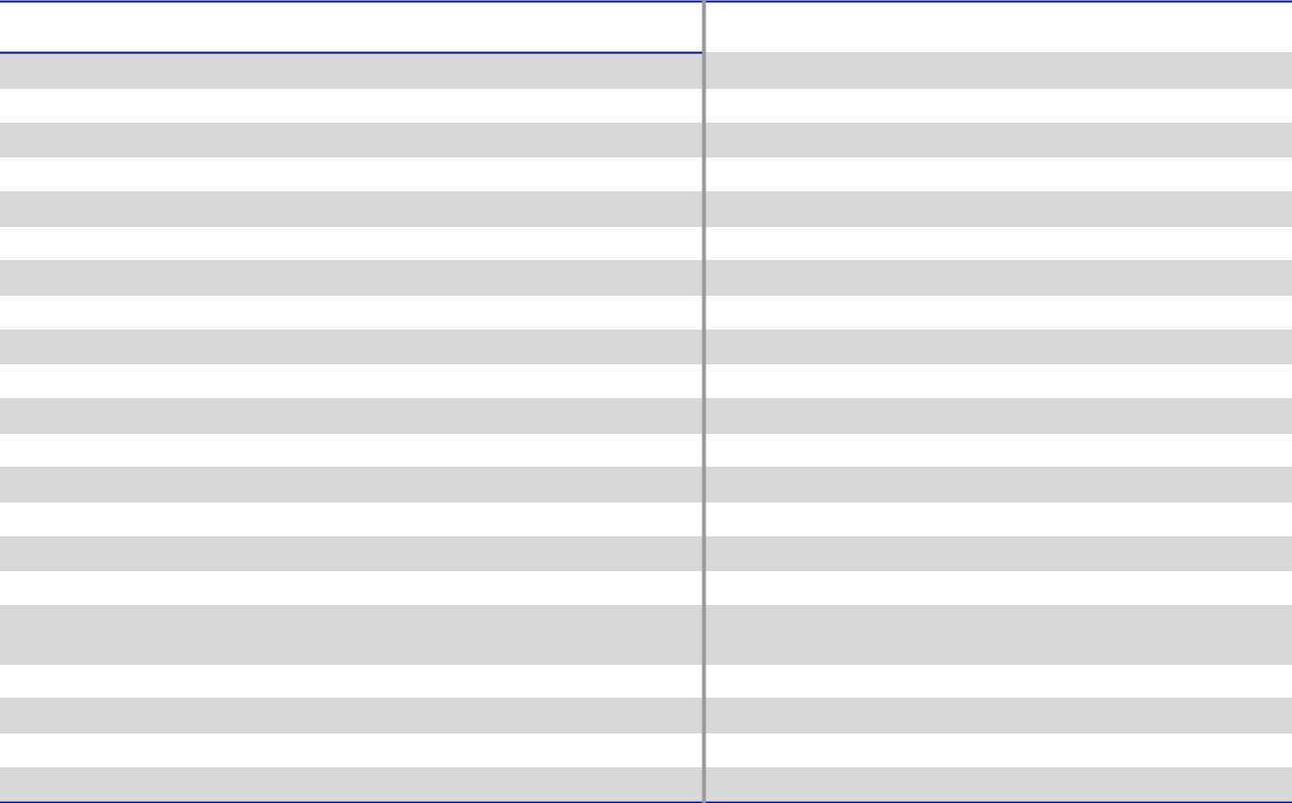

NAME OF BENEFICIAL OWNER

DIRECTORS (EXCEPT MR. TOBIN):

DEBORAH L. DEHAAS (2)

H. JOHN GILBERTSON, JR.

KRISTIANE C. GRAHAM (3)

MICHAEL F. JOHNSTON (4)

ERIC A. SPIEGEL (5)

STEPHEN M. TODD (6)

STEPHEN K. WAGNER (7)

KEITH E. WANDELL

MARY A. WINSTON

NEOS:

RICHARD J. TOBIN (8)

BRAD M. CEREPAK (9)

IVONNE M. CABRERA (10)

GIRISH JUNEJA (11)

KIMBERLY K. BORS (12)

DIRECTORS AND EXECUTIVE OFFICERS AS A GROUP (18 PERSONS) (13)

5% BENEFICIAL OWNERS:

BLACKROCK, INC. (14)

JPMORGAN CHASE & CO. (15)

THE VANGUARD GROUP (16)

Number of
Shares(1) | Percentage(1)
767 | *
3,873 | *
238,355 | *
19,596 | *
7,739 | *
22,105 | *
18,105 | *
8,263 | *
16,348 | *
606,259 | *
414,362 | *
224,532 | *
29,863 | *
3,399 | *
1,670,963 | 1.2 *
10,713,313 | 7.4%
11,268,963 | 7.8%
16,671,379 | 11.6%

- Less than one percent.

- In computing the number of shares beneficially owned by an executive officer and the percentage ownership of such executive officers, we have included (i) shares of common stock subject to stock-settled appreciation rights (“SSARs”) held by that person that are currently exercisable or exercisable within 60 days of March 9, 2022 and (ii) shares of common stock subject to restricted stock units that are scheduled to vest within 60 days of March 9, 2022, subject to the executive being an employee of Dover on the date of vesting. Such shares, however, are not deemed to be outstanding for purposes of computing the percentage ownership of any other person. Information about shares held through Dover’s 401(k) plan is as of March 9, 2022; fractional shares held in 401(k) accounts have been rounded down.

DOVER CORPORATION – 2022 Proxy Statement 80

Table of Contents

SHARE OWNERSHIP INFORMATION

In computing the number of shares beneficially owned by a director and the percentage ownership of such director, we have included shares of common stock subject to deferred stock units which become payable upon the director’s termination of service. Such shares, however, are not deemed to be outstanding for purposes of computing the percentage ownership of any other person.

- Reflects 767 deferred stock units.

- Includes 32,571 shares held by foundations of which Ms. Graham is a director and in which she disclaims any beneficial ownership, 2,460 shares held by her children to which Ms. Graham disclaims any beneficial ownership and 14,127 deferred stock units.
- Includes 15,596 deferred stock units.

- Includes 5,374 deferred stock units.

- Includes 14,127 deferred stock units.

- Includes 14,127 deferred stock units.

- Includes 3,126 deferred stock units, 394,869 shares in respect of vested SSARs, 18,186 shares in respect of restricted stock units scheduled to vest on March 15, 2022 and 320 shares held in our 401(k) plan.
- Includes 346,757 shares in respect of vested SSARs, 4,790 shares in respect of restricted stock units scheduled to vest on March 15, 2022 and 2,712 shares held in our 401(k) plan.
- Includes 198,729 shares in respect of vested SSARs, 2,158 shares in respect of restricted stock units scheduled to vest on March 15, 2022 and 1,827 shares held in our 401(k) plan.
- Includes 23,537 shares in respect of vested SSARs, 1,621 shares in respect of restricted stock units scheduled to vest on March 15, 2022 and 381 shares held in our 401(k) plan.
- Includes 474 shares in respect of restricted stock units scheduled to vest on March 15, 2022 and 229 shares held in our 401(k) plan.

- Includes 1,003,163 shares in respect of vested SSARs, 67,244 deferred stock units, 28,958 shares in respect of restricted stock units scheduled to vest on March 15, 2022 and 14,412 shares held in our 401(k) plan.
- Number of shares beneficially owned and percentage ownership based on information contained in a Schedule 13G/A filed with the SEC on February 1, 2022 by BlackRock, Inc. with respect to beneficial ownership of Dover common stock as of December 31, 2021. BlackRock reported sole voting e power with regard to 9,182,312 of the shares and sole dispositive power with regard to 10,713,313 of such shares. BlackRock, Inc.’s offices are located at 55 East 52nd Street, New York, NY 10055.
- Number of shares beneficially owned and percentage ownership based on information contained in a Schedule 13G/A filed with the SEC on January 10, 2022 by JPMorgan Chase & Co. with respect to beneficial ownership of Dover common stock as of December 31, 2021. JPMorgan Chase & Co. reported sole voting power with regard to 10,926,681 of the shares, shared voting power with regard to 14,491 of the shares, sole dispositive power with regard to 11,220,659 of the shares and shared dispositive power with regard to 42,143 of the shares. JPMorgan Chase & Co.’s address is 383 Madison Avenue, New York, NY 100179.
- Number of shares beneficially owned and percentage ownership based on information contained in a Schedule 13G/A filed with the SEC on February 9, 2022 by The Vanguard Group with respect to beneficial ownership of Dover common stock as of December 31, 2021. The Vanguard Group reported sole voting power with regard to none of the shares, shared voting power with regard to 226,974 of the shares, sole dispositive power with regard to 16,671,379 of the shares and shared dispositive power with regard to 577,667 of the shares. The Vanguard Group’s address is 100 Vanguard Blvd., Malvern, PA 19355.

Stock Ownership Guidelines

Our Board has adopted a policy that directors are expected to hold at any time a number of shares at least equal to the aggregate number of shares they received as the stock portion of their annual retainer during the past five years, net of an assumed 30% tax rate.

Executive officers are expected to hold a number of shares with a value at least equal to a multiple of their annual salary. For a discussion of the executive officer share ownership guidelines, see “Compensation Discussion and Analysis — Other Elements of Compensation” on page 60.

DOVER CORPORATION – 2022 Proxy Statement 81

Table of Contents

General Information About the Annual Meeting

We are providing this Proxy Statement to our shareholders in connection with the solicitation of proxies by the Board for use at the Annual Meeting. We are mailing this Notice of Annual Meeting and Proxy Statement beginning on or about March 17, 2022.

Record Date

The record date for determining shareholders eligible to vote at the Annual Meeting is March 9, 2022. As of the close of business on that date, we had outstanding 144,106,147 shares of common stock. Each share of common stock is entitled to one vote on each matter.

Electronic Delivery of Proxy Materials

As permitted under SEC rules, we are making this Proxy Statement and our Annual Report to Shareholders (which includes our Annual Report on Form 10-K for the year ended December 31, 2021) available to shareholders electronically via the internet. We believe electronic delivery expedites receipt of our proxy materials by shareholders, while lowering the costs and reducing the environmental impact of the Annual Meeting. If you receive a notice of internet availability of proxy materials by mail, you will not receive a printed copy of the proxy materials by mail unless you specifically request them. Instead, the notice of internet availability will provide instructions as to how you may review the proxy materials and submit your voting instructions over the internet. If you receive the notice by mail and would like to receive a printed copy of the proxy materials, you should follow the instructions in the notice of internet availability for requesting a printed copy. In addition, the proxy card contains instructions for electing to receive proxy materials over the internet or by mail in future years.

Shareholders of Record; Beneficial Owners

Most holders of our common stock hold their shares beneficially through a broker, bank or other nominee rather than of record directly in their own name.

As summarized below, there are some differences in the way to vote shares held of record and those owned beneficially.

If your shares are registered directly in your name with our transfer agent, you are considered the shareholder of record of those shares, and the notice of internet availability or proxy materials are being sent directly to you. As a shareholder of record, you have the right to grant your voting proxy directly to the persons named as proxy holders or to vote in person at the Annual Meeting. If you received or requested printed copies of the proxy materials, Dover has enclosed a proxy card for you to use. You may also submit your proxy on the internet or by telephone as described in the proxy card.

If your shares are held in a brokerage account or by a bank or other nominee, you are considered the beneficial owner of the shares held in “street name,” and these proxy materials are being forwarded to you by your broker or nominee who is considered the shareholder of record of those shares. As the beneficial owner, you generally have the right to direct your broker on how to vote and are also invited to attend the Annual Meeting. However, since you are not the shareholder of record, you may not vote those shares in person at the Annual Meeting unless you have a proxy, executed in your favor, from the holder of record of your shares. Your broker or nominee has enclosed a voting instruction card for you to use in directing your broker or nominee as to how to vote your shares. We strongly encourage you to instruct your broker or nominee how you wish to vote.

Vote Required; Abstentions and Broker Non-Votes; Quorum

For Proposal 1, a majority of the votes cast at the Annual Meeting is required to elect each of the directors. This means that the number of votes cast “FOR” a director must exceed the number of votes cast “AGAINST” that director in order for that director to be elected. Our organizational documents do not provide for cumulative voting.

Proposal 2 will require the affirmative vote of at least a majority of shares present in person or represented by proxy and entitled to vote thereon.

Proposal 3 is a nonbinding, advisory resolution so its ultimate adoption is at the discretion of the Board. The affirmative vote of a majority of shares present in person or represented by proxy and entitled to vote thereon will be deemed to be approval by the shareholders of Proposal 3.

Proposal 4 will require the affirmative vote of at least a majority of shares present in person or represented by proxy and entitled to vote thereon. Proposal 4 is a shareholder advisory resolution that will not itself effect any amendment to our charter or by-laws.

DOVER CORPORATION – 2022 Proxy Statement 82

Table of Contents

GENERAL INFORMATION ABOUT THE ANNUAL MEETING

If you are a shareholder of record and you sign and return your proxy card or vote electronically without making any specific selection, then your shares will be voted FOR all director nominees listed in Proposal 1 and FOR Proposals 2 and 3, and AGAINST Proposal 4.

If you specify that you wish to “ABSTAIN” from voting on an item, then your shares will not be voted on that particular item. Abstentions will not affect the outcome of the vote on Proposal 1. However, they will have the same effect as a vote against Proposals 2, 3, and 4.

If you are a beneficial owner and hold your shares through a broker or other nominee and do not provide your broker or nominee with voting instructions, the broker or nominee will have discretionary authority to vote your shares on routine matters only and will not vote your shares on non-routine matters. This is generally referred to as a “broker non-vote.” Only Proposal 2 will be considered a routine matter for the Annual Meeting. Accordingly, a broker or other nominee will not be able to vote on Proposals 1, 3, and 4 without voting instructions. Broker non-votes will not affect the outcome of the vote on Proposals 1, 3 and 4 as they will not be counted as being present and entitled to vote on such proposals.

For purposes of the Annual Meeting, there will be a quorum if the holders of a majority of the outstanding shares of our common stock entitled to vote at the Annual Meeting are present in person or represented by proxy. Abstentions and broker non-votes will be counted for purposes of determining if a quorum is present.

Voting Procedures

If you are a shareholder of record, you may vote in person at the Annual Meeting or submit your proxy or voting instruction form over the internet, by telephone or by mail by following the instructions provided in our notice of internet availability, in the proxy materials or in the voting instruction form. If you hold your shares beneficially in “street name” through a broker or other nominee, you must follow the instructions provided by your broker or nominee to vote your shares.

Revoking Your Proxy/Changing Your Voting Instructions

If you are a shareholder of record, whether you give your proxy over the internet, by telephone or by mail, you may revoke it at any time before it is exercised. You may submit a new proxy by using the internet or the telephone or by mailing a new proxy card bearing a later date so long as it is received before the Annual Meeting. You may also revoke your proxy by attending the Annual Meeting and voting in person, although attendance at the Annual Meeting will not, by itself, revoke your proxy. If you hold your shares beneficially in “street name” through a broker or other nominee, you must follow the instructions provided by your broker or nominee as to how you may change your voting instructions.

Shareholders Sharing the Same Address

SEC rules permit us to deliver one copy of the Proxy Statement or a notice of internet availability of the Proxy Statement to multiple shareholders of record who share the same address and have the same last name, unless we have received contrary instructions from one or more of such shareholders. This delivery method, called “householding,” reduces our printing and mailing costs. Shareholders who participate in householding will continue to receive or have internet access to separate proxy cards.

If you are a shareholder of record subject to householding and wish to receive a separate copy of the Proxy Statement or notice of internet availability of the proxy materials, now or in the future, at the same address or if you are currently receiving multiple copies of such materials at the same address and wish to receive only a single copy, please write to or call the Corporate Secretary, Dover Corporation, 3005 Highland Parkway, Downers Grove, Illinois 60515, telephone: (630) 541-1540.

Beneficial owners sharing an address who are currently receiving multiple copies of the proxy materials or notice of internet availability of the proxy materials and wish to receive only a single copy in the future, or who currently receive a single copy and wish to receive separate copies in the future, should contact their bank, broker or other holder of record to request that only a single copy or separate copies, as the case may be, be delivered to all shareholders at the shared address in the future.

Proxy Solicitation Costs

We will pay the reasonable and actual costs of printing, mailing and soliciting proxies, but we will not pay a fee to any of our officers or employees or to officers or employees of any of our subsidiaries as compensation for soliciting proxies. We have retained Morrow Sodali, LLC to solicit brokerage houses and other custodians, nominees or fiduciaries, and to send proxies and proxy materials to the beneficial owners of such shares, for a fee of approximately $12,000 plus expenses.

DOVER CORPORATION – 2022 Proxy Statement 83

Table of Contents

GENERAL INFORMATION ABOUT THE ANNUAL MEETING

Other Matters

Our Board and management have not received notice of, and are not aware of, any business to come before the Annual Meeting other than the agenda items referred to in this Proxy Statement. If, however, any other business properly comes before the meeting, the persons named as proxies will use their best judgment in voting the proxies.

Shareholder Proposals and Director Nominations for 2023 Annual Meeting

In order for shareholder proposals to be included in our proxy statement for the Annual Meeting of Shareholders to be held in 2023 (the “2023 Annual Meeting”), they must be received by our Corporate Secretary at our principal executive offices, 3005 Highland Parkway, Downers Grove, Illinois, 60515, no later than the close of business on November 17, 2022.

In 2016, we adopted a proxy access right to permit a shareholder or a group of up to 20 shareholders owning 3% or more of our outstanding common stock continuously for at least three years to nominate and include in our proxy materials director candidates constituting up to the greater of two individuals or 20% of the Board, provided that the shareholder(s) and the nominee(s) satisfy the requirements specified in our by-laws. In order to be timely, notice of proxy access director nominees must be received by our Corporate Secretary at our principal executive offices at the address above no earlier than the open of business on October 18, 2022 and no later than the close of business on November 17, 2022 being, respectively, 150 days and 120 days prior to the first anniversary of the date we first distributed this proxy statement.

All other shareholder nominations and proposals, in order to be voted on at the 2023 Annual Meeting, must be received by us no earlier than the open of business on January 6, 2023, and no later than the close of business on February 5, 2023 being, respectively, 120 days and 90 days prior to the date of the first anniversary of the 2022 Annual Meeting.

Where You Can Find Additional Information

Our website is located at www.dovercorporation.com. You can view additional information on our website, such as:

- Charters of our Board committees

- Corporate Governance Guidelines

- Code of Business Conduct & Ethics

- Related Person Transactions Policy

- Standards for Director Independence

- Other governance materials and reports that we file with the SEC. Copies of these documents also may be obtained free of charge by writing or calling the Corporate Secretary, Dover Corporation, 3005 Highland Parkway, Downers Grove, Illinois 60515, telephone: (630) 541-1540

All Dover Corporation website addresses contained in this proxy statement are intended to be inactive, textual references only. The information on, or accessible through, any such website identified in this proxy statement is not a part of, and is not incorporated by reference into, this proxy statement.

Caution Concerning Forward-Looking Statements

This proxy statement contains forward-looking statements that are inherently subject to uncertainties and risks. We caution investors to be guided in their analysis of Dover by referring to the documents we file with the SEC, including our Annual Report on Form 10-K for 2021, for a list of factors that could cause our results to differ from those anticipated in any such forward-looking statements.

DOVER CORPORATION – 2022 Proxy Statement 84

Table of Contents

GENERAL INFORMATION ABOUT THE ANNUAL MEETING

Non-GAAP Disclosures

In an effort to provide investors with additional information regarding our results as determined by accounting principles generally accepted in the United States of America (“GAAP”), we also disclose non-GAAP information that we believe provides useful information to investors. Adjusted net earnings, adjusted diluted net earnings per share, total segment earnings (EBIT), adjusted segment EBIT, adjusted segment EBIT margin, free cash flow, free cash flow as a percentage of revenue, free cash flow as a percentage of earnings, and organic revenue growth are not financial measures under GAAP and should not be considered as a substitute for net earnings, diluted net earnings per share, cash flows from operating activities, or revenue as determined in accordance with GAAP, and they may not be comparable to similarly titled measures reported by other companies.

Adjusted Net Earnings Per Share

(in millions, except per share data) |  |  |  | 2021 |  |  | 2020 |  |  |  | 2019
Adjusted net earnings:
 | Net earnings | $ |  | 1,124 |  | $ | 683 |  | $ |  | 678
 | Acquisition-related amortization, pre-tax 1 |  |  | 142 |  |  | 139 |  |  |  | 138
 | Acquisition-related amortization, tax impact 2 |  |  | (35) |  |  | (34) |  |  |  | (35)
 | Rightsizing and other costs, pre-tax 3 |  |  | 38 |  |  | 51 |  |  |  | 32
 | Rightsizing and other costs, tax impact 2 |  |  | (7) |  |  | (11) |  |  |  | (7)
 | Gain on dispositions, pre-tax 4 |  |  | (206) |  |  | (5) |  |  |  | —
 | Gain on dispositions, tax impact 2 |  |  | 53 |  |  | 1 |  |  |  | —
 | Loss on extinguishment of debt, pre-tax 5 |  |  | — |  |  | — |  |  |  | 24
 | Loss on extinguishment of debt, tax impact 2 |  |  | — |  |  | — |  |  |  | (5)
 | Loss on assets held for sale 6 |  |  | — |  |  | — |  |  |  | 47
 | Adjusted net earnings | $ |  | 1,109 |  | $ | 824 |  | $ |  | 872
Diluted average shares outstanding
 |  |  |  | 145 |  |  | 145 |  |  |  | 147
 | Adjusted diluted net earnings per common share*:
 | Net earnings | $ |  | 7.74 |  | $ | 4.70 |  | $ |  | 4.61
 | Acquisition-related amortization, pre-tax 1 |  |  | 0.98 |  |  | 0.95 |  |  |  | 0.94
 | Acquisition-related amortization, tax impact 2 |  |  | (0.24) |  |  | (0.24) |  |  |  | (0.24)
 | Rightsizing and other costs, pre-tax 3 |  |  | 0.26 |  |  | 0.35 |  |  |  | 0.22
 | Rightsizing and other costs, tax impact 2 |  |  | (0.05) |  |  | (0.07) |  |  |  | (0.06)
 | Gain on dispositions, pre-tax 4 |  |  | (1.42) |  |  | (0.03) |  |  |  | —
 | Gain on dispositions, tax impact 2 |  |  | 0.37 |  |  | 0.01 |  |  |  | —
 | Loss on extinguishment of debt, pre-tax 5 |  |  | — |  |  | — |  |  |  | 0.16
 | Loss on extinguishment of debt, tax impact 2 |  |  | — |  |  | — |  |  |  | (0.04)
 | Loss on assets held for sale 6 |  |  | — |  |  | — |  |  |  | 0.32
Adjusted diluted net earnings per common share |  | $ |  | 7.63 |  | $ | 5.67 |  | $ |  | 5.93

¹ Includes amortization on acquisition-related intangible assets and inventory step-up.
- Adjustments were tax effected using the statutory tax rates in the applicable jurisdictions or the effective tax rate, where applicable, for each period.
³ Rightsizing and other costs include actions taken on employee reductions, facility consolidations and site closures, product line exits and other asset charges. 2021 includes a $12.1 million other than temporary impairment charge related to an equity method investment and a $6.1 million write-off of assets incurred in connection with an exit from certain Latin America countries within our Climate & Sustainability Technologies segment, as well as a $9.1 million payment received for previously incurred restructuring costs related to a product line exit in our Engineered Products segment.

⁴ 2021 represents a $181.6 million gain on the disposition of Unified Brands, a wholly owned subsidiary of the Company within the Climate & Sustainability Technologies segment, and a $24.7 million gain on disposition of our Race Winning Brands equity method investment in the Engineered Products segment. 2020 represents a $5.2 million net gain on the sale of AMS Chino within the Climate & Sustainability Technologies segment, including working capital adjustments.

⁵ Represents a loss on early extinguishment of €300.0 million 2.125% notes due 2020 and $450.0 million 4.30% notes due 2021.

DOVER CORPORATION – 2022 Proxy Statement 85

Table of Contents

GENERAL INFORMATION ABOUT THE ANNUAL MEETING

- Represents a loss on assets held for sale of Finder Pompe S.r.l. (“Finder”). Under local law, no tax benefit is realized from the loss on the sale of a wholly-owned business.

* Per share data and totals may be impacted by rounding.

Adjusted Segment EBIT Margin

Segment earnings (EBIT) is adjusted by the effect of rightsizing and other costs, loss on assets held for sale, and gain on dispositions to derive at total adjusted segment earnings (EBIT). Total adjusted segment earnings (EBIT) is divided by total segment revenue to derive at adjusted segment EBIT margin as follows:

(in thousands)
Segment earnings (EBIT)
Engineered Products
Clean Energy & Fueling
Imaging & Identification
Pumps & Process Solutions
Climate & Sustainability Technologies
Total segment earnings (EBIT) ¹
Rightsizing and other costs ²
Loss on assets held for sale ³
Gain on dispositions ⁴

Adjusted segment EBIT

Adjusted segment EBIT margin

2021 2020 2019

- 285,511 $ 238,167 $ 291,848
271,388236,974231,873
237,147193,473229,484
546,863305,276240,081
322,622102,872118,832
1,663,531 | 1,076,762 | 1,112,118
33,907 | 44,171 | 26,555
— | — | 46,946
(206,338) | (5,213) | —
- 1,491,100 $ 1,115,720 $ 1,185,619

18.9%16.7%16.6%

¹ Refer to the table below for reconciliation of total segment earnings (EBIT) to net earnings.

- Rightsizing and other costs include actions taken on employee reductions, facility consolidations and site closures, product line exits and other asset charges. 2021 includes a $9,078 payment received for previously incurred restructuring costs related to a product line exit in our Engineered Products segment, as well as a $12,073 other than temporary impairment charge related to an equity method investment and a $6,072 write-off of assets incurred in connection with an exit from certain Latin America countries within our Climate & Sustainability Technologies segment.

³ Represents a loss on assets held for sale for Finder. Under local law, no tax benefit is realized from the loss on the sale of a wholly-owned business.
⁴ 2021 represents a $181,615 gain on the disposition of Unified Brands, a wholly owned subsidiary of the Company within the Climate & Sustainability Technologies segment, and a $24,723 gain on disposition of our Race Winning Brands equity method investment in the Engineered Products segment. 2020 represents a $5,213 net gain on the sale of AMS Chino within the Climate & Sustainability Technologies segment, including working capital adjustments.

(in thousands) |  |  | 2021 |  |  | 2020 |  |  | 2019
Net earnings:
Total segment earnings (EBIT) |  | $ | 1,663,531 |  | $ | 1,076,762 |  | $ | 1,112,118
Corporate expense / other |  |  | 160,827 |  |  | 126,662 |  |  | 147,817
Interest expense |  |  | 106,319 |  |  | 111,937 |  |  | 125,818
Interest income |  |  | (4,441) |  |  | (3,571) |  |  | (4,526)
Net earnings before provision for income taxes |  |  | 1,400,826 |  |  | 841,734 |  |  | 843,009
Provision for income taxes |  |  | 277,008 |  |  | 158,283 |  |  | 165,091
Net earnings |  | $ | 1,123,818 |  | $ | 683,451 |  | $ | 677,918

DOVER CORPORATION – 2022 Proxy Statement 86

Table of Contents

GENERAL INFORMATION ABOUT THE ANNUAL MEETING

Free Cash Flow

Free cash flow represents net cash provided by operating activities minus capital expenditures as follows:

(in thousands) |  |  |  | 2021 |  |  | 2020 |  |  | 2019
 | Cash flow from operating activities
 | Cash flow from operating activities | $ |  | 1,115,865 |  | $ | 1,104,810 |  | $ | 945,306
Less: Capital expenditures |  |  |  | (171,465) |  |  | (165,692) |  |  | (186,804)
 | Free cash flow | $ |  | 944,400 |  | $ | 939,118 |  | $ | 758,502
 | Free cash flow as a percentage of revenue |  |  | 11.9% |  |  | 14.1% |  |  | 10.6%
Free cash flow as a percentage of net earnings |  |  |  | 84.0% |  |  | 137.4% |  |  | 111.9%

Organic Revenue Growth Factor

 |  |  | 2021
 |  |  | Full Year
 | Organic |  | 15.3%
 | Acquisitions |  | 1.3%
 | Dispositions |  | (0.2)%
 | Currency translation |  | 1.9%
 | Total |  | 18.3%

Non-GAAP Disclosures

Adjusted net earnings represents net earnings adjusted for the effect of acquisition-related amortization, rightsizing and other costs, gain on dispositions, loss on extinguishment of debt, and loss on assets held for sale. We exclude after-tax acquisition-related amortization because the amount and timing of such charges are significantly impacted by the timing, size, number and nature of the acquisitions the Company consummates. We exclude the other items because they occur for reasons that may be unrelated to the Company’s commercial performance during the period and/or Management believes they are not indicative of the Company’s ongoing operating costs or gains in a given period.

Adjusted diluted net earnings per share represents adjusted net earnings divided by average diluted shares.

Total segment earnings (EBIT) is defined as net earnings before income taxes, net interest expense, and corporate expenses. Total segment earnings (EBIT) margin is defined as total segment earnings (EBIT) divided by revenue.

Management believes these measures are useful to investors to better understand the Company’s ongoing profitability as it will better reflect the Company’s core operating results, offer more transparency and facilitate easier comparability to prior and future periods and to its peers.

Free cash flow represents net cash provided by operating activities minus capital expenditures. Free cash flow as a percentage of revenue equals free cash flow divided by revenue. Free cash flow as a percentage of net earnings equals free cash flow divided by net earnings. Management believes that free cash flow and free cash flow ratios are important measures of operating performance because they provide management and investors a measurement of cash generated from operations that is available for mandatory payment obligations and investment opportunities, such as funding acquisitions, paying dividends, repaying debt and repurchasing our common stock.

Management believes that reporting organic revenue growth, which excludes the impact of foreign currency exchange rates and the impact of acquisitions and dispositions, provides a useful comparison of our revenue performance and trends between periods.

DOVER CORPORATION – 2022 Proxy Statement 87

Table of Contents
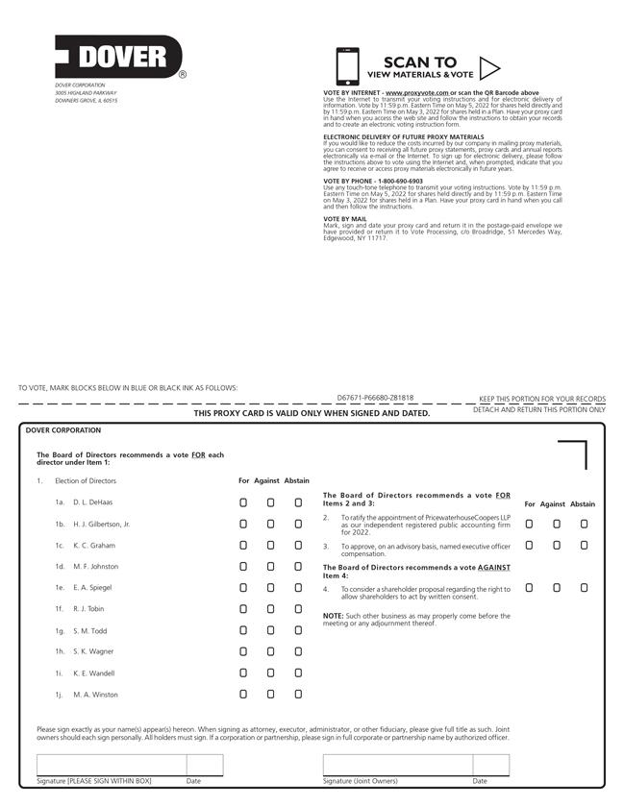

Table of Contents


